RECYCLE

Problem Statement:

The following flow diagram describes the synthesis of n-octane into 1-octene and hydrogen. The feed conditions and the specifications for each major unit operation are described in the flow diagram.

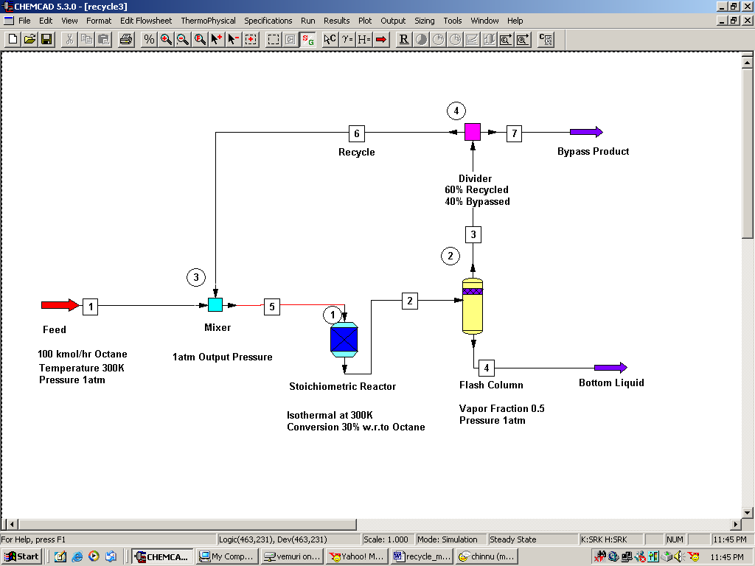

Perform a steady state simulation of this flow network and report the composition and condition of the all the intermediate, recycle and product streams.

Procedure:

Step 1: Creating the flow sheet
Step 2: Entering the components and formatting engineering units
Step 3: Entering the feed stream composition
Step 4: Entering the mixer specs
Step 5: Entering the reactor specs
Step 6: Entering the flash column specs
Step 7: Entering the divider specs
Step 5: Running the simulation and retrieving the results

Step 1: Creating the flow sheet

Select and click the feed, mixer, stoichiometric reactor, flash, divider and product(2) icons on the workspace.

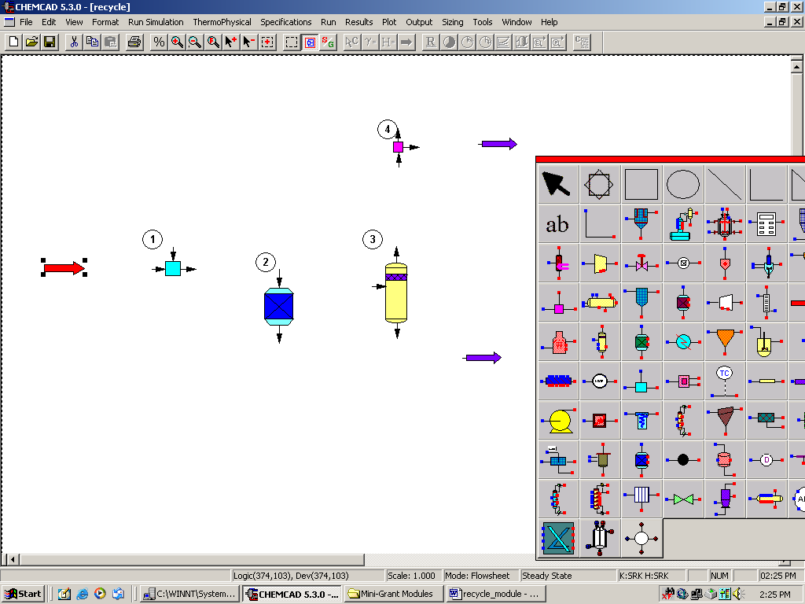

Connect all the unit operations appropriately using Stream. Click once on the S/G icon on the menu bar to switch the simulation mode from Edit Simulation to Run Simulation. Note that one of the streams on the flow sheet is in red, indicating the presence of recylce in the flow sheet.

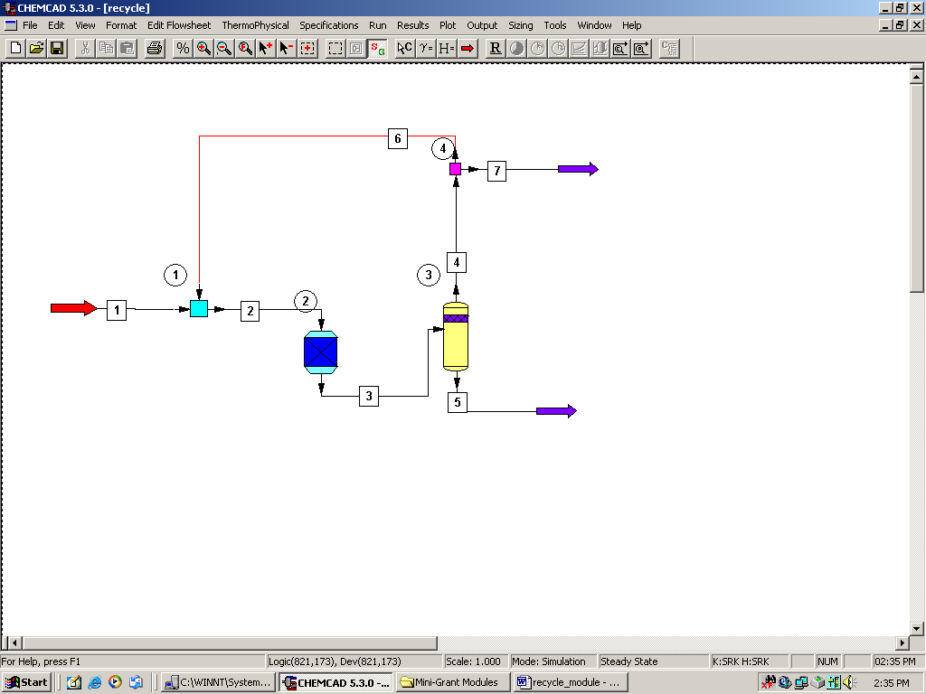

Step 2: Entering the components and formatting engineering units

Go to the Thermophysical on the menu bar and click on Components List. Find n-octane, 1-octene and hydrogen from the CHEMCAD components list and add them to the component list. Go to the Format menu and click on Engineering Units and select the desired units for such properties as temperature, pressure etc. Click OK to continue.

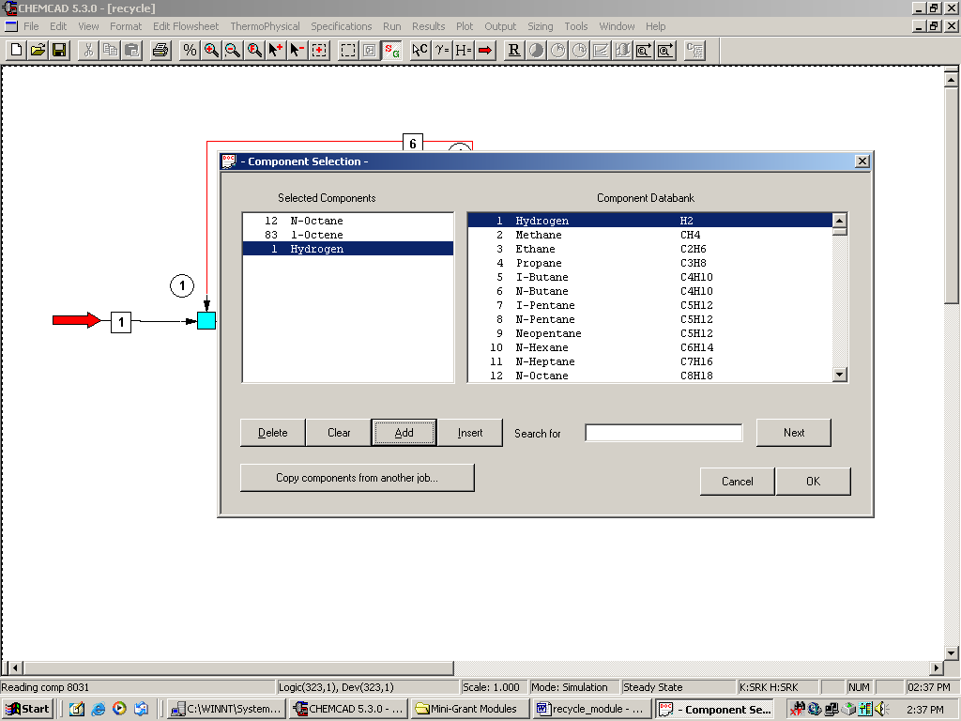

Step 3: Entering the feed stream composition

Double click on the feed stream and enter the feed information (temperature, pressure, total flow rate and component mole fractions) given in the problem statement. Click once on Flash to get the feed stream enthalpy and vapor fraction in feed at the feed conditions.

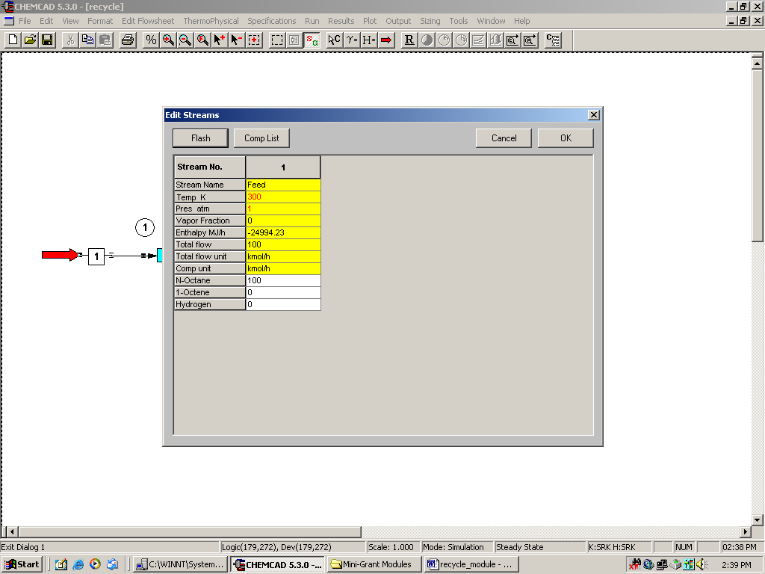

Step 4: Entering the mixer specs

Double click on the Mixer. Enter 1atm as the output pressure and click OK.

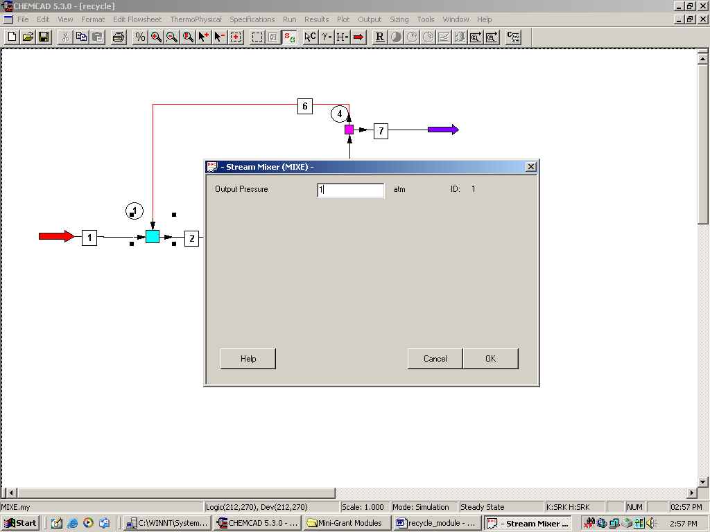

Step 5: Entering the reactor specs

Double click on the Stoichiometric Reactor. Under the General Specifications tab, enter the following information.

Specify Thermal Mode:
Select the radio button corresponding to Isothermal and enter 300K in the box provided.

Key Component:
Select N-Octane from the drop box

Fractional Conversion:
Enter 0.3 in the space provided

Heat of Reaction, Reactor Pressure and Calc. H. of Reac. can all be left blank.

Stoichiometric Coefficients:
Choose option 0, mole base (default) and enter the stoichiometric coefficients corresponding to all the components in the spaces provided as shown in the following figure.

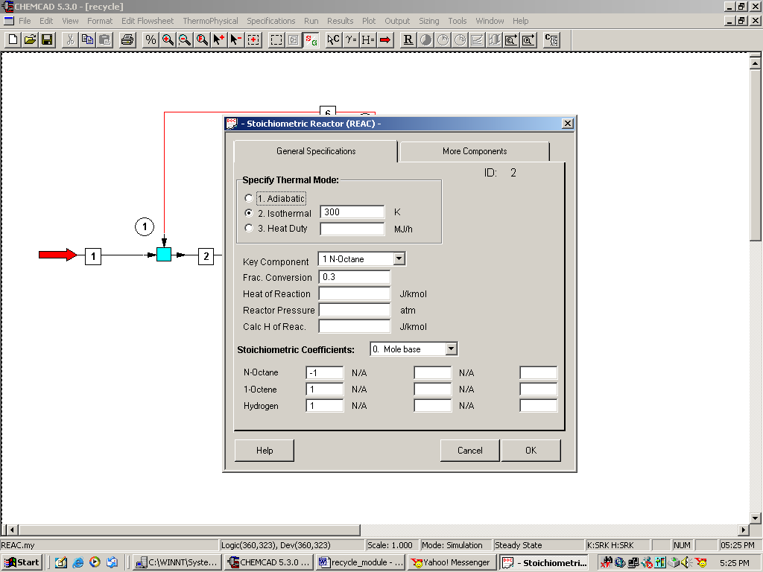

Click on OK to continue.
Step 6: Entering the flash column specs

Double click on the Flash column. Under the Specifications tab, choose option 1, Specify V/F and P; Calculate T and Heat, as the problem statement contains the information on pressure and vapor fraction.

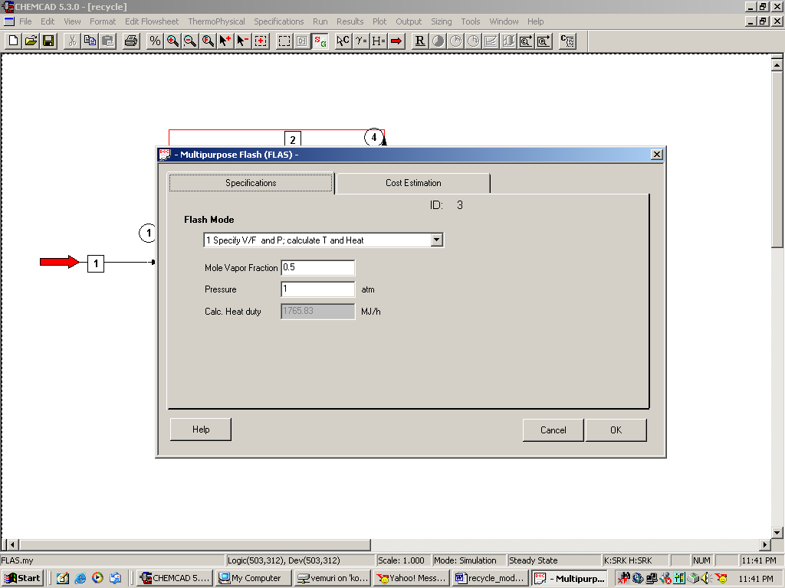

Click on OK to continue.

Step 7: Entering the Divider specs

Double click on the Divider. The specifications given in the problem statement say that 60% of the flow coming into the divider is recycled and 40% is bypassed.
Choose option 0, Flow ratio, for the split basis. Identify the bypass stream (stream 7 in my case) and recycle stream (stream 6 in my case) on the flowsheet and enter 0.4 and 0.6 respectively as shown in the figure.

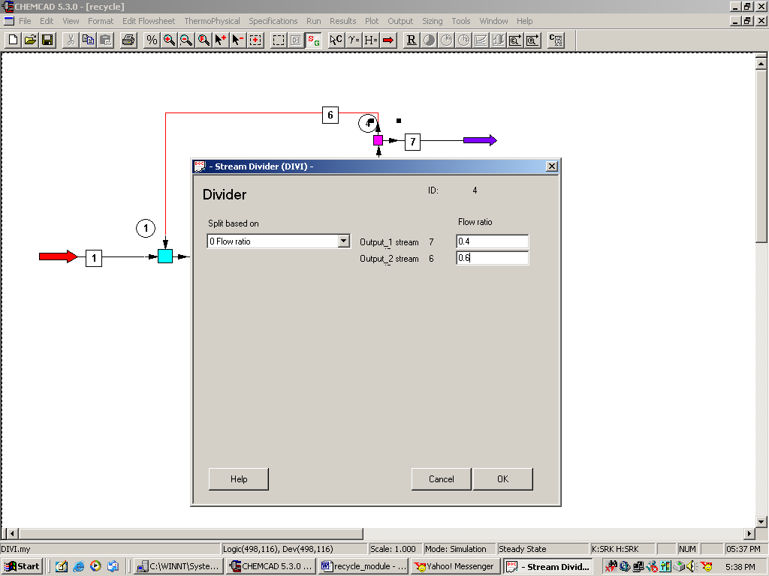

Click on OK to continue.

Step 8: Running the simulation and retrieving the results:

Now the simulation is ready to be run. Click once on R to run the simulation. Alternatively, one can run the simulation by clicking on Run on the menu bar and selecting Run all. The status of the simulation can be found at the bottom left hand corner of the screen. The message, Recycle calculation has converged, appears if the run is successfully completed. The stream properties can found either by clicking once on the product stream or by clicking once on Results on the menu, selecting Stream Composition and then clicking on All Streams. The results will again be available in a WordPad file.

