SHORTCUT COLUMN

Problem Statement:

A 100 kmol/hr stream of ethanol (50 mol%) and n-propanol (50 mol%) is fed to a continuous distillation column at room temperature (298 K) and atmospheric pressure. The pressure drop across the column is negligible and a reflux ratio of 1.5 is used. About 93 mol% of ethanol in feed and 5 mol% of n-propanol in feed is desired to be present in the distillate stream.

Design a continuous distillation column to meet the desired specifications using Shortcut column in CHEMCAD and report the total number of stages, minimum number of stages, feed stage location, minimum and calculated reflux ratios, final distillate and bottom stream concentrations and the reboiler and condenser heat duties.

Procedure:

Step 1: Creating the flow sheet
Step 2: Entering the components and engineering units
Step 3: Entering the composition of feed stream
Step 4: Entering the shortcut column specs
Step 5: Running the simulation and retrieving the results

Step 1: Creating the flow sheet

Go to new on the File menu and save the blank simulation. Click on Shortcut column on the CHEMCAD palette and click once on simulation window to paste it. Click on the feed icon on the palette and paste it on the workspace. Similarly, click on the product icon and place it on the workspace (do the product twice as there are two product streams). After making sure that all the necessary icons are placed on the workspace, they can be connected by using stream. CHEMCAD automatically assigns numbers to streams and unit operations the order in which they are placed on the workspace. After completing the flow sheet, click once in the S/G icon found on the menu bar so that the simulation is changed from edit mode to run mode. The same icon can be used to toggle between these two simulation modes. Alternatively, one can toggle between Edit Flowsheet and Run Simulation on the menu bar to achieve the same.

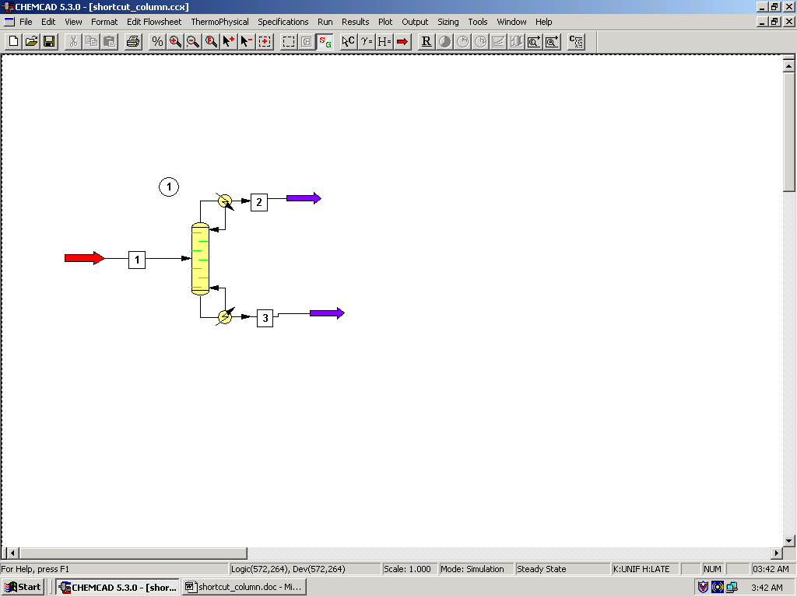

Step 2: Entering the components and engineering units

Go to the Thermophysical on the menu bar and click on Components List. Find ethanol and n-propanol from the CHEMCAD components list and add them to the component list. Go to the Format menu and click on Engineering Units and select the desired units for such properties as temperature, pressure etc. Click OK to continue.

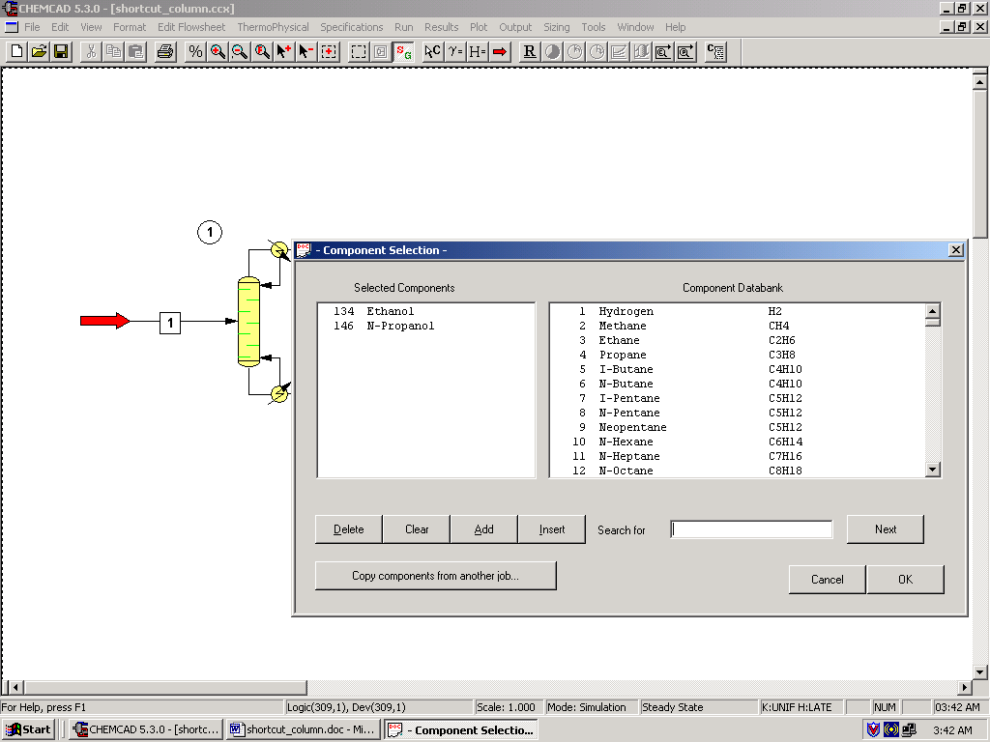

Step 3: Entering the composition of feed stream

Double click on the feed stream and enter the feed information (temperature, pressure, total flow rate and component mole fractions) given in the problem statement. Click once on Flash to get the feed stream enthalpy and vapor fraction in feed at the feed conditions.

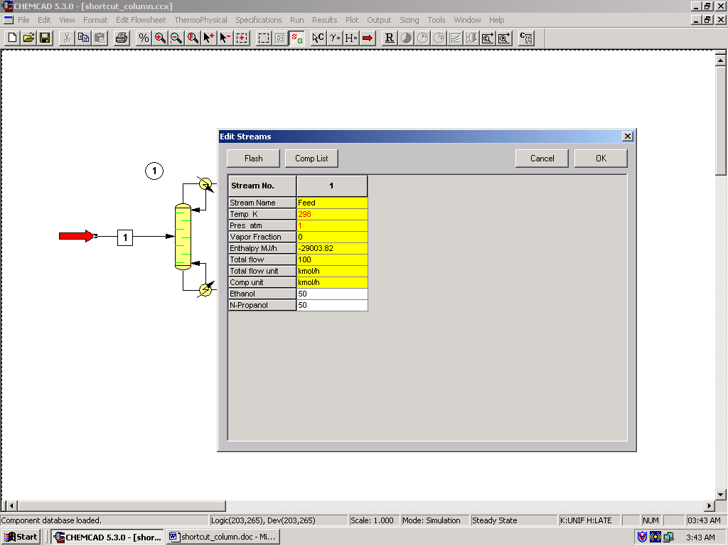

Step 4: Entering the Shortcut column specs

Double click on the ShortCut Column.

1. Select mode:
The Shortcut column can be used for both design and rating of a distillation column. As we need to design a column, option 2 or option 3 can be used for the design mode. Select one of these two and continue.

2. Select condenser type:
As this is not explicitly stated in the problem statement, the condenser can be assumed to be total and can be left to this default option.

3. Column pressure:
As there is negligible pressure drop across the column, one can enter the same pressure as that of the feed stream in this field (1 atm). This can also be left blank and CHEMCAD sets the pressure to default, which is the pressure of the feed stream.

4. Column pressure drop:
This can be left blank.

5. Number of stages:
CHEMCAD calculates the number of stages and stores the calculated number in this box. The user needs to leave this box blank.

6. Reflux ratio:
Enter the value ‘1.5’ in this field.

7. R/Rmin:
One needs to enter only one of the two specs, reflux rato or R/Rmin. As the reflux ratio is specified, this field needs to be left blank.

8. Case study:
This is optional and can be left blank for our purpose.

9. Key component specifications:
- Light key component: Select ‘Ethanol’
- Light key split: Enter ‘0.93’
- Heavy key component: Select ‘n-propanol’
- Heavy key split: Enter ‘0.05’

10. Calculated results:
These are the parameters that CHEMCAD calculates and stores the values of. All these fields need to be left blank.

Click Ok when finished.

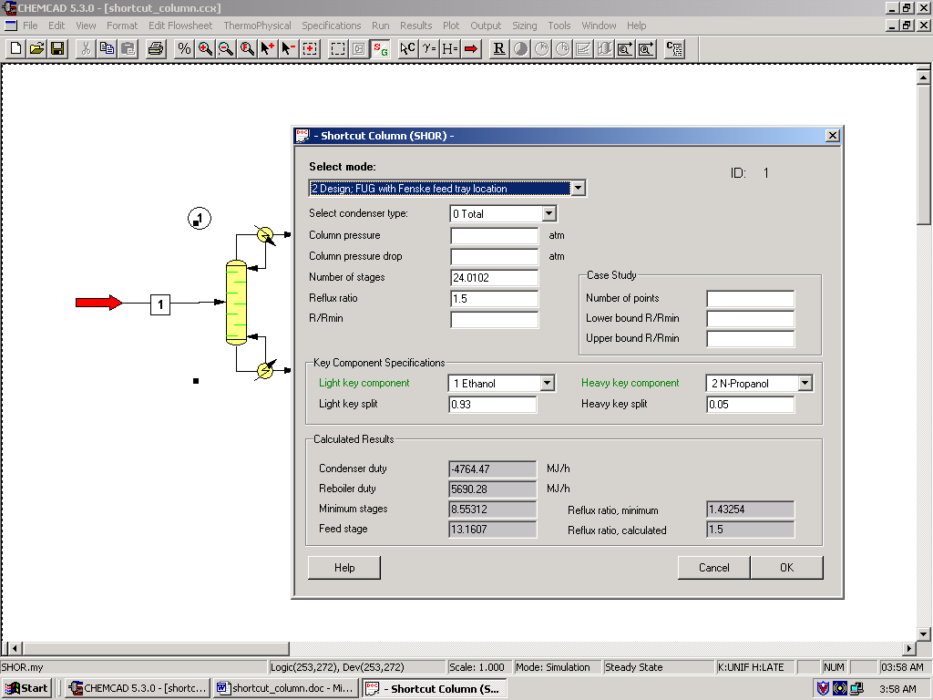

Step 5: Running the simulation and retrieving the results

After entering the available information on the workspace as described in the previous steps, one can run the simulation by clicking on R on the menu bar. Alternatively, one can run the simulation by clicking on Run on the menu bar and selecting Run all. The simulator indicates the same warnings regarding the estimates as before and one can ignore them again and continue with the simulation by clicking on Yes. The status of the simulation can be found at the bottom left hand corner of the screen. The message, Run Finished appears in this place if the run is successfully completed. To view the product stream compositions, one can either double click on the individual product streams or by clicking Results on the menu bar and selecting Stream Compositions and further selecting All Streams. The results obtained from the latter method will be in a WordPad file.

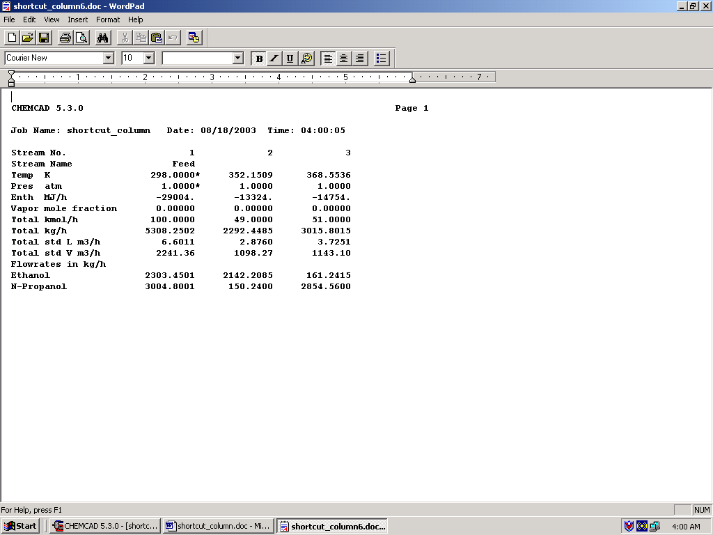

All the results associated with the shortcut column can be found by clicking on Results menu and selecting Unit Op’s and then the shortcut Column. The results will then be available in a WordPad file.

