SPLITTER

Problem Statement:

A 100 kmol/hr stream of benzene (50 mol%), toluene (20 mol%) and O-xylene (30 mol%) is fed to a splitter at room temperature (298 K) and atmospheric pressure. If the split in the splitter is based on
- Flow ratio of 0.3, 0.2, 0.5 for product streams 1,2 and 3 respectively
- Molar flow rate of 50, 25, 25 kmol/hr for streams 1,2 and 3 respectively
Estimate the composition of benzene, toluene and O-xylene in streams 1, 2 and 3.

Procedure:

Step 1: Creating the flow sheet
Step 2: Entering the components and engineering units
Step 3: Entering the composition of feed stream
Step 4: Entering the Splitter specs
Step 5: Running the simulation and retrieving the results

Step 1: Creating the flow sheet

Go to new on the File menu and save the blank simulation. Find Divider on the CHEMCAD palette and right click on the icon to find the divider with one input stream and three output streams (Divider#5).

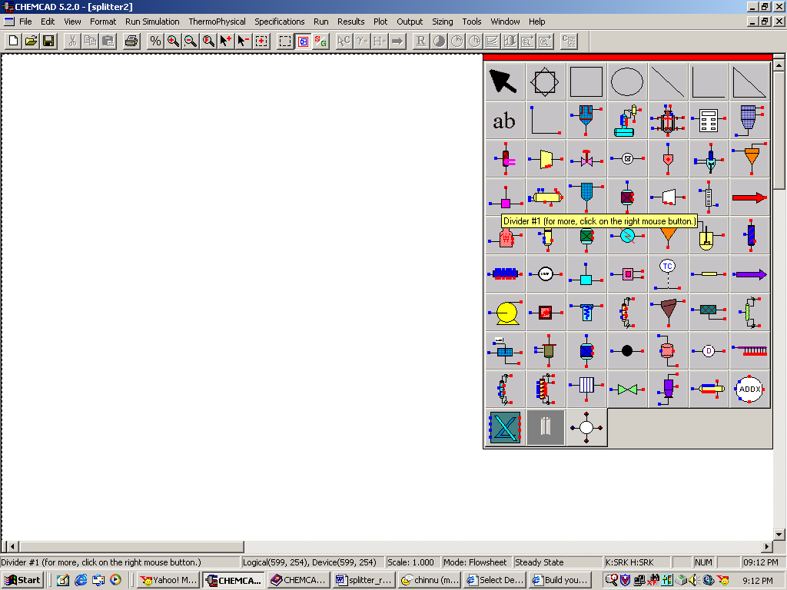

After the divider with suitable configuration is pasted on the workspace, click on the feed icon on the palette and paste it on the workspace. Similarly, click on the product icon and place it on the workspace. One can right click on the product icon to get the product icons pointing upwards and downwards. After making sure that all the necessary icons are placed on the workspace, they can be connected by using stream. CHEMCAD automatically assigns numbers to streams and unit operations the order in which they are placed on the workspace. After completing the flow sheet, click once in the S/G icon found on the menu bar so that the simulation is changed from edit mode to run mode. The same icon can be used to toggle between these two simulation modes. Alternatively, one can toggle between Edit Flowsheet and Run Simulation on the menu bar to achieve the same.

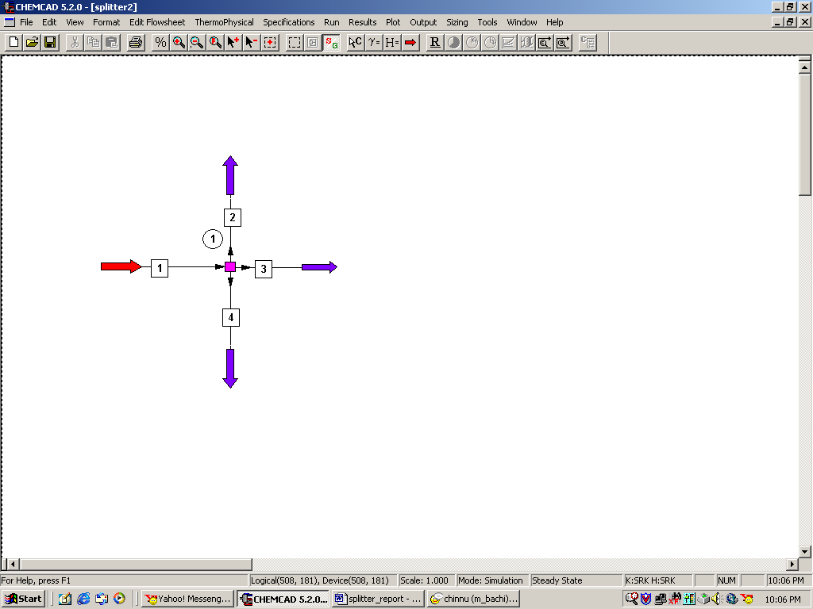

Step 2: Entering the components and engineering units

Go to the Thermophysical on the menu bar and click on Components List. Find benzene, toluene and O-xylene from the CHEMCAD components list and add them to the component list. Go to the Format menu and click on Engineering Units and select the desired units for such properties as temperature, pressure etc. Click OK to continue.

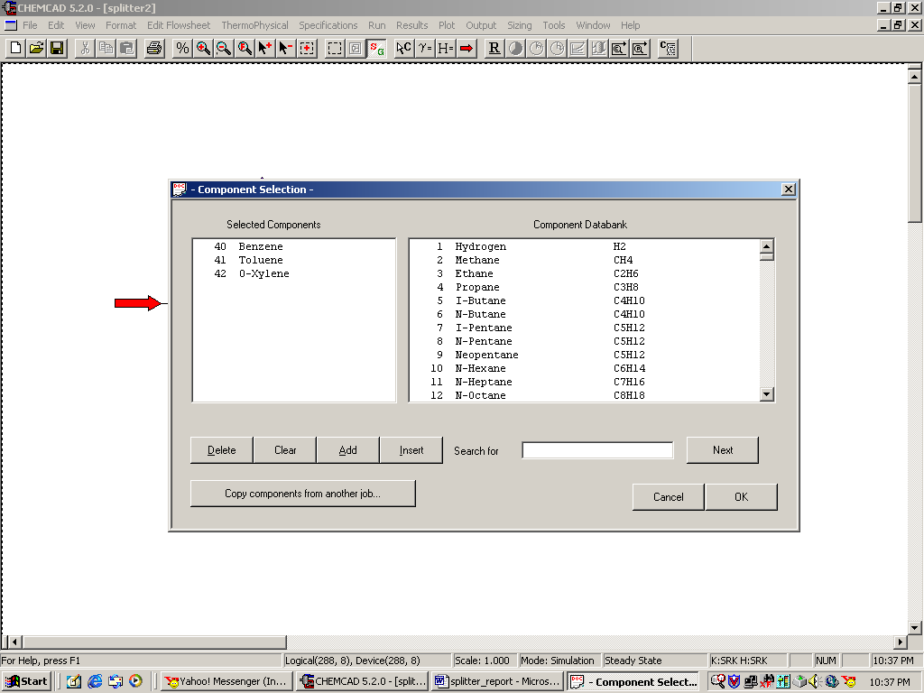

Step 3: Entering the composition of feed stream

Double click on the feed stream and enter the feed information (temperature, pressure, total flow rate and component mole fractions) given in the problem statement. Click once on Flash to get the feed stream enthalpy and vapor fraction in feed at the feed conditions.

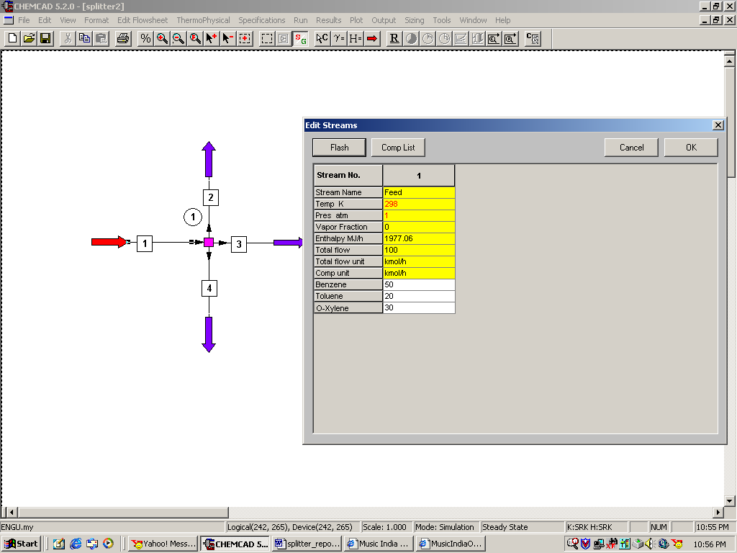

Step 4: Entering the Splitter specs

Double click on the Splitter. There are two different questions posed in the problem statement.

- For the split based on Flow Ratio, select option ‘0’ (this is the default option) for the splitter specs and enter the corresponding flow ratios for each product stream. (One can always click on help button on the bottom of this window to get familiar with the other options for splitter specs).
- For the split based on Molar f low rate, select option ‘1’ for the splitter specs and enter the flow rates desired for each product stream as given in the problem statement.

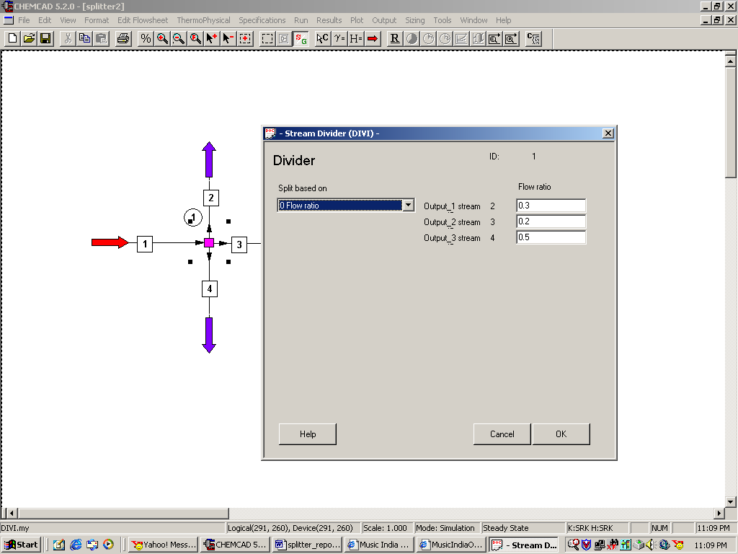

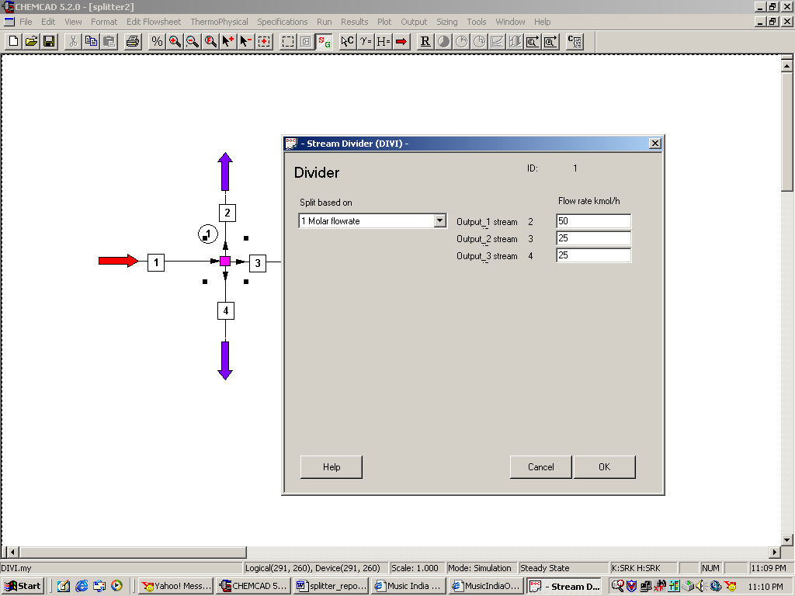

Step 5: Running the simulation and retrieving the results

After entering the available information on the workspace as described in the previous steps, one can run the simulation by clicking on R on the menu bar. Alternatively, one can run the simulation by clicking on Run on the menu bar and selecting Run all. The status of the simulation can be found at the bottom left hand corner of the screen. The message, Run Finished appears in this place if the run is successfully completed. To view the product stream compositions, one can either double click on the individual product streams or by clicking Results on the menu bar and selecting Stream Compositions and further selecting All Streams. The results obtained from the latter method will be in a WordPad file.

For question 1, verify that the following results are obtained.

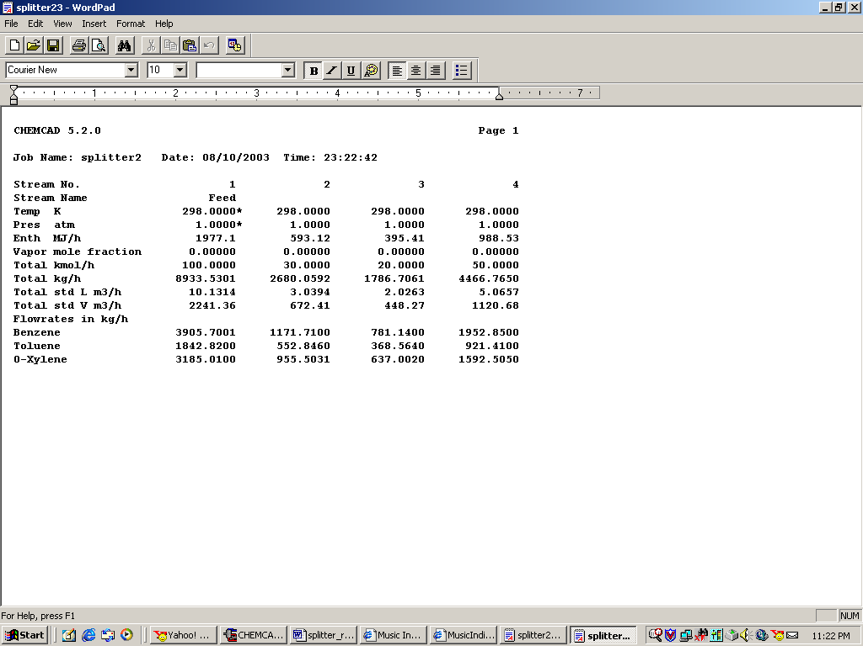

For question 2, verify that the following results are obtained.

