Stoichiometric Reactor
(updated 8/3/05)

Problem Statement:

Reaction:
Decomposition of di-t-butyl peroxide (DTBP) to acetone and ethane
$$({\text{CH}}_{3})_{3}\text{COOC}({\text{CH}}_{3})_{3}→2({\text{CH}}_{3})_{2}\text{CO}+C_{2}H_{6}$$

Reaction kinetics:
$$\begin{aligned}k_{c}=2\text{.}\text{095}∗{\text{10}}^{−2}{\text{min}}^{−1} \\ −r_{A}=k_{c}C_{A}\end{aligned}$$

Reaction conditions:
Temperature 154.6 ºC
Pressure 491.8 mmHg

Feed and feed conditions:
100 kmol/h of (DTBP) at 110 ºC and 760 mmHg

Information for steady state:
- Reaction is isothermal
- Conversion with respect to DTBP is 85 %
- Reference temperature for heat of reaction is 25 ºC

Perform a stoichiometric reactor simulation to determine the heat of reaction and the steady-state mole rates of components in the product stream.

Procedure:

Step 1: Creating the flow sheet
Step 2: Entering the components and formatting engineering units
Step 3: Entering the feed stream composition
Step 4: Entering the reactor specs
Step 5: Running the simulation and retrieving the results
Step 1: Creating a flow chart.

Select and click the stoichiometric reactor, feed and product icons on the workspace. Connect the three using the stream. Click once on the S/G icon on the menu bar to switch the simulation mode from Edit Simulation to Run Simulation.

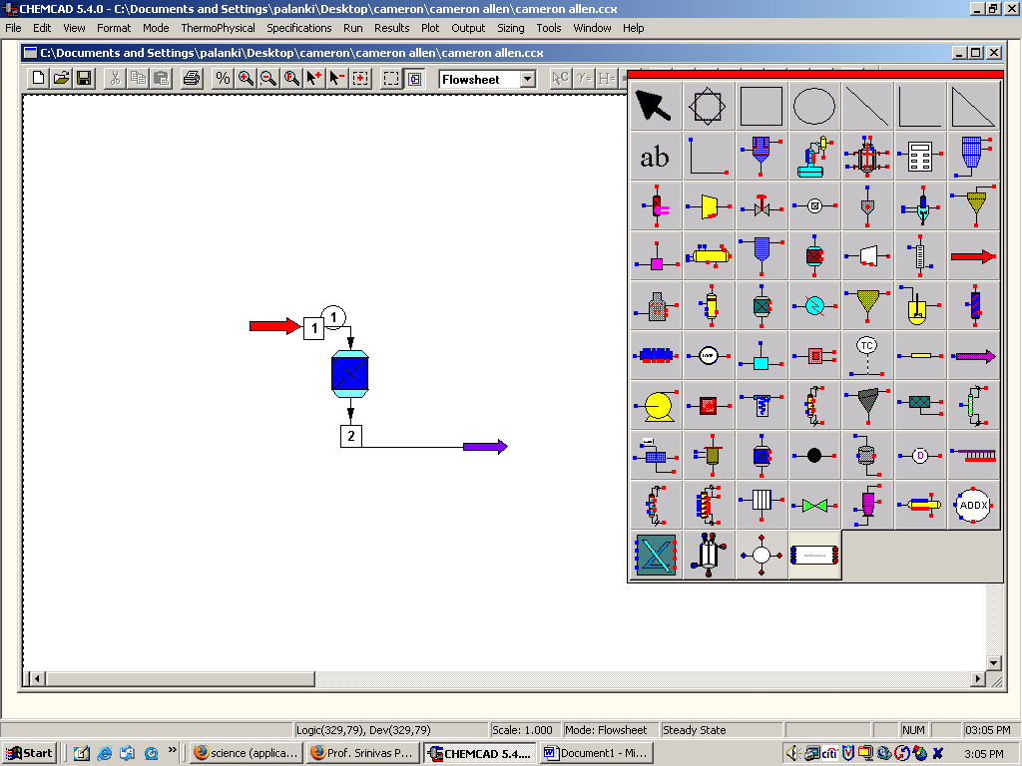
Step 2: Entering the components and formatting engineering units

Go to the Thermo physical on the menu bar and click on Components List. Find DTBP (Ditertiary butyl peroxide), acetone and ethane from the CHEMCAD components list and ass them to the components list. Go to the Format menu and click Engineering Units and select the desired units for such properties as temperature, pressure etc. Use SI option to convert all units at the same time. Click OK to continue.

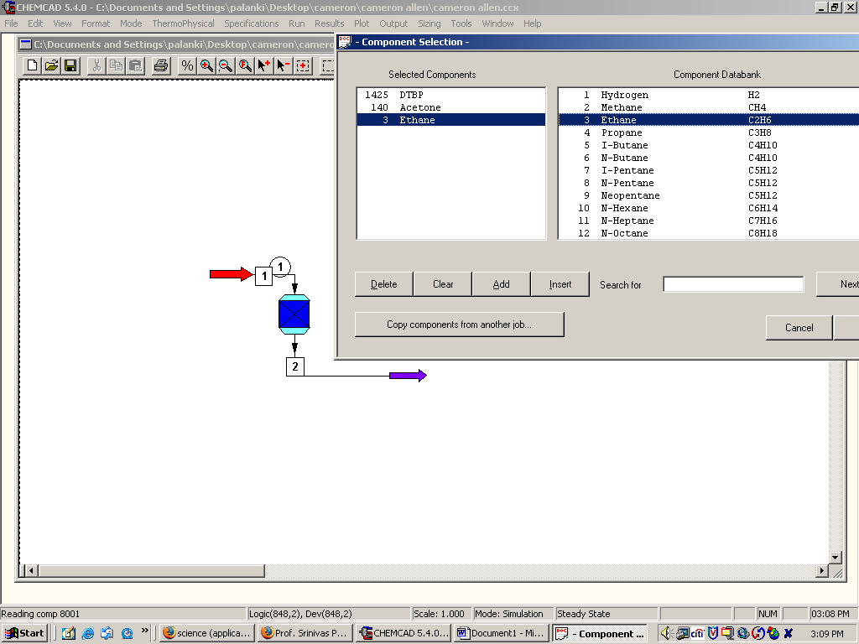
Step 3: Entering the feed stream composition

Double click on the feed stream and enter the feed information (temperature, pressure, total flow rate and component mole fractions) given in the problem statement. Click once on Flash to get the feed stream enthalpy and vapor fraction in feed at the feed conditions

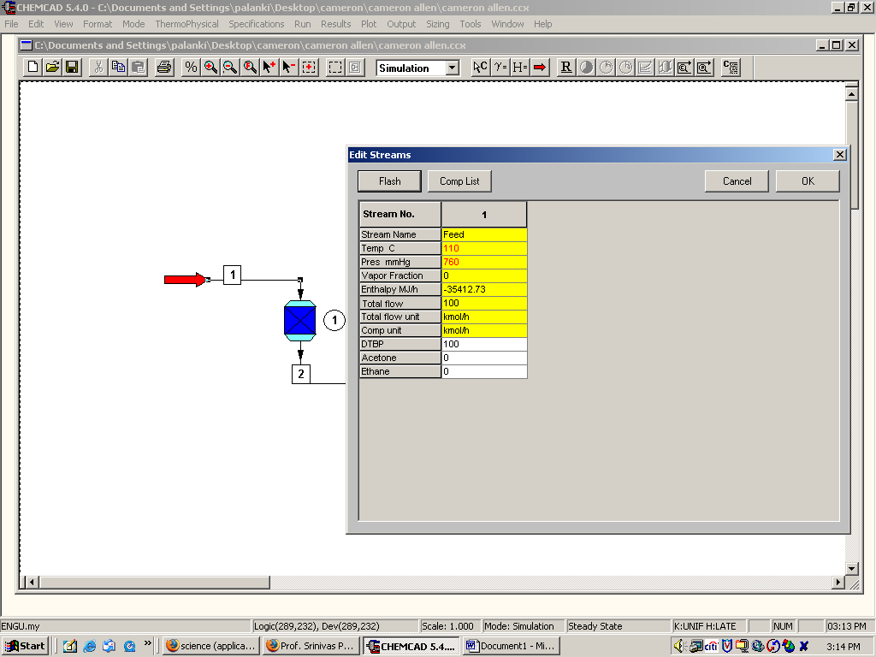

Step 4: Entering the reactor specs

Double click on the reactor.

General Specifications Page:

a. Specify Thermal Mode: As the given reaction is isothermal, with reaction temperature of 154.6 ºC, select the radio button Isothermal and enter the corresponding temperature.

b. Key Component: As the conversion is given in terms of DTBP, enter DTBP as the key component.

c. Fractional Conversion: Enter the given conversion (0.85).

d. Heat of Reaction: The value for the heat of reaction can be entered in this box. This field can be left blank, as the heat of reaction was not given in the problem statement.

e. Reaction Pressure: Enter the reactor pressure (491.8 mmHg)

f. Calculated Heat of Reaction: This needs to be left blank. This is the field where the heat of reaction as calculated by CHEMCAD appears after the simulation.

g. Stoichiometric Coefficients: Select Mole base, as the units given in the problem statement are moles and enter the corresponding stoichiometric coefficients for each of the components. (Indicate a negative sign for the reactants)

Click OK after completing the General specifications page.

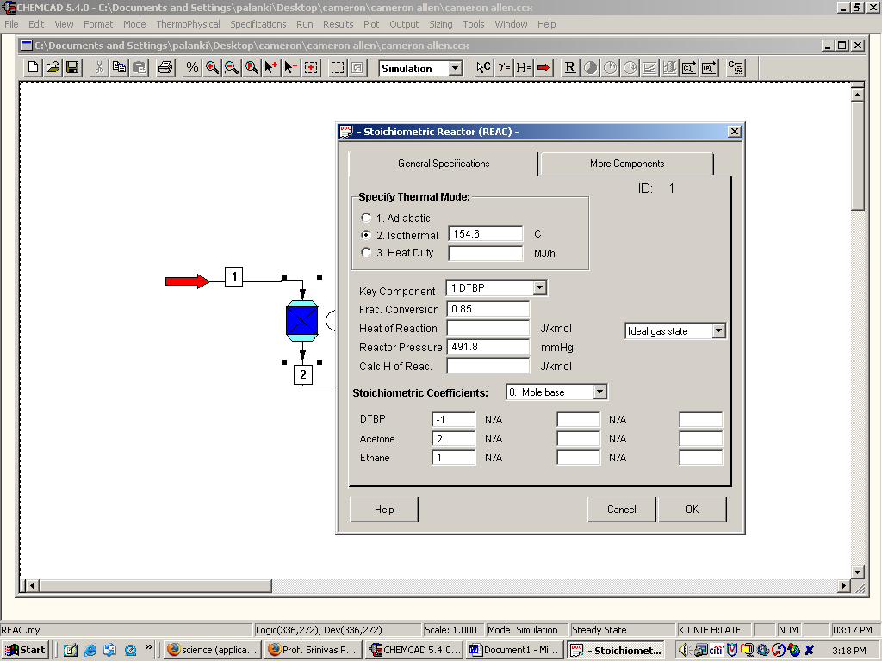
Step 5: Running the simulation and retrieving the results:

Now the simulation is ready to be run. Click once on R to run the simulation. Alternatively, one can run the simulation by clicking on Run on the menu bar and selecting Run all. The status of the simulation can be found at the bottom left hand corner of the screen. The message, Run Finished appears in this place if the run is successfully completed. All the results associated with the stoichiometric reactor can be found by clicking on Results menu and selecting Unit Op’s and then the reactor. The results will then be available in a WordPad file.

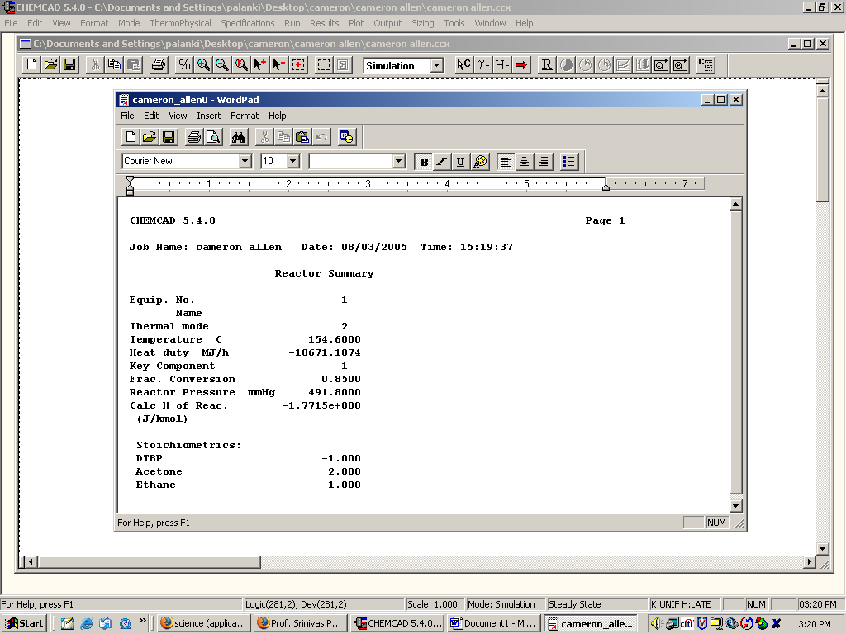

Similarly, the product stream properties can found either by clicking once on the product stream or by clicking once on Results on the menu, selecting Stream Composition and then clicking on All Streams. The results will again be available in a WordPad file.

