Isobaric vessel level control practice 1: Control at the inlet stream
This practice will introduce Dynamic Vessel (DVSL) and PID Controller (PIDC) models. You will calculate the DVSL in simplest mode, isobaric process.

The process scheme
At initial state, the vessel is already filled to desired liquid level of 2 m and it is fed at rate of 4000 kg/h with water. There is constant liquid outflow from the vessel equal to 4000 kg/h. Therefore the system is continuous and practically steady state. After 10 minutes, demand for water at the outlet falls linearly to zero over 5 minutes and no water leaves the vessel for next 5 minutes. Afterwards, 16000 kg/h of water is suddenly needed and this demand continues for next 5 minutes. Finally, the demand falls down to original 4000 kg/h and remains for 15 minutes. A sensor is measuring liquid level in the vessel, and a controller tries to maintain a constant liquid level of 2 m in the vessel by regulating inlet feed flowrate, by a control valve.
You will have a chance to study influence of PID controller settings on the system.

PID controller logic in ChemCAD
The PID Controller model involves Sensor, Transmitter, and Controller in one unit operation.
Measured var

Cset
Cin
e
PID
algorithm
Ctrl out
Sensor
function

(calibration)
- The Sensor portion of PIDC can measure any ChemCAD variable in any Stream or any Unit Operation in a flowsheet.
- Sensor input is transformed into analog controller input signal Cin via a sensor function that can be linear or quadratic. ChemCAD calculates coefficients of the sensor function according to calibration range you specify.
Note: These are sensor functions:
Linear: Cin = A + Bx where x is measured value
Quadratic: Cin = A + Cx²
So, by specifying Calibration range between points x₁ and x₂, and Cin range by 4 to 20 mA, ChemCAD can calculate coefficients A and B, or A and C, respectively.
- The control error e expressed in milliamps is calculated in either way:
a. e = Cin - Cset, where Cset is controller input at set point and Cin is actual controller input, or
b. e = Cset - Cin
- Controller output Pout is calculated as follows:
Pout = P + I + D + P₀
where:
P = 100/PB * error [proportional action]
I = 100/PB * (1/Ti) * integral (error * dt) [integral action]
D = 100/PB * Td * d(error)/dt [derivative action]
P₀ = controller signal at steady state

Note: If nothing is entered for Ti term, ChemCAD disregards the integral term. If any value > 0 is entered in Ti field, the integral term is calculated. The smaller value of Ti, then the higher integral gain of the controller is.
This signal is used to regulate the CVAL.
- Position of PIDC in a flowsheet is usually different from that met in real world. Although the measurement can be taken at any place of the flowsheet, the PIDC symbol must connect to either side of respective CVAL symbol. We will explain how to do it in this and other practices in this book.

Control Valve logic in ChemCAD
The output from the controller is used by the control valve to determine the valve position, that is, how far open (in percentages) the valve is at any point in time. The valve position, u, is determined as follows:
The position of the valve (opening) is defined as:
Tv * (du/dt) + u = Av * P + Bv
Where:
Tv - valve time constant
u - valve position, 0..1
P - signal, usually 4..20 mA
In the default condition, the time dependent term is equal zero.

Normally Closed and Normally Open Valve
The engineer takes a decision whether valve should be closed or opened at emergency. For example, valve that regulates flowrate of cooling water at the reactor should be open when there is no signal, so cooling water can flow through reactor’s jacket. If the valve regulates the reactant feed rate, then it should close at emergency to stop the reaction.
If the valve is fully closed when at minimum or no signal, then the valve is Normally Closed (NC):
0 = Av * 4 + Bv
1= Av * 20 + Bv
then
Av = 0.0625
Bv = -0.25
If the valve is fully open at minimum or no signal, then it is it Normally Opened (NO):
1 = Av * 4 + Bv
0= Av * 20 + Bv
then
Av = -0.0625
Bv = 1.25
The default setting for CVAL is Normally Closed valve. You should replace default Av and Bv parameters with values shown above if you wish to have Normally Opened valve.
Time valve constant Tv must be either 0 or positive. The larger this value is, the slower is valve response to the signal.

The flowsheet
The flowsheet involves a single component, Water and it takes thermodynamic model as in first practice.
The flowsheet should be constructed in the following way:
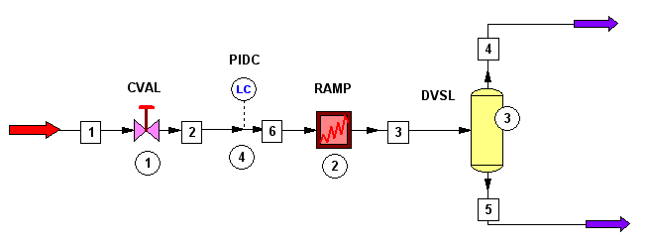
Note: If your flowsheet has different stream and unit operation numbers, replace our numbers with your numbers during the practice.

Parameter definition at Steady State
You have to be in Steady State mode.

Sizing the vessel
We will design the vessel, so it would be large enough to accommodate liquid.
- Enter these values for Stream 3 (the vessel inlet stream): T = 20 C, P = 3 bar, F = 25000 kg/h of Water
- Highlight the vessel DVSL 3, and then select Sizing ⇨ Vessel from menu. Enter 10 bar as Design Pressure, accept all other defaults and click OK.
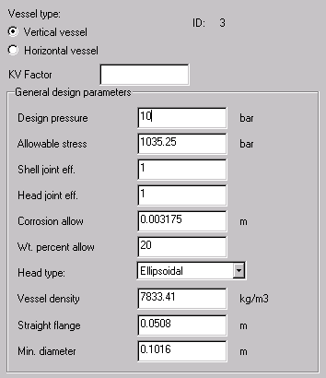
- Enter these values in the next dialog:
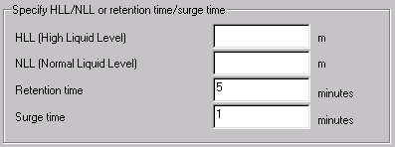
Calculation results will appear in WordPad. These preliminary design values will be entered to the DVSL model automatically. We will modify these values to standard European dimensions. Switch from WordPad to ChemCAD first.
- Open the DVSL dialog (right-click the symbol and apply Edit Unit Op Data option.)
Enter these data:
Geometry
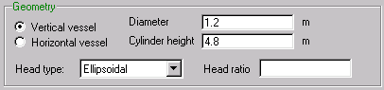
Mode
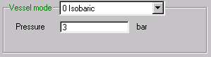
Initial conditions
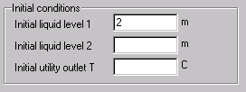
(We would like to start with liquid level of 2 meter in vessel initially.)
Liquid and vapor flow specifications
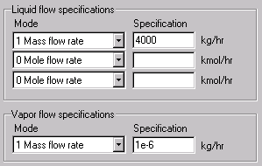
Here, we assume constant outflow of liquid from vessel and no vapor outflow.
- Turn the Recorder on and click OK to close the dialog.

Feed Stream
- Enter these initial values for Stream 1, the Feed: T = 20 C, P = 4 bar a, F = 4000 kg/h of Water

Control Valve
CVAL 1 should have nearly same parameters as in the first practice. However, this time you specify PID Controller ID for the PIDC to act on this valve:
Controller / Valve Position define the CVAL as Normally Closed; see discussion before.
As this control valve regulates its inlet stream mass flowrate directly, this section
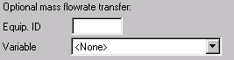
should be made blank.

PID Controller
The dialog for PIDC is rather extensive. Let's have a look at various sections of it:
General
The controller should be activated. The set point is 2 m.
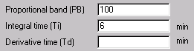
These values define controller settings. P (reciprocal of gain) has been set to 100. The gain of controller would be G = 100/PB = 100/100 = 1. Integral term Ti = 6 minutes. This can be estimated by hand calculations. We will study the effect of Ti later.
Set point has been defined as 2 meters: . How do we know it is vessel liquid level expressed in meters? You have to look at Measured Object.
Measured Object
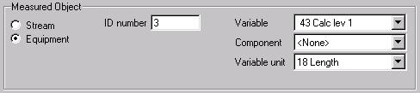
Sensor is then located in the Equipment 3, i.e., at the Dynamic Vessel 3. It is measuring Calculated Level of the first liquid phase (and there is only one liquid phase in our problem). The unit of measure is Length.
Controller / Sensor function
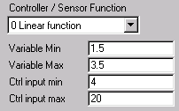
We have selected Linear sensor function, so Cin = A + B*X (Cin - controller input, X - measured variable). This function calibrates liquid level range of 1.5..3.5 m to controller input 4..20 mA.
Error definition
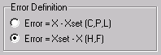
A. If error grows and to reduce it you need to increase controller output, then use e = X - Xset.
B. If error grows and to reduce it you need to decrease controller output, then use e = Xset - X.
You select the error definition according to the following reasoning:

If I increase controller output, what will the response of the process be?
What is our situation? If the controller output grows, then our Normally Closed valve will open and this will cause higher liquid level, thus increasing error. Therefore, to decrease error you need to decrease controller output. The correct Error Definition is B.
Control Valve
This PIDC is acting upon CVAL 1: .

RAMP schedule
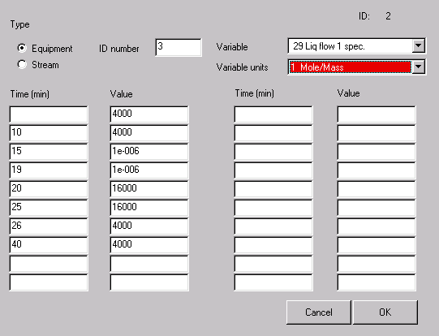
This time, we are scheduling mass flowrate at the first liquid outlet from the vessel.

Preparing and verifying initial state parameters
- Run all unit operations in Steady State, by button
This calculation will first of all propagate feed stream flowrate and temperature parameters throughout the system. CVAL works as a Valve model in steady state, so it will reduce pressure to 3 bar downstream. DVSL works as steady state Flash, and it will direct all liquid to the first liquid outlet, stream 5.
Interesting are results of steady state calculation of dynamic objects.
Control Valve and PID Controller
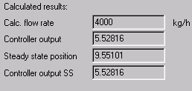
At 4000 kg/h given control valve is open in 9.5%. The controller output signal at steady state is 5.53 mA.

Dynamic simulation and results
- Switch to Dynamic mode via Run ⇨ Convergence menu
- Set Run time to: 1 operation, duration of 60 minutes and step size of 0.5 min.
- Record Streams 3 and 5
- Record CVAL 1 and PIDC 4.
- Run from Initial State
- Highlight DVSL 3 and use Plot ⇨ Batch Reactor/DVSL History option from main menu. In respective dialog, change Time unit to "min", and check the box. Click OK. Observe results.
- Restore to Initial State . Set Ti coefficient for PIDC equal to 3 minutes. Repeat dynamic run and plot results.
- Restore to Initial State . Set Ti coefficient for PIDC equal to 1 minute. Repeat dynamic run and plot results.
Below, we prepared an Excel plot comparing liquid level history dependence on Ti term.
If you plot mass flowrate of dynamic Stream 5, you will see what is the test signal for the system:
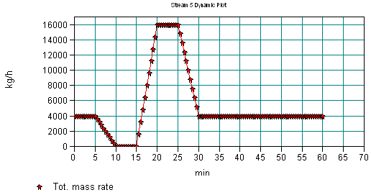
You can also observe mass flowrate of dynamic Stream 3 (calculated flowrate of feed):
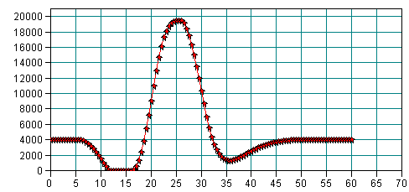
The chart above is for Ti = 6 [min]
Finally, plot valve position % in function of time (chart below is for Ti = 6 min):
