Control Valve

RAMP and CVAL practice: direct flowrate calculation
The objective of this practice is to set up the job from the very beginning, to explain settings of Control Valve (CVAL) and Ramp schedule (RAMP) models, and perform a trivial dynamic simulation. We are explaining the very simplest concepts here in very detail. However, you have to understand these basic ideas before you begin simulations that are more complex.
In the practice, we intend to size a control valve for flowrate of 25000 kg/h of water given allowable pressure drop. Afterwards, we would like to schedule the valve opening to get desired flowrate profile over time, in other words, we would simulate manual opening and closing of the valve.

Making a flowsheet
The basic for your simulation is a diagram named flowsheet. Flowsheet involves all equipment models (Unit Operations or UnitOps) that your simulation requires connected via streams that transfer material from one UnitOp to another UnitOp.
- Start ChemCAD 5.0 from Start Menu
- Click button in the toolbar.
- Enter “RAMP and CVAL sample” in File name field and click Save button:
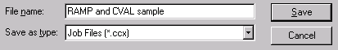
This will create a folder by this name and a set of job files in the work folder. ChemCAD will open the new job in Graphic mode, so you can draw flowsheets.
We suggest you modify layout of your Palette now.
- Select from View menu. You can try these settings with 1024 x 768 screen resolution:
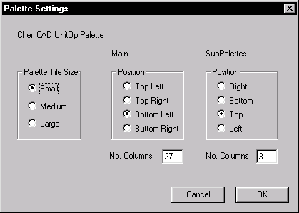
This will allow you to see more of the screen.
- Click 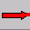 icon in the main palette, and insert the Feed Arrow somewhere at left side of your page:
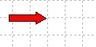
- Similarly, insert Product arrow far to the right at your page, so there is significant space between both arrows:
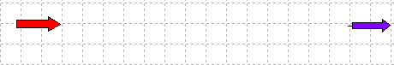
- If you are not sure which of items of the Main Palette represent your unit operation, then click  icon. Now, select Control Valve from list and click Add Main Symbol.
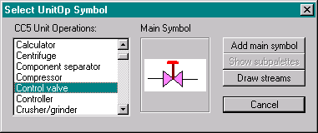
Insert Control Valve symbol near to the Feed Arrow by left mouse click:
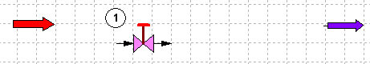
Select Ramp Schedule from the list, Add Main Symbol and insert it to the right of the valve:
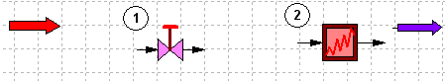
- Click Draw Streams button. Move mouse cursor next to the tip of the Feed Arrow and left-click:
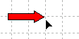
Move cursor towards the valve symbol until you see “IN-LET” label, then left-click again:
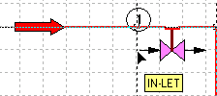 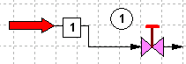
- Continue placing streams until you connect all objects. Left-click in empty space to stop drawing streams:
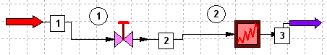
- Click Cancel to close the selection list. Try to drag your objects with mouse to clean up the diagram:
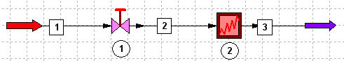
- Click button in toolbar to save the diagram and click button to switch to Simulation Mode.
Note: You can switch to Graphic mode with the same button and modify the diagram any time you like, but you should not do it in Dynamic mode.

Formatting Engineering Units
We would like you to work with the same Engineering Units (or Units of Measure) as we do.
- Select from Format menu.
- Click button, then one.
- Click OK button.
From this moment, all newly created jobs, including this one, would use “Alternative SI” set of Engineering Units until you change the system of units again.
You do not need to repeat this option in the future.

Entering components and defining thermodynamics
Your flowsheet requires at least one component (process or utility medium) be included in simulation.
- Click button in the toolbar. After a second, the Component List will appear. Enter W or 62 in “Search for” field. Component “Water” will be selected. Click Add button or press [Enter] key:
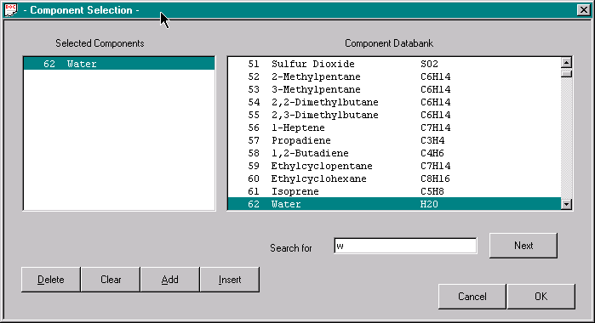
Click OK button. For this practice, we will just need the single component, water.
- We will select simple thermodynamics for this case.
Click button in the toolbar.
Select 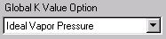, and then close the “K Value Options” dialog with OK button. This simple method is very fast and accurate for water in liquid state.
Click button in toolbar.
Select 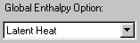 from list and close the dialog. “Latent Heat” option handles liquid enthalpy calculation better than other methods.
Select from ThermoPhysical menu.
Select from list and close the dialog. “API Lu’s” method is the only of ChemCAD methods that can consider pressure influence on liquid density.

Defining stream specifications
We would like to size the control valve in the way it would be large enough to pass 25000 kg/h of water at pressure drop of 1 bar. Therefore, we need to specify the inlet stream (Stream 1) in the following way:
Temperature: 20 °C
Pressure: 4 bar absolute
Flowrate: 25000 kg/h
Composition: Pure water
- Right-click Stream 1 and select Edit Stream from pop-up menu:
- Enter the following and click OK
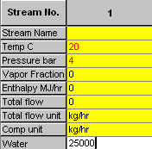:

Note: Ensure that your stream is still selected (has black rectangles displayed) before you continue

Sizing the control valve
- Select Sizing ➔ Control Valve from main ChemCAD menu. If Stream 1 has been selected, you will see a dialog box as shown below. If the stream has not been selected, ChemCAD will ask you to select desired stream, do so. Enter 3 bar as Downstream pressure and click OK:
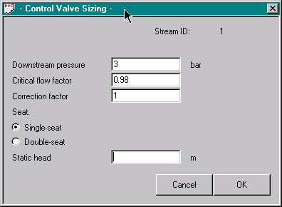
- ChemCAD will display sizing results in WordPad:
Flow type Subcritical flow
Calc. coefficient Cvc 28.9312
Capacity coefficient Cv 54.0000
Cvc / Cv ratio 0.5358
Valve size 0.0635 m
As you can see, ChemCAD has selected a nominal 65mm valve from its library of industrial valves. The rated C_{v} (valve flow coefficient) for such a valve is 54.0. Calculated (or required) C_{vc} is only 28.9, so the selected valve is oversized. It is OK to have somewhat oversized valve, because it can control flowrate in broader range. However, you still can make your decisions:
- If valve seems to be really too large, decrease flowrate of Stream 1 and repeat sizing
- If valve does belong to your valve schedule, modify flowrate of Stream 1 and repeat sizing until you find a correct valve
- You can also enter valve’s C_{v} directly in valve specification dialog, see later in this section.
- The smallest possible catalog valve has C_{v} = 9.0. However, your valve can be smaller than that. If your calculated C_{vc} is much smaller than 9.0, apply the following rule: let Cv be a value in range of C_{vc}/0.6 - C_{vc}/0.7. You can enter such value of Cv in Control Valve dialog by hand later.
- Close WordPad window and right-click on the control valve symbol. Select option from pop-up menu.

Control Valve
The objective of the Control Valve (CVAL) model is to calculate:
- Required mass flowrate through the valve if the valve position is set by PID controller, or by another external “device”, such as Ramp Schedule, or
- Valve position to match inlet flowrate if the valve position has not been set.
CVAL requires inlet and outlet pressure values to be specified. Inlet pressure is taken from the inlet stream. Outlet or downstream pressure can be specified directly, or it can be overtaken indirectly from a unit operation present in the flowsheet.
The CVAL model assumes that mass balance around the valve must be kept. Therefore:
- CVAL can directly adjust its inlet flowrate only if it immediately follows Feed arrow
- If CVAL is following any unit operation different from Feed Arrow, it must pass calculated mass flowrate to another unit operation upstream. The other unit operation must then adjust inlet flowrate to the CVAL in such way that valve inlet flowrate is equal to calculated (or desired) value.
We will show direct flowrate control (a) in this practice. Next practice will explain the indirect CVAL scheme (b).

Control Valve input for simple case
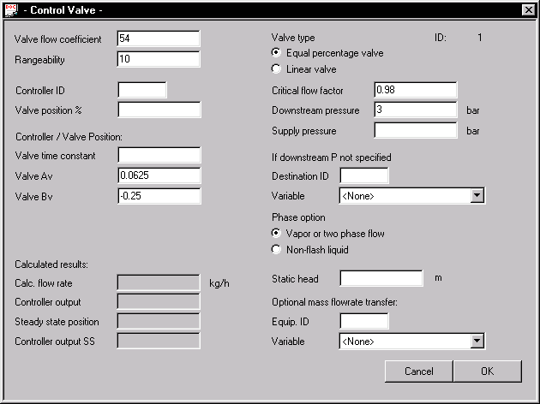
We will discuss logic of Control Valve model later in this book. Here, we will describe important parameters for a standalone valve (such one that is not regulated by a PID Controller.)

CVAL parameters entered through Sizing
Control valve sizing routine has filled some data to the CVAL dialog for you:
Valve flow coefficient of 54.0
Critical flow factor of 0.98
Downstream pressure of 3 bar

Other CVAL parameters
- "Controller/Valve position" settings are used to define the valve as Normally Opened or Normally Closed. These settings are not important until you regulate the valve by PID Controller.
- Default “Rangeability” (ratio between maximum and minimum controllable flowrate) is 10
- Default valve type is “Equal percentage valve” and this setting would be changed to Linear valve type.
- Default phase option is Vapor or Two-phase flow. There are two equations for a valve: one for vapor or gas, and one for liquids. You should select appropriate option for your stream.
Note: Engineering rules disallow mounting control valves on mixed phase streams.
Control Valve model requires more parameters when used in real control situation. For this practice, we do not need more variables. We will describe other parameters in next practices.

Changing default values
- Change Valve Type to Linear Valve
- Change Phase to “Non-flash liquid”
- Click Save (OK) to close the Control Valve dialog. You will see warning:
ChemCAD is telling you that you’ve forgotten to specify which PID controller would act on this valve. We do not specify PID controller here on purpose. Click Yes to ignore the warning.

Calculating control valve in steady state
Now, let’s calculate our control valve in steady state to see how it works.
- Right-click the valve symbol and apply pop-up menu option. ChemCAD will produce warning box again. Click Yes to continue.
- Right-click on the valve symbol and then click . Have look at this field:
According to the calculation result, at 25000 kg/h and given pressure drop the valve position would be 59.7 %.
- Click Cancel to close the dialog.

Ramp schedule

Ramp Schedule model (RAMP) allows changing any ChemCAD parameter over time.
In this practice, RAMP will open and close the control valve according to given schedule.
We would like to:
- Start with closed valve and keep it closed for 1 minute
- Open the valve linearly to 10% over 5 minutes
- Keep the 10% opening for another 5 minutes
- Linearly open the valve to 50% over next 5 minutes
- Keep the 50% opening for 4 minutes
- Close valve to 20% over 1 minute and keep it open at 20 % for 4 minutes
- Shut the valve during 3 minutes and keep it shut for two minutes
All actions require total 30 minutes to complete.
The schedule would then be:
Time [min] | Valve1 position [%]
0.0 | 1e-6
1.0 | 1e-6
6.0 | 10
11.0 | 10
16.0 | 50
20.0 | 50
21.0 | 20
25.0 | 20
28.0 | 1e-6
30.0 | 1e-6

Entering data for RAMP
- Right-click on the Ramp Schedule symbol. Select option from pop-up menu.
- Enter data as shown below:
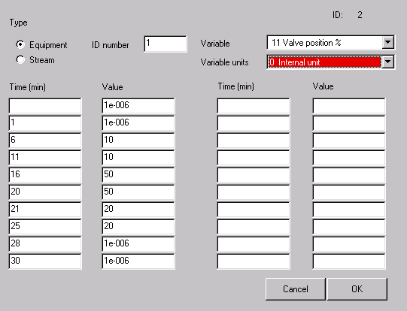
Click OK.

Checking initial state
- It is critical that all streams and unit operations are set to parameters then would correctly represent initial state before you begin a dynamic simulation.
If you forget verifying and adjusting initial state parameters, then in some cases your dynamic simulation would not perform correctly. In other cases, the dynamic results might be OK, but the first point of calculation would appear wrong.
In our case, streams 1 and 2 are set to 25000 kg/h flowrate, and valve position at initial state is 59.6%. On the other hand, RAMP model is set to shutting the control valve at the beginning of the dynamic simulation. Therefore, the first point of dynamic results would represent wrong situation of full flowrate, while our intention is having zero flow. So, you will adjust initial state parameters now:
- Right-click Stream 1 and select . Enter 1e-6 as Water flowrate and click OK.
- Click (Run All) button to calculate the flowsheet in steady state. Click Yes to bypass warning window.
Your action will set flowrate and thermal state of all streams to the state of Stream 1, and the valve would be shut. On stead-state calculation, RAMP model takes no effect. However, setting the inlet stream to "zero" flowrate causes CVAL to be calculated.
- Have a look at CVAL dialog to see that valve appears to be shut:
- Have a look at Streams 2 and 3 to see they overtook Stream 1 parameters. However, pressure drop to 3 bar as caused by Control Valve was applied to streams following CVAL.

Switching to Dynamic simulation
- Select Convergence option from Run menu. Select Dynamics from this list and click OK:
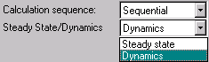

Dynamic simulation
Although various actions for dynamic simulation can be done via toolbar, we would go to the Dynamics menu once.
- Select Dynamics from Run menu. The Dynamics menu will appear:
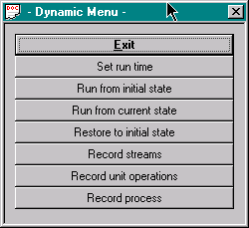

Run time
- Click Set run time (this option can be also activated by button). A dialog will appear. In the first tab, you define number of operations. Dynamic operation is a part of dynamic simulation conducted for specified time duration or until some criterion is met. In our case, one operation is appropriate.
- Click Step 1 tab. Enter parameters as shown and click OK.
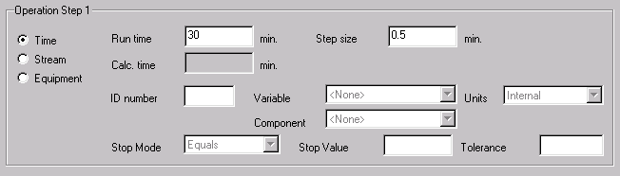
In our case, we would like to simulate the process for 30 minutes with step size of 0.5 minutes or 30 seconds. Selection of correct step size is very important, and it requires some experience or practicing by trial and error. Step size should be not longer than a shortest action in the system. Our RAMP will change parameters in even 1 minute, so step size should not be greater than 1 minute. If step size is too large, then simulation would omit critical points, and the calculation results might be completely wrong. On the other hand, applying a very short step size slows calculation down significantly, and it can cause very large data files to be created.
These situations require very short time step size for the system:
- Pressure calculations
- Processes that need fast response of the control system
Note: Dynamic Reactor (BREA) and Dynamic Column (DCOL) have own integrator methods. Therefore, calculation results for these UnitOps do not rely on the overall time step size.
A good advice for selection appropriate step size is manipulating this value and assessing the results. Very often, part of simulation can be stable, while another part can be very sensitive and require short step size. In such situation, you would define several operation steps using different step sizes.

Recording streams
You have to define regions of interest. By recording a stream during a dynamic simulation, you would be able to access all stream parameters after the simulation is finished. You should only record streams of your interest. Calculation results are stored in history files that may grow significantly large. Recording too many parameters will also slow your simulation down.
- Click in Dynamic menu.
- Enter 3 in a dialog that appears, then click OK.
Note: you also might select Stream 1 or 2. Stream 2 is identical to Stream 3. Stream 1 would have same flowrate as streams 2 and 3, only its pressure would be higher by one bar. As you can see, recording one stream is enough in this case.
Important: You can select streams graphically, checking the option. This however depends on current selection of objects in the flowsheet. If you have had any Stream(s) selected (highlighted) graphically before, only this/these Stream(s) would be taken. If you have had no graphic selection, ChemCAD would ask you to point to appropriate Streams. This follows general ChemCAD 5.0 ideas: "select objects in advance and perform desired action upon them" and "select objects you want to perform action upon if nothing has been graphically selected".

Recording unit operations
Similarly to recording Streams, you should select Unit Operations to be recorded. Dynamic Vessel, Dynamic Reactor, and Dynamic Column have their own Record options in their dialogs. All other unit operations would be recorded from Dynamic Menu.
- Click . Enter 1 in the dialog and click OK.
There is no recordable parameter for RAMP schedule, so we will only record CVAL history.

Performing a Dynamic simulation
- Click option in Dynamic Menu. (This is equivalent to clicking button in toolbar.) Ignore warning by clicking Yes. After a while you will see message "Dynamic run finished". Click OK.
The Dynamic Menu disappears automatically.

Viewing results
- Click (Plot dynamic UnitOp histories) button. Enter these values and click Save button.
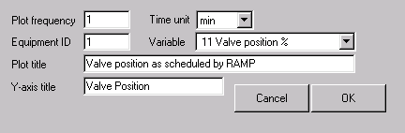
A plot will appear:
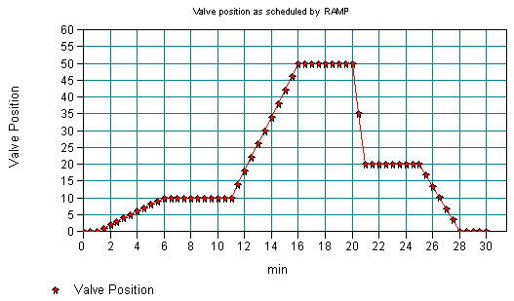
As you can see, the valve positions follow schedule set by RAMP model.
- Close the graphics window by clicking button.
- Click (Plot dynamic Stream histories). Enter these values in first tab of dialog:
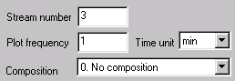
- Click the second tab and check the option, then click OK.
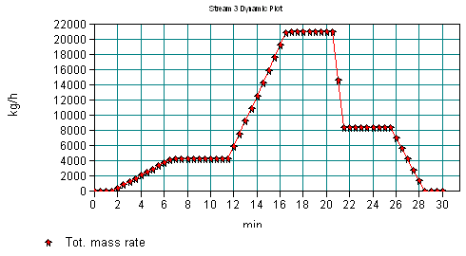
The result is calculated outlet flowrate, as the result of pressure difference, valve characteristics, and valve opening/closing schedule.
- Close the graphics window by clicking button.

Restoring to Initial State
You are not allowed to do any changes to input values at dynamic state. These can only be applied at Initial State or in Steady State mode. Changing to Initial State will not clear your History files, so you would still be able to view the histories. Now, the status line of ChemCAD reads: .
- Click (Restore to initial state) and you will see in the status line.

Practice with Equal Percentage Control Valve
Now, you will apply Equal percentage valve.
- Open the CVAL dialog and change valve type: 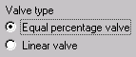
- Run from Initial State
- Display mass flowrate of dynamic Stream 3
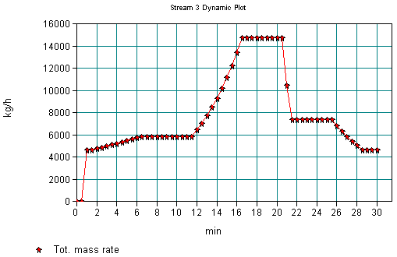
As you can see:
- The flow characteristic is not linear anymore
- You cannot regulate flowrate at small values
Therefore, you should carefully select valve type. In continuous processes, equal percentage valve is frequently applied, while linear valve is more common in batch technologies.
- Restore to Initial State. Change valve type back to Linear. Close all windows.

ChemCAD requires small positive value to represent zero value. For many settings, value as small as 1e-20 is allowed, but you will be on the safe side if you apply values not less than 1e-6 unless told otherwise.

