RAMP CONTROLLER

Purpose:
Ramp controller can be used to change various operating parameters with respect to time. Examples for operating parameters that could be changed are: flow rate of a stream, composition of a stream, temperature of a unit operation, or specifications of a unit operation.

Problem Statement:
A mixer operating at 1atm has two feed streams coming in at 298 K and 1 atm. First feed stream contains 10 kmol/hr of ethanol and the second, 10 kmol/hr of n-propanol at time t=0 so that the initial product from the mixer contains 50 mol% ethanol and 50 mol% n-propanol. It is desired that the product from the mixer contained 75-mol% ethanol and 25-mol% n-propanol at 20 kmol/hr after 50 minutes of its operation. Simulate this dynamic process using RAMP CONTROLLER in CHEMCAD for 100 min of simulation time.

Action Plan:
As per the product specifications, the output from the mixer should have 20 kmol/hr of total flow with 75% ethanol (15 kmol/hr) and 25% n-propanol (5 kmol/hr) from 50min in to the operation. To accomplish this, one can use two ramp controllers, one for each of the feed streams. The ramp for ethanol stream will step up the stream flow rate to 15 kmol/he at 50min. The ramp for n-propanol stream will step down the stream flow rate to 5 kmol/hr.

Step 1: Create the flow sheet
The following icons are needed to complete the flow sheet:
- Feed (2)
- Ramp controllers (2)
- Mixer (1)
- Product (1)

Select and click all the above icons on the workspace. Connect them using the stream. Click once on the S/G icon on the menu bar to switch the simulation mode from Edit Simulation to Run Simulation. Completed flow sheet should be as shown below:

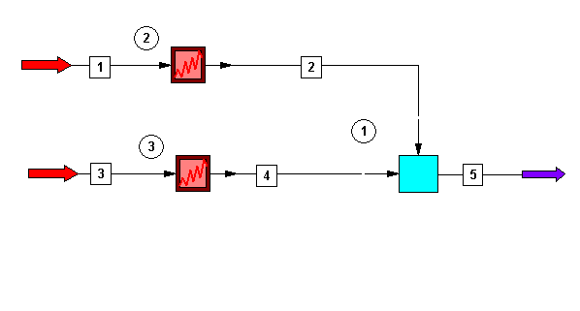

Step 2: Enter the components and format engineering units
Go to the Thermophysical on the menu bar and click on Components List. Find ethanol and n-propanol and add them to the component list. Go to the Format menu and click on Engineering Units and select the desired units for such properties as temperature, pressure etc. Use SI option to convert all units at the same time. Click OK to continue.

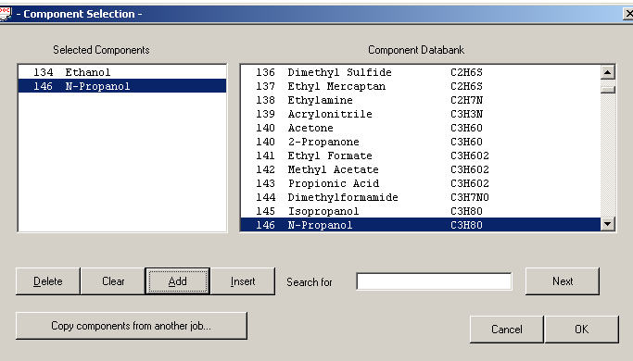

Step 3: Entering the feed stream composition
Double click on the feed stream and enter the feed information (temperature, pressure, total flow rate and component mole fractions) given in the problem statement. Click once on Flash to get the feed stream enthalpy and vapor fraction in feed at the feed conditions. Repeat the same for the second feed stream.

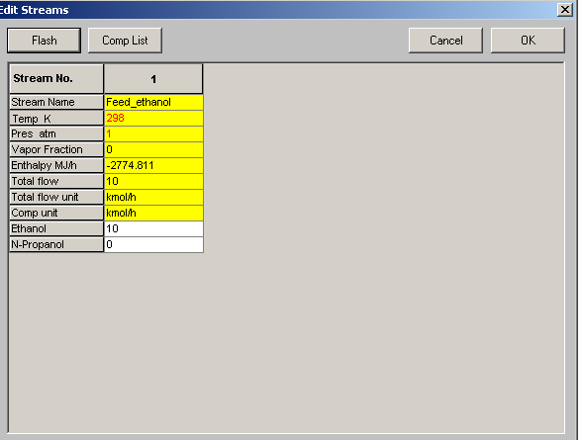

Step 4: Enter RAMP CONTROLLER specs

Step 4.1: RAMP CONTROLLER for ethanol
To specify the stream that needs to be ramped, select the radio button for stream under Type and enter the stream number corresponding to ethanol feed stream for ID number. Select option 5, Total mole rate as the variable to be ramped. Also select option 1, Mole/Mass, for Variable Units. Now, we need to specify the time versus total mole flow rate data in the space provided. One can use the table just the same way as a spreadsheet to enter the data. The RAMP CONTROLLER will simply interpolate between two consecutive entries to determine the value of the parameter at for increments in time. The completed dialogue box for the ramp controller of ethanol stream would look as follows:
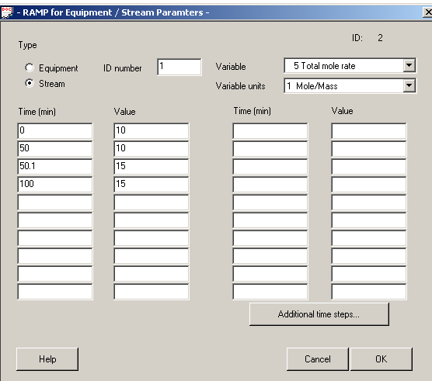

Note: In the above dialogue box, it would be incorrect to skip the third set of entry
(Time (min): 50.1, Value: 15). This is because, if this set was skipped, CHEMCAD would linearly interpolate between the values 10 and 15 during the time 50-100 min. Clearly, this would not be the desired result. The desired result is that the flow rate of ethanol be kept constant at 15 kmol/hr during the time 50-100 min. The third set in the above dialogue box will ensure that the flow rate is 15 kmol from 50.1 min to 100 min. The linear interpolation between the values 10 and 15 kmol/hr would be restricted to the relatively negligible time between 50-50.1 min.

Step 4.2: RAMP CONTROLLER for n-propanol
Ramping n-propanol stream is very similar to that of ethanol except that at 50 min, the flow rate of n-propanol would be ramped down to 5 kmol/hr instead of the 15 kmol/hr in case of ethanol. The completed RAMP CONTROLLER dialogue box for n-propanol would look as follows:
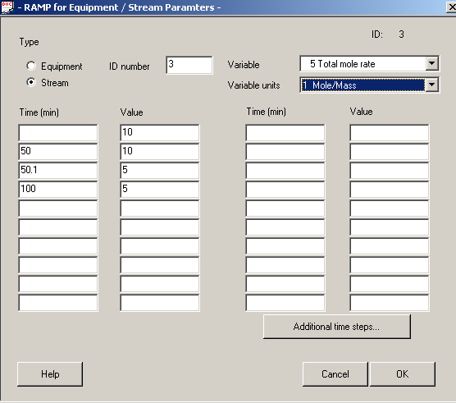
Step 5: Enter Mixer Specifications
Double click on Mixer and enter the Output Pressure as 1 atm. Click OK to continue.

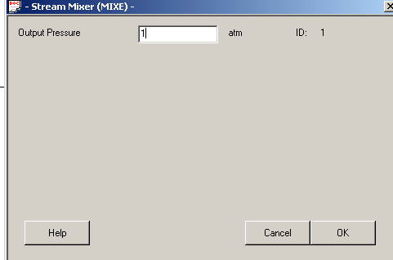

Step 6: Enter dynamic simulation specifications

Step 6.1: Change convergence to dynamic mode
Go to Run menu and click on Convergence. Change Steady State/Dynamics option to Dynamics. Click on OK to continue.

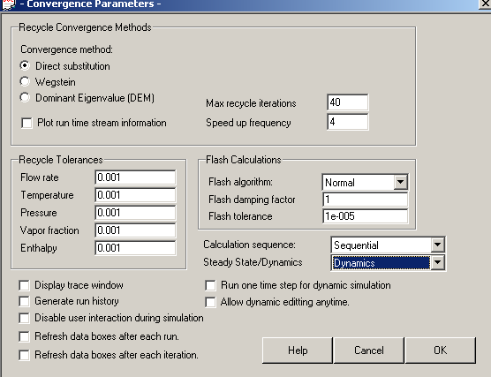

Step 6.2: Specify run time
Go to Run menu and click on Dynamics. The following window appears:

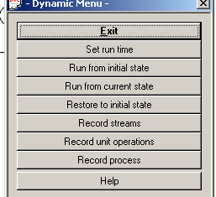

Now, Click on Set run time. The following window appears:

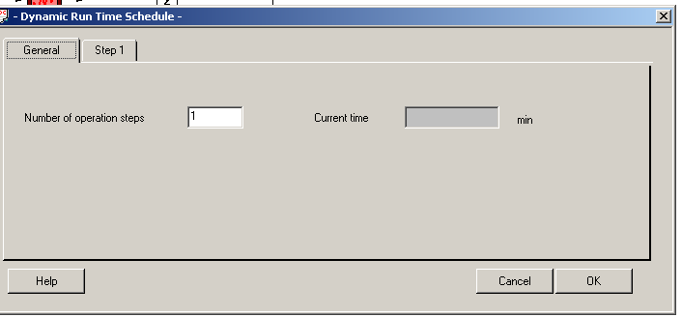

Under General tab, leave the Number of operation steps at its default value. This field will be most useful when the stop criterion for the dynamic simulation is a parameter other than time. For instance, one can run a distillation column in two operation steps, the first of which may be performed under total reflux conditions for a finite amount of time and the second operation step may be performed until the concentration of a certain component in the distillate stream reaches a pre-defined value. In the second step of the example just mentioned, the simulation time is not pre-determined. As the problem considered in this module has a finite simulation time (100 min), one can simulate the system within just one operating step.

Click on Step1 tab and enter 100 min as the Run time. One can choose any value between 0 and the specified run time as the Step size. The value chosen for step size represents the increments of time after which CHEMCAD calculates and prints the results for various parameters. The lower this step size, the more accurate the results and the longer the simulation would take to converge. The step size chosen for this problem is 1 min. The rest of the dialogue box need not be filled as it corresponds to the case when the stop criterion is a parameter other than time. Click on OK to continue.

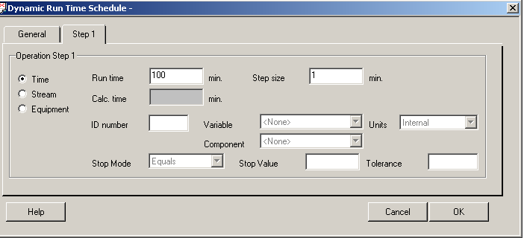

Step 6.3: Record Streams
One has to record streams in order to plot the properties of the corresponding streams. This can be done by entering the stream numbers and checking the Run Time Plot option in the Record Streams window as follows.
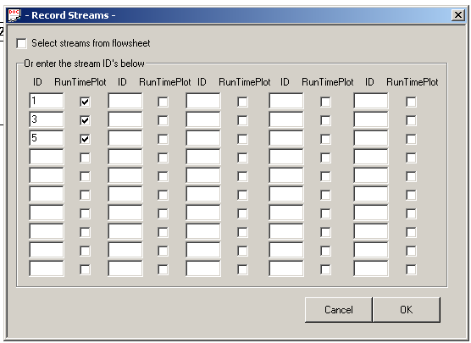

After clicking OK button in the above window, the Dynamic Stream Plot Options window comes up for each of the stream for which the Run Time Plot option is checked. One can select the property of the stream to be plotted in this window as follows:

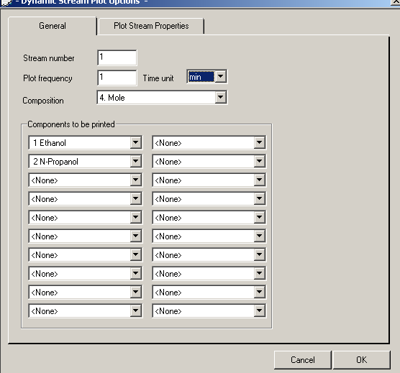

The Dynamic Stream Plot Options window can be completed similarly for all the remaining streams.

Step 6.4: Record unit operations
Parameters pertaining to unit operations can be recorded similar to the streams as described in the previous section. The completed windows would look as follows:

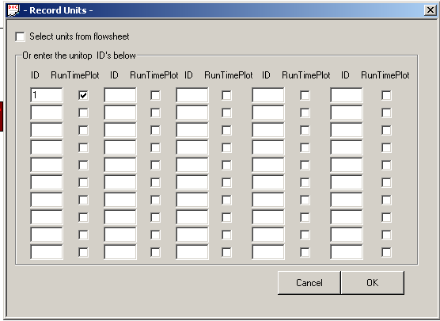

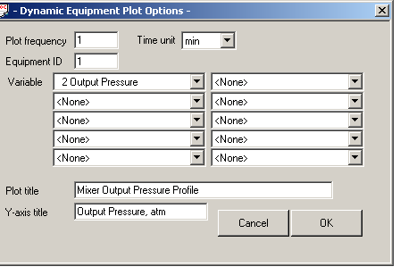

Step 6.5: Record Process
In addition to recording the stream and unit-operation information, the total process parameters can be recorded at any desired time by clicking on Record Process.

Step 7: Running the dynamic simulation
After all the information in entered as mentioned in previous steps, the dynamic simulation can be run by clicking on Run from initial state. The simulation runs for 100 min and plots for the chosen streams and unit operations are produced during the run time. The status of the dynamic simulation can be found by looking at DTime on the bottom of CHEMCAD screen. When the dynamic simulation is complete, DTime on the bottom indicates the final time (100 min). Also the following message appears.

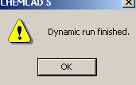

Step 8: Viewing the plots
The results of the dynamic simulation are plotted during the simulation. The results obtained for this example are as follows:

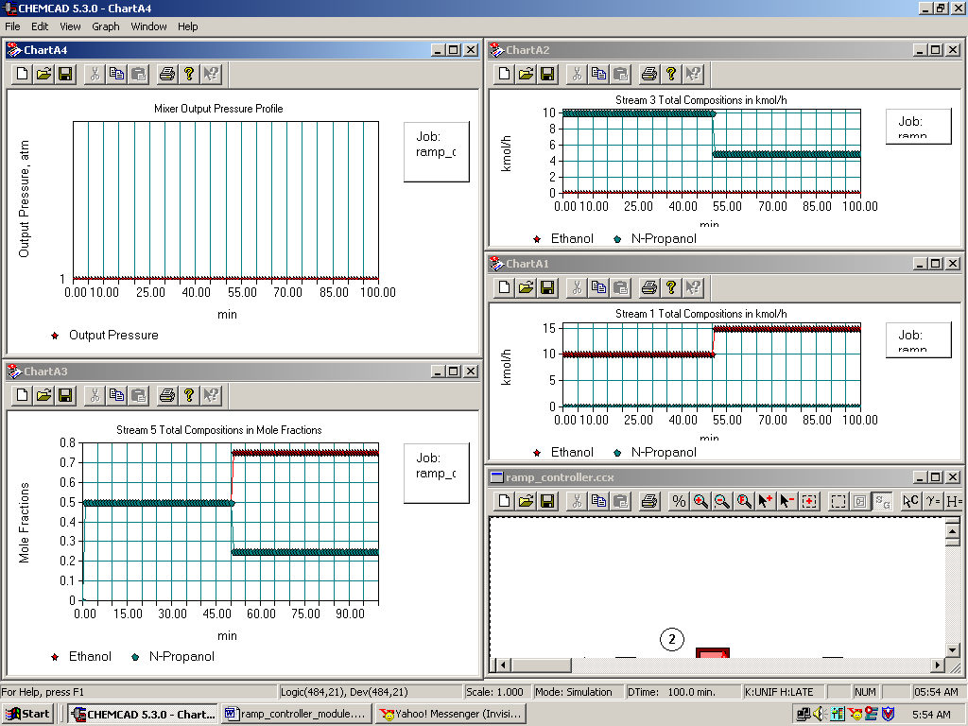

One can see that the product stream from the mixer (stream 5) has the required 75-mol% ethanol and 25-mol% n-propanol from 50 min onwards as required in the problem.

Alternatively, the results can also be plotted by going to Plot menu and clicking on Dynamic Stream History.

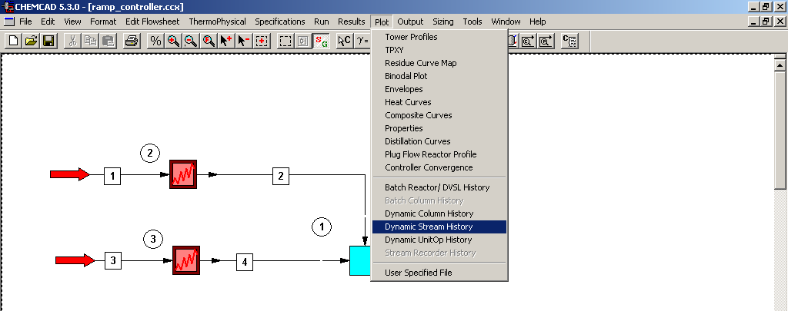
By using this alternative method of plotting, we can also convert the plot data into an excel file. To do this, one can go to Graph menu on the plot window and click on Data to Excel CSV file as shown in the following figure.

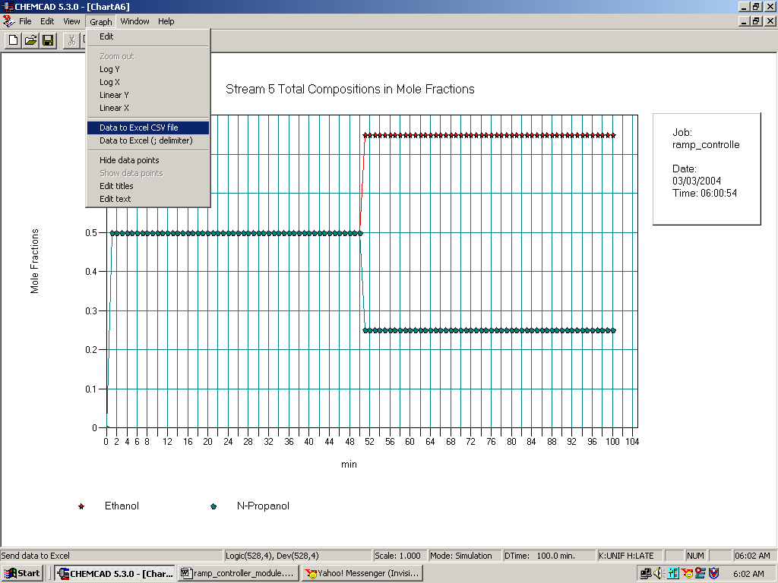

The results then appear in an excel file as shown in the following figure. It has to be noted however that the graphs plotted during run time cannot be converted into excel files. One had to plot them from the Graph menu in order to convert the plot data into excel file.
