Two Function Generator Setup

This setup is very useful when the experiment requires switching from one frequency to another. By using this method that user can change from one resonance mode to the next in a fraction of a second. This switch can also be done by changing the frequency of one function generator manually, but will take too long.

The experiments that use this setup are any experiment that needs to change from one resonance freq. to the next.
- Elastic String
- Chandli Plates
- Resonance Beams
- Resonance Tube

The figure above shows the correct equipment setup.

Output
Switch between inputs
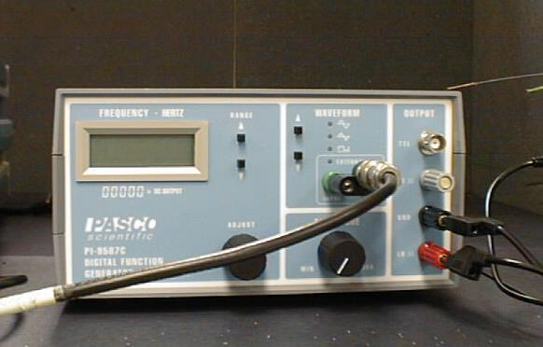
Output to mechanical driver
In this setup the use first sets the desired frequencies in each of the function generator. The next step is to change between the two frequencies by using the control switch. By moving up or down select the driving equipment.

