Homework 1

12–18. A car is to be hoisted by elevator to the fourth floor of a parking garage, which is 48 ft above the ground. If the elevator can accelerate at 0.6 ft/s², decelerate at 0.3 ft/s², and reach a maximum speed of 8 ft/s, determine the shortest time to make the lift, starting from rest and ending at rest.

12–26. Ball A is released from rest at a height of 40 ft at the same time that a second ball B is thrown upward 5 ft from the ground. If the balls pass one another at a height of 20 ft, determine the speed at which ball B was thrown upward.

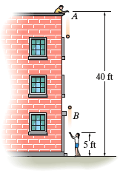

12–31. Determine the time required for a car to travel 1 km along a road if the car starts from rest, reaches a maximum speed at some intermediate point, and then stops at the end of the road. The car can accelerate at 1.5 m/s² and decelerate at 2 m/s².

12–47. The v–t graph for the motion of a train as it moves from station A to station B is shown. Draw the a–t graph and determine the average speed and the distance between the stations.
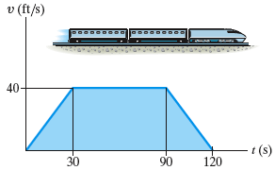

12–54. A two-stage rocket is fired vertically from rest at s = 0 with an acceleration as shown. After 30 s the first stage A burns out and the second stage B ignites. Plot the v–t and s–t graphs which describe the motion of the second stage for 0 ≤ t ≤ 60 s.

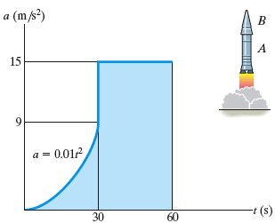

12–62. The v–s graph for an airplane traveling on a straight runway is shown. Determine the acceleration of the plane at s = 100 m and s = 150 m. Draw the a–s graph.

