EML 3013 HW-2

12–74. A particle moves along the curve y=e^{2x} such that its velocity has a constant magnitude of v = 4 ft/s. Determine the x and y components of velocity when the particle is at y = 5 ft.

12–82. The balloon A is ascending at the rate v_{A} = 12 km/h and is being carried horizontally by the wind at v_{w} = 20 km/h. If a ballast bag is dropped from the balloon at the instant h = 50 m, determine the time needed for it to strike the ground. Assume that the bag was released from the balloon with the same velocity as the balloon. Also, with what speed does the bag strike the ground?

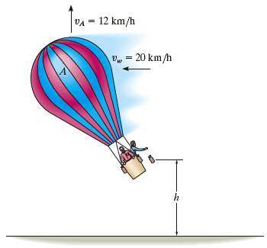

12–84. Determine the smallest angle θ measured above the horizontal, that the hose should be directed so that the water stream strikes the bottom of the wall at B. The speed of the water at the nozzle is v_{C} = 48 ft/s.

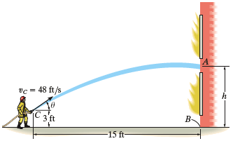

12–99. The projectile is launched from a height h with a velocity v₀. Determine the range R.

