EML 3013 HW-3 Spring 2007

12–106. The jet plane travels along the vertical parabolic path. When it is at point A it has a speed of 200 m/s, which is increasing at the rate of 0.8 m/s². Determine the magnitude of acceleration of the plane when it is at point A.

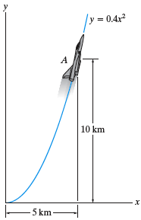

12–113. The automobile is originally at rest at s = 0. If its speed is increased by where t is in seconds, determine the magnitudes of its velocity and acceleration when t = 18 s.

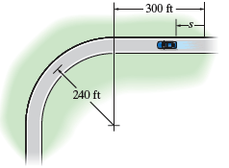

12–127. The race car has an initial speed v_{A} = 15 m/s at A. If it increases its speed along the circular track at the rate a_{t} = (0.4s) m/s², where s is in meters, determine the time needed for the car to travel 20 m. Take ρ = 150 m.

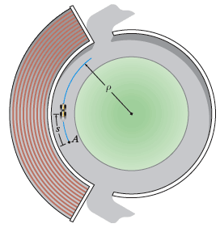

12–158. For a short time the arm of the robot is extending at a constant rate such that when r = 3 ft,z = (4t²) ft, and θ = 0.5t rad, where t is in seconds. Determine the magnitudes of the velocity and acceleration of the grip A when t = 3 s.

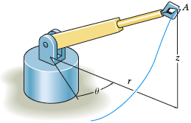

12–165. The mechanism of a machine is constructed so that for a short time the roller at A follows the surface of the cam described by the equation r = (0.3 + 0.2 cos θ) m. If and determine the magnitudes of the roller’s velocity and acceleration at the instant, θ = 30°. Neglect the size of the roller. Also determine the velocity components (v_{A})_{x} and (v_{A})_{y} of the roller at this instant. The rod to which the roller is attached remains vertical and can slide up or down along the guides while the guides move horizontally to the left.

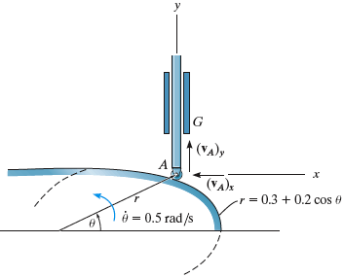

12–168. The pin follows the path described by the equation r = (0.2 + 0.15 cos θ) m. At the instant θ = 30°, and . Determine the magnitudes of the pin’s velocity and acceleration at this instant. Neglect the size of the pin.

