EML 3013 HW-4 Spring 2007

12–185. If the end A of the cable is moving upwards at v_{A} = 14 m/s, determine the speed of block B.

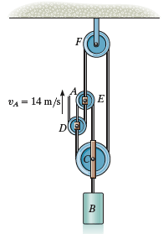

12–187. The cord is attached to the pin at C and passes over the two pulleys at A and D. The pulley at A is attached to the smooth collar that travels along the vertical rod. Determine the velocity and acceleration of the end of the cord at B if at the instant s_{A} = 4 ft the collar is moving upwards at 5 ft/s, which is decreasing at 2 ft/s².

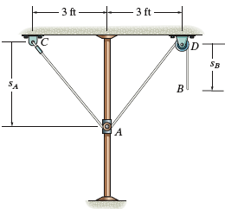

12–200. Two boats leave the shore at the same time and travel in the directions shown. If v_{A} = 20 ft/s and v_{B} = 15 ft/s, determine the speed of boat A with respect to boat B. How long after leaving the shore will the boats be 800 ft apart?

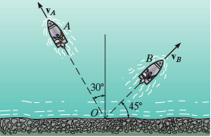

13–14. Each of the two blocks has a mass m. The coefficient of kinetic friction at all surfaces of contact is μ. If a horizontal force P moves the bottom block, determine the acceleration of the bottom block in each case.

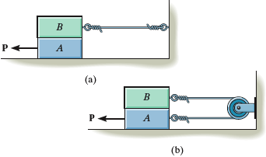

13–26. At the instant shown the 100-lb block A is moving down the plane at 5 ft/s while being attached to the 50-lb block B. If the coefficient of kinetic friction is μ_{k} = 0.2, determine the acceleration of A and the distance A slides before it stops. Neglect the mass of the pulleys and cables.

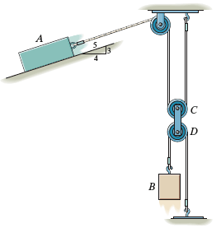

13–43. Blocks A and B each have a mass m. Determine the largest horizontal force P which can be applied to B so that A will not slip up B. The coefficient of static friction between A and B is μ_{s} Neglect any friction between B and C.

