EML 3013 HW-5 Spring 2007

13–58. Prove that if the block is released from rest at point B of a smooth path of arbitrary shape, the speed it attains when it reaches point A is equal to the speed it attains when it falls freely through a distance h; i.e., . (Do not need to solve this problem. Simply use the formula for 13-59)
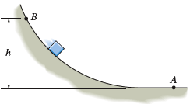
13–59. The sled and rider have a total mass of 80 kg and start from rest at A(10 m, 0). If the sled descends the smooth slope, which may be approximated by a parabola, determine the normal force that the ground exerts on the sled at the instant it arrives at point B. Neglect the size of the sled and rider. Hint: Use the result of Prob. 13–58.

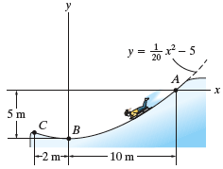

13–70. A collar having a mass of 0.75 kg and negligible size slides over the surface of a horizontal circular rod for which the coefficient of kinetic friction is μ_{k} = 0.3. If the collar is given a speed of 4 m/s and then released at θ = 0° determine how far, s, it slides on the rod before coming to rest.

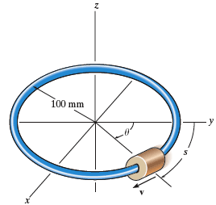

13–73. The 5-kg pendulum bob B is released from rest when θ = 0°. Determine the initial tension in the cord and also at the instant the bob reaches point D, θ = 45° Neglect the size of the bob.

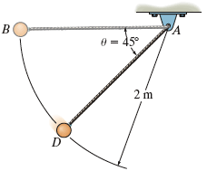

13–94. The 2-lb collar slides along the smooth horizontal spiral rod, r = (2θ) ft, where θ is in radians. If its angular rate of rotation is constant and equals ,determine the tangential force P needed to cause the motion and the normal force that the rod exerts on the spool at the instant θ = 90°. (Do not need to solve this but note that an additional force (weight of the collar) has to be taken into account in 13-95 and this is the only difference between 13-94 and 13-95)

13–95. Solve Prob. if the spiral rod is vertical.

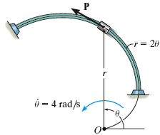

13–99. Determine the normal and frictional driving forces that the partial spiral track exerts on the 200-kg motorcycle at the instant , , and . Neglect the size of the motorcycle.

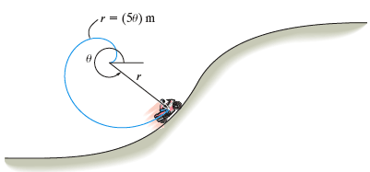

13–101. The ball has a mass of 2 kg and a negligible size. It is originally traveling around the horizontal circular path of radius r₀ = 0.5 m such that the angular rate of rotation is . If the attached cord ABC is drawn down through the hole at a constant speed of 0.2 m/s, determine the tension the cord exerts on the ball at the instant r = 0.25 m. Also, compute the angular velocity of the ball at this instant. Neglect the effects of friction between the ball and horizontal plane. Hint: First show that the equation of motion in the θ direction yields When integrated, , where the constant C is determined from the problem data.

