EML 3013 HW-6 Spring 2007

14–3. The 20-kg crate is subjected to a force having a constant direction and a magnitude F = 100 N, where s is measured in meters. When s = 4 m, the crate is moving to the right with a speed of 8 m/s. Determine its speed when s = 25 m. The coefficient of kinetic friction between the crate and the ground is μ_{k} = 0.25.
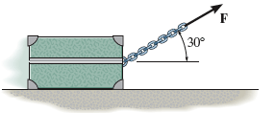

14–15. Block A has a weight of 60 lb and block B has a weight of 10 lb. Determine the speed of block A after it moves 5 ft down the plane, starting from rest. Neglect friction and the mass of the cord and pulleys.

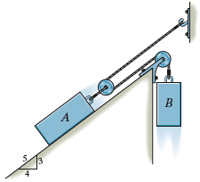

*14–24. The block has a mass of 0.8 kg and moves within the smooth vertical slot. If it starts from rest when the attached spring is in the unstretched position at A, determine the constant vertical force F which must be applied to the cord so that the block attains a speed v_{B} = 2.5 m/s when it reaches B; s_{B} = 0.15 m. Neglect the size and mass of the pulley. Hint: The work of F can be determined by finding the difference Δl in cord lengths AC and BC and using U_{F} = F Δl.

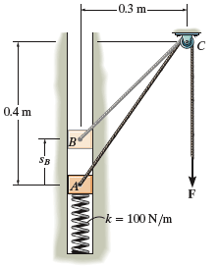
14–38. The spring has a stiffness k = 50 lb/ft and an unstretched length of 2 ft. As shown, it is confined by the plate and wall using cables so that its length is 1.5 ft. A 4-lb block is given a speed v_{A} when it is at A, and it slides down the incline having a coefficient of kinetic friction μ_{k} = 0.2. If it strikes the plate and pushes it forward 0.25 ft before stopping, determine its speed at A. Neglect the mass of the plate and spring.

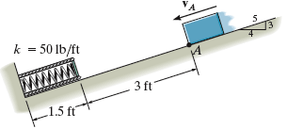

14–49. The 50-lb crate is given a speed of 10 ft/s in t = 4 s starting from rest. If the acceleration is constant, determine the power that must be supplied to the motor when t = 2 s. The motor has an efficiency ∈ = 0.76. Neglect the mass of the pulley and cable.

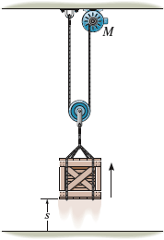

14–54. The crate has a mass of 150 kg and rests on a surface for which the coefficients of static and kinetic friction are μ_{s} = 0.3 and μ_{k} = 0.2, respectively. If the motor M supplies a cable force of F = (8t²+20) N, where t is in seconds, determine the power output developed by the motor when t = 5 s.

