Lab Assignment - Forced Vibration

Experiment-8 Theory
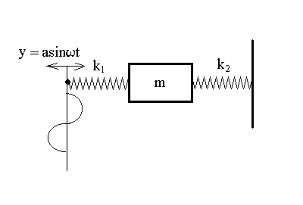
For a forced vibration system shown in figure 1, a cart is placed on the cart track with the two springs, k₁ and k₂, attached to either side of the cart. The other end of spring k₂ is fixed. The other end of spring k₁ moves back and forth in a harmonic function $y=a\text{sin}ωt$.

The free body diagram is shown in figure 2.
Figure 1
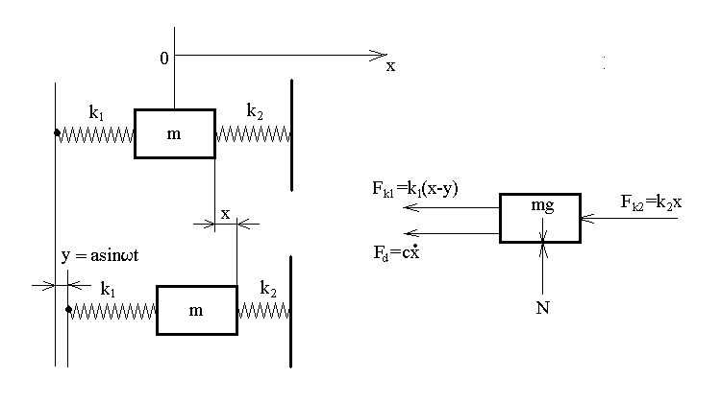
Figure 2: free body diagram

The spring force of k₁ is:$F_{k1}=k_{1}(x−y)=k_{1}(x−a\text{sin}ωt)$
The spring force of k₂ is:$F_{k2}=k_{2}x$
Due to the friction force, there is also damping force acting on the cart, which is $F_{d}=c\overset{˙}{x}$, where c is the damping ratio.

From the free body diagram, we can write the equation of motion for the cart:
$$m\overset{¨}{x}=−k_{1}(x−a\text{sin}ωt)−k_{2}x−c\overset{˙}{x}$$
$$m\overset{¨}{x}+c\overset{˙}{x}+(k_{1}+k_{2})x=k_{1}a\text{sin}ωt$$

This equation of motion is a nonhomogeneous, linear, second-order differential equation with constant coefficients. Its general solution consists of two parts, a particular solution and a complementary solution. The complementary solution will always decay away with time. The particular solution is the steady-state vibration. That is, after the transient part of the solution has decayed away, the system will oscillate according to the particular solution as long as the harmonic input is applied.
Figure 1
Figure 1

The particular solution is:
$$x(t)=A\text{sin}(Ωt−ψ)$$
The response oscillation frequency of the cart is the same as the driving frequency, $Ω=ω$.
The oscillation amplitude $A=\frac{k_{1}a}{\sqrt{{\left[(k_{1}+k_{2})−{mω}^{2}\right]}^{2}+(cω)^{2}}}$
The phase angle $ψ$: $\text{tan}ψ=\frac{cω}{k_{1}+k_{2}−{mω}^{2}}$

Assignment: Determine the system response x=x(t) without the forcing. $\text{That is }a=0\text{ and }m\overset{¨}{x}+c\overset{˙}{x}+(k_{1}+k_{2})x=0\text{.}$You should follow steps given in chapter 22.4, viscous damped free vibration. Compare your derivation to results obtained in experiment 8. Determine the damping coefficient c (hint: use figure 22-17, plot the logarithm function of the peak values for the damped signal as a function of time. You should get a straight line with a slope directly relates to the damping coefficient c.)

