Summary of nodal finite-difference relations for various configurations

Configuration Finite-Difference relations for Δx=Δy

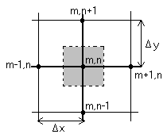 Case 1 Interior Node

$T_{m,n+1}+T_{m,n−1}+T_{m+1,n}+T_{m−1,n}−4T_{m,n}=0$

Case 2 Node at an internal corner with convection

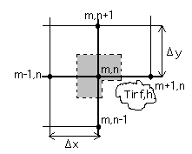

T∞, h

Case 3 Node at a plane surface with convection
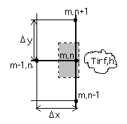

T∞, h

Case 4 Node at an external corner with convection
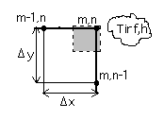

T∞, h

Case 5 Node at a plane surface with uniform heat flux
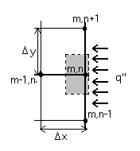

$$(2T_{m−1,n}+T_{m,n+1}+T_{m,n−1})+\frac{2q\text{''}Δx}{k}−4T_{m,n}=0$$

This nodal point table can be found in most of the heat transfer textbooks, for example: see table 4.2 of “Introduction to Heat Transfer” by Incropera and DeWitt.

