Write the displacement Function for the following elements

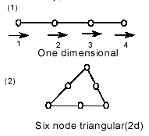

Analyze the bar shown below for:

(a) Displacement at B
(b) End Forces
(c) Average Stresses in bar AB & BC

