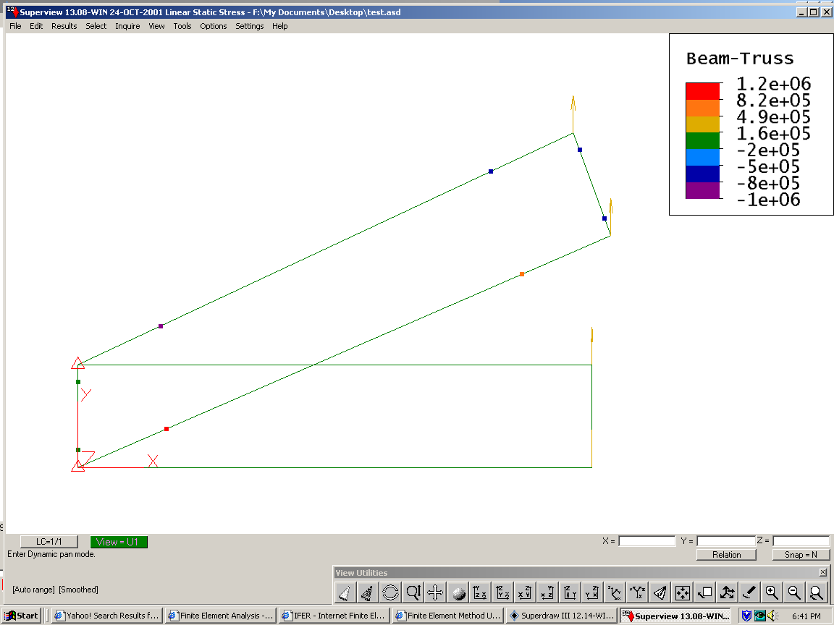
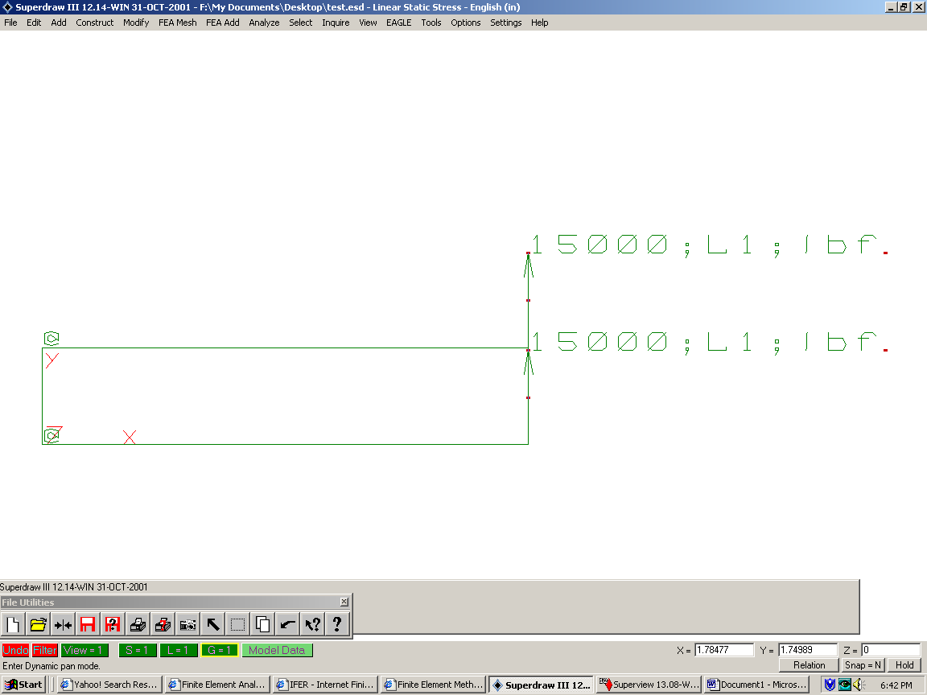

http://gilmore-engineers.com/fea.html#SELECTED%20GIL%20ENG%20FEA%20CASE%20STUDIES

