Session 2526

Integration of Optical Diagnostic Techniques into the Teaching of the Thermal and Fluid Sciences Laboratory Course

Chiang Shih, Luiz Lourenco and Farrukh Alvi
Department of Mechanical Engineering
FAMU-FSU College of Engineering
Florida A&M University and Florida State University

Abstract

Visual presentation has always played an important role in teaching thermal and fluid related courses because "seeing is believing". However, traditional visualization techniques do not readily provide quantitative information about the flow field of interest, therefore, these techniques have primarily been used for qualitative demonstrations. In the current paper, we illustrate by example, the integration and use of two quantitative visualization/image-processing techniques into an undergraduate Thermal and Fluid sciences laboratory (TFSL) course. First, the Particle Image Velocimetry (PIV) technique is used to provide detailed whole-field velocity measurement. Sample projects include the flow-field characterization of a turbulent wake behind a circular cylinder and the droplet injection process of a Hewlett-Packard inkjet printhead. Second, the Laser Speckle Displacement (LSD) method is used to measure the density/temperature variation of selected flow fields, such as the shock-cell structure of a supersonic jet. Several sample projects involve the use of these two techniques are described in the paper. All laboratory manuals are documented in html format and made available to students before the experiments. Students are required to acquire and process PIV/speckle images and compare the processed data with other theoretical and experimental results in their laboratory reports. In our opinion, by taking advantage of the visual appeal of flow visualization techniques together with the ability to provide quantitative measurements, the integration of the advanced optical diagnostic techniques into the Thermal and Fluid Sciences Laboratory not only enhances students' understanding of the subject but also stimulate their interests in this discipline.

Introduction

"Thermal and Fluid Sciences" are among the most difficult curricula for undergraduate engineering students. A primary reason is the difficulty in conceptually visualizing thermal and fluid behaviors because most fluids are transparent and their motions and the associated thermal processes are invisible to human. Consequently, visualization methods usually play an important role in teaching thermal and fluid related courses because "seeing is believing". However, traditional visualization techniques do not readily provide quantitative information about the flow field of interest, therefore, they have mainly been used for the purpose of demonstration and their results can not effectively be correlated to the available theoretical and analytical solutions. In light of this, we propose to integrate two quantitative visualization/image-processing techniques into the teaching of an undergraduate thermal and fluid science laboratory (TFSL) course. Moreover, the visualization-based courseware produced in the image-processing
laboratory will be used extensively in the teaching of a newly designed integrated thermal and fluid curriculum, which will also be described in the following section.

Course description

The TFSL course belongs to a series of integrated thermal courses, which are designed to provide the students with a solid foundation in the thermal and fluid sciences with strong design content and extensive laboratory experience. The first phase of the series starts with a two-semester class sequence that integrates Thermodynamics, Fluid Mechanics and Heat Transfer to provide the theoretical background of the thermal engineering concepts with an emphasis on practical design applications. Innovative project-oriented "just-in-time" delivery methodology has been implemented in the teaching of this class. Frequent introduction of real-world applications and hands-on experiments, which demonstrate the physical principles learned and emphasize the connectivity between heat transfer, fluid mechanics and thermodynamics, is critical to the success of this integrated approach. The use of optical techniques and related instructional courseware provide an efficient teaching tool to achieve this goal. Second phase of the curriculum includes advanced thermal classes such as Propulsion, Advanced Heat Transfer, Aerodynamics, Thermal-Fluid Design, Senior Design Project, etc. These courses are intended to further enhance the student's understanding of the concept of design and provide practical experience in a laboratory environment. The TFSL course involves engineering laboratory measurements in fluid and thermal applications, including basic concepts of experiments, measurement devices and their performance characteristics; measurement of fluid and thermal properties, including pressure, velocity, and temperature; calibration procedures; design of engineering experimental systems; laboratory work and report writing. In TFSL, students are required to use these optical techniques in their laboratory assignments and final projects. Basic principles of the optics and image-processing algorithm, including the introduction of the CCD (Charge-Coupled Device) technology, are also provided in lectures. Finally, to complete the learning package, related topics in other engineering fields are integrated to provide students with a broad-based cross-disciplinary understanding of the subject.

Particle Image Velocimetry (PIV)

Particle image velocimetry is a whole flow-field measuring technique, which provides both qualitative and quantitative information on the flow behavior ^{1,2}. The operation of the technique involves the illumination of the flow, seeded with small tracer particles, with a thin pulsed laser light sheet. The light scattered by the seeding particles, which follow the local fluid motion, generates a moving particle-image pattern. A typical PIV configuration is shown in figure 1. The image pair pattern can be recorded using multiple exposure photographic technique, either on films or in digital formats. The whole-field velocity information can be obtained by evaluating the distance between successive images of particles within a specific interrogation region. Digital image processing technique, using a Fast Fourier Transform algorithm, is used to determine the image separation and convert this information into local velocity data (figure 1). Please refer to Lourenco et al. ³ for a more detailed description of the scheme. Followings are descriptions of two sample projects implemented in the laboratory course using the PIV technique. More experiments will be added in the future.

Sample Project 1: turbulent wake behind a circular cylinder in cross flow

Vortex shedding behind a bluff body has been related to many important applications, for example the vortex flow meter can be used to measure flow velocity. Failure to consider this effect can also lead to engineering disasters, such as the collapse of Tacoma Narrows Bridge as a result of the wind-induced vibration. The phenomenon involves the flow separation from the surface, the emergence of shear layer instability and the generation of strong oscillatory loading on the body due to fluid/structure interaction. Traditional techniques based on single point measurement can not fully characterize the behavior of this unsteady event. However, the use of PIV can capture, at any specific instant, the whole-field velocity and vorticity data and provides a detailed overall view of the flow field. A typical sequence of vortex shedding behind a circular cylinder is shown in figure 2. Color-coded vorticity data is superimposed on the local velocity vector plot to reveal the shedding process. It can be clearly seen that boundary layer from either side of the cylinder separates alternately and vortices are periodically released into the wake from both sides. Corresponding pressure measurements on the cylinder also indicate strong oscillations and are correlated to the PIV data. In addition, time-averaged PIV velocity data are used to describe other phenomena such as flow separation from the cylinder's surface, velocity deficit inside the wake, etc. Finally, lift and drag forces on the cylinder are estimated by performing a momentum balance using the PIV velocity data and the result can be compared to the data obtained by integrating the pressure distribution on the cylinder surface.

A copy of the laboratory manual for this sample experiment is attached at the end of the paper as a reference. The manual is written in html code and is available through the Internet at www.eng.fsu.edu/~shih/eml4304/cylinder/cylinder.htm. Please feel free to use this page and other available instructional materials in the page to fit into your teaching needs.

Sample project 2: droplet injection process of an inkjet printhead

A new experiment concerning the droplet injection process of a HP inkjet cartridge was developed. Using stroboscopic illumination and a microscope, the near-field ink droplet injection process is visualized and the droplet velocity is measured using the PIV system as shown in figure 3. The emergence of a primary droplet and several satellite droplets can be clearly seen. The far-field droplet trajectory can be visualized using a CCD camera and back illuminating the flow using a strobelight (figure 4). The visualized results can then be compared to the theoretical data predicted by using the droplet injection velocity and the associated aerodynamic drag force acting on the droplet. This experiment is interesting since it uses advanced diagnostics techniques (PIV & image processing) on a commonly used commercial product (an inkjet printer) and illustrates several fundamental thermal principles (e.g., surface tension driven stability, aerodynamic drag, and boiling heat transfer of the thermal bubble formation).

Laser Speckle Displacement LSD technique

The basic principle of the LSD technique to measure density has been described by Kopf ⁴. When a collimated laser source is used to illuminate a piece of ground glass, a random speckle pattern is produced as a result of the interference of light scattered by the fine grain in ground glass (see figure 5). When viewing the ground glass through a flow field of interest involving density variation, the speckle pattern is displaced due to the change of refractive index inside the flow. Keeping in mind that, the change of the refractive index is directly related to the change of the fluid density by the Gladstone-Dale constant, the speckle displacements of a flow medium can be measured with reference to the quiescent and isothermal ambient background. The whole-field speckle displacement field can therefore be directly related to the variation of the density field due to the presence of the flow. The technique can thus be used to obtain density and temperature fields of compressible flows and thermally driven convective flows. A sample project using this technique is described in he following.

Sample project 3: periodic shock-cell structure of an under-expanded supersonic jet

The density field of an axisymmetric jet, with a design Mach number of 2 operating at an under-expanded condition, is shown in figure 6. The density field is obtained by integrating the measured speckle displacement (density gradient) field for the entire flow field of interest (figure 6(a)). The presence of a periodic shock cell structure can be clearly seen in the figure. Using the LSD field data, the density variation can also be digitally reconstructed to obtain first order spatial density gradients in the entire flow field therefore producing images analogous to those obatined using traditional schlieren methods, (figures 6(b) & 6(c)). Similarly, the second order spatial density gradients analogous to tradition shadowgraph (figure 6(d)) can also be obtained via reconstruction of LSD data. The existence of a periodic shock cell structure in a supersonic jet is important since it can interact with the jet turbulence and generates intense screeching noises (screech tones). These high decibel tones can produce premature material fatigue and significant structural damage to neighboring mechanical devices. Also, the propulsion efficiency of a jet decreases significantly because of the loss of thrust due to the presence of these shocks.

Evaluation and dissemination

All experiments, accompanied with comprehensive operation manuals, are made available in electronic form either via Internet WWW access for any groups of interest and in CD-ROM format for internal usage and upon request. Demonstration laboratories will not only be presented in the laboratory class but also in all related thermal and fluids classes. Demonstration courseware with detailed descriptions of the experiments will be archived into digital formats and included in the course Web pages, which will be available not only to our students but also to the entire teaching community. A complete evaluation of the effectiveness of the program will be conducted at the end of each class through student evaluation surveys. Specific questions and comments will be solicited to continually improve the program in the future. Currently, preliminary results from the project have been submitted to SUCCEED (The Southeastern University and College Coalition for Engineering Education) to be disseminated through their CDROM project. At the conclusion of the project, we intend to submit the final package of the courseware to NSF-sponsored NEEDS (the National Engineering Education Delivery System) program to be included in their national dissemination database. Internally, workshop(s) will be arranged both in the College of Engineering and through the SUCCEED to assist other faculty members from this College and other member institutions in getting into visualization-based teaching.

Conclusion

Optical diagnostic techniques, based on digital image-processing algorithm, have been integrated into the teaching of an undergraduate Thermal and Fluid sciences laboratory (TFSL) course. First, the Particle Image Velocimetry (PIV) technique is used to provide the detailed whole-field velocity measurement. Sample projects using PIV include the flow-field characterization of a turbulent wake and the droplet injection process of a Hewlett-Packard inkjet printhead. Second, the Laser Speckle Displacement (LSD) method is used to measure the density/temperature variation of selected flow fields, such as the shock-cell structure of a supersonic jet. Sample projects involving the use of these two techniques are described in the paper. Students are required to acquire and process PIV/speckle images and compare the processed data with other theoretical and experimental results in their laboratory reports. In our opinion, the integration of the advanced optical diagnostic techniques in the Thermal and Fluid Sciences Laboratory not only enhances students' understanding of the subject but also stimulate their interests in participation. Finally, demonstration courseware with detailed descriptions of the experiments will be archived into digital formats and be published on the Web, which will be made available to the entire engineering educational community.

Acknowledgements

The authors would like to thank Mr. Bahadir Alkislar for providing his LSD supersonic jet data. We would also like to thank Dr. Fang-Gang Tseng who kindly allowed us to use his inkjet droplet photographs in the project. Partial support for this work was provided by the National Science Foundation's Division of Undergraduate Education through grant DUE# 9750785.

Bibliography
1. Lourenco, L., Krothapalli, A. and Smith, C.R., "Particle Image Velocimetry," Lecture Noted in Engineering, 45, Advances in Fluid Mechanics Measurements, pp. 128-199, ed. Gad-el-Hak, Springer-Verlag, 1989.
2. Adrian, R.J., "Particle Imaging Techniques for Experimental Fluid Mechanics," Annual Review of Fluid Mechanics, 23, pp. 261-304, 1991.
3. Lourenco, L., Gogineni, S. and LaSalle, R., "On-Line Particle-Image Velocimeter: an Integrated Approach," Applied Optics, Vol. 33, No. 13, pp. 2465-2470, 1994.
4. Kopf, U., "Application of Speckling for Measuring the Deflection of Laser Light by Phase Objects," Optics Communications, n.5, pp. 347-350, 1972.

Chiang Shih
Chiang Shih is an Associate Professor of the Department of Mechanical Engineering at the FAMU-FSU College of Engineering. He is the principal investigator of the NSF ILI-IP project. Dr. Shih received his Ph.D. from the Aerospace Engineering Department at the University of Southern California in 1988. He is a member of the American Society of Engineering Education.

Luiz Lourenco
Luiz Lourenco is a Professor of the Department of Mechanical Engineering at the FAMU-FSU College of Engineering. Dr. Lourenco is also the director of the Fluid Mechanics Research Laboratory and is responsible for the development of the digital PIV and LSD techniques for the project. Dr. Lourenco received his D.Sc. degree from Oporto University, Portugal, (1984); Docteur es Sciences Appliquees from the University of Brussels (1982).

Farrukh Alvi
Farrukh Alvi is an Assistant Professor of the Department of Mechanical Engineering at the FAMU-FSU College of Engineering. He currently teaches the undergraduate Fluid and Thermal sciences laboratory. Dr. Alvi received a B.S. degree in Mechanical Engineering from the University of California at Berkeley in 1987 and a Ph.D. from the Mechanical Engineering Department at the Penn State University in 1992.

figure 1 Schematic arrangement of the PIV system
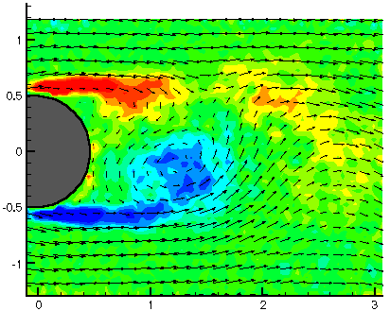
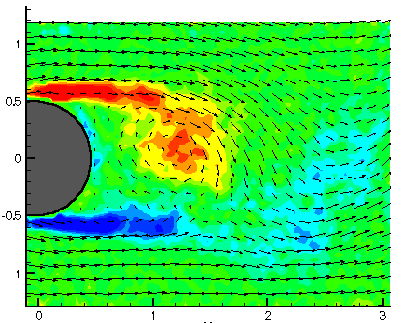
X/D
Y/D
Y/D
X/D
X/D

Figure 2 Vortex shedding behind a circular cylinder, color-coded vorticity plus velocity vector fields, depicting the vortex shedding process of the flow behind a circular cylinder during two different instants of its development.

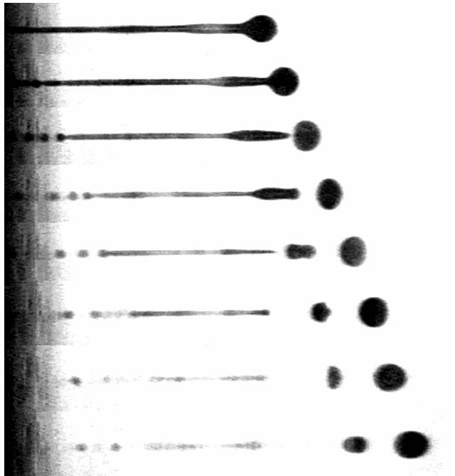
100 μm
50 μs
55 μs
60 μs
65 μs
70 μs
75 μs
80 μs
85 μs
Satellite droplets

Figure 3 Near field visualization of the inkjet droplet injection process, showing the emergence of primary and satellite droplets.

HP Inkjet Printhead

Figure 4 Far field visualization of the inkjet droplet injection process. Due to their different sizes and initial velocities, the trajectories of the main droplets are drastically different from that from the satellite droplets. (Figures 3 & 4 are photographs courtesy of Dr. Fang-Gang Tseng)

laser
beam
microscopic
lens
pin
hole
collimating
lens
phase
object
ground
glass
focused
plane
camera
lens
camera
sensor
deflected
beam

Figure 5 Schematic arrangement of the LSD system

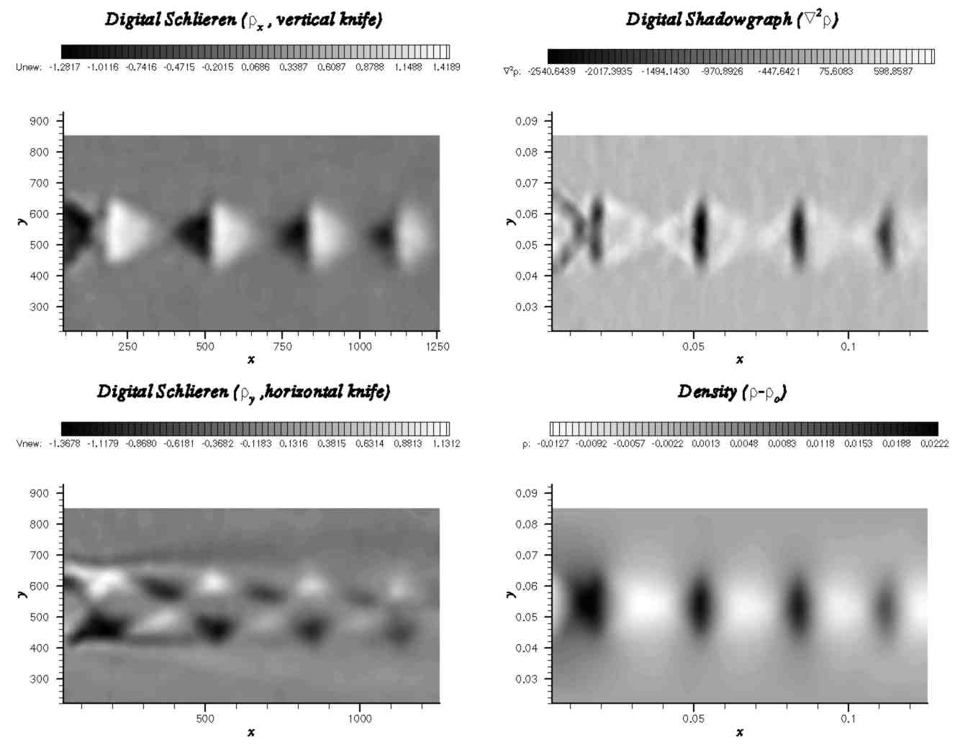
Figure 6 Periodic shock-cell structure of an under-expanded supersonic jet, showing the presence of periodic shock cells in a supersonic jet by the LSD data. It contains a sequence of four figures: (a) density field, (b) density gradient along the stream-wise directions, (c) density gradient along the cross-stream directions, (d) the second derivative of the density field.

<div align="center">
<big> </big> |  | Sample Laboratory Manual:  Flow Over a Circular Cylinder
<div align="center">
<big> </big>
Introduction  (a) Background  Flow separation  Wake  Vortex shedding  Vortex-induced vibrations  Lift and drag/momentum balance  (b) PIV technique  (c) CCD technology  (d) Other links  Other Pages  Laboratory Setup  Lab. Procedures  Report Writing  Further Readings  FAQ |  | 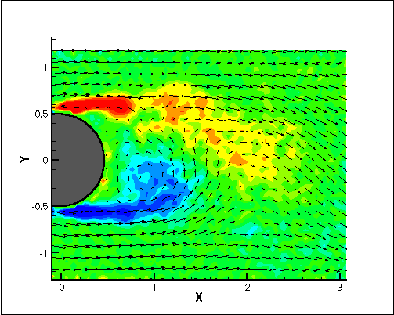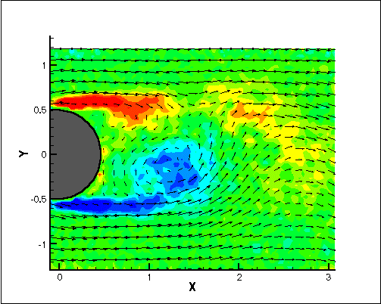  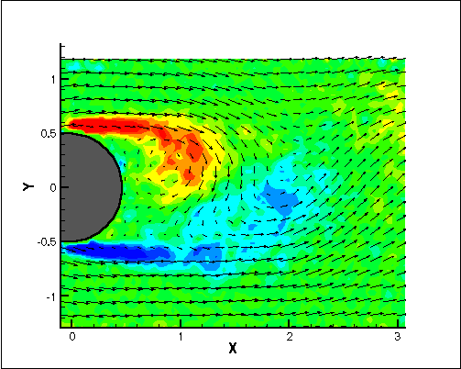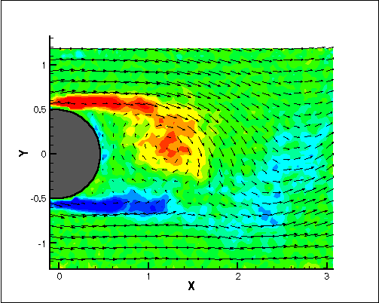  Figure 1. A sequence of four PIV velocity/vorticity fields depiciting different stages of development within a vortex shedding cycle. Vortices are shed alternatively from the upper and lower surfaces of the cylinder, creating a periodic flow pattern. Color-code is used to indicate the strength of the flow vorticity. Red color represents the clockwise vorticiity; blue color represents the counterclockwise vorticity. PIV velocity field is represented by the velocity vector data.  Introduction  External flows past objects have been studied extensively because of their many practical applications. For example, airfoils are made into streamlined shapes in order to increase the lift while at the same time, reducing the aerodynamic drag exerted on the wings. On the other hand, flow past blunt body, such as a circular cylinder, usually experiences boundary layer separation and very strong flow oscillations in the wake region behind the body. In certain Reynolds number range, a periodic flow motion will develop in the wake as a result of boundary layer vortices being shed alternately from either side of the body. This regular pattern of vortices in the wake is called a Karman vortex street. It creates an oscillating flow at a discrete frequency that is related to the Reynolds number of the flow. The periodic nature of the vortex shedding phenomenon can sometimes lead to unwanted structural vibrations, especially when the shedding frequency matches one of the resonant frequencies of the structure. One example is the famous Tacoma Narrow bridge incident and it will be discussed I more details later. In this laboratory, we are going to investigate the flow past a circular cylinder inside a towing tank facility. You are asked to make measurements of the cylinder wake flow field using Particle Image Velocimetry (PIV) technique. Based on your PIV velocity field measurements and the cylinder surface pressure distribution data taken from an earlier experiment, you are required to write a laboratory report which will be due two weeks from today. In your report, you should include comprehensive discussion about boundary layer flow separation, wake flow, vortex shedding, vortex-induced oscillations, the concept of momentum balance and how it relates to the lift and drag forces on the cylinder. A more detailed discussion of these topics is given in the following section.  Background  <small><small>Flow Separation:<small> The presence of the fluid viscosity slows down the fluid particles very close to the solid surface and forms a thin slow-moving fluid layer called a boundary layer. The flow velocity is zero at the surface to satisfy the no-slip boundary condition. Inside the boundary layer, flow momentum is quite low since it experiences a strong viscous flow resistance. Therefore, the boundary layer flow is sensitive to the external pressure gradient (as the form of a pressure force acting upon fluid particles). If the pressure decreases in the direction of the flow, the pressure gradient is said to be favorable. In this case, the pressure force can assist the fluid movement and there is no flow retardation. However, if the pressure is increasing in the direction of the flow, an adverse pressure gradient condition is said to exist. Under this condition, in addition to the presence of a strong viscous force, the fluid particles now also have to move against the increasing pressure force. Therefore, the fluid particles can be stopped and their direction of travel can even be reversed, causing the neighboring particles to move away from the surface. This phenomenon is called the boundary layer separation.  </small></small></small>  <small><small><small>Wake: Consider a fluid particle flows within the boundary layer around the circular cylinder surface. From the pressure distribution measured in an earlier experiment, the pressure is maximum at the stagnation point and gradually decreases along the front half of the cylinder. The flow stays attached in this favorable pressure region as expected. However, the pressure starts to increase in the rear half of the cylinder and the fluid particle now experiences an adverse pressure gradient. Consequently, the flow separates from the surface and creating a highly turbulent region behind the cylinder called the wake. Inside the wake region, the flow is dominated by the regular vortex shedding process and the emergence of a highly irregular turbulent motion. The pressure inside the wake region remains low and a net pressure force (pressure drag) is produced. Right behind the body in the near wake region, the time-averaged flow field shows a closed recirculating pattern with strong flow reversal (see PIV velocity profiles). Further downstream, the mean velocity profiles still shown a significant slowing-down near the center and the exist of this momentum deficit region can be directly related to the generation of drag force on the body.  </small></small></small>  Vortex Shedding<small>:<small><small> </small></small></small>The boundary layer which separates from the surface forms a free shear layer which it is highly unstable. This shear layer will eventually roll into a discrete vortex and detach from the surface (a phenomenon called vortex shedding). Another type of flow instability emerges as the shear layer vortices shed from both the top and bottom surfaces interact with one another. They shed alternatively from the cylinder and generate a regular vortex pattern (the Karaman vortex street) in the wake (figure 1). The vortex shedding occurs at a discrete frequency and is a function of the Reynolds number. The dimensionlese frequency of the vortex shedding, the shedding Strouhal number, St = f D/V, is approximately equal to 0.21 when the Reynolds number is greater than 1,000.  Vortex-Induced Vibrations<small>:<small><small> When vortices shed from the cylinder, uneven pressure distribution develops between the upper and lower surfaces of the cylinder, generating an oscillatory aerodynamic loading (lift) on the cylinder. This unsteady force can induce significant vibrations on a structure, especially if the "resonance" condition is met. That is when the frequency of an external forcing signal matches that of the natural frequency of the mechanical system. The most famous example is the collapse of Tacoma Narrow bridge in 1940 under the action of wind-induced vibrations. It is believed that natural vortex shedding frequency behind the bridge matched one of the resonant modes of the bridge and eventually lead to a catastrophic vibration that eventually destroys the bridge. Please refer to the other links section for a more comprehensive account of the incident.  </small></small></small>  Lift and Drag/Momentum Balance:<small><small><small> According to the Newton's second law, time rate change of the linear momentum is equal to the sum of all external forces acting on a system. Therefore, an integration of the linear momentum inside a control volume surrounding the circular cylinder can provide information of the aerodynamic forces (lift and drag) acting on the cylinder. In general, there is a momentum deficit in the wake along the streamwise direction, therefore, according to the Newton's law there must be a net drag force acting on the cylinder. Also, from figure 1, there are alternative upward and downward flows in the wake as the result of vortex shedding. Consequently, there must be also an oscillatory lift force acting periodically on the cylinder in order to produce this alternative change of flow directions inside the wake. This periodic forcing is responsible for the vortex-induced vibrations as described earlier.</small></small></small>  PIV Technique  The PIV is a quantitative flow visualization technique, which can be used to determine the instantaneous whole-field fluid velocities by recording and processing the multiply exposed particle image pattern of small traces suspended in the fluid. The PIV particle image is first obtained by illuminating the seeded flow field with a thin laser sheet. The light scattered by the seed particles generates a particle image pattern. This pattern is recorded using a digital CCD video technique (see figure 2). The local fluid velocity is then obtained using digital signal processing techniques.  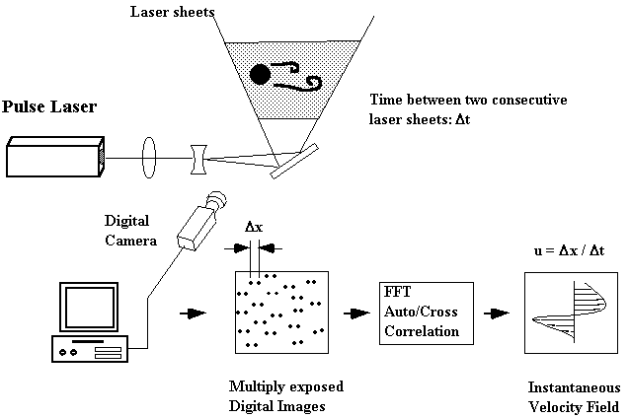  Figure 2. Schematic arrangement of the PIV system  Figure 3 is a sample PIV image pattern of the flow past a circular cylinder. The multiple illumination is provided using a rotating multi-faceted mirror. A total of four images are recorded for each particle in successive instants. Fast Fourier Transform (FFT) algorithm and an autocorrelation scheme are used to determine the separation between particle pairs. The whole-field velocity vectors can be determined by time differentiation and the result is shown in figure 3.  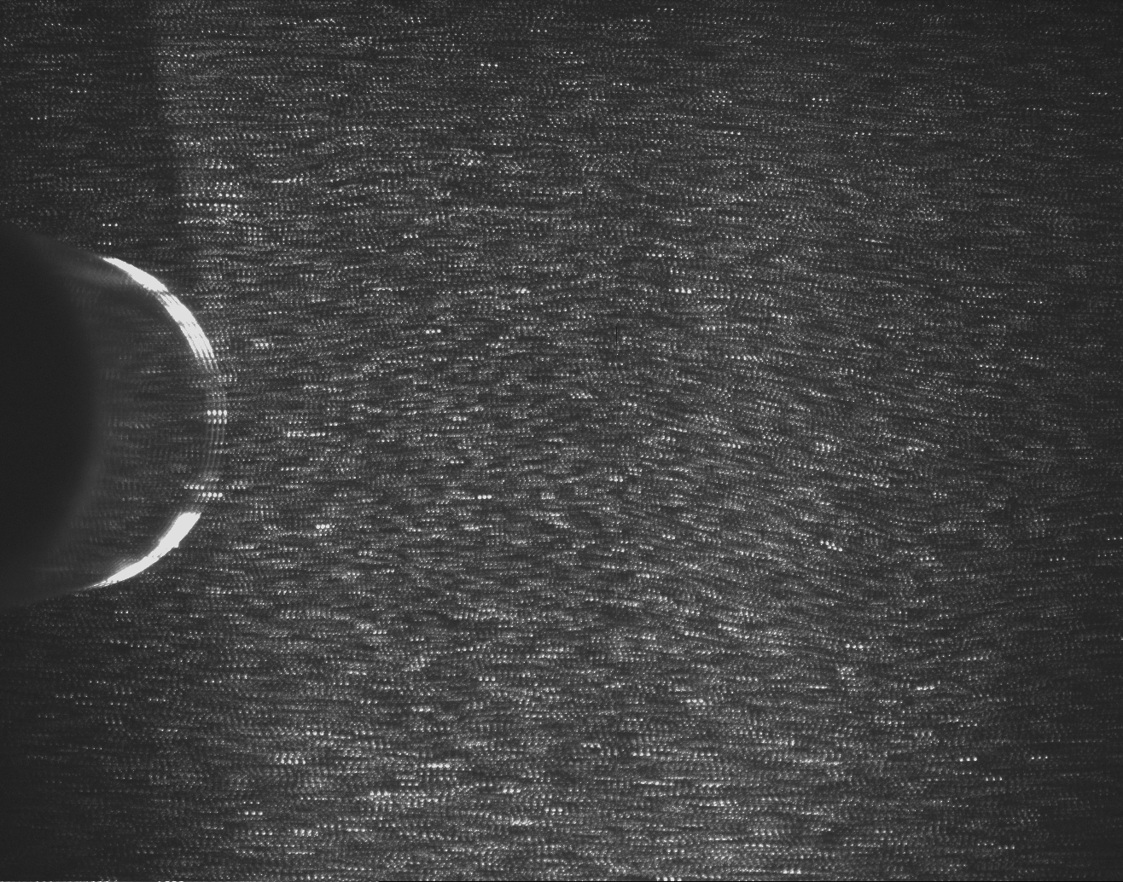  Figure 3 Multiply exposed PIV particle image field of the flow past a circular cylinder  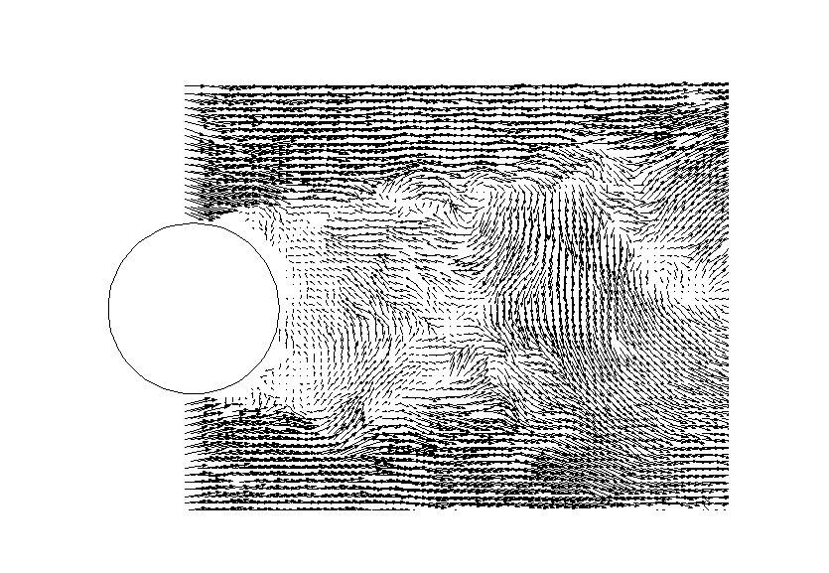  Figure 4. PIV velocity vector field processed using the image pattern in figure 3  CCD Technology  CCD (Charge-couple device) technology has been used commonly for digital video recording for many years. A CCD imager consists of an array of sensing elements, called pixels, connected to a set of Metal-Oxide Semiconductor (MOS) Capacitors. When a CCD sensor receives light, each pixel absorbs photons and generates electric charge to be stored into the MOS capacitor. The sensitivity of a CCD depends on the capacity (potential well) of the amount of charge it can hold. These charges will need to be transferred to attached electrodes and be amplified to convert into digital signal before the pixels can be exposed to another "picture". Full frame transfer is more sensitive since all sensing array is light sensitive. However, it is usually much slower and not suitable for PIV measurement. Interline transfer mode allows the charges to be moved from the MOS capacitors to neighboring masked area which serves as a buffer area between the readout elements and the photosensing elements. Continuous image acquisition at video rate (30 frame/sec) is therefore possible. One added advantage of this mode is that it enables the double exposure mode, which allows two consecutive images to be recorded within a very short time period (in the order of μsec.) This feature is important for the PIV system as being described in the PIV section.  Other Useful Links  - PIV Animation  - PIV Velocity and Vorticity Fields  - CFD Animations  - Tacoma Narrows Bridge Incident
</div>

