Robust Vortex Control of a Delta Wing

Using Distributed MEMS Actuators

Gwo-Bin Lee*, Chiang Shih**, Yu-Chong Tai†, Thomas Tsao†, Chang Liu±, Adam Huang⁺⁺, and Chih-Ming Ho††

*National Cheng Kung University, Tainan, Taiwan, Republic of China
** FAMU-FSU College of Engineering, Tallahassee, FL, USA

†California Institute of Technology, Pasadena, CA, USA
±University of Illinois at Urbana-Champaign, Urbana, IL, USA
††University of California, Los Angeles, CA, USA

Abstract

Micromachined actuators have been used successfully to control leading-edge vortices of a delta wing by manipulating the thin boundary layer before flow separation. In an earlier work³⁸, we have demonstrated that small disturbances generated by these micro actuators can alter large-scale vortex structures, and consequently, generate appreciable aerodynamic moments along all three axes for flight control. In the current study, we explored the possibility of independently controlling these moments. Instead of using a linearly distributed array of micro actuators covering the entire leading edge as done in the previous study, we applied a shorter array of actuators located on either the

*Assistant Professor, National Cheng Kung University, Tainan, Taiwan 701, Republic of China, Member AIAA.
**Associate Professor, FAMU-FSU College of Engineering, Tallahassee, FL, USA
⁺Associate Professor, California Institute of Technology, Pasadena, CA 91125, USA
±Assistant Professor, University of Illinois at Urbana-Champaign, Urbana, IL 61801, USA
††Professor, University of California, Los Angeles, CA 90095, USA, AIAA fellow

forward or the rear half section of the leading edge. Both one- and two-sided control configurations have also been investigated. Data showed that pitching moment could be generated independently by appropriate actuation of micro actuators. In order to understand the interaction between the micro actuators and leading-edge vortices, surface pressure distribution, direct force measurements and flow visualization experiments were conducted. The effects of micro actuators on the vortex structure, especially vortex core location, were investigated. Experimental results showed that asymmetric vortex pairs were formed, which leads to the generation of significant torques in all three axes.

Nomenclature

A-T = Apex to Trailing edge

AOA = angle of attack (α)

c = chord length
C_{m} = pitching moment coefficients
C_{n} = yawing moment coefficients

C_{l} = rolling moment coefficients
C_{p} = pressure coefficient = 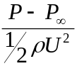
d = characteristic length
H-A-T = Half Apex to Trailing edge
L_{v} = vortex lift
P = surface pressure
P∞ = free-stream pressure
S = half span
U = free-stream velocity
- = density
- = angular position of the actuator array measured from the bottom surface
Re = Reynolds number

Introduction
Flows over delta wings have been studied extensively in the literature¹⁻⁵. Even at small angles of attack, a pair of spiral vortices originating from the leading edges characterize the flow on the leeward side of the wing (Fig. 1). Peckham⁶ reported that leading-edge vortices could be observed at an angle of attack (AOA) as low as 2° for delta wings with sharp leading edges. For wings with rounded leading edges, the vortex pairs occur at higher angles of attack due to delay of flow separation. Earnshaw and Lawford⁷ found that these vortices start to appear at an angle of attack of 5°. The boundary layer flow separating from the leading edges will form a free shear layer, which will roll up into a core of high vorticity residing above the leeward side of the wing. The vortex core grows in radius along the downstream direction and the transverse size of the vortex is on the order of half the wing span at high angles of attack. In addition to the swirl velocity component, each of the two leading-edge vortices contains an axial flow component in the central core region. As the vortex convects downstream, vorticity is continuously fed into the core region, and the circulation about the core increases. Thus, a low-pressure region will be generated by the leading-edge vortices. “Vortex lift”, which is distinguished from potential lift, is created as the result of the presence of this low-pressure region. At high angles of attack, the cores of leading-edge vortices on the wing tend to “ burst ” or “ breakdown”⁸. Before vortex breakdown occurs, a significant portion of the total lift is attributed to the emergence of these leading-edge vortices⁹. It implies that we can generate a torque for flight control if we can break the symmetry of these two vortices.
The majority of vortex control techniques discussed in the literature falls into four categories: (a) blowing¹⁰⁻²³, (b) suction²⁴⁻²⁵, (c) trailing edge jet control²⁶⁻²⁷, (d) large mechanical flaps²⁸⁻³², and (e) heating³³. These approaches achieve vortex control by either altering the vorticity generation near the leading edges or manipulating the vorticity convection along the vortex core. Recently, a new delta wing vortex control strategy using a linearly distributed array of micro actuators has been developed³⁴⁻³⁵. This actuator array covering the entire leading edge from the apex to the trailing edge, called “A-T”(Apex-Trailing edge) actuator, has been shown to be effective in torque generation. It has been shown that if the deflection amplitude of the actuators is comparable to the boundary layer thickness near the leading edge separation point, it is possible to perturb the separated flow and break the symmetry of the primary vortex pair. For this purpose, micro actuators with out-of-plane deflection length on the order of 1-2 mm have been used to control a delta wing. A significant increase in rolling, pitching, and yawing moments has been observed. It has also been found that the optimum angular location of actuators for the maximum torque generation is closely related to leading edge flow separation²⁷. On delta wings with rounded leading edges, the position of flow separation depends not only on the Reynolds number but also on the leading edge curvature that determines the local pressure gradient. Consequently, the leading edge flow separation line usually is not a straight line from the apex to the trailing edge. As a result, a straight array of distributed micro actuators cannot match exactly with the curved separation line to produce the optimum effect. Furthermore, a partially misplaced actuator array can sometimes produce adverse effects to offset the overall control goal. In this paper, different types of distributed micro actuators are employed to investigate potential solutions to this problem. A shorter array of micro actuators which covers only half the length from the apex to trailing edge, called “H-A-T” (Half Apex to Trailing edge) actuator, was used to explore the possibility of providing more robust vortex control. Since the angular position of the H-A-T actuator array can be adjusted to fit more closely to the separation line on the forward (or rear) half part of the leading edge, it is expected to generate higher torques in all three axis. Consequently, fewer actuators will be required for effective flight control and it implies simpler hardware arrangement and less power consumption. When the H-A-T actuators were installed on one of the leading edges, it did destroy the symmetry of the vortex pair and produced higher rolling, pitching and yawing moments. In addition, we also demonstrated a strategy to control the pitching moment independently by applying H-A-T actuators on both sides of the wing. Figure 2 presents schematically all different actuator configurations used in the paper. A detailed discussion of these results will be presented in the results and discussion section. Currently, we are proceeding to employ a large number of actuators for truly distributed control along the curved separation line.
In order to investigate the interaction between the micro actuators and the vortices, a fundamental understanding of the flowfield is essential. In light of this, we conducted a series of aerodynamic tests, including surface pressure, direct force measurements and flow visualization experiments, with and without the flow control. The objective of this work is to investigate how the vortex structure is altered by the use of micro actuators and how an unbalanced vortex pair can be used to generate appreciable torques at high angles of attack.

Experimental Setup and Procedures
A delta wing model with a sweep angle of 56.5° was sting mounted in a 0.9 x 0.9 m² low-speed wind tunnel. The model support rig has a pitch angle range of –5° to 40°, resulting in a 45° range in angle of attack. The wing has a constant thickness of 1.27 cm (approximately 4.23 % of the root chord) with a circular leading-edge profile (Fig. 3). Maximum wind tunnel blockage ratio is about 5 % and no correction of the blockage effect was applied. Seven rows of pressure measuring sections, distributed uniformly between 30 % to 90 % chord locations, were selected to provide upper-surface pressure measurements. Lower-surface pressure distribution was obtained by inverting the wing. At each row of the pressure measuring section, there are 18 pressure taps along the half span, including 3 taps located on the circular surface of the leading edge. Each pressure tap was connected to a commercially-available solid-state gauge pressure sensor (NPC-1210, Lucas NovaSensor) to map out the pressure distribution. Test Reynolds numbers range from 2.1x10⁵ to 8.4x10⁵, based on the wing root chord and the freestream velocities from 10 to 40 m/s.
A robust magnetic MEMS actuator was designed and fabricated for this study³⁶⁻³⁷. The surface-micromachined magnetic actuator (Fig. 3(c)) has two torsional support beams and has been successfully employed in vortex flow control in an earlier study³⁵. The actuator has a flap-type structure with an electroplated magnetic layer, which is supported by silicon-nitride torsional beams. The flap can be activated under the influence of an external magnetic field. Experimental results have demonstrated that the flexural actuator can achieve a vertical displacement of 2 mm (at a deflection angle of 90º) and is robust enough to withstand a high wind loading. In this work, The micro actuators were applied on the leading edge surface of the wing model to control the vortices. Due to the limited supply of micro actuators, we also used miniature mechanical actuators for some wind tunnel tests. Basically, the mechanical actuator has the same deflection length as micro actuators except that the stiffness of the mechanical actuator is larger. The effects caused by using either MEMS actuators or miniature mechanical actuators were found to be comparable.
Normal force and 3-axis moment data were measured using a six-component force/moment transducer (AMTI, Inc.). This transducer system was used to record changes in torques induced by the use of micro actuators. Data were digitized by an analog-to-digital converter and processed by a personal computer (PC).
Qualitative flow behaviors with and without flow control were also observed using laser-sheet flow visualization technique. Special attention was placed on the tracking of the movement of vortex cores under control condition. Figure 4 shows the experimental setup for the flow visualization on the upper side of the wing model. To visualize the flow, a sheet of laser light (2 mm thick) from a pulsed Nd:YAG laser was projected across the wind tunnel to intercept the delta wing at any chosen chordwise location. Smoke particles generated from a stage smoke generator were used to seed the flow. The cross-flow plane of the wing was illuminated to investigate the structure of the vortices. The tests were conducted in the UCLA 0.3 x 0.3 m² low-speed wind tunnel. It is specially designed for the purpose of flow visualization. A 1/2-scaled wing model of the one used in 0.9 x 0.9 m² wind tunnel was used for flow visualization. Instead of using 2 mm actuators in the large wind tunnel, shorter 1 mm MEMS actuators were employed because of the relatively smaller size of the wing model. An image processing system, consisting of a high-resolution CCD video camera, an image interface card and a PC, was used for image acquisition.

Results and Discussion

Baseline Testing
First, tests were conducted without flow control to establish the baseline condition. Figure 5(b) represents the variation of the pressure coefficient, C_{p,} along the spanwise location at different cross sections at an AOA of 25°. For each of the measured profile, the negative pressure distribution reaches a maximum at around 65 % spanwise location. This negative peak value increases toward the wing apex and attains a maximum value of –3.5 at 30 % chord location. This indicates that the leading edge vortex has a well-defined conical structure and the vortex core is located approximately above this spanwise position. Further downstream, the negative peak pressure regions gradually expand and their peak values decrease, signifying the downstream growth of the vortex. However, the negative pressure peak at each chordwise location still remains close to 65 % spanwise location. Although not presented here, similar pressure distributions were also measured at several other angles of attack, ranging from 5° to 35°. By integrating the pressure distributions on both the upper and lower surfaces of a delta wing, one can obtain the total normal force acting on the wing. Note that pressure distributions near the apex were extrapolated from the measured data based on the conical vortex structure assumption. Figure 6(a) shows the results of the integrated pressure force at different angles of attack. The normal force increases with AOA until it reaches a maximum value at an AOA of 30°. When compared with data obtained from the six-component transducer system, it was found that the difference was within 3 % for each case. This confirms the reliability of the aerodynamic loading data obtained by integrating the surface pressure distributions.

A-T Micro Actuators

The previous study³⁴ has shown that rolling and pitching moments could be generated by activating a linearly distributed array of A-T micro actuators at strategic locations. Figures 6(b) & (c) show the increased rolling and pitching moments obtained from integrating the surface pressure field, while A-T actuators were activated at different Reynolds numbers. The rolling and pitching moments obtained from the six-component transducer are also plotted on the same figures for comparison. In order to characterize the effectiveness of the vortex control on the wing's maneuverability, the torques measured either from the six-component transducer or from the surface pressure integration were normalized by a reference torque, which is defined as the estimated magnitude of the torque generated by a single vortex. The procedures used for the normalization of the torque data are described as follows: First, the magnitude of vortex lift (L_{v}) at a specific angle of attack is calculated from theoretical prediction⁹. The theoretical formula has been verified by experimental data for vortical flow before vortex breakdown occurs. Then, the reference torque produced by this vortex is defined by multiplying this vortex lift to a characteristic length (d), which is chosen as the distance from the centerline of the whole wing to the centroid of a half wing (Fig. 3). The reference torque represents the nominal capability of a single leading edge vortex to produce torque on a delta wing and can be used as a standard to measure the relative magnitude of the torque generated by using the actuators. In this paper, all changes of the three-axis torques were normalized by this reference torque for easy comparison.

Data in Fig. 6(b) show that the change of normalized rolling moment as a function of the Reynolds number. About 70 % increase of normalized rolling moment can be achieved for Reynolds numbers higher than 6x10⁵. It is believed that the micro actuators become increasingly more effective because the leading edge boundary layers are thinner at higher Reynolds number cases. For pitching moment generation as shown in Fig. 6(c), the increment of normalized pitching moment also shows slight dependence on Reynolds number. About 30 % increase in pitching moment can be achieved at Reynolds number of 2 x 10⁵. Data from integration of surface pressure field are consistent with those measured using the six-component transducer. The maximum difference between data measured by these two methods is less than 5 % for all cases.
The data from six-component transducers were also converted into moment coefficients as shown in Fig. 7. The pitching, yawing, and rolling moment coefficients are defined, respectively, as
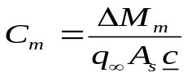 (1)
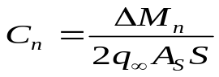 (2)
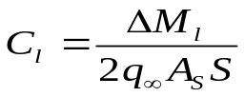 (3)

where ΔM_{m,} ΔM_{n}, and ΔM_{l} are changes in the pitching, yawing, and rolling moments induced by micro actuators. q∞, A_{s,} and c are the dynamic pressure of the free-stream, wing area, and the distance measured between the apex and the centroid of the wing. The maximum pitching and rolling moment coefficients are 0.025 and 0.028, respectively. However, the maximum value of the yawing moment coefficient is measured to be only 0.0043.

H-A-T Micro Actuators

In a previous study³⁵, an A-T actuator array (figure 2(a)), covering the whole leading edge from the apex to the trailing edge, was used to successfully generate torques for flight control. In addition, it had also been shown that two leading edge vortices appeared to act independently when they were under external control. In the present case, a shorter actuator array covering only half of the leading edge, called H-A-T (Half Apex to Trailing edge) actuator (figures 2(b) and 2(c)), was used to explore the possibility of more effective torque generation. Also, two H-A-T actuator arrays (called “two-sided H-A-T actuators”, as shown in figures 2(d) and 2(e)) were placed along each side of the leading edge of the wing in order to control the two leading edge vortices individually, hence increasing the control capability.

Rolling Moment
From a previous study³⁵, it has been shown that the normalized rolling moment can be increased up to a maximum of ±35 % using a linearly distributed array of 2-mm A-T actuators (Fig. 8). The variation of the rolling moment is plotted as a function of the angular position (as defined in figure 3) of the actuator array for different Reynolds numbers. A positive peak is generated when the actuator array is placed between 40° and 50° angle, while a negative peak appears when the actuator is located at 80° angle. In the current study, we concentrated on investigating the use of the H-A-T actuator for more effective torque generation. Initially, a single H-A-T actuator was placed at the forward half of one side of the leading edge at an AOA of 25º (as shown in figure 2(b)). Figures 9-11 show the changes of normalized rolling, pitching, and yawing moments while H-A-T actuators are placed at different angular locations, respectively. Somewhat surprising, the maximum increase of the positive rolling moment (55 % at 60° angle) obtained under this control condition (Fig. 9) was found to be much higher than the increased value (35 %) obtained using the A-T actuator array (Fig. 8). On the other hand, the maximum increase of the negative rolling moment is not as high relative to that generated by using an A-T actuator array (-15 % at 100° angle as compared to –35 %). This might be due to the fact that the separation line is not straight along the leading edge and the vortical flow in different sections responds differently to the local actuator array. In order to examine this possibility, we measured the separation line (from apex to trailing edge of the wing) using distributed micromachined shear-stress sensors³⁴ and the result is shown in Fig. 12. The micromachined shear-stress sensor array is a thermal-type sensor which relates the convective heat loss of an electrically-heated sensor to the local surface shear stress. It has been applied successfully in detecting boundary layer separation³⁴. It is noticed that the optimum angular position of H-A-T actuator where the maximum rolling moment is produced (θ = 60º) is very close to the measured separation line on the forward half of the leading edge. This is reasonable since micro actuators should be most effective while placed close to the separation line where the separating boundary layer is most susceptible to external perturbations. On the other hand, an A-T actuator array that spans the whole length of the leading edge cannot match closely the entire separation line. Consequently, there might be some adverse effects due to this mismatch and the use of a full AT actuator can actually reduce the overall control. Further investigation concerning the effect of the actuator array on the rear half of the wing has also been undertaken by placing a H-A-T actuator at the rear half of the wing as shown in Fig. 2(c). It is found that the rear H-A-T actuator array is not as effective in generating rolling moment as the forward half case (Fig. 13 as compared to Fig. 8). The maximum increase of the rolling moment is only about 30 % or lower and it occurs at an angle of 60°, close to the optimum angle for the forward H-A-T case. It is speculated that the rear H-A-T actuator cannot follow closely the rear half of the separation line because it curves inward toward the upper surface of the wing more as compared to the separation line in the forward section (Fig. 12). Moreover, it takes time for the vorticity of the separated shear layer to roll into a vortex and perturbations generated at the leading edge will only affect the region further downstream of the wing section. Therefore, the vortex control is more effective when the actuator is placed close to the apex of the wing. This is consistent with the fact that most of the vorticity within the leading edge vortex actually originates near the apex of the wing. Another interesting observation is that the rear actuator array does not generate negative rolling moment (figure 13).

Pitching and Yawing Moments
In addition to the rolling moment, pitching and yawing moments can also be induced by manipulating the leading edge vortex pair. The generation of pitching and yawing moments could be explained by the redistribution of surface pressure field caused by micro actuators, which will be discussed in detail in the next section. When a single H-A-T actuator is placed at the forward half of the wing, a maximum peak of 15 % for pitching moment (Fig. 10), and 4 % to –4 % for yawing moment (Fig. 11) can be achieved. For the forward H-A-T actuators, the most effective angular positions for the pitching and the yawing control are different. The optimum angle is θ= 60º for pitching moment and θ = 40º for yawing moment. Furthermore, when comparing the results for the forward and rear H-A-T actuators, the forward H-A-T actuator was found to be more effective for pitching moment control (15 % in Fig. 10 as compared to 5 % in Fig. 14) while the rear H-A-T actuator was more effective for yawing moment control (4 % in Fig. 11 as compared to 7.5 % in Fig. 15).

Two-Sided H-A-T Actuators

In an earlier study, it has been demonstrated that the two leading-edge vortices could be controlled independently³⁴. Taking advantage of this behavior, it is possible to obtain additional rolling moment if we can simultaneously activate two H-A-T actuator arrays located on both sides of the leading edges of the wing. For example, for a wing at an AOA of 25° , we can place one H-A-T actuator array at 60° angle on one leading edge and place the other array at 100° angle on the opposite side of the wing (Fig. 2(d)). As a result, a total amount of 70 % rolling moment increase can be achieved if two H-A-T actuators are activated simultaneously at both leading edges³⁴.
Another major objective of this work is to investigate the possibility to control pitching, rolling and yawing moments independently by micro actuators. As shown in figures 9 to 11, all three moments are produced at the same time when the actuator array is activated only on one side of the leading edge. Based on simple geometric consideration, the rolling moment is produced by the emergence of an asymmetric vortex pair with respect to the wing's centerline. This implies that we can eliminate the rolling moment by activating two symmetrically-located actuator arrays. As shown in figure 16, a maximum of 30 % pitching moment can be generated by this configuration without the production of appreciable rolling (< 2.8 %) and yawing (< 1.5 %) moments. This test suggests that it is possible to provide pitching moment without generating rolling and yawing moments. A similar attempt had been tried to provide maximum yawing moment using the two-sided control configuration as shown in figure 2(e). A yawing moment in the order of 10 % can be generated without inducing significant pitching moment change (< 2 %). However, we could not avoid the generation of notable rolling moments (~20 %) using this configuration (figure 17).

Mechanisms for Torque Generation

The rolling moment can be generated by two possible mechanisms. The first possibility is that the global structure of the leading edge vortex is distorted such that an asymmetrically-distributed vortex pair is generated. On the other hand, it is also possible that the relative strength of the two vortices has been altered by the actuators. Figure 18 shows the surface pressure fields at several cross sections on the left-hand side of the wing with and without actuation control. The distortion of global vortex structure can be observed by surface pressure measurements. The results indicate that if the micro actuator array is placed upstream of the separation point, it can move the peak of surface pressure distributions outboard (figure 18(a)), generating a positive rolling moment mainly due to an increase of the moment arm with respect to the centerline. On the other hand, the activation of micro actuators downstream of the separation point moves the peak of the surface pressure distributions inboard (figure 18(b)), and a negative rolling moment is generated as the moment arm is shortened. From both the integration of the surface pressure field and the direct force measurement data, the normal force of the wing does not show any appreciable change when micro actuators were activated only on one side of the delta wing. This seems to suggest that the overall strength of the vortex system has not been changed drastically under control.

From our measurements, the maximum positive peak rolling moment emerged when the actuator array was placed at an angular position of 60°, while the maximum negative rolling moment took place when the actuator array was located at 100° (Figure 9). It was expected that the most dramatic changes would occur at these angles, therefore, they were chosen to investigate the effects of micro actuators' positions on vortex structures. Figure 19 shows a sequence of three flow visualization pictures corresponding, respectively, to the leading edge vortex without control and with actuator control placed at two different angular positions. All three pictures were taken at the same chordwise location that was 30 % chord downstream of the apex where vortex breakdown has not yet occurred. Figure 19(a) shows the right-sided leading edge vortex with no control, and it clearly reveals that a pair of counter-rotating stationary vortices lies on the leeward side of the wing. One can see the shear layer separating from the leading edge and rolling into a large vortex, the primary vortex. The primary vortex reattaches to the surface but separates again as the attached flow moves outboard. This leads to the emergence of the secondary vortex, as can be clearly seen underneath the separating shear layer. By carefully measuring the location of the vortex core from the picture, it was found that the vortex core was located at about 65 % spanwise location for a wing at an AOA of 25°. This result is consistent with the surface pressure measurements (Fig. 18).
The corresponding vortex structure when an array of forward H-A-T actuators is activated at θ=60° is shown in the following picture (figure 19(b)). It can be clearly seen that the core of the vortex has moved outboard relative to the uncontrolled vortex. This observation is concordant with the result from the surface pressure measurements. It is also evident that the shear layer separates from the leading edge with a steeper angle. It seems that the effect of the micro actuators is to push the shear layer “away” from the surface. Since at this angular position the micro actuators are placed ahead of the original separation point, therefore, the flow is forced to separate earlier due to higher pressure gradient caused by the presence of the micro actuator. Consequently, the separation vortex moves outboard and a positive rolling moment is generated because the vortex pair is unbalanced. Finally, the controlled case appears to have a larger primary vortex and a smaller secondary vortex as compared to the wing without control. From both the direct force and the surface pressure measurements, the strength of the displaced primary vortex does not seem to increase drastically. It is believed that the vortex is simply becoming more diffuse rather than being strengthened.
Figure 19 (c) shows the flow visualization result of the vortex when a H-A-T actuator is activated at θ=100°. Also consistent with the data from surface pressure measurements, the core of the vortex under this mode of actuation control has shifted inboard relative to an uncontrolled vortex. It is also noticed that the shear layer now separates from the leading edge with a smaller angle. It appears that the micro actuators tend to pull the separating shear layer “towards” the wing's surface. One possible mechanism is explained as follows: When the flap actuator extends away from the surface downstream of the original separation point, it actually reduces the effective curvature experienced by the local flow such that the adverse pressure gradient is alleviated. As a result, the flow follows the surface longer and the separation is delayed. It is expected that the boundary layer eventually separates from the surface and reattaches to the extended tip of the actuator array where it experiences a stronger inward flow stream and, consequently, the separated layer is pulled further inward and the resulting vortex also moves inboard. A negative rolling moment is therefore generated. The vortex appears to be smaller but closer to the surface. As a result, the pressure field induced by the vortex does not change significantly (Fig. 18).
In the following, we focus our visual observation on the region near the leading edges of the delta wing where the interaction between the micro actuators and the separated flow is the most critical to ensure an effective flow control. Our objective is to identify the relationship between the leading edge separation pattern and the position of the actuator array.
Figure 20 shows the vortical flow patterns near the leading edge corresponding to the same configurations as shown in figure 19. Our interpretations of the behavior of the vortex under different control conditions are illustrated schematically next to the corresponding flow visualization pictures. Without control, the flow accelerates near the leading edge and separates due to the presence of an adverse pressure gradient further downstream. From this picture (figure 20(a)), the boundary layer flow separates at about 60°. If an array of actuators is employed before the separation line at θ=50°, it is found that the flow separates earlier and the deflection angle of the shear layer after separation is changed (Fig. 20(b)). Due to the presence of the micro actuators, the boundary layer is forced to separate from the tip of the actuator array and the separated shear layer is pushed “away” from the surface. The flow at this location tends to carry the shear layer further outward and, consequently, the deflection angle of the shear layer is larger than the case without any actuation. As a result, the vortex structure is moved outboard as has also been discussed before (Fig. 19(b)). Accordingly, the suction pressure peak associated with the vortex also moved outboard and a positive rolling moment was generated by the unbalanced vortex pair.
On the other hand, when the actuators were placed at θ=100°, downstream of the uncontrolled separation position, a different trend was observed and the results were shown in Fig. 20 (c). The separated boundary layer seems to attach back to the extended tip of the actuator. The effective local curvature near the actuator tip is much smaller than without the flap. Consequently, the outflow tends to turn more sharply toward the surface of the wing so that it carries the shear layer further inward. As a result, the deflection angle of the shear layer becomes smaller and the vortex structure is moved inboard (Fig. 19(c)). This is consistent with the results presented in the previous sections. Consequently, a negative rolling moment is created.

Conclusions

A pair of nearly symmetric vortices separating from the leading edge characterizes the flow over a delta wing. At high angles of attack, these vortices make a significant contribution to the total lift of the wing. Hence, if the symmetry of these vortices can be broken by using micro actuators, it is possible to generate appreciable moments for flight control. A linearly distributed array of MEMS actuators has been applied in a previous study³¹ to generate torques for flight control successfully. In this study, an H-A-T actuator covering only half the length from the apex to the trailing edge was used to explore the possibility of providing robust vortex control. It has been found that a higher rolling moment could be obtained by activating an array of H-A-T micro actuators at an appropriate location, because it could be aligned more closely to the separation line. Two-sided H-A-T actuator arrays have also been tested to increase the control capability. Data showed that pitching moment could be generated independently without rolling and yawing moments by applying symmetric actuation on both sides of the wing. A laser-sheet flow visualization of the delta wing flow field was used to examine the interaction between micro actuators and the cross flow patterns of the separated boundary layer near the leading edge. Special attention has been focused on the identification of the distortion of the vortex structure, particularly the movement of the vortex core, under the influence of the actuation control. It has been found that the shear layer separated with a steeper angle if the actuator array was placed at or before the original separation point, hence, the vortex moved outboard and away from the surface, generating a positive rolling moment. On the other hand, the shear layer separated with a smaller angle if the actuator array was positioned downstream of the original separation point. This type of control forced the vortex to move inboard and closer to the surface, producing a negative rolling moment. These flow visualization observations are consistent with data obtained using surface pressure and direct force measurements.

Acknowledgements
This work is support by the DARPA ETO and managed by AFOSR. The authors would like to thank John Seymour for his assistance in assembling the experimental setup.

References
- Ericsson, L. E. and Reding, J. P., “Approximate Nonlinear Slender Wing Aerodynamics,” Journal of Aircraft, Vol. 14, No. 12, 1977, pp. 1197-1204.
- Payne, F. M., Ng, T. T. and Nelson, R. C., “Visualization and Wake Surveys of Vortical Flow over a Delta Wing,” AIAA Journal, Vol. 26, No. 2, 1988, pp. 137-143.
- Fink, P. T., and Taylor, J., “ Some Early Experiments on Vortex Separation,” Aeronautical Research Council, R & M., No. 3489, 1967.
- Lambourne, N. C. and Bryer, D.W., ” The Bursting of Leading-Edge Vortices-Some Observations and Discussion of the Phenomenon,” Aero. Res. Council, Reports and Memoranda, No. 3282, 1961, pp. 1-37.
- Lee, M. and Ho, C. M., ”Lift force of delta wings,” Applied Mech. Rev, Vol. 43, No. 9, 1990, pp. 209-221.
- Peckham, D. H., “Low-speed Wind-Tunnel Tests on a Series of Uncambered Slender Pointed Wings with Sharp Edges,” Aeronautical Research Council, R. & M. No. 3186, 1958.
- Earnshaw, P. B. and Lawford, J. A., “Low-Speed Wind-Tunnel Experiments on a Series of Sharp Leading-edged Delta Wings,” Aeronautical Research Council, R. & M. No. 3424, 1964.
- Hall, M. G., “Vortex Breakdown,” Annual Review of Fluid Mechanics, Vol. 4, 1972, pp. 195-218.
- Polhamus E. C., “Predictions of Vortex-Lift Characteristics by a Leading-Edge Suction Analogy,” Journal of Aircraft, Vol. 8, No. 4, 1971, pp. 193-199.
- Bradley R. G. and Wray W. O., “A Conceptual Study of Leading-Edge-Vortex Enhancement by Blowing,” Journal Aircraft, Vol.11, No. 1, 1974, pp. 33-38.
- Wood, N. J. and Roberts, L., “The Control of Vortical Lift on Delta Wings by Tangential Leading Edge Blowing,” AIAA paper No. 87-0158, 1987.
- Campbell J. F., “ Augmentation of Vortex Lift by Spanwise Blowing,” Journal of Aircraft, Vol. 13, No. 9, 1976, pp. 727-732.
- Greenwell, D. I., and Wood, N. J., “ Roll Moment Characteristics of Asymmetric Tangential Leading-Edge Blowing on a Delta Wing,” Journal of Aircraft, Vol. 31, No. 1, 1994, pp. 161-168.
- Johari, H., Olinger, D. J., and Fitzpatrick, K. C., “ Delta Wing Vortex Control via Recessed Angled Spanwise Blowing,” Journal of Aircraft, Vol. 32, No. 4, 1995, pp. 804-810.
- Gu, W., Robinson, O., and Rockwell D., “ Control of Vortices on a Delta Wing by Leading-Edge Injection,” AIAA Journal, Vol. 31, No. 7, 1993, pp. 1177-1186.
- Miyaji, K., Fujii, K., and Karashima, K., “ Enhancement of the Leading-Edge Separation Vortices by Trailing-Edge Lateral Blowing,” AIAA Journal, Vol. 34, No. 9, 1996, pp. 1943-1945.
- Meyer, J., and Seginer, A., “ Pulsating Spanwise Blowing on a Fighter Aircraft,” AIAA-92-4359-CP, 1992, pp. 188-197.
- Gad-el-Hak, M., and Blackwelder, R. F.,” Control of the Discrete Vortices from a Delta Wing,” AIAA Journal, Vol. 25, 1987, pp. 1024-1049.
- Celik, Z.Z. and Roberts, L., "Aircraft Control at High-Alpha by Tangential Blowing," AIAA Paper 92-0021, Jan. 1992.
- Greenwell, D. I. and Wood, N. J., "Static Roll Moment Characteristics of Asymmetric Tangential Leading Edge Blowing on a Delta Wing at High Angles of Attack," AIAA 93-0052, Jan. 1993.
- Fitzpatrick, K. Johari, H. and Olinger, D., "A Visual Study of Recessed Angled Spanwise Blowing Method on a Delta Wing," AIAA Paper 93-3246, July 1993.
- Malcom, G. N. and Skow, A. M., "Flow Visualization Study of Vortex Manipulation of Fighter Configurations at High Angles of Attack," AGARD CP-413, 1986.
- Alexander, M. and Meyn, L. A., "Wind Tunnel Results of Pneumatic Forebody Vortex Control Using Rectangular Slots on a Chined Forebody," AIAA Paper 94-1854, June. 1994.
- Hummel, D., “Zur Umstromung sharfkantiger shlanker Deltaflugel bei grossen Anstellwinkeln,” Z. Flugwiss., Vol. 15, No. 10, 1967, pp. 376-385.
- Ross, F. W. and Kegelman, J. T., "Recent Explorations of Leading Edge Vortex Flowfields," NASA CP 3149, Vol. 1, Pt. 1, Oct. 1990, pp. 157-172.
- Shih, C. and Ding. Z., "Trailing-Edge Jet Control of Leading-Edge Vortices of a Delta Wing," AIAA Journal, Vol. 34, No. 7, 1996, pp. 1447-1457.
- Helin, H.E. and Watry, C.W., "Effects of Trailing-Edge Jet Entrainment on Delta Wing Vortices," AIAA Journal, Vol. 32, No. 4, April 1994, pp. 802-804.
- Wahls, R. A., Vess, R. J. and Moskovitz, C. A., “Experimental Investigation of Apex Fence Flaps on Delta Wings,” Journal of Aircraft, Vol. 23, No. 10, 1986, pp. 789-797.
- Marchman, J. F., “Aerodynamics of Inverted Leading-Edge Flaps on Delta Wings,” Journal of Aircraft, Vol. 18, No. 12, 1981, pp.1051-1056
- Rao, D. M. and Buter, T. A., “ Experimental and Computational Studies of a Delta Wing Apex-Flap,” AIAA paper no. 83-1815, 1983..
- Rao, D. M., and Johnson, T. D. Jr., “ Investigation of Delta Wing Leading-Edge Devices,” AIAA Journal, Vol. 18, No. 3, 1981, pp. 161-167.
- Spedding, G. R., Maxworthy, T. and Rignot, E., “ Unsteady Vortex Flows over Delta Wings,” Proc. 2nd AFOSR Workshop on Unsteady and Separated Flows, Colorado, Springs, 1987.
- Marchman J. F., “Effect of heating on Leading Edge Vortices in Subsonic Flow,” Journal of Aircraft, Vol. 12, No. 2, 1975, pp. 121-123.
- Lee, G. B., “Control of a Delta-Wing Aircraft by Using Micromachined Sensors and Actuators,” Ph.D. Thesis, University of California Los Angeles, 1998.
- Lee, G. B., Jiang, F., Tsao, T., Tai, Y. C., and Ho, C. M., "Macro Aerodynamics Devices Controlled by Micro Systems,” IEEE Aerospace Conference, Snowmass, CO, Feb. 1-8, 1997.
- Ho, C. M., and Tai, Y. C. "Micro-electro-mechanical-systems (MEMS) and Fluid Flows," Annual Review of Fluid Mechanics, Vol. 30, pp. 579-612, 1998.
- Liu, C., Tsao, T., Tai, Y. C., and Ho, C. M., 1994, "Surface Micromachined Magnetic Actuators," An Investigation of Micro Structures, Sensors, Actuators, Machines, and Systems (Proc. 7th Ann. Int. Workshop MEMS, Oiso, Japan) IEEE, New York, 1994, pp. 57-62.
- Lee, G. B., Ho, C. M., Jiang, F., Liu, C., Tsao, T., Tai, Y. C., "Distributed Flow Control by MEMS," ASME 1996 International Mechanical Engineering Congress & Exposition, Atlanta, Georgia, USA, Nov. 17-22, 1996.

Fig. 1 Typical vortical flow over a delta wing (with round leading edges) at moderate angles of attack.
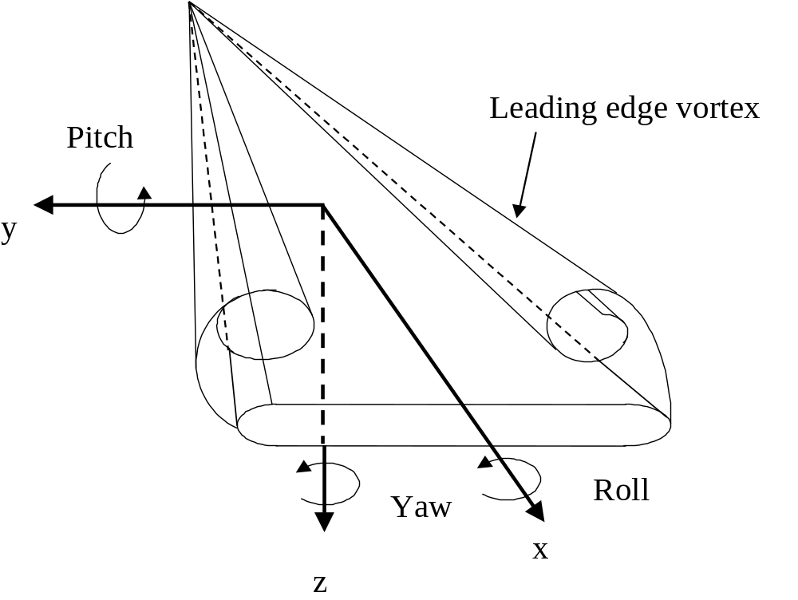

Fig. 2 (a) A-T actuator, (b) forward H-A-T actuator, (c) rear H-A-T actuator, (d) two-sided H-A-T actuators for pitching control, and (e) two-sided H-A-T actuators for yawing control. (Note: actuators are represented by the thicker line segments.)
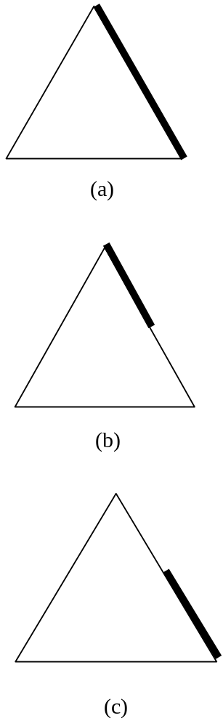

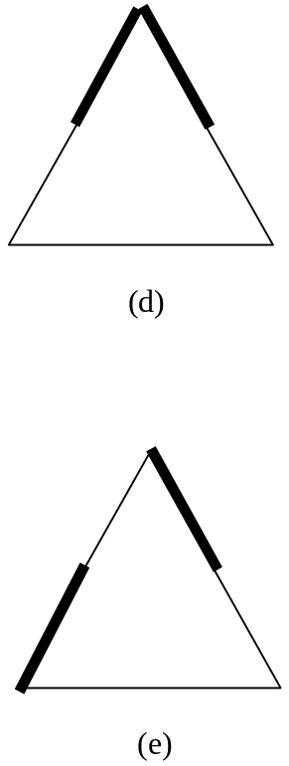

Fig. 3 (a) Delta wing model, and (b) schematic of micro actuators setup on the leading edge, and (c) picture of a surface-micromachined actuator.
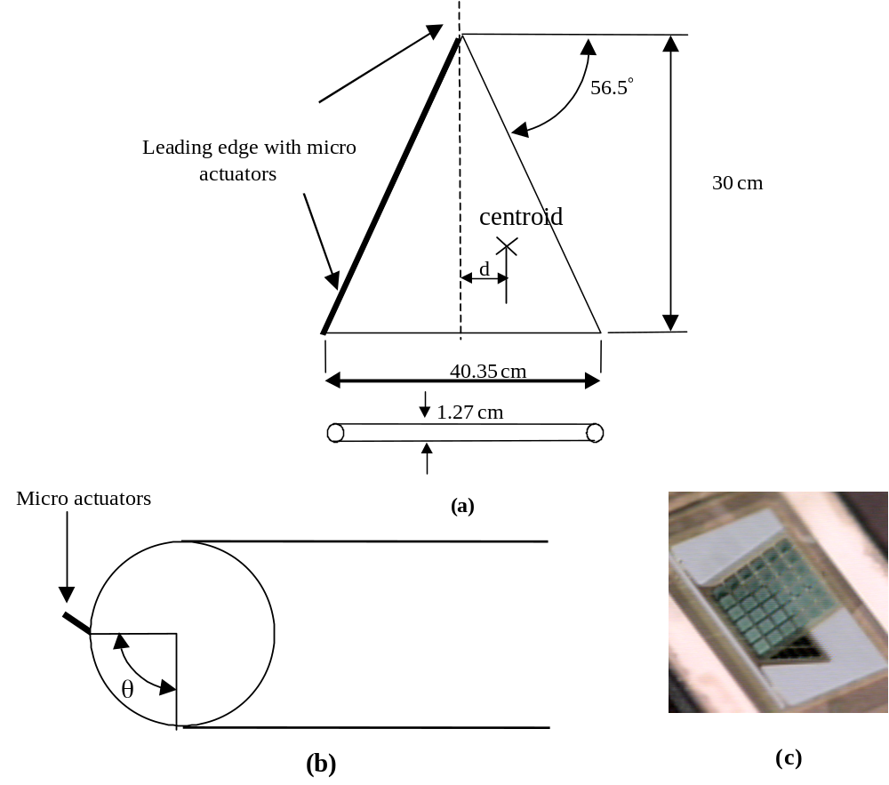
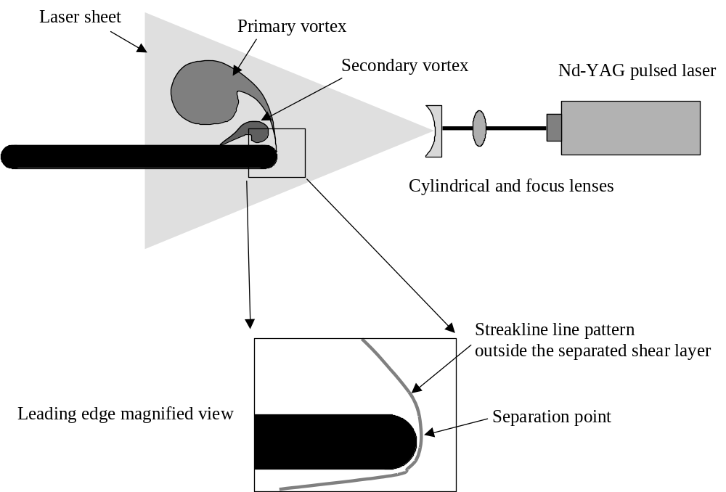
Fig. 4 Experimental setup for flow visualization.

Fig. 5 (a) Schematic setup for surface pressure measurement for a delta wing, (b) Pressure distributions of a delta wing at AOA=25°.
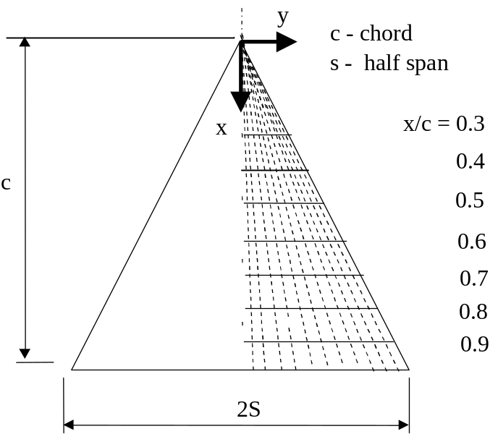

(a)

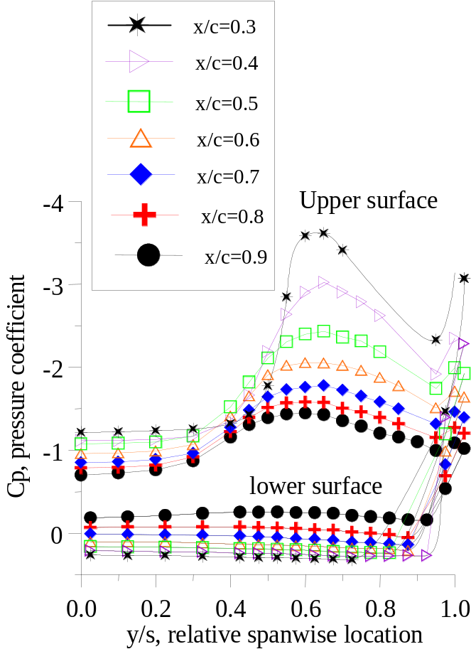

(b)
Fig. 6 Comparison of the normal force from surface pressure measurements and six-component sensor: (a) normal force, (b) rolling moment, and (c) pitching moment.
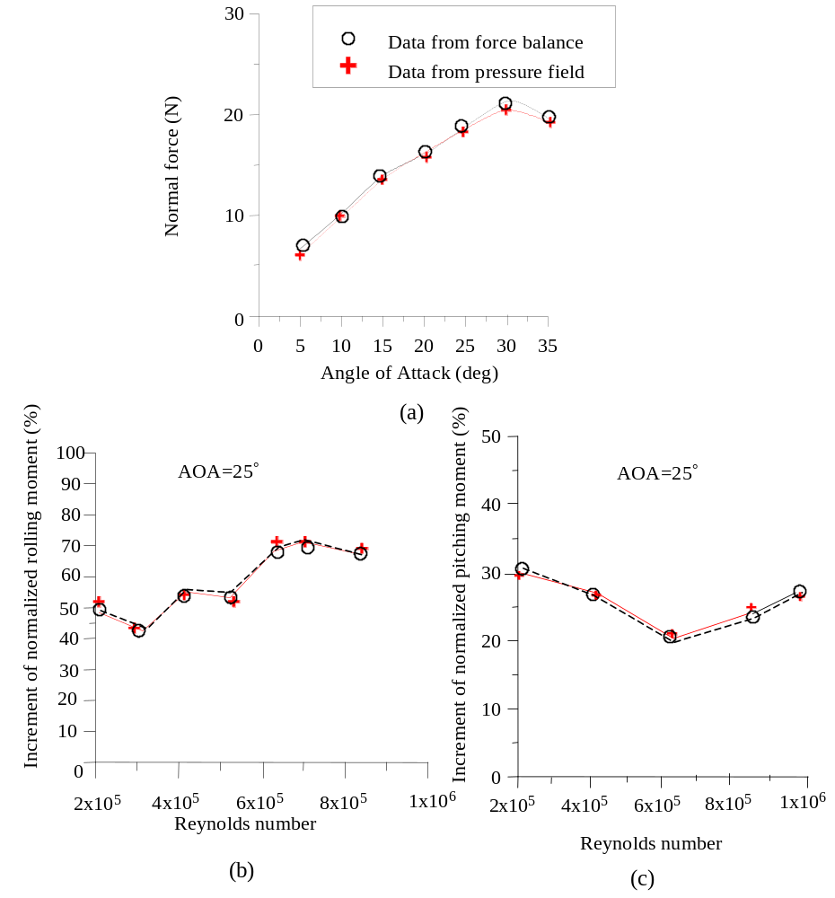
Fig. 7 Maximum rolling, pitching, and yawing moment coefficients at AOA=25°.

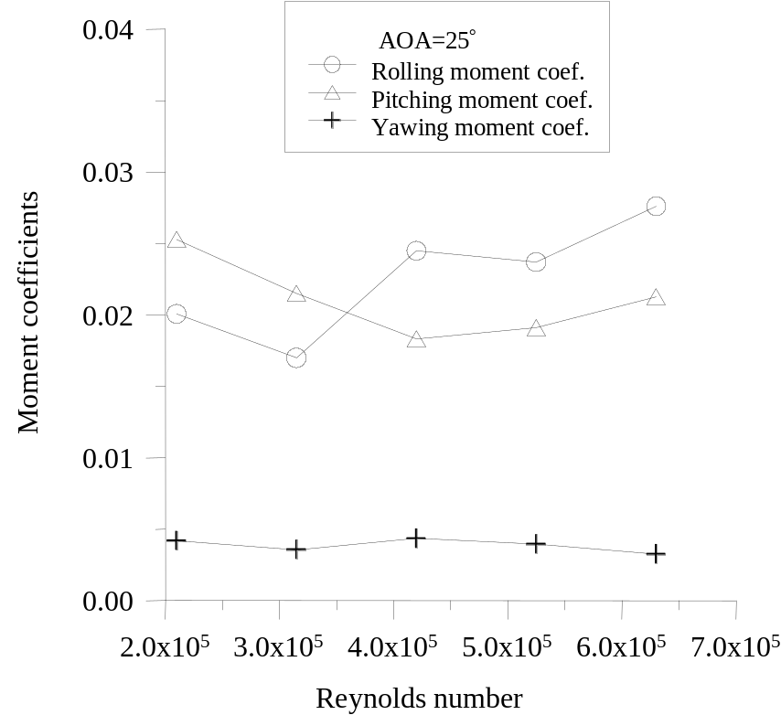
Fig. 8 Normalized rolling moment vs. actuation locations at AOA = 25° for A-T actuator.
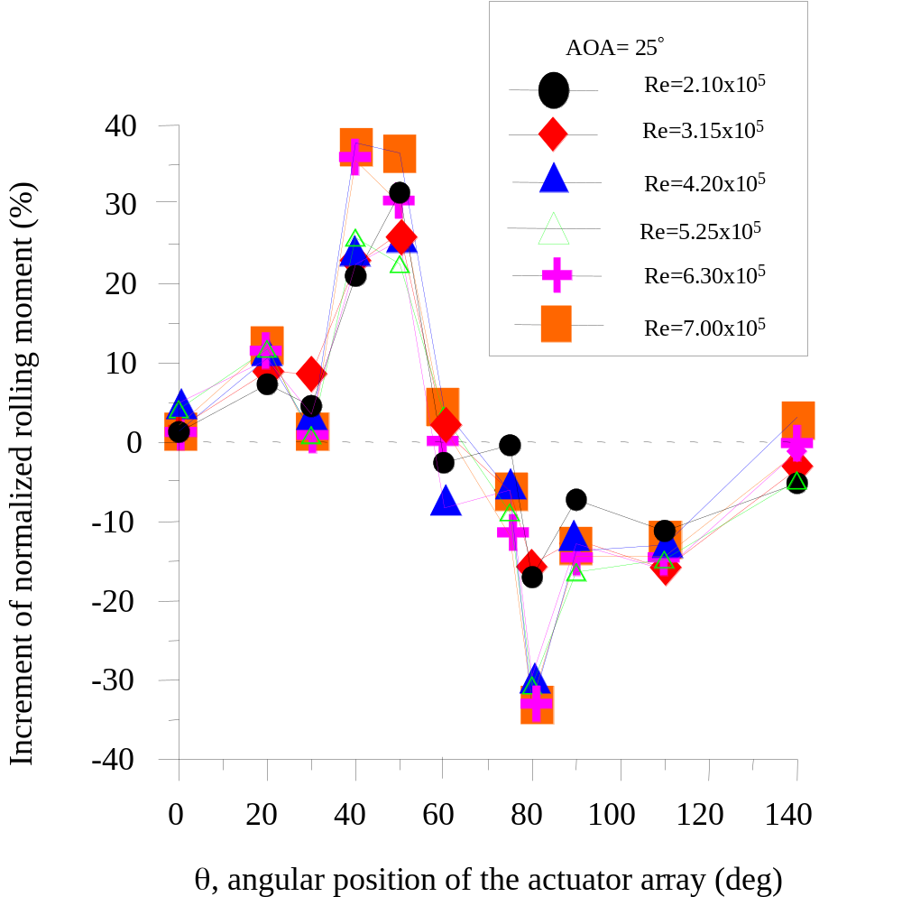

Fig. 9 Normalized rolling moment vs. actuator location at AOA=25º for forward H-A-T actuators.
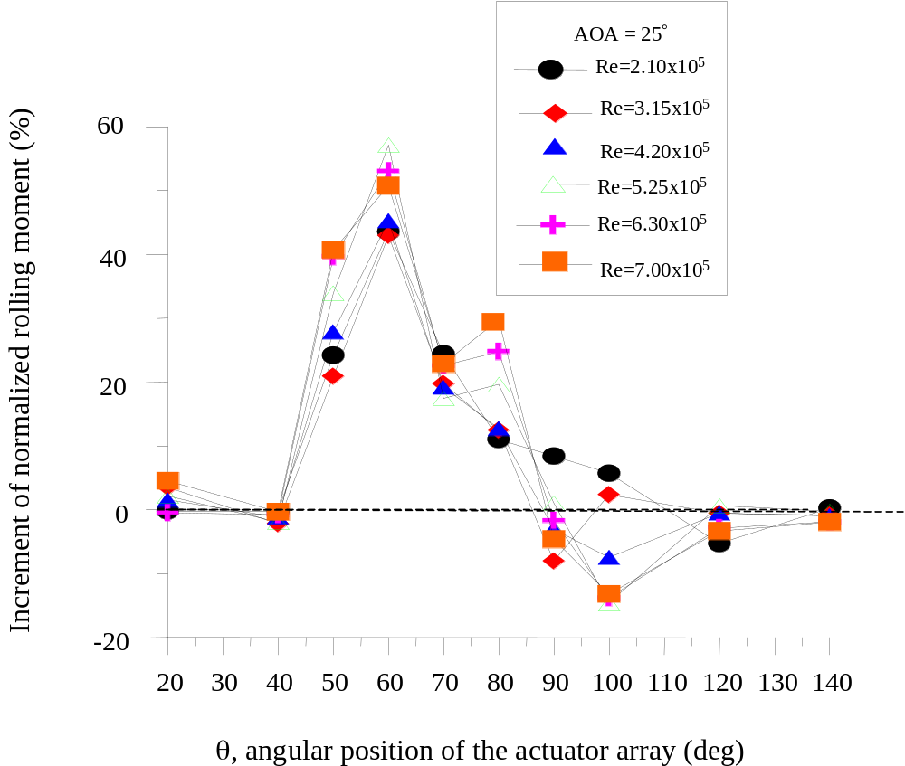

Fig. 10 Normalized pitching moment vs. actuator location at AOA=25º for forward H-A-T actuators.
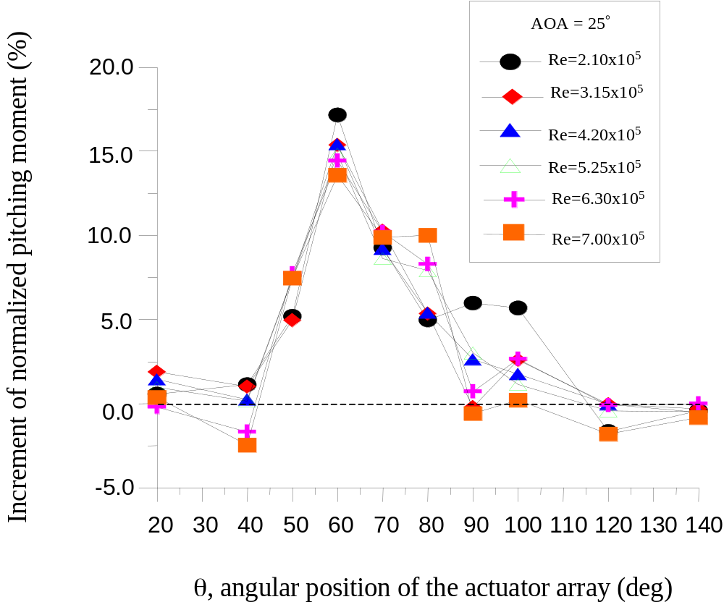

Fig. 11 Normalized yawing moment vs. actuator location at AOA=25º for forward H-A-T actuators.
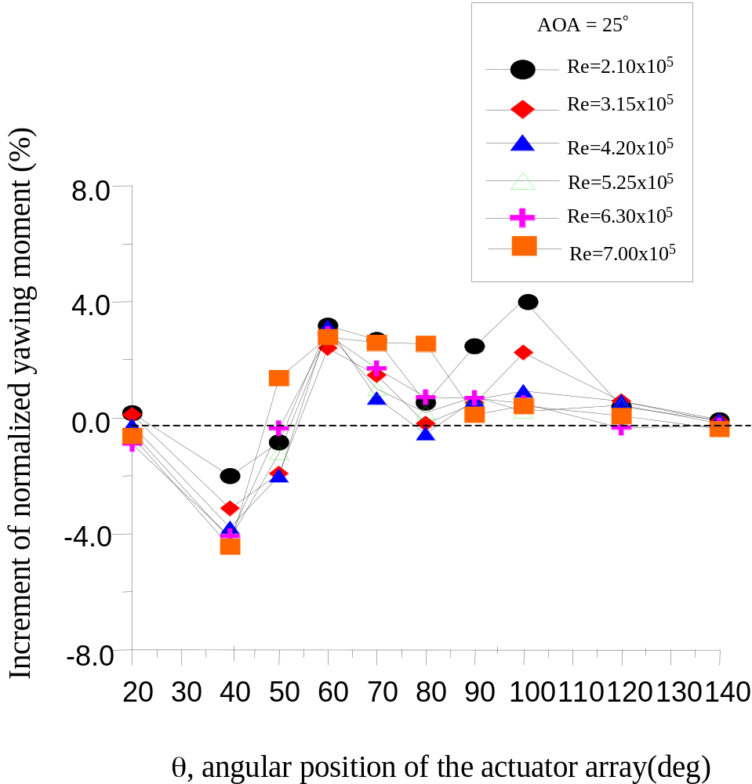

Fig. 12 Boundary layer separation line along the wing’s leading edge determined using distributed shear-stress sensors at AOA=25° (Re=6x10⁵ ). The contour lines indicate constant value of shear stress and the thicker line represents the location where flow starts to separate.
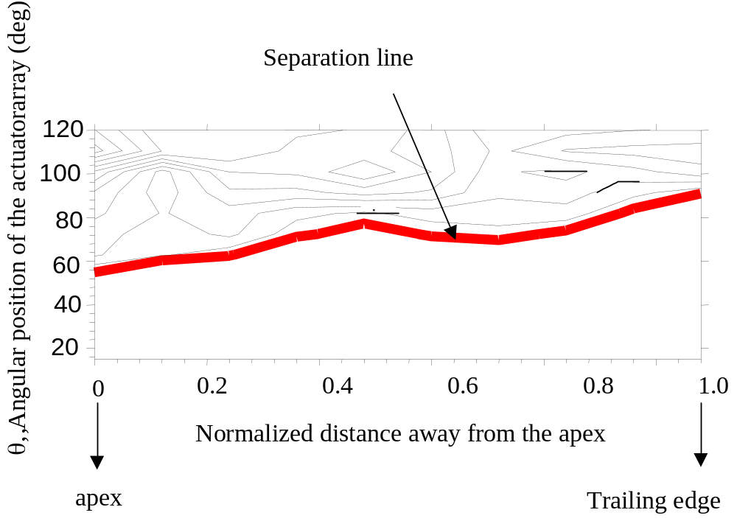
Fig. 13 Normalized rolling moment vs. actuator location at AOA=25º for rear H-A-T actuators

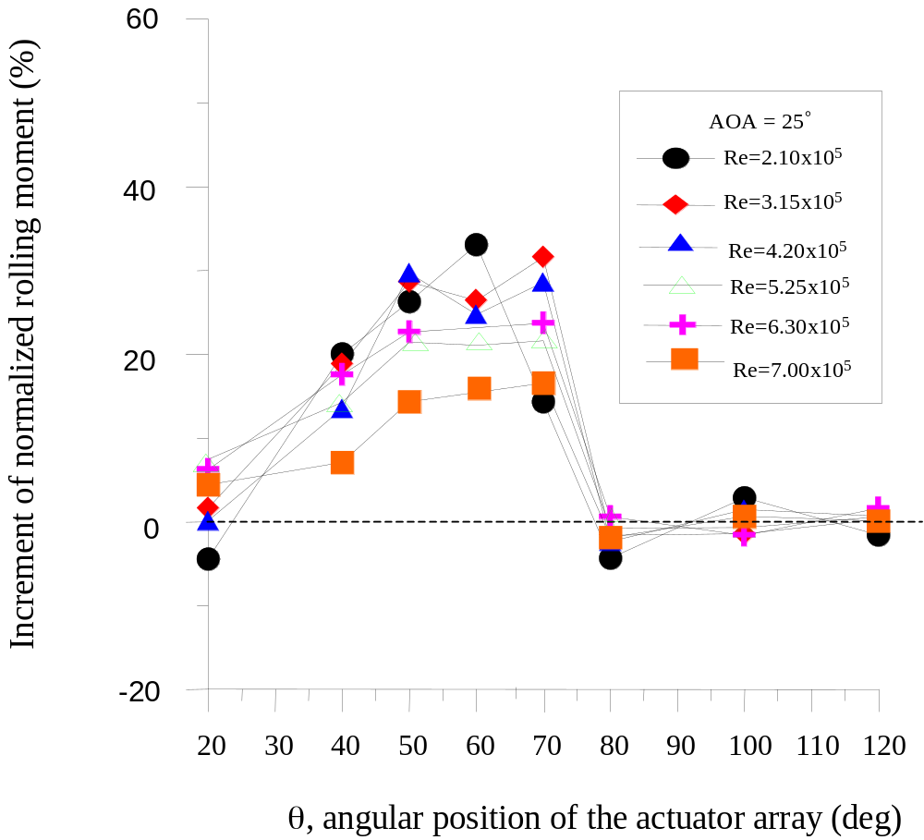

Fig. 14 Normalized pitching moment vs. actuator location at AOA=25º for rear H-A-T actuators.
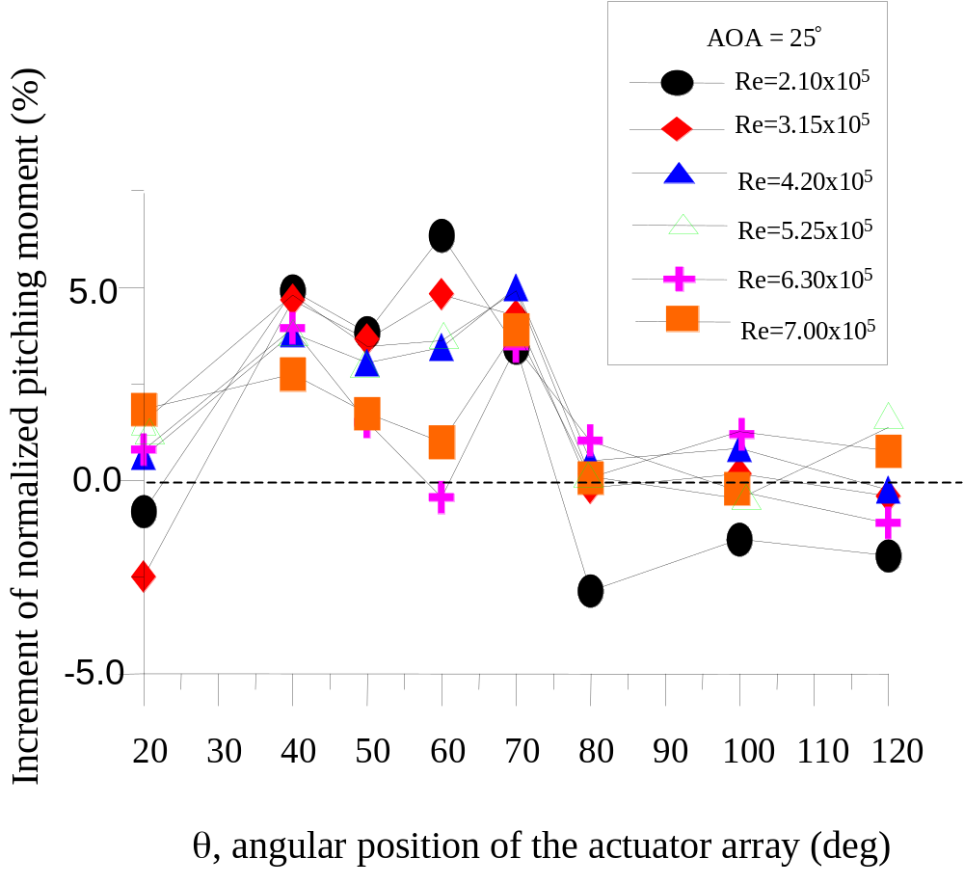

Fig. 15 Normalized yawing moment vs. actuator location at AOA=25º for rear H-A-T actuators.
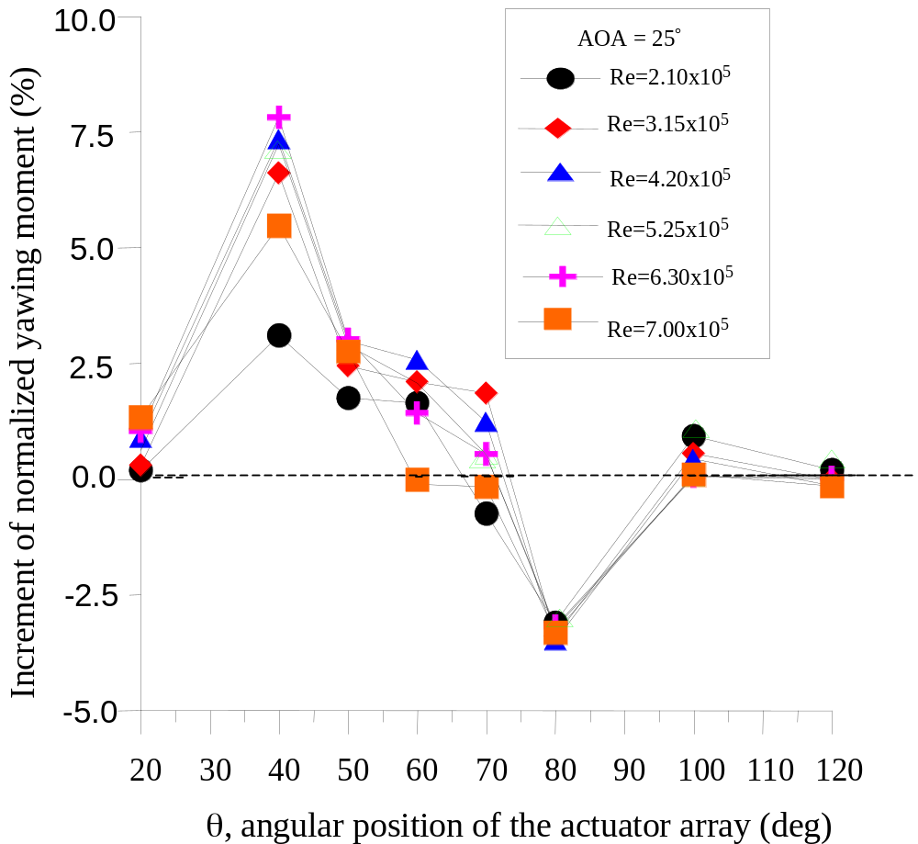

Fig. 16 Normalized pitching moment vs. Reynolds number at AOA=25º. Actuators are located at θ=60°.
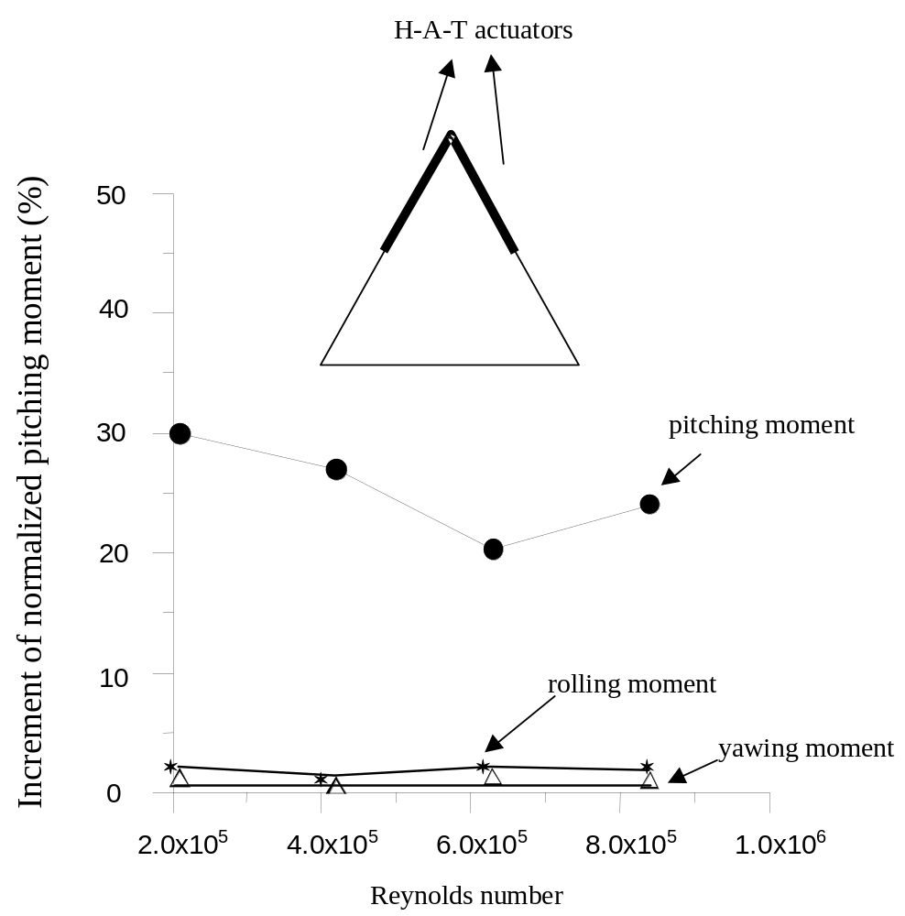

Fig. 17 Normalized yawing moment vs. Reynolds number at AOA=25º , two-sided H-A-T actuators.
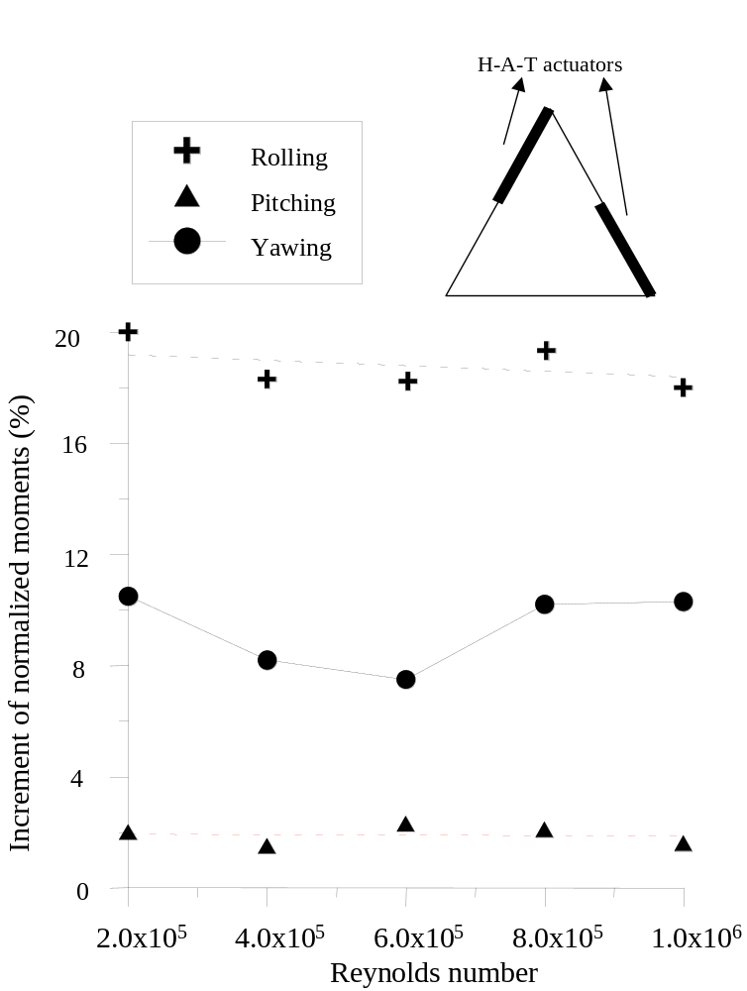
Fig. 18 Surface pressure distribution on the upper side of the wing for (a) actuators before separation line, and (b) actuators downstream separation line.
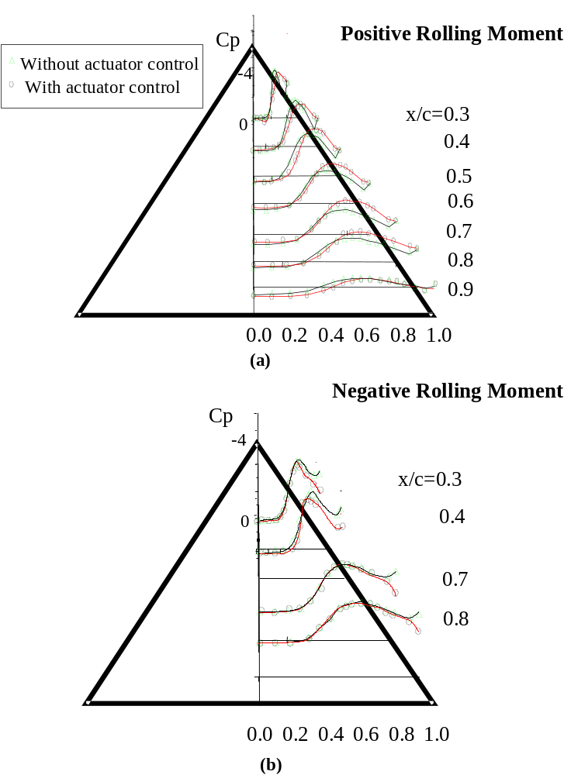
Fig. 19 (a) Vortical structure without micro actuators, (b) with actuators at θ=50°,and (c) at θ=100° .
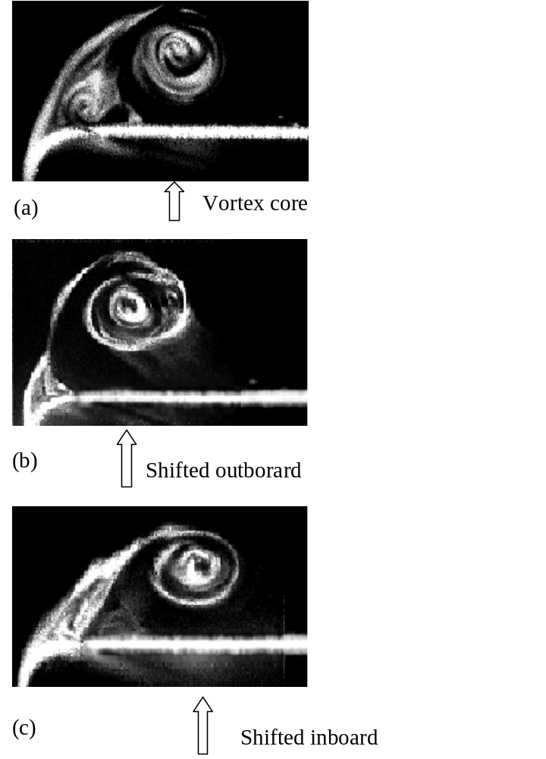

Fig. 20 Streakline flow pattern near the leading edge (a) without any actuator, (b) actuators before the original separation line and (c) actuators downstream the original separation line. Dotted lines indicate the original streamlines, while the solid lines represent separating streamlines under control.
(a)
(b)
(c)
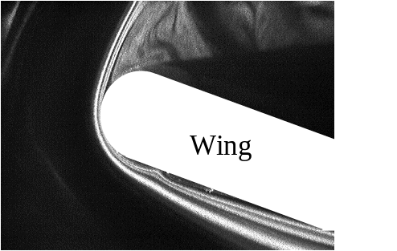
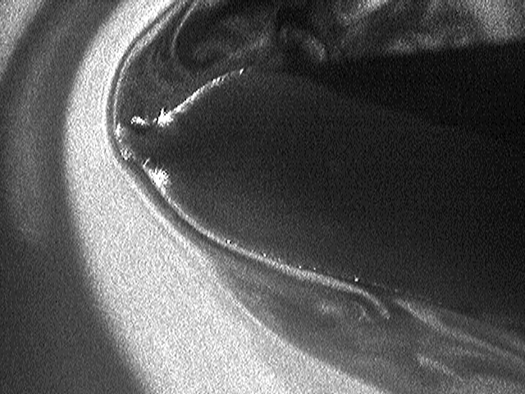
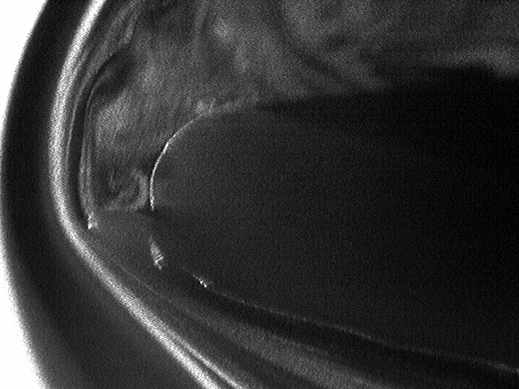
Wing
Wing

