http://history.msfc.nasa.gov/special/rtfor95.html
Note: The following article originally appeared in "Technology for the Stars: Extending our Reach," the Marshall Space Flight Center 1995 Annual Research and Technology Report.
MSFC Propulsion Center of Excellence is Built on Solid Foundation
Mike Wright
Marshall Space Flight Center Historian
MSFC's propulsion expertise continued in 1995, as the launch of STS-70 in 1995 marked the first flight of an upgraded version of the space shuttle main engine. Managed by MSFC, the new Block 1 engine featured such improvements as a new liquid-oxidizer turbopump built by Pratt & Whitney. Many of the turbopump parts were produced through a casting process designed to eliminate all but six of the more than 300 welds that had existed in the previously used turbopump. "The engine performed just as expected," said Otto Goetz, deputy manager of the Space Shuttle Main Engine Project. <1>
The successful flight of the new engine was in keeping with MSFC's historic role as NASA's primary propulsion development center. 1995 marked MSFC's 35th anniversary, but the roots of its propulsion expertise run to the latter half of the 1940's and to the New Mexico desert. There, members of a German V-2 rocket team, originally assembled by Wernher von Braun in Germany, reassembled to work on missile and rocket developments under contract to the U.S. Army. In 1950, the Army transferred the Von Braun team to Huntsville and expanded its membership. Throughout the 1950's, engineers and scientists on Redstone Arsenal made new strides in rocket and missile development for the Army. On September 8, 1960, President Eisenhower came to Huntsville to dedicate the new George C. Marshall Space Flight Center, where hundreds of those same engineers and scientists who had worked for the Army formed the nucleus of the new NASA center.
The V-2 Rocket Motor
The V-2 rocket motor has been called "the immediate ancestor of many of the American rockets to follow." <2> The 46-foot V-2 rocket could carry a 1,650-pound warhead 225 miles. During World War II, an estimated 1,115 V-2 rockets were successfully fired against England and 1,675 against continental targets.<3> After World War II, more than 100 V-2 missiles were launched at White Sands, where they provided invaluable data in the beginning of America's missile program.
The engine for the V-2 used a 5,000-revolutions-per- minute turbine to develop 504 kilowatts (675 horsepower). The rocket produced a thrust of 59,500 pounds at sea level and 70,000 pounds at altitudes above 25 miles. According to rocket and space historian Willy Ley, the fuel for the V-2 "was ordinary ethyl alcohol-in this case made from potatoes-to which enough water had been added to bring its strength down to 75 percent by volume." Liquid oxygen was used as the oxidizer. For the first time a turbopump was incorporated, powered by an 80-percent hydrogen-peroxide steam generator.<4> In the late 1940's and throughout the 1950's, V-2 rocket motor technology directly influenced plans for the development of missiles and rockets in the United States.
Engine Proposals for Hermes C
After World War II, American rocket experts at White Sands were anxious to exploit German V-2 rocket motor technology. For example, they initiated the Hermes program, actually a conglomeration of different projects and proposals. For a while, engineers proposed building a three-stage Hermes C rocket using six rocket motors in clusters of two in its first stage. These motors would be designed to develop a total of 600,000 pounds of thrust during a burning time of 1 minute. After jettisoning the first stage, the second-stage motors would provide an additional 100,000 pounds of thrust during a 1-minute burning time. A winged third stage would have given Hermes C a range of about 2,000 miles. Hermes C, and an even smaller version known as Hermes C-2, turned out to be too ambitious, and the project was scaled back. <5> Nevertheless, Hermes research conducted by General Electric contributed to the advancing state of the art in rocket motor design, especially for the Redstone. "The Hermes C-1 study was handed to our team, and the design and development of the new rocket with a 500-mile range was given a very high priority by the Chief of Ordnance in the fall of 1950," Von Braun said.<6>
Navaho Booster Engines
The development of the propulsion system for Redstone was also directly linked to an Air Force project, i.e., Navaho, which had roots in the V-2 engine. Before the Air Force became convinced that ballistic missiles represented the most effective approach to unmanned strategic long-range weapons, it developed early air-breathing cruise missiles. Even though it used a ramjet engine for sustained flight to the target, the Navaho was boosted into the air by three liquid-propellant rocket engines originally designed with 75,000 pounds of thrust. <7> MSFC engineers Alex McCool and Keith B. Chandler traced the development trends of early liquid-propellant engines and noted that while early V-2 concepts were incorporated in these engines, many new design features and improvements were also brought in for the Navaho. A new thrust-chamber design provided better cooling for the higher heat-transfer rate and an improved single injector replaced 18 separate injectors. <8> Eventually the engine was updated to 135,000 pounds of thrust.
The Redstone NAA 75-110
The Navaho production contract was later canceled, but its research and development effort directly influenced future rocket engines, including the engine for the Redstone. The Navaho XLR43- NA-1 engine, basically a redesigned version of the V-2, came nearer than any other engine did to meeting the special requirements for the Redstone. "We decided to adapt to our purpose the liquid-propulsion system then used in the Navaho test missile-a North American Aviation engine," Von Braun wrote.<9> The Redstone engine was designated " NAA 75-110 " and rated at 75,000 pounds thrust at sea level, with a thrust-burning time of 110 seconds. <10> Improvements in the performance features and components of the engine yielded seven different engine types, A-1 through A-7. The A-7 engine was the power plant for the Mercury-Redstone launch vehicles. Basically, it was the same power plant used in the latest tactical Redstone ballistic missiles with modifications to improve overall efficiency and safety. The engine generated 78,000 pounds of thrust at sea level. <11> In May 1961, a Mercury-Redstone designed by the Von Braun team in Huntsville and managed by the new Marshall Center launched Alan B. Shepard, the first American astronaut, into space.<12>
Jupiter S-3D Engine
On May 31, 1957, an Army Jupiter Intermediate-Range Ballistic Missile was fired to an altitude of 250 to 350 miles and to a range of 1,500 miles, marking the limit of its design capability and the first successful flight of such a missile. <13> The success was tied to Huntsville where members of the Von Braun team at Redstone Arsenal had modified existing engine hardware to meet new requirements. Like the Redstone, the Jupiter missile drew power from a V-2 engine originally adapted for the Navaho. <14> For the Jupiter, however, the engine was scaled up to a thrust of 150,000 pounds. The engine was also designed to operate on liquid oxygen and kerosene (RP-1) instead of the liquid oxygen and ethyl alcohol used in the Redstone, resulting in about a 7-percent gain in propellant performance. The engine also utilized a tubular-wall, regeneratively cooled thrust chamber that provided a major reduction in weight, cost, and fabrication, as compared to previous double-walled chambers. <15> The Rocketdyne Division of North American Aviation supplied the S-3D engine. The Jupiter space flight that probably attracted more public attention than any other came on May 28, 1959, when two primates, Able and Baker, rode in a capsule aboard a nose cone and survived the flight in spite of reentry temperatures of approximately 5,000 °F. <16>
Jupiter C Engine
Other launch vehicles, including the Jupiter C, developed by the Army missile team in Huntsville also received their inheritance from the experience the team had acquired on the V-2, the Hermes, and the Redstone. On August 7, 1957, an Army Jupiter C, developed by the Von Braun team in Huntsville, fired a one-third-scale model nose cone 1,200 miles down range from a Florida launch site. The nose cone reached a summit altitude of 600 miles and was recovered the next day. On November 7, the nose cone was shown on television by President Eisenhower as evidence that the United States had marked another milestone in the missile and space race. <17> Engineers at Redstone Arsenal had solved the reentry heating problem for the Jupiter missile. They had also modified the Redstone and designed it to serve as the first stage for the Jupiter C. Two clustered stages of solid-propellant motors developed by the Jet Propulsion Laboratory in California served as the second and third stages for the vehicle. Changes to the Jupiter C stage included increasing the tankage so that it could hold more fuel and oxidizer, thus extending engine burning time. The engine itself was also modified to burn a more powerful fuel, Hydyne (unsymmetrical dimethylhydrazine and diethylene triamine), boosting the first-stage thrust to 83,000 pounds. <18> On January 31, 1958, the engineers from Huntsville used the Jupiter C to tackle the biggest test of all: they used the Jupiter C rocket to launch Explorer I, the first U.S. satellite, into orbit. <19>
H-1 Engines for Saturn I and Saturn IB
As the United States planned for the decade of the 1960's, its missile and space experts reviewed their existing inventory of launch vehicles. The review demonstrated the clear need to develop a large-scale engine that could be arranged in a cluster in the first stage to launch communications satellites and other scientific payloads, including weather satellites and instrumented probes. <20> The engine would eventually boost the Saturn launch vehicle. The history of the Saturn program began in the Spring of 1957; Wernher von Braun recalled, "Our preliminary designers were studying a large, clustered-engine, first-stage arrangement. In the late summer of 1958, we were authorized to proceed with the design and development of a 1.5-million-pound thrust stage based on this bunching concept." The H-1 engine based on the Jupiter S-3D engine was selected for the new booster that would eventually be known as Saturn I. <21> The S-I stage for the Saturn I became the S-IB first stage for the Saturn IB. The design used Von Braun's clustering concept. This involved using former Redstone and Jupiter tanks, which were lengthened to carry added propellant, while the basic diameter of the 70-inch Redstone and the 105-inch Jupiter tanks were retained. The tank arrangement gave an alternate pattern of the four fuel and four oxidizer tanks, clustered around the 105-inch center oxidizer tank.
Rocketdyne was selected as the contractor to modify the S-3D design for the H-1, which would use liquid oxygen and RP-1. <22> "The H-1 also shed a number of accessories carried over from the Jupiter engine system," wrote Saturn historian Roger Bilstein. "Early versions of the H-1 relied on the Jupiter's lubrication system, which featured a 73-liter (20-gallon) oil tank. The H-1 designers arranged for the vehicle's own fuel, RP-1 (along with some additives), to do the same job. This arrangement eliminated not only the oil tankage, but also a potential source of contamination." <23> Rocketdyne's Edward E. Straub also reviewed the modifications made to the H-1. Two ground start tanks (with complex accessories) for the Jupiter engine were replaced on the H-1 by a simple solid-propellant cartridge starter. In addition, a complex thrust-level control system for the Jupiter engine was modified for the H-1.<24> Initial versions of the Saturn I vehicle, called "Block I," had eight H-1 engines-each producing 165,000 pounds of thrust. H-1 engines were also used in a Block II design that increased thrust to 188,000 pounds each. By the time the tenth and last Saturn I vehicle lifted off on July 30, 1965, the United States had clearly committed itself to President Kennedy's challenge to land a man on the Moon by the end of the decade. The final Saturn I flight climaxed with what MSFC officials termed as a "program which started the U.S. on the road to the Moon with 10 straight successes."<25>
RL-10 Upper-Stage Engines
During the 1960's, many MSFC efforts were directed toward advanced engine technology and higher energy propellants. Fuel-efficiency assessments pointed to liquefied gases as the promising new propellants for advanced missions, and to liquid hydrogen, in particular, for the Saturn upper stages.<26> Liquid hydrogen, however, introduced even more risk and danger into missile and space research. Joel E. Tucker, who has traced the history of Pratt & Whitney's RL-10 upper-stage rocket engine, has noted that the company's key engineers and researchers were introduced to hydrogen-fueled projects in 1956, with a sketch of the Hindenburg's last fateful moments and a report on an explosion of a hydrogen lab. <27> Undaunted, but cautious, industry and government rocket experts were drawn by what Saturn historian Roger Bilstein has called the "lure of liquid hydrogen." Studies showed that "compared to an RP-1- fueled engine of similar size, liquid-hydrogen fuel could increase the specific impulse of an engine by 40 percent," Bilstein noted. <28> The RL-10 engine was rooted in liquid-hydrogen engine research. Pratt & Whitney had explored liquid hydrogen for the Air Force for the super-secret high-altitude reconnaissance aircraft known later as the "SR71 Blackbird." The Air Force was also interested in a liquid-hydrogen engine that would enable it to launch heavier payloads, such as communications satellites. <29> NASA eventually inherited responsibility for the RL-10 engine under development by Pratt & Whitney-and destined for use in the Saturn I upper stages. The first flight of the engine occurred in 1964 after engineers at MSFC and Pratt & Whitney logged hours of engine testing in Huntsville and at other sites. The tests helped score hundreds of innovative design breakthroughs in cryogenic pumps, the thrust chamber, the injector face, and the lubrication system. <30>
J-2 Engines for Saturn IB and Saturn V
The selected configuration for the Saturn I second stage, the S-IV stage, was a cluster of six RL-10 engines, each having 15,000 pounds of thrust. But as NASA looked beyond Saturn I to large launch vehicles for future missions, clustering the RL-10 was not enough. Beginning in 1960, development of the J-2 engine, a single-chamber hydrogen/oxygen engine of 200,000 pounds thrust was underway. <31> By late 1960, the first experimental components for the J-2 were being fabricated and assembled by a research and development team. Like the RL-10, the development of the J-2 engine was dependent on innovation and design simplicity. For example, engineers had to design a system for forming some 600 uniform posts on the face of the J-2 injector, and they had to tackle new problems of insulation, metals embrittlement, and sealing. In addition, engineers had to develop a new method of brazing high-strength stainless-steel tubing to form the J-2's regeneratively cooled thrust chamber. <32> These huge engines, built by Rocketdyne for MSFC, became the powerhouse for Saturn IB and Saturn V upper stages. A single J-2 was used in the Saturn IB second stage and Saturn V third stage. Five J-2 engines were clustered in the Saturn V second stage for a million pounds of thrust.
Saturn V F-1 Engine
The origins of the Saturn launch vehicle concept are rooted in the research conducted within the Army Ballistic Missile Agency in the late 1950's. However, interest in the program moved well beyond the borders of Redstone Arsenal after President Kennedy's challenge in 1961 to land a man on the Moon before the end of the decade. In reality, the Von Braun team had recognized early on that a rocket engine of tremendous capabilities would be needed if man ever embarked on lunar journeys or sent probes into deep space. As a result, development started in the 1950's on the 1.5-million-pound-thrust F-1 engine even before a vehicle was designed for it. The F-1 would burn the familiar liquid oxygen and RP-1, and had roots in the Air Force Navaho program. The F-1 was based on an initial concept for a 360,000-pound-thrust E-1 engine that would burn liquid oxygen and RP-1. <33>
Rocketdyne was selected as the contractor for the F-1, and-for a brief while-NASA considered using the F-1 on a vehicle of tremendous size, the Nova, which would be capable of direct flights to the Moon. The Nova never materialized, but the F- 1 did and would eventually be used in the first stage (S-IC) of the vehicle that would launch men on their way to the Moon. Five F-1 engines would provide a total thrust of 7.5 million pounds in the Saturn V S-IC stage.
Rocketdyne's Bob Biggs has pointed out that although the giant F-1 engine was simple, it was not developed without problems. "Its very 'bigness' created a brand-new territory for technical problems." According to Biggs, the most significant problem was also the one most expected and the most difficult to solve- combustion instability. The engine was designed to the man-rated safety concept, which required that it be dynamically stable. If any engine system was disturbed from any source, the system was required to automatically overcome the disturbance and return to stable operations. <34>
Saturn historian Roger Bilstein has recounted the efforts that Rocketdyne and MSFC engineers used to solve the stiff challenge of combustion instability. "The most bizarre aspect of F-1 testing (like the H-1) involved the use of small bombs to upset the thrust exhaust pattern to measure the engine's ability to recover from disturbance."<35> Biggs has termed the F-1 as "the No-Frills Giant." <36> NASA and Rocketdyne news releases often tried to put the size and power of the engine in perspective by pointing out, for example, that "the fuel pump of the Rocketdyne F-1 pushes fuel with the force of 30 diesel locomotives," or that the five engines generated "double the amount of potential hydroelectric power that would be available at any given moment if all the moving waters of North America were channeled through turbines."<37> Of course, those who watched the launch of Apollo 11 on July 15, 1969, understood the power of the Saturn V vehicle that Wernher von Braun called the "Giant." <38>
Space Shuttle Main Engine
The last Saturn F-1's that NASA employed helped lift Skylab into orbit in 1973. By then, NASA engineers were already deep into the design for the space shuttle main engine, a concept that broke with the past, according to shuttle historian Dennis R. Jenkins. The challenge, Jenkins said, was "not to build a larger, more powerful engine, but to build a small, compact engine that could be throttled during ascent to provide some measure of control over the maximum dynamic pressure and speed of the vehicle." <39> MSFC engineers who have traced the technology projects leading to the development of the space shuttle main engine have pointed to an "aggressive technology program in high-pressure tubomachinery initiated in the 1960's." They point out that much of the work was done by Pratt & Whitney under MSFC's sponsorship, with outgrowth known in-house as the concept for the HG-3, a 350,000-pound-thrust engine named after Hans G. Paul, the long-time chief of the Propulsion Division. In essence, the HG-3 concept eventually became the space shuttle main engine.<40>
The main engines would become the most advanced cryogenic liquid-fueled rocket engines ever built. To get very high performance from an engine compact enough that it could not encumber the orbiter or diminish its desired payload capability, MSFC worked closely with its prime contractor, the Rocketdyne Division of Rockwell International. The greatest problem was to develop the combustion devices and complex turbomachinery-the pumps, turbines, seals, and bearings-that could contain and deliver propellants to the engines at pressures several times greater than in the Saturn engines. The shuttle main engine was also designed as the first propulsion system with a computer mounted directly on the engine to control operation and automatically make corrective adjustments or shut down the engine safely. For improved fuel efficiency, engineers developed an ingenious, staged combustion cycle never before used in rocket engines.<41> Rocketdyne's Bob Biggs has reported on the first 10 years of the shuttle main engine and has traced the technical hurdles and challenges that engineers at Rocketdyne and MSFC faced during the development period. These included predicting the transient behavior of the propellants and engine hardware during start and shutdown. Rocketdyne engineers and officials, such as Rocketdyne Vice President Matt Eck, also sought solutions to concerns with high-pressure fuel turbopump bearing instability problems, explosions, and blade failures. On various occasions during different tests, engineers confronted a fire that started in the engine's main oxidizer valve, a major fracture in the housing for the main fuel valve, the rupture of a nozzle fuel coolant feedline, and a fire that burned through the engine's fuel preburner. Solutions were also sought to heat-exchanger failures, weld cracks in the main combustion chamber, and problems with the main injector posts. A major portion of the problems were answered by conducting ground test after ground test. In fact, a goal of 65,000 seconds of total ground testings was reached during an engine test on March 24, 1980-a little more than a year before the first space shuttle was launched on April 12, 1981. <42>
http://users.commkey.net/Braeunig/space/propuls.htm
It is possible to draw charts and diagrams that trace the origins of MSFC's expertise in liquid-propulsion systems all the way back to the days of the V-2 or the Navaho missile. Unfortunately, charts and diagrams do not adequately convey the thousands of hours engineers at MSFC and its contractor sites have spent year after year, studying, designing, analyzing, testing, and dissecting pumps, bearings, valves, insulation, fuel mixtures, nozzles, feedlines, and thousands of other rocket engine components. Better evidence of that expertise came in 1995 when NASA launched the first flight of the upgraded space shuttle main engine and marked more than 200 main engine flights overall.

Specific heat ratio⁽²⁾ varies depending on the composition and temperature of the exhaust gases, but it is usually about 1.20. The thermodynamics involved in calculating combustion temperatures are quite complicated, however, flame temperatures generally range from about 4,500 to 6,500º F (2,500-3,600º C). Chamber pressures can range from about about 10 to 250 atmospheres. Pe should be equal to the ambient pressure at which the engine will operate, more on this later. Click Here for sample values of adiabatic flame temperature, average molecular weight, and specific heat ratio for some common rocket propellants at various mixture ratios and pressures.
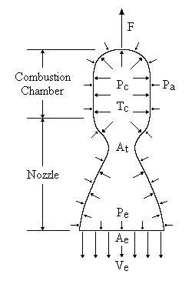

Adiabatic Flame Temperature (T), Molecular Weight (M),
and Specific Heat Ratio (k)

Propellants (reactants) |  | O/F |  | Pressure (atmospheres)
Oxidizer | Fuel | O/F |  | 25 | 50 | 75 | 100
Liquid Oxygen  LO₂ | Liquid Hydrogen  LH₂ | 5.00 | T  M  k | 3220º K  11.7 g/mol  1.21 | 3280º K  11.8 g/mol  1.21 | 3310º K  11.8 g/mol  1.21 | 3330º K  11.8 g/mol  1.21
Liquid Oxygen  LO₂ | Liquid Hydrogen  LH₂ | 6.00 | T  M  k | 3380º K  13.3 g/mol  1.20 | 3470º K  13.4 g/mol  1.20 | 3510º K  13.5 g/mol  1.20 | 3550º K  13.5 g/mol  1.20
Liquid Oxygen  LO₂ | Kerosene  C₁₂H₂₆ | 2.25 | T  M  k | 3400º K  21.2 g/mol  1.22 | 3470º K  21.4 g/mol  1.22 | 3510º K  21.4 g/mol  1.22 | 3540º K  21.5 g/mol  1.22
Liquid Oxygen  LO₂ | Kerosene  C₁₂H₂₆ | 2.60 | T  M  k | 3510º K  22.5 g/mol  1.22 | 3610º K  22.7 g/mol  1.21 | 3660º K  22.9 g/mol  1.21 | 3700º K  22.9 g/mol  1.21
Nitrogen Tetroxide  N₂O₄ | Dimethyl-Hydrazine  (CH₃)₂NNH₃ | 2.10 | T  M  k | 3220º K  21.7 g/mol  1.23 | 3270º K  21.8 g/mol  1.23 | 3300º K  21.8 g/mol  1.23 | 3320º K  21.9 g/mol  1.23
Nitrogen Tetroxide  N₂O₄ | Dimethyl-Hydrazine  (CH₃)₂NNH₃ | 2.60 | T  M  k | 3320º K  23.4 g/mol  1.22 | 3400º K  23.5 g/mol  1.22 | 3440º K  23.6 g/mol  1.22 | 3480º K  23.7 g/mol  1.22
Nitric Acid (RFNA)  HNO₃ | Dimethyl-Hydrazine  (CH₃)₂NNH₃ | 2.70 | T  M  k | 2950º K  22.3 g/mol  1.21 | 2980º K  22.4 g/mol  1.21 | 3000º K  22.4 g/mol  1.21 | 3010º K  22.5 g/mol  1.21
Ammonium Perchlorate  NH₄ClO₄ | Aluminum  + PBAN | 2.40 | T  M  k | 3390º K  25.5 g/mol  1.27 | 3450º K  25.7 g/mol  1.26 | 3490º K  25.8 g/mol  1.26 | 3510º K  25.8 g/mol  1.26

Engines / Nozzles
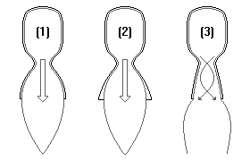
A typical rocket motor consists of the combustion chamber, the nozzle, and the injector, as shown in the figure below. The combustion chamber is where the burning of propellants takes place at high pressure. The chamber must be strong enough to contain the high pressure generated by, and the high temperature resulting from, the combustion process. Because of the high temperature and heat transfer, the chamber and nozzle are usually cooled. The chamber must also be of sufficient length to ensure complete combustion before the gases enter the nozzle.
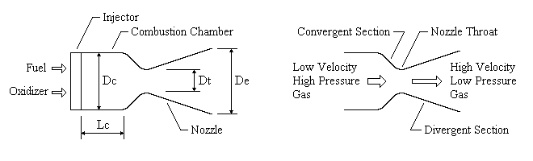
The function of the nozzle is to convert the chemical-thermal energy generated in the combustion chamber into kinetic energy. The nozzle converts the slow moving, high pressure, high temperature gas in the combustion chamber into high velocity gas of lower pressure and temperature. Since thrust is the product of mass and velocity, a very high gas velocity is desirable. Nozzles consist of a convergent and divergent section. The minimum flow area between the convergent and divergent section is called the nozzle throat. The flow area at the end of the divergent section is called the nozzle exit area. The nozzle is usually made long enough (or the exit area is great enough) such that the pressure in the combustion chamber is reduced at the nozzle exit to the pressure existing outside the nozzle. It is under this condition, Pe=Pa where Pe is the pressure at the nozzle exit and Pa is the outside ambient pressure, that thrust is maximum and the nozzle is said to be adapted, also called optimum or correct expansion. When Pe is greater than Pa, the nozzle is under-extended. When the opposite is true, it is over-extended.
We see therefore, a nozzle is designed for the altitude at which it has to operate. At the Earth's surface, at the atmospheric pressure of sea level (14.7 psi or 0.1 MPa), the discharge of the exhaust gases is limited by the separation of the jet from the nozzle wall. In the cosmic vacuum, this physical limitation does not exist. Therefore, there have to be two different types of engines and nozzles, those which propel the first stage of the launch vehicle through the atmosphere, and those which propel subsequent stages or control the orientation of the spacecraft in the vacuum of space.
The figure above-right shows three different exhaust nozzles. The most efficient nozzle (1) is contoured to the exhaust stream, allowing the escaping gas to expand just enough to fill the nozzle. A nozzle that lets the gas expand too much (2), or too little (3), wastes the energy and thrust potential of the exhaust system.
The nozzle throat area, At, can be found if the total propellant flow rate is known and the propellants and operating conditions have been selected. Assuming perfect gas law theory, we have
(2.19) At = (q / Pt) x SQRT[ (R' x Tt) / (M x k) ]
where q is the propellant mass flow rate, Pt is the gas pressure at the nozzle throat, Tt is the gas temperature at the nozzle throat, R' is the universal gas constant, and k is the specific heat ratio. Pt and Tt are given by
(2.20) Pt = Pc x [1 + (k - 1) / 2] ^{-k/(k-1)}

(2.21) Tt = Tc x [1 / (1 + (k - 1) / 2)]
where Pc is the combustion chamber pressure and Tc is the combustion chamber flame temperature.
Click here for example problem #2.7
The hot gases must be expanded in the diverging section of the nozzle to obtain maximum thrust. The pressure of these gases will decrease as energy is used to accelerate the gas. We must find that area of the nozzle where the gas pressure is equal to the outside atmospheric pressure. This area will then be the nozzle exit area.
Mach number Nm is the ratio of the gas velocity to the local speed of sound. The Mach number at the nozzle exit is given by the perfect gas expansion expression
(2.22) Nm² = (2 / (k - 1)) x [(Pc / Pa) ^{(k-1)/k} - 1]
where Pa is the pressure of the ambient atmosphere.
The nozzle exit area, Ae, corresponding to the exit Mach number is given by
(2.23) Ae = (At / Nm) x [(1 + (k - 1) / 2 x Nm²)/((k + 1) / 2)] ^{(k+1)/(2(k-1))}
The section ratio, or expansion ratio, is defined as the area of the exit Ae divided by the area of the throat At.
Solid Fuel Geometry
A solid fuel's geometry determines the area and contours of its exposed surfaces, and thus its burn pattern. There are two main types of solid fuel blocks used in the space industry. These are cylindrical blocks, with combustion at a front, or surface, and cylindrical blocks with internal combustion. In the first case, the front of the flame travels in layers from the nozzle end of the block towards the top of the casing. This so-called end burner produces constant thrust throughout the burn. In the second, more usual case, the combustion surface develops along the length of a central channel. Sometimes the channel has a star shaped, or other, geometry to moderate the growth of this surface.
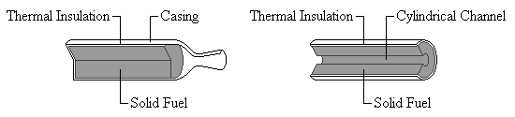
The shape of the fuel block for a rocket is chosen for the particular type of mission it will perform. Since the combustion of the block progresses from its free surface, as this surface grows, geometrical considerations determine whether the thrust increases, decreases or stays constant.
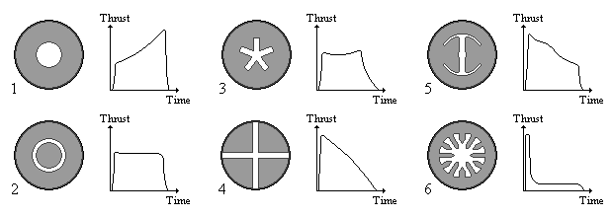
Fuel blocks with a cylindrical channel (1) develop their thrust progressively. Those with a channel and also a central cylinder of fuel (2) produce a relatively constant thrust, which reduces to zero very quickly when the fuel is used up. The five pointed star profile (3) develops a relatively constant thrust which decreases slowly to zero as the last of the fuel is consumed. The 'cruciform' profile (4) produces progressively less thrust. Fuel in a block with a 'double anchor' profile (5) produces a decreasing thrust which drops off quickly near the end of the burn. The 'cog' profile (6) produces a strong inital thrust, followed by an almost constant lower thrust.
COMPOSITION OF SOLID ROCKET PROPELLANTS
Propellant | Type | Composition
Balistite (USA) | Double Base Homogeneous | Nitrocellulose (51.5%), Nitroglycerine (43.0%), Plasticiser (1.0%), Other (4.5%)
Cordite (Soviet) | Double Base Homogeneous | Nitrocellulose (56.5%), Nitroglycerine (28.0%), Plasticiser (4.5%), Other (11.0%)
SRB Propellant | Composite | Aluminum Powder (16%) as fuel, Ammonium Perchlorate (69.93%) as oxidizer, Iron Oxidizer Powder (0.07%) as catalyst, Polybutadiene Acrylic Acid Acrylonitrile (12.04%) as rubber-based binder, Epoxy Curing Agent (1.96%)

Propellant is the chemical mixture burned to produce thrust in rockets and consists of a fuel and an oxidizer. A fuel is a substance which burns when combined with oxygen producing gas for propulsion. An oxidizer is an agent that releases oxygen for combination with a fuel. Propellants are classified according to their state - liquid, solid, or hybrid.
The gauge for rating the efficiency of rocket propellants is specific impulse, stated in seconds. Specific impulse indicates how many pounds (or kilograms) of thrust are obtained by the consumption of one pound (or kilogram) of propellant in one second. Specific impulse is characteristic of the type of propellant, however, its exact value will vary to some extent with the operating conditions and design of the rocket engine.
Liquid Propellants
In a liquid propellant rocket, the fuel and oxidizer are stored in separate tanks, and are fed through a system of pipes, valves, and turbopumps to a combustion chamber where they are combined and burned to produce thrust. Liquid propellant engines are more complex then their solid propellant counterparts, however, they offer several advantages. By controlling the flow of propellant to the combustion chamber, the engine can be throttled, stopped, or restarted.
A good liquid propellant is one with a high specific impulse or, stated another way, one with a high speed of exhaust gas ejection. This implies a high combustion temperature and exhaust gases with small molecular weights. However, there is another important factor which must be taken into consideration: the density of the propellant. Using low density propellants means that larger storage tanks will be required, thus increasing the mass of the launch vehicle. Storage temperature is also important. A propellant with a low storage temperature, i.e. a cryogenic, will require thermal insulation, thus further increasing the mass of the launcher. The toxicity of the propellant is likewise important. Safety hazards exist when handling, transporting, and storing highly toxic compounds. Also, some propellants are very corrosive, however, materials that are resistant to certain propellants have been identified for use in rocket construction.
Liquid propellants used by NASA and in commercial launch vehicles can be classified into three types: petroleum, cryogenics, and hypergolics.
Petroleum fuels are those refined from crude oil and are a mixture of complex hydrocarbons, i.e. organic compounds containing only carbon and hydrogen. The petroleum used as rocket fuel is kerosene, or a type of highly refined kerosene called RP-1 (refined petroleum). It is used in combination with liquid oxygen as the oxidizer.
RP-1 and liquid oxygen are used as the propellant in the first-stage boosters of the Atlas/Centaur and Delta launch vehicles. It also powered the first-stages of the Saturn 1B and Saturn V rockets. RP-1 delivers a specific impulse considerably less than cryogenic fuels.
Cryogenic propellants are liquefied gases stored at very low temperatures, namely liquid hydrogen (LH₂) as the fuel and liquid oxygen (LO₂) as the oxidizer. LH₂ remains liquid at temperatures of -423 degrees F (-253 degrees C) and LO₂ remains in a liquid state at temperatures of -298 degrees F (-183 degrees C).
Because of the low temperatures of cryogenic propellants, they are difficult to store over long periods of time. For this reason, they are less desirable for use in military rockets which must be kept launch ready for months at a time. Also, liquid hydrogen has a very low density (0.59 pounds per gallon) and, therefore, requires a storage volume many times greater than other fuels. Despite these drawbacks, the high efficiency of liquid hydrogen/liquid oxygen makes these problems worth coping with when reaction time and storability are not too critical. Liquid hydrogen delivers a specific impulse about 40% higher than other rocket fuels.
Liquid hydrogen and liquid oxygen are used as the propellant in the high efficiency main engines of the space shuttle. LH₂/LO₂ also powered the upper stages of the Saturn V and Saturn lB rockets as well as the second stage of the Atlas/Centaur launch vehicle, the United States' first LH₂/LO₂ rocket (1962).
Hypergolic propellants are fuels and oxidizers which ignite spontaneously on contact with each other and require no ignition source. The easy start and restart capability of hypergolics make them ideal for spacecraft maneuvering systems. Also, since hypergolics remain liquid at normal temperatures, they do not pose the storage problems of cryogenic propellants. Hypergolics are highly toxic and must be handled with extreme care.
Hypergolic fuels commonly include hydrazine, monomethyl hydrazine (MMH) and unsymmetrical dimethyl hydrazine (UDMH). The oxidizer is typically nitrogen tetroxide (N₂O₄) or nitric acid (HNO₃). UDMH is used in many Russian, European, and Chinese rockets while MMH is used in the orbital maneuvering system (OMS) and reaction control system (RCS) of the Space Shuttle orbiter. The Titan family of launch vehicles and the second stage of the Delta use a fuel called Aerozine 50, a mixture of 50% UDMH and 50% hydrazine.
Hydrazine is also frequently used as a mono-propellant in catalytic decomposition engines . In these engines, a liquid fuel decomposes into hot gas in the presence of a catalyst. The decomposition of hydrazine produces temperatures of about 1700 degrees F and a specific impulse of about 230 or 240 seconds.
Solid Propellants
Solid propellant motors are the simplest of all rocket designs. They consist of a casing, usually steel, filled with a mixture of solid compounds (fuel and oxidizer) which burn at a rapid rate, expelling hot gases from a nozzle to produce thrust. When ignited, a solid propellant burns from the center out towards the sides of the casing. The shape of the center channel determines the rate and pattern of the burn, thus providing a means to control thrust. Unlike liquid propellant engines, solid propellant motors can not be shut down. Once ignited, they will burn until all the propellant is exhausted.
There are two families of solids propellants: homogeneous and composite. Both types are dense, stable at ordinary temperatures, and easily storable.
Homogeneous propellants are either simple base or double base. A simple base propellant consists of a single compound, usually nitrocellulose, which has both an oxidation capacity and a reduction capacity. Double base propellants usually consist of nitrocellulose and nitroglycerine, to which a plasticiser is added. Homogeneous propellants do not usually have specific impulses greater than about 210 seconds under normal conditions. Their main asset is that they do not produce traceable fumes and are, therefore, commonly used in tactical weapons. They are also often used to perform subsidiary functions such as jettisoning spent parts or separating one stage from another.
Modern composite propellants are heterogeneous powders (mixtures) which use a crystallized or finely ground mineral salt as an oxidizer, often ammonium perchlorate, which constitutes between 60% and 90% of the mass of the propellant. The fuel itself is aluminum. The propellant is held together by a polymeric binder, usually polyurethane or polybutadienes. Additional compounds are sometimes included, such as a catalyst to help increase the burning rate, or other agents to make the powder easier to manufacture. The final product is rubberlike substance with the consistency of a hard rubber eraser.
Solid propellant motors have a variety of uses. Small solids often power the final stage of a launch vehicle, or attach to payloads to boost them to higher orbits. Medium solids such as the Payload Assist Module (PAM) and the Inertial Upper Stage (IUS) provide the added boost to place satellites into geosynchronous orbit or on planetary trajectories.
The Titan, Delta, and Space Shuttle launch vehicles use strap-on solid propellant rockets to provide added thrust at liftoff. The Space Shuttle uses the largest solid rocket motors ever built and flown. Each booster contains 1,100,000 pounds (499,000 kg) of propellant and can produce up to 3,300,000 pounds (14,680,000 Newtons) of thrust.
Hybrid Propellants
Hybrid propellant engines represent an intermediate group between solid and liquid propellant engines. One of the substances is solid, usually the fuel, while the other, usually the oxidizer, is liquid. The liquid is injected into the solid, whose fuel reservoir also serves as the combustion chamber. The main advantage of such engines is that they have high performance, similar to that of solid propellants, but the combustion can be moderated, stopped, or even restarted. It is difficult to make use of this concept for vary large thrusts, and thus, hybrid propellant engines are rarely built.
Rocket Propulsion - Supplement #1
Rocket Nozzle Design: Optimizing Expansion for Maximum Thrust
A rocket engine is a device in which propellants are burned in a combustion chamber and the resulting high pressure gases are expanded through a specially shaped nozzle to produce thrust. The function of the nozzle is to convert the chemical-thermal energy generated in the combustion chamber into kinetic energy. The nozzle converts the slow moving, high pressure, high temperature gas in the combustion chamber into high velocity gas of lower pressure and temperature. Gas velocities from 2 to 4.5 kilometers per second can be obtained in rocket nozzles. The nozzles which perform this feat are called DeLaval nozzles (after the inventor) and consist of a convergent and divergent section. The minimum flow area between the convergent and divergent section is called the nozzle throat. The flow area at the end of the divergent section is called the nozzle exit area.
Hot exhaust gases expand in the diverging section of the nozzle. The pressure of these gases will decrease as energy is used to accelerate the gas to high velocity. The nozzle is usually made long enough (or the exit area great enough) such that the pressure in the combustion chamber is reduced at the nozzle exit to the pressure existing outside the nozzle. It is under this condition that thrust is maximum and the nozzle is said to be adapted, also called optimum or correct expansion. To understand this we must examine the basic thrust equation:
F = q x Ve + (Pe - Pa) x Ae

where F = Thrust
q = Propellant mass flow rate
Ve = Velocity of exhaust gases
Pe = Pressure at nozzle exit
Pa = Ambient pressure
Ae = Area of nozzle exit
The product qVe is called the momentum, or velocity, thrust and the product (Pe-Pa)Ae is called the pressure thrust. As we have seen, Ve and Pe are inversely proportional, that is, as one increases the other decreases. If a nozzle is under-extended we have Pe>Pa and Ve is small. For an over-extended nozzle we have Pe<Pa and Ve is large. Thus, momentum thrust and pressure thrust are inversely proportional and, as we shall see, maximum thrust occurs when Pe=Pa.
Let us now consider an example. Assume we have a rocket engine equipped with an extendible nozzle. The engine is test fired in an environment with a constant ambient pressure. During the burn, the nozzle is extended from its fully retracted position to its fully extended position. At some point between fully retracted and fully extended Pe=Pa (see figure below).
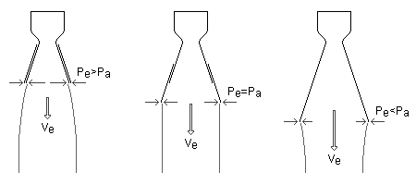
As we extend the nozzle, the momentum thrust increases as Ve increases. At the same time the pressure thrust decreases as Pe decreases. The increase in momentum thrust is greater than the decrease in pressure thrust, thus the total thrust of the engine increases as we approach the condition Pe=Pa. As we continue to extend to nozzle the situation changes slightly. Now the pressure thrust changes in magnitude more rapidly than the momentum thrust, thus the total thrust begins to decrease.
Let's now apply some numbers to our example and run through the calculations to prove that this is true. Assume our rocket engine operates under the following conditions:
q = Propellant mass flow rate = 100 kg/s
k = Specific heat ratio = 1.20
M = Exhaust gas molecular weight = 24
Tc = Combustion chamber temperature = 3600º K
Pc = Combustion chamber pressure = 5 MPa
Pa = Ambient pressure = 0.05 MPa
If the nozzle is properly adapted to the operating conditions we have Pe=Pa, or Pe=0.05 MPa.
The gas pressure and temperature at the nozzle throat is less than in the combustion chamber due to the loss of thermal energy in accelerating the gas to the local speed of sound at the throat. Therefore, we calculate the pressure and temperature at the nozzle throat,
Pt = Pc x [1 + (k - 1) / 2]^{-k/(k-1)}
Pt = 5 x [1 + (1.20 - 1) / 2]^{-1.20/(1.20-1)}
Pt = 2.82 MPa = 2.82x10⁶ N/m²

Tt = Tc x [1 / (1 + (k - 1) / 2)]
Tt = 3,600 x [1 / (1 + (1.20 - 1) / 2)]
Tt = 3,273º K
The area at the nozzle throat is given by
At = (q / Pt) x SQRT[ (R' x Tt) / (M x k) ]
At = (100 / 2.82x10⁶) x SQRT[ (8,314 x 3,273) / (24 x 1.20) ]
At = 0.0345 m²
The hot gases must now be expanded in the diverging section of the nozzle to obtain maximum thrust. The Mach number at the nozzle exit is given by
Nm² = (2 / (k - 1)) x [(Pc / Pa)^{(k-1)/k} - 1]
Nm² = (2 / (1.20 - 1)) x [(5 / 0.05)^{(1.20-1)/1.20} - 1]
Nm² = 11.54
Nm = (11.54)^{1/2} = 3.40
The nozzle exit area corresponding to the exit Mach number is given by
Ae = (At / Nm) x [(1 + (k - 1) / 2 x Nm²)/((k + 1) / 2)]^{(k+1)/(2(k-1))}
Ae = (0.0345 / 3.40) x [(1 + (1.20 - 1) / 2 x 11.54)/((1.20 + 1) / 2)]^{(1.20+1)/(2(1.20-1))}
Ae = 0.409 m²
The velocity of the exhaust gases at the nozzle exit is given by
Ve = SQRT[ (2 x k / (k - 1)) x (R' x Tc / M) x (1 - (Pe / Pc)^{(k-1)/k}) ]
Ve = SQRT[ (2 x 1.20 / (1.20 - 1)) x (8,314 x 3,600 / 24) x (1 - (0.05 / 5)^{(1.20-1)/1.20}) ]
Ve = 2,832 m/s
Finally, we calculate the thrust,
F = q x Ve + (Pe - Pa) x Ae
F = 100 x 2,832 + (0.05x10⁶ - 0.05x10⁶) x 0.409
F = 283,200 N

Let's now consider what happens when the nozzle is under-extended, that is Pe>Pa. If we assume Pe=Pa x 2, we have
Pe = 0.05 x 2 = 0.10 MPa

At = 0.0345 m²

Nm² = (2 / (1.20 - 1)) x [(5 / 0.10)^{(1.20-1)/1.20} - 1]
Nm² = 9.19
Nm = (9.19)^{1/2} = 3.03

Ae = (0.0345 / 3.03) x [(1 + (1.20 - 1) / 2 x 9.19)/((1.20 + 1) / 2)]^{(1.20+1)/(2(1.20-1))}
Ae = 0.243 m²

Ve = SQRT[ (2 x 1.20 / (1.20 - 1)) x (8,314 x 3,600 / 24) x (1 - (0.10 / 5)^{(1.20-1)/1.20}) ]
Ve = 2,677 m/s

F = 100 x 2,677 + (0.10x10⁶ - 0.05x10⁶) x 0.243
F = 279,850 N

Now we consider the over-extended condition, that is Pe<Pa. If we assume Pe=Pa / 2, we have
Pe = 0.05 / 2 = 0.025 MPa

At = 0.0345 m²

Nm² = (2 / (1.20 - 1)) x [(5 / 0.025)^{(1.20-1)/1.20} - 1]
Nm² = 14.18
Nm = (14.18)^{1/2} = 3.77

Ae = (0.0345 / 3.77) x [(1 + (1.20 - 1) / 2 x 14.18)/((1.20 + 1) / 2)]^{(1.20+1)/(2(1.20-1))}
Ae = 0.696 m²

Ve = SQRT[ (2 x 1.20 / (1.20 - 1)) x (8,314 x 3,600 / 24) x (1 - (0.025 / 5)^{(1.20-1)/1.20}) ]
Ve = 2,963 m/s

F = 100 x 2,963 + (0.025x10⁶ - 0.05x10⁶) x 0.696
F = 278,900 N

We see that both the under-extended and over-extended nozzles produce thrusts less than that produced when the condition Pe=Pa is satisfied. When we plot a graph of total thrust versus the ratio Pa/Pe we obtain the following:
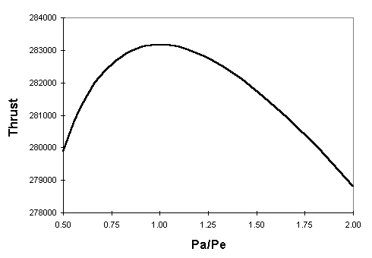
As can be easily seen, thrust is maximum when Pa/Pe=1, or when Pe=Pa.

The shuttle weighs 165,000 pounds empty. The external tank weighs 78,100 pounds empty. The two solid rocket boosters weigh 185,000 pounds empty each. But then you have to load in the fuel. Each SRB holds 1.1 million pounds of fuel. The external tank holds 143,000 gallons of liquid oxygen (1,359,000 pounds) and 383,000 gallons of liquid hydrogen (226,000 pounds). The whole vehicle - shuttle, external tank, solid rocket booster casings and all the fuel - has a total weight of 4.4 million pounds at launch. 4.4 million pounds to get 165,000 pounds in orbit is a pretty big difference! To be fair, the shuttle can also carry a 65,000 pound payload (up to 15 x 60 feet in size), but it is still a big difference. The fuel weighs almost 20 times more than the Shuttle. [Reference: The Space Shuttle Operator's Manual]
All of that fuel is being thrown out the back of the Space Shuttle at a speed of perhaps 6,000 MPH (typical rocket exhaust velocities for chemical rockets range between 5,000 and 10,000 MPH). The SRBs burn for about 2 minutes and generate about 3.3 million pounds of thrust each at launch (2.65 million pounds average over the burn). The 3 main engines (which use the fuel in the external tank) burn for about 8 minutes, generating 375,000 pounds of thrust each during the burn.
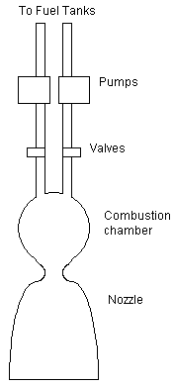

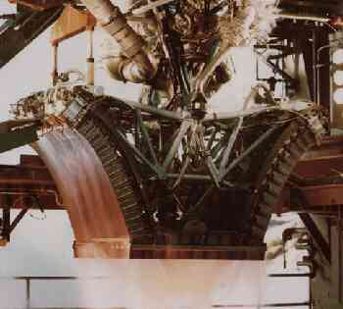
Although quicker to integrate into the Space Shuttle, the SSMEs are far too complex. They are arranged on a gimball system which allows the SSMEs to be turned somewhat to direct the craft while under thrust. You can imagine how difficult it is to direct the output of engines generating 37 million horsepower. The moving parts of the SSMEs require constant maintenance and inspection for continued flying safety.
The aerospike has been revived and enhanced to power the RLV. The aerospike is 75 percent shorter than an equivalent bell nozzle engine. It is also lighter, and its form blends well with the RLV's lifting body airframe for lower drag during flight. The shape spreads thrust loads evenly at the base of the vehicle, causing less structural weight. The X-33 will use two smaller test versions of the aerospike. The full-scale RLV in its current configuration will use seven aerospike engines.
The Linear Aerospike does not control the size of the plume. Hence it is free to expand to its optimum size at any altitude. At sea level it will produce a long narrow plume and in space an extremely wide plume. Thus the Aerospike achieves maximum efficiency at all altitudes with no moving parts.
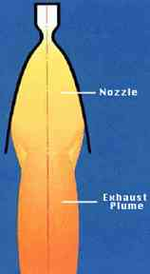  Conventional rocket engine. | 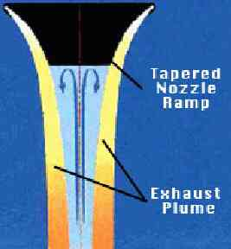  Aerospike engine.
The linear aerospike engine has two chief advantages over conventional rocket engines. (1) It automatically achieves close to maximum efficiency at both sea level and high altitude. A conventional engine would need to change the shape of its nozzle to achieve this. (2) The aerospike engine can change the direction of its thrust and steer by varying the rate at which fuel flows to different parts of the engine. No moving parts are needed, unlike in a conventional engine.
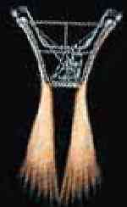  1. |   2. |   3.
1. The exhaust plumes on the two sides of the aerospike engine are equal. The rocket is propelled straight forward.
2. The right exhaust plume is stronger than the left one. The rocket is propelled to the left.
3. The left exhaust plume is stronger than the right one. The rocket is propelled to the right.
Aerospike engines now have over 4,000 seconds of ground based test firings. That may not sound like a lot but it represents more than 11 flights into orbit. Many different configurations have been tried - including the annular (circular) aerospike pictured below
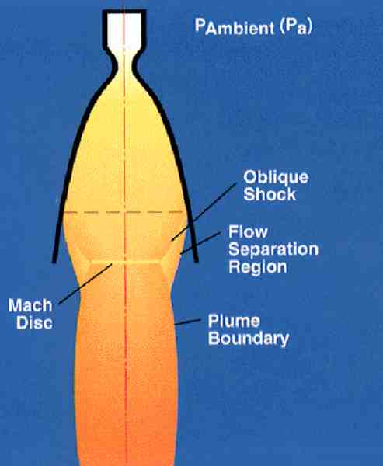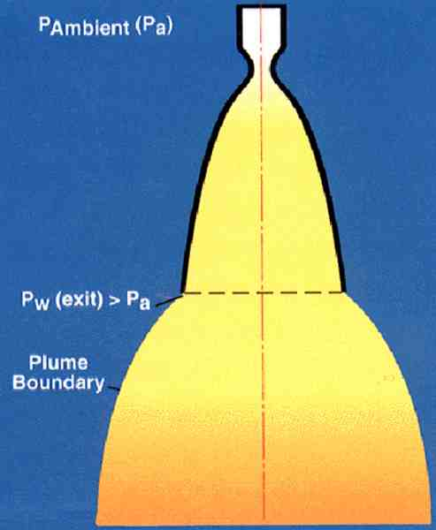
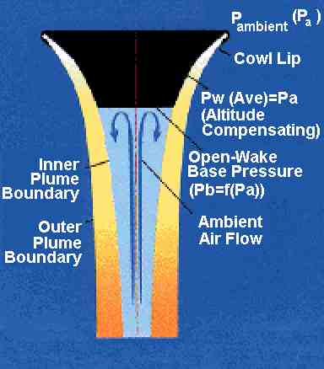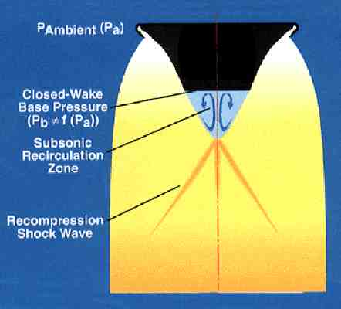
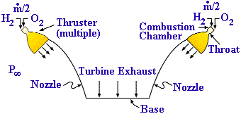

- H₂ & O₂ combine and burn in combustion chamber
- Combustion products exhaust through throat
- Nozzle expands combustion products, increasing velocity & decreasing pressure
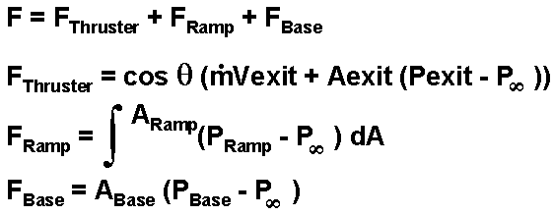
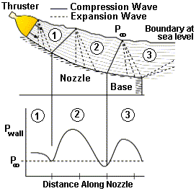 |  |  | - Thruster flow discharges to ramp  - Expansion waves turn flow axially  - Ramp curves, turns flow axially (at low altitudes)  - Turning causes compression wave from (1) to (2) - nozzle pressure increases  - Compression wave reflects off boundary causing expansion waves  - Flow crosses expansion waves in (2) - nozzle pressure decreases  - Ramp continues to curve and turn flow  - Process repeats (2) to (3)
  Average nozzle pressure > P, therefore no losses or separation, therefore large area ratio nozzle can be used, enabling SSTO
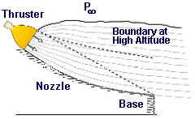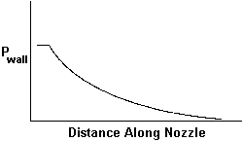 | - Thruster flow discharges to ramp  - Expansion waves turn flow axially  - No compression waves exist - all flow turning done by expansion waves  - Nozzle behaves likes a bell
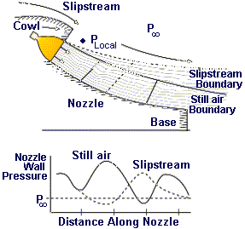 |  | - Air streaming over cowl lowers local pressure -  P _{Local} < P_{infinity}  - Exhaust plume expands beyond still air case  - Expansion and compression wave systems move aft from still air case  - Average ramp pressure decreases, causing thrust loss  - Effect is temporary as vehicle flies between ~Mach 1 and 2
Gas Core Nuclear Rocket -- GCNR
The GCNR is a concept which was also experimentally investigated in the 1960s during the Rover program. The idea is to use a gaseous nuclear fuel instead of the solid graphite core used in NERVA. A gaseous fuel could attain tempertures of several tens of thousands of degrees which would allow specific impulses of 3000 to 5000 seconds to be considered. Such an engine would allow manned missions to Mars to be accomplished in a few months each way. Currently, research into the GCNR concept is underway at the Los Alamos National Laboratory under a program from the NASA Marshall Space Flight Center. Some of the research problems that are being studied are:
1) Can a stable vortex of hot (5 eV) uranium plasma be created and maintained?
2) How is the uranium injected into the hot plasmoid during operation to make-up losses?
3) How can we reduce the heat load on the wall of the chamber? Current goals are to withstand 100 megawatts per square meter.
4) Is hydrogen the best propellant?
Here are 3 schematics (33K) showing how a Gas Core Nuclear Rocket might work.
The results of computational modeling during 1997 indicate the the counterflow toroid concept, #3 in the figures, has the best chance for stability and performance. Research is continuing.
Here is a newly published paper Reducing the Risk to Mars: the Gas Core Nuclear Rocket that shows more details of the mission comparisons with the NASA design reference mission. This is in html format to read here. The latest engine geometry look slike this:
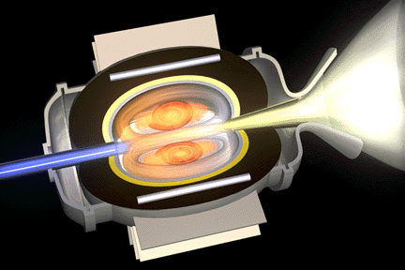

Nuclear propulsion is a very attractive option for human exploration and development of space. NASA Marshall's Propulsion Research Center is investigating fission, antimatter and other safe, in-space nuclear propulsion concepts.
The energy density of nuclear fuel is enormous and could enable rapid, affordable access to any point in the solar system.
Nuclear Fission
Fission systems have been used safely for nearly six decades by the government, industry and universities. Fissioning a soft drink can full of uranium yields 50 times the energy contained in the Space Shuttle External Tank. This equates to 80,000,000,000 J/g fuel.
Potential fission-based transportation options include high specific power, continuous impulse propulsion systems and bimodal nuclear thermal rockets.
Despite their tremendous potential for enhancing or enabling deep space and planetary missions, space fission systems have only been used in Earth orbit.
The first step toward using advanced fission propulsion systems is development of a safe, affordable fission system that can enhance or enable near-term missions of interest.
NASA Marshall is leading a Safe Affordable Fission Engine (SAFE) test series, designed to demonstrate a 300 kW flight configuration system using non-nuclear testing. The test series is carried out in collaboration with other NASA centers, other government agencies, industry and universities.
The SAFE-30 test series is a full core test capable of producing 30 kW using resistance heating to simulate the heat of fission. The 30 kW core consists of 48 stainless steel tubes and 12 stainless steel/sodium heat pipes welded together longitudinally to formulate a core similar to that of a fission flight system. Heat is removed from the core via the 12 heat pipes, closely simulating the operation of an actual system.
The primary objective of the SAFE-30 was to obtain experimental data demonstrating the robust operation of the simulated nuclear core and heat pipe system. Information gained will be used for validation of existing computational models and design of follow-on systems.
After SAFE-30 primary heat transport performance was evaluated, the next core to be evaluated was the SAFE-300. It consists of a refractory metal core using molybdenum heat pipes capable of delivering 300 kW thermal at 1100 C, even following multiple heat pipe failures.
Each resistance heater for the SAFE-300 is capable of operating at 1450 C and providing 1.6 kW or more. The core was designed with good neutronic characteristics and adequate resistance to thermal stresses generated within the core. Modules are being used and tested for material compatibility and strength, as well as to provide insight into the structural stability of the unit.
Components and systems undergoing tests in the SAFE series:
- Refractory metal modules
- Heat pipes
- High temperature heaters
- Stainless steel cores
- End-to-end demonstrators
- In-space fueling
At least one SAFE option would call for the fuel to be launched in a canister separate from the reactor. When the desired orbit is achieved, the canister would pivot into place and insert fuel to propel the vehicle in space.
A small-scale canister and fueling mechanism have been designed and fabrication is getting under way. Initial non-nuclear testing is scheduled to begin in late 2001. Non-nuclear tests are affordable and timely, and the cause of component and system failures can be quickly and accurately identified.
Antimatter
Matter/antimatter annihilation has the highest energy release per unit mass of any reaction known in physics. NASA Marshall researchers are exploring the possibility of antimatter propulsion for space travel.
Antimatter can be thought of as the mirror image of normal matter seen in everyday life. An antiparticle has identical mass as its normal matter twin, but opposite charge and spin.
Matter is composed of electrons, protons and neutrons. Each of these particles has an antimatter counterpart referred to as positron, antiproton and antineutron, respectively. For every normal matter particle created in high-energy processes, such as collisions in particle accelerators, an antiparticle is created.
An interesting property of antimatter is its dramatic interaction with its normal matter counterparts. When a paticle and antiparticle come in close contact, they annihilate each other through a series of interactions with the ultimate result that their rest mass is converted entirely into energy.
Antimatter stores energy at very high density. Approximately 42 milligrams of antiprotons (about 0.6 cubic centimeters in the form of antihydrogen) have energy content equal to the 750,000 kilograms of fuel and oxidizer stored in the Space Shuttle External Tank.
Boeing 601HP Thruster:  13 centimeters in diameter  2568 seconds ISP  18 mN of thrust  Boeing 702 Thruster:  25 centimeters in diameter  3800 seconds ISP  165 mN of thrust | 