STOVL Presentation Homework Due Oct. 29, 2001
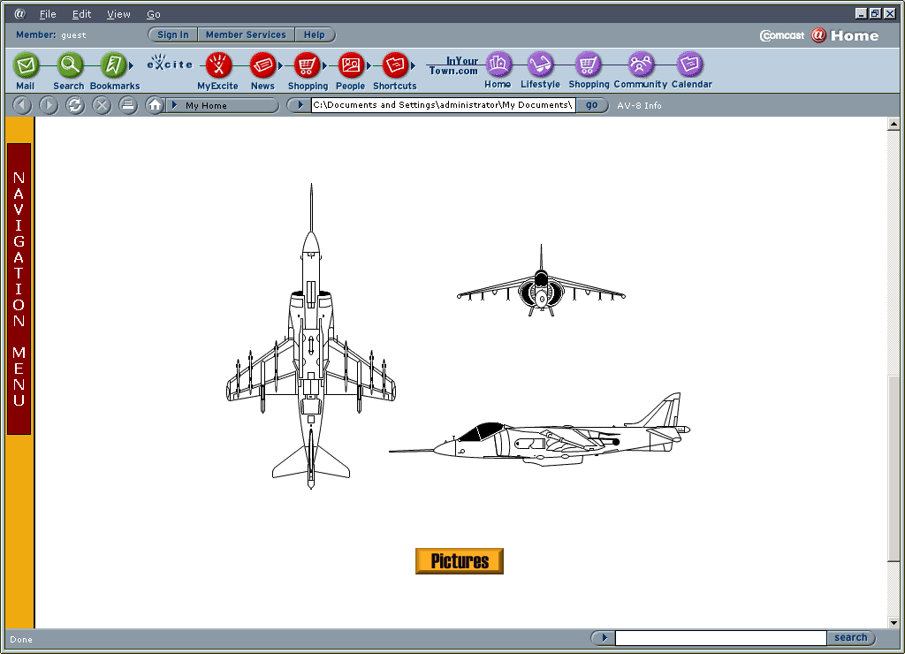
First derive…. Just kidding! Given the specifications below, calculate first the percentage of engine thrust (not vertical thrust) required to make the Harrier “hover” a fair distance from the ground (no lift loss). Assume that only 80% of the engine thrust can be redirected through the nozzles to give vertical thrust. Next calculate the velocity, in Mach number, of the air exiting each vertical nozzle at full thrust when the nozzles are at 90 degrees (vertical). Lastly, find the angle at which the vertical nozzles must be positioned to make the plane “hover” in a stationary position. Assume that this particular Harrier has the Rolls Royce F402-RR408 turbofan engine. Exiting gas properties: γ=1.33, R=0.287kJ/kg.K, T=1750K.
+y
+x

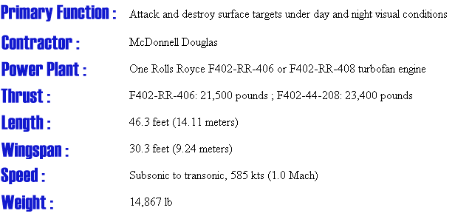

Nozzle Outlet Area: 0.525 ft²
Intake area: 1.00 ft²

