Combustion Chamber Shapes
There are several basic combustion chamber shapes that are used in production in spark ignition engines today. The four most commonly used shapes are the wedge, the crescent, the hemispherical, and the bowl-in-piston chambers. Illustrations of each of these chambers will be given. Then, the design considerations for combustion chambers will be discussed. The advantages and disadvantages of each chamber will be discussed in the context of the design considerations.

Wedge Chamber
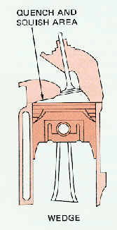The wedge chamber shape is an asymmetrical design. The wedge is called an open chamber head since the cylinder head is concave. The valves are not placed in the center of the chamber. Rather, the valves are inclined in an off-center position. Figure 1 shows an illustration of a wedge chamber shape.
Figure 1. Wedge chamber with quench and squish area

Hemispherical Chamber
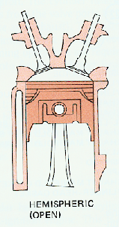The hemispherical combustion chamber is a very popular design. This chamber is a symmetrical design. It is also an open chamber due to the concavity of the cylinder head. The valves are placed on an arc-shaped head. The hemi (abridgement of hemispherical) chamber is very popular in high performance automobiles. A high performance engine known as the “426 Hemi” used this type of combustion chamber. This engine dominated the high performance automobile scene during its era. Also, the hemi chamber was very successful in drag racing. Figure 2 shows a picture of a hemispherical chamber.
Figure 2. Hemispherical Chamber

Crescent (Pent-Roof) Chamber
The crescent combustion chamber is very similar to the hemi chamber. The main difference between the two chambers is that in the crescent chamber the valves are placed on a trapezoidal-shaped head instead of an arc-shaped head. The valves of a crescent shaped chamber are placed at an angle on flat surfaces (rather than curved) on the head. The crescent chamber is also called the “pent-head” or “pent-roof” combustion chamber. The “pent-head” chamber is used the Jaguar XK engine. Figure 3 represents an example of a crescent, or “pent-head”, chamber.
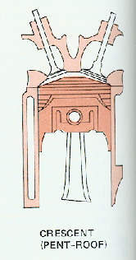
Figure 3. A crescent combustion chamber

Cup (Bowl) Chamber
Some chambers are called closed rather than open. In closed chambers, the cylinder head is virtually flat. However, the piston is dished. The dish in the piston simply creates concavity in the piston. A bowl-in-piston chamber is an example of a closed chamber. In this chamber, the valves are placed perpendicular to the head. Figure 4 is an example of a
bowl-in-piston chamber.
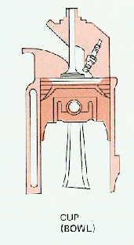 Figure 4. Bowl-in-piston combustion chamber

