Design Considerations
In designing a combustion chamber, there are several objectives that optimize the combination of performance and emission. The objectives that need to be accomplished are a fast combustion process, a high volumetric efficiency at wide-open throttle (WOT), minimum heat loss to the combustion chamber walls, and certain characteristics of flow inside the cylinder. The chambers mentioned above differ in the extent to which they accomplish these objectives. For the design objectives listed, the chambers will be compared to each other.

Fast Combustion
Fast combustion is highly desired in an internal combustion engine. In a fast-burn combustion chamber the fuel burning occupies a shorter portion of the crank angle interval at a given engine speed than a slow-burning combustion chamber. Fast-burn rates yield efficiency and emission improvements over slow-burn rates. The fast burn also allows more EGR, which further improves emissions. In addition, a fast-burning chamber yields improved fuel consumption due to reduced pumping work and lower heat transfer.
There are several ways in which to control the speed of combustion. One method is to vary the location of the spark plugs in the combustion chamber. The location of the spark plug is related to the size of the flame front surface area. The flame front area is the leading edge of the spherical surface of the flame front contained within the combustion chamber. The larger this surface, the faster the fuel can be burnt (i.e., faster combustion). Figure 5 shows the size of the flame front for different spark plug locations with and without swirl. Swirl is flow in which the axis of rotation is parallel to the axis of the cylinder passing through the piston along its direction of travel. Swirl will be further discussed in the context of flow in the cylinder.

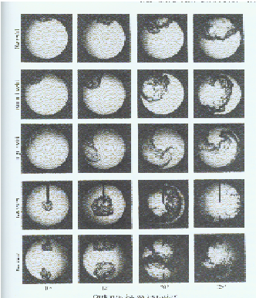 Figure 5. Effect of spark plug location on the size of the flame front
Side Plug without Swirl
Side Plug with Normal Swirl
Side Plug with High Swirl
Central Plugs without Swirl
Two Plugs without Swirl

The figure shows the size of the flame front at four different crank angles for different plug locations. The duration between the first picture and the last picture for a given plug location occupies the same amount of degrees of the crank angle interval. It can be seen that adding swirl to the side plug location increases the area of the flame front and, thus, the rate of combustion. A central plug without swirl is better in producing a large flame front than the side plug with any degree of swirl shown. Two plugs are not much better than a single, central plug in production of a large flame front. Since the performances are very similar, a single, central plug would be a better choice due to its cost benefits. In addition to varying with spark plug location, the area of the flame front also varies with the shape of the combustion chamber. Figure 6 shows how the flame front is related to combustion chamber shape.
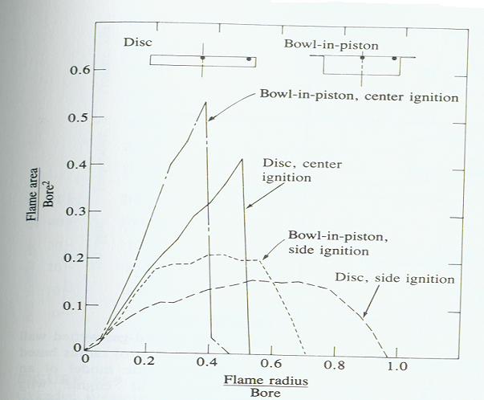

Figure 6. Schematic of the normalized flame area as a function of flame radius for different combustion
chambers and spark plug locations

The graph shows the flame front area and radius for a disc and bowl-in-piston combustion chamber. The magnitude of the flame area is more significant in this graph than flame radius since the area of the flame front determines the speed of the combustion. For both spark plug locations, the bowl-in-piston chamber has a larger flame front area and, thus, faster rate of combustion than the disc chamber. The disc chamber is simply a more compact version of the bowl-in-piston chamber. Furthermore, the central plug location for both chambers yields a faster combustion.
In addition to the comparing flame front area to flame front radius, the flame front area can also be compared to flame front volume. Figure 7 shows a plot representing the latter situation.
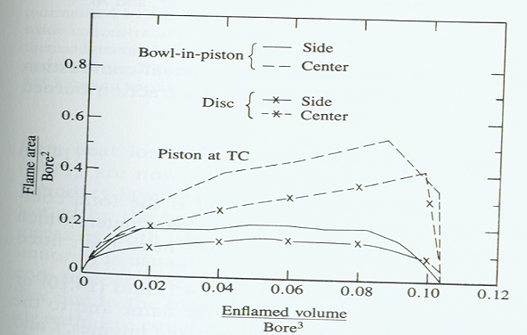

Figure 7. Normalized flame front area as a function of normalized enflamed volume for
different spark plug locations and combustion chambers

The graph has enflamed volume on the independent axis. Enflamed volume is the same as the flame front volume. Figure 7 shows the same trends as Figure 6. The center spark location is superior to the side plug location in producing fast combustion. Also, the bowl-in-piston chamber yields a faster combustion than the disc combustion chamber.

The rate of combustion of the bowl-in-piston and disc combustion chambers can also be compared to that of hemi and open chambers. Figure 8 is a comparison of burn angles for different chambers and spark plug locations.

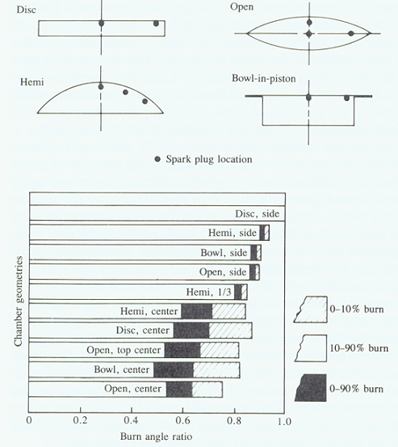

Figure 8. Comparison of burn angle ratio for different geometries

A burn angle ratio is the independent axis in Figure 8. This ratio is determined by using the fact that the disc combustion chamber with a side spark plug and 10-90% burn has longest burn time. All other burn times for the other chambers and spark plug configurations are normalized by dividing their times by the longest burn time of the disc. Also combustion is classified into three categories: 0-10% burn, 10-90% burn, and 0-90% burn. For the 10-90% burn with a side spark plug, the order of the chambers with respect to burn times (from fastest to slowest) is open, bowl, hemi, and then disc. The order holds for the other combustion categories. The hemi chamber with a 1/3 (or 60 degrees) spark plug location has burn time between that that of a central location and a side location. For all the chambers, the central plug produces a faster burn time than the side plug. For 10-90% combustion, the order of chambers with respect to burn times (from fastest to slowest) is bowl, open, disc, and then hemi. For 0-10% burn, the order is open, bowl, hemi, and then disc. For 0-90% burn, the order is open, bowl, disc, and then hemi. Therefore, the way in which combustion is classified affects the rate of burn time for different combustion chambers.

Volumetric Efficiency
Combustion chamber shape affects volumetric efficiency by its influence on valve size and degree of swirl. However, swirl is often produced primarily by the intake port or the design o the valves. For maximum performance, the size of the valve heads should be as large as possible. Open chambers, such as the hemi and pent-roof, maximize the size of the valve heads. However, the location of the spark plug influences the size of the valves.

Heat Loss
Maintaining heat inside the combustion chamber is very critical in combustion chamber design. Retaining heat allows for high temperatures and pressures, which produce a large amount of power on the power stroke. Open (including hemispherical chambers) have the low heat transfer due to low surface area to volume ratio. Closed (including bowl-in-piston) chambers have a higher heat transfer due to a high surface area to volume ratio.
There is a limit on how hot the combustion chamber should become. Excessive temperature and pressures will cause knock. Knock can be classified into surface ignition and auto-ignition (or self-ignition.). Auto ignition occurs when the mixture of fuel vapor and air reaches a particular temperature and pressure at which it will spontaneously ignite. Surface ignition is caused by the contact of the mixture with a hot surface, such as an exhaust valve. Both types of knocking are destructive to an engine. During knocking, the previously, orderly combustion becomes an explosion. This chaotic explosion results in structural vibration of the engine.
The octane requirement of a combustion chamber is related to knock. The compression ratio of an engine is determined by the octane requirement of the chamber. High compression ratios produce high temperatures and pressures in the combustion chambers. These high temperature and pressures can lead to knock. At higher compression ratios, a higher octane-rated fuel is needed to prevent knock.

There are two octane ratings for fuel that are currently used. These ratings are the Research Octane Number (RON) and the Motor Octane Number (MON). These ratings are very similar except that the MON applies slightly more stringent standards. Sometimes, the average of the two ratings is taken. This average can be seen as “R+M/2” on the gasoline pumps at many popular gas stations.
The method for developing an octane rating is similar for both ratings. First, one chooses a test fuel of which he wants to know the octane rating. The rpm (revolutions per minute) of an engine are increased until knocking is produced. The rpm at which knocking first occurs is recorded. Next, a reference fuel is used. This fuel will contain N-Heptane and Iso-Octane. The amounts of these two compounds are adjusted. The percentage of Iso-Octane in the fuel gives the octane rating. Basically, the engine will be run up to the same rpm as before with the test fuel. The amount of Iso-Octane of the fuel mixture will be varied until the engine first knocks at the same rpm with the reference fuel as it did with the test fuel. The percentage of Iso-Octane in the fuel at this time represents the octane number. Sometimes, the octane rating will be over 100. This rating represents the amount of tetraethyl lead added to 100% Iso-Octane.
There is some chemical theory behind the mixture of N-Heptane and Iso-Octane. Essentially, Iso-Octane is more knock resistant than N-Heptane. The reason for this knock resistance lies in the make-up of the chemical bonds. Figure 9 shows the chemical compositions of N-Heptane and Iso-Octane.

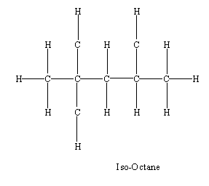
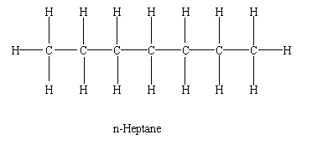

Figure 9. Chemical compositions of N-Heptane and Iso-Octane

Straight chain C-H bonds such as heptane have weaker C-H bonds than branched chained C-H bonds in branch chained HC such as iso-octane. These straight bonds are easier to break

Flow In A Cylinder

The flow inside of a cylinder in an internal combustion engine is a rather complicated matter. Fluid flow can be one of two types, laminar, which is characterized by microscopic mixing of adjacent layers producing a smooth and uniform flow, or turbulent, which is a more random and unorganized flow.

Turbulence
The flow inside a cylinder of an internal combustion engine is usually turbulent. Turbulent flow is desired so that sufficient mixing can take place in a given amount of time. It is important to note that this given amount of time decreases with increasing engine speed. Several problems can arise do to insufficient mixing, such as knock, a decrease in engine efficiency, and a decrease in overall engine performance. Turbulence decreases the time it takes for the air and fuel to mix and burn, thereby reducing the temperature of combustion. This lowering of temperature reduces knock and the emission of nitrous oxides and carbon dioxides. In addition, turbulence allows for a leaner air to fuel mixture to be used, such as those in stratified charged engines. By using a leaner mixture, there is a reduction in the emission of hydrocarbons. With the appropriate amount of mixing, which is related to the level of turbulence inside of the cylinder, these and other problems can be corrected.

Generating Turbulence
There are different ways to generate turbulence inside of the cylinder. The shape of the cylinder can contribute to the turbulence. One way the shape can contribute is by creating a squish area, which is the area where the piston crown comes very close to the cylinder head. The piston crown’s close proximity to the cylinder head creates a “squishing” of the air-fuel mixture and pushes it into the non-squish area, thereby increasing the tumble flow in the cylinder. The wedge combustion chamber shown in Figure 1 has this squish area. Timing, valve, and valve port design are some other ways to produce turbulent flow inside the cylinder.

Swirl Flow
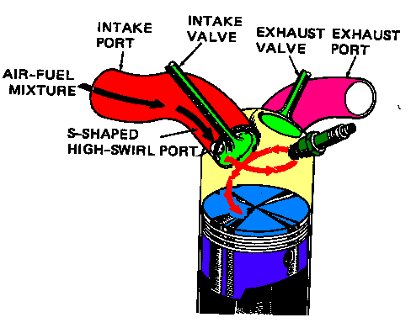 Swirl is a type flow, associated with turbulence, produced inside of the cylinder of a spark ignition engine. Note, that swirl flow is not turbulent but exists in the presence of turbulent flow in the cylinder. Swirl flow is defined as a rotational flow with its axis of rotation parallel with the axis of the cylinder. See Figure 10.

Figure 10. Swirl Flow

One way of measuring the swirl flow is to use a honeycomb flow straightener, see Figure 11. The honeycomb flow straightener measures the total torque exerted by the swirl flow. This angular velocity of the swirl flow ω_{s} can be calculated by modeling the flow as a solid body with the same angular velocity. The angular velocity ω_{s} can then be related to the rotational speed of the crankshaft with a swirl ratio R_{s}.

R_{s} = (ω_{s})(2πN)⁻¹ (1)

where N is equal to the crankshaft rotational speed.

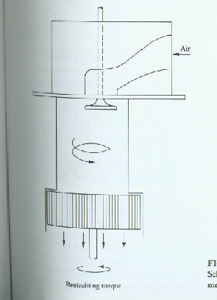 Figure 11. Honeycomb Flow Straightener

Tumble Flow
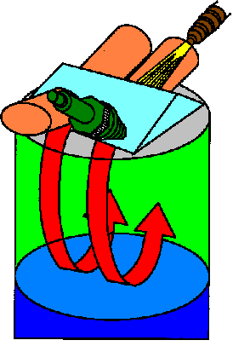Another type of flow in the cylinder associated with turbulent flow is tumble flow. Tumble flow has an axis of that is rotation perpendicular to the cylinder’s axis. See Figure 12.
Figure 12. Tumble Flow

Tumble is associated with swirl. If swirl flow is present, then tumble flow must also be present. However, tumble flow can exist without swirl flow. Like swirl flow, tumble flow has a ratio R_{t} that relates the angular velocity of the tumble flow ω_{t}, which is also modeled after a solid body with the same angular momentum, to the angular velocity of the crankshaft N.

R_{s} = (ω_{s})(2πN)⁻¹ (2)

