Combustion Chamber Design

EML 4421

Internal Combustion Engines and Fundamentals of Propulsion Systems

Final Report

Bradford Scott Grimmel

James Ian Fulton

Nicholas Toro
Abstract

This report focuses on the combustion chamber design of a spark-ignition engine. The thermal and fluid aspects involved in the design of the combustion chamber will be included. It was discovered that the combustion chamber must have certain features in order to yield an engine with maximum performance and efficiency. An optimal chamber should have large valve heads to ensure a high volumetric efficiency. The chamber must minimize heat loss to produce a rapid combustion. A central spark plug location will help produce this rapid combustion. Sufficient turbulent flow must be present to mix the air-fuel mixture in order to help prevent knocking and decrease the combustion time.
Table of Contents
Section Page
1.0 Introduction 1
2.0 Definition of Combustion Chamber 1
3.0 Combustion Chamber Shapes 1
3.1 Wedge Chamber 1
3.2 Hemispherical Chamber 2
3.3 Crescent (Pent-Roof) Chamber 2
3.4 Cup (Bowl) Chamber 3
4.0 Design Considerations 3
4.1 Fast Combustion 3
4.2 Volumetric Efficiency 6
4.3 Heat Loss 6
4.4 Flow In A Cylinder 7
4.4.1 Turbulence 8
5.0 Conclusion 11
References 12
Web Links 12
Evaluation Report 13

Introduction
This report discusses combustion chambers in internal combustion engines. There are two main types of internal combustion engines: spark ignition engines and compression ignition engines. Spark ignition engines have spark plugs, which produce a flame that is used to ignite the fuel. Compression ignition engines compress the air and fuel mixture inside the cylinder to a pressure and temperature at which the mixture will ignite. This report will focus on the spark ignition engine since these engines are more common in passenger cars.

Definition of Combustion Chamber
The combustion chamber in an internal combustion engine consists of an upper and lower portion. The upper portion of the chamber comprises the bottom of the cylinder head and the cylinder wall. The lower portion of the chamber is made up of the piston head (crown), the piston rings, and the cylinder wall. It is important to note that the piston rings and more precisely the compression rings make the seal around the piston to prevent blow by and help produce compression.

Combustion Chamber Shapes
There are several basic combustion chamber shapes that are used in production in spark ignition engines today. The four most commonly used shapes are the wedge, the crescent, the hemispherical, and the bowl-in-piston chambers. Illustrations of each of these chambers will be given. Then, the design considerations for combustion chambers will be discussed. The advantages and disadvantages of each chamber will be discussed in the context of the design considerations.

Wedge Chamber
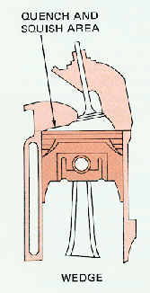The wedge chamber shape is an asymmetrical design. The wedge is called an open chamber head since the cylinder head is concave. The valves are not placed in the center of the chamber. Rather, the valves are inclined in an off-center position. Figure 1 shows an illustration of a wedge chamber shape.
Figure 1. Wedge chamber with quench and squish area

Hemispherical Chamber
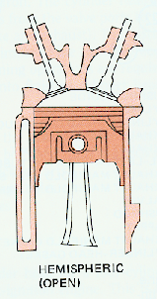The hemispherical combustion chamber is a very popular design. This chamber is a symmetrical design. It is also an open chamber due to the concavity of the cylinder head. The valves are placed on an arc-shaped head. The hemi (abridgement of hemispherical) chamber is very popular in high performance automobiles. A high performance engine known as the “426 Hemi” used this type of combustion chamber. This engine dominated the high performance automobile scene during its era. Also, the hemi chamber was very successful in drag racing. Figure 2 shows a picture of a hemispherical chamber.
Figure 2. Hemispherical Chamber

Crescent (Pent-Roof) Chamber
The crescent combustion chamber is very similar to the hemi chamber. The main difference between the two chambers is that in the crescent chamber the valves are placed on a trapezoidal-shaped head instead of an arc-shaped head. The valves of a crescent shaped chamber are placed at an angle on flat surfaces (rather than curved) on the head. The crescent chamber is also called the “pent-head” or “pent-roof” combustion chamber. The “pent-head” chamber is used the Jaguar XK engine. Figure 3 represents an example of a crescent, or “pent-head”, chamber.
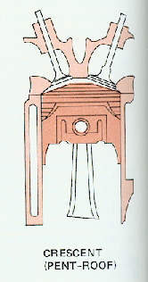
Figure 3. A crescent combustion chamber

Cup (Bowl) Chamber
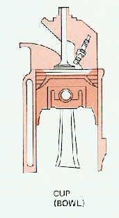Some chambers are called closed rather than open. In closed chambers, the cylinder head is virtually flat. However, the piston is dished. The dish in the piston simply creates concavity in the piston. A bowl-in-piston chamber is an example of a closed chamber. In this chamber, the valves are placed perpendicular to the head. Figure 4 is an example of a bowl-in-piston chamber.
Figure 4. Bowl-in-piston combustion chamber

Design Considerations
In designing a combustion chamber, there are several objectives that optimize the combination of performance and emission. The objectives that need to be accomplished are a fast combustion process, a high volumetric efficiency at wide-open throttle (WOT), minimum heat loss to the combustion chamber walls, and certain characteristics of flow inside the cylinder. The chambers mentioned above differ in the extent to which they accomplish these objectives. For the design objectives listed, the chambers will be compared to each other.

Fast Combustion
Fast combustion is highly desired in an internal combustion engine. In a fast-burn combustion chamber the fuel burning occupies a shorter portion of the crank angle interval at a given engine speed than a slow-burning combustion chamber. Fast-burn rates yield efficiency and emission improvements over slow-burn rates. The fast burn also allows more EGR, which further improves emissions. In addition, a fast-burning chamber yields improved fuel consumption due to reduced pumping work and lower heat transfer.

There are several ways in which to control the speed of combustion. One method is to vary the location of the spark plugs in the combustion chamber. The location of the spark plug is related to the size of the flame front surface area. The flame front area is the leading edge of the spherical surface of the flame front contained within the combustion chamber. The larger this surface, the faster the fuel can be burnt (i.e., faster combustion). Figure 5 shows the size of the flame front for different spark plug locations with and without swirl. Swirl is flow in which the axis of rotation is parallel to the axis of the cylinder passing through the piston along its direction of travel. Swirl will be further discussed in the context of flow in the cylinder.

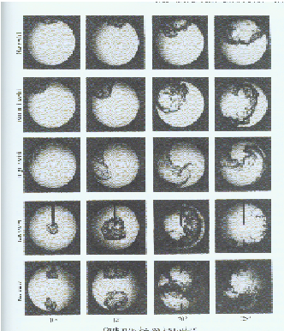 Figure 5. Effect of spark plug location on the size of the flame front
Side Plug without Swirl
Side Plug with Normal Swirl
Side Plug with High Swirl
Central Plugs without Swirl
Two Plugs without Swirl

The figure shows the size of the flame front at four different crank angles for different plug locations. The duration between the first picture and the last picture for a given plug location occupies the same amount of degrees of the crank angle interval. It can be seen that adding swirl to the side plug location increases the area of the flame front and, thus, the rate of combustion. A central plug without swirl is better in producing a large flame front than the side plug with any degree of swirl shown. Two plugs are not much better than a single, central plug in production of a large flame front. Since the performances are very similar, a single, central plug would be a better choice due to its cost benefits. In addition to varying with spark plug location, the area of the flame front also varies with the shape of the combustion chamber. Figure 6 shows how the flame front is related to combustion chamber shape.
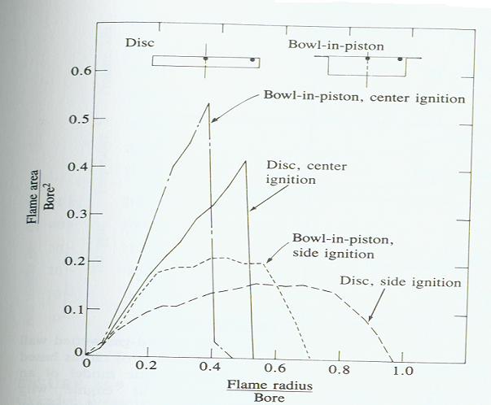

Figure 6. Schematic of the normalized flame area as a function of flame radius for different combustion
chambers and spark plug locations

The graph shows the flame front area and radius for a disc and bowl-in-piston combustion chamber. The magnitude of the flame area is more significant in this graph than flame radius since the area of the flame front determines the speed of the combustion. For both spark plug locations, the bowl-in-piston chamber has a larger flame front area and, thus, faster rate of combustion than the disc chamber. The disc chamber is simply a more compact version of the bowl-in-piston chamber. Furthermore, the central plug location for both chambers yields a faster combustion.

In addition to the comparing flame front area to flame front radius, the flame front area can also be compared to flame front volume. Figure 7 shows a plot representing the latter situation.
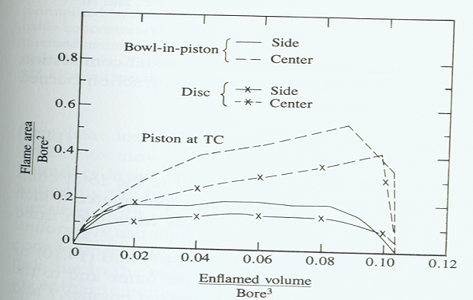

Figure 7. Normalized flame front area as a function of normalized enflamed volume for
different spark plug locations and combustion chambers

The graph has enflamed volume on the independent axis. Enflamed volume is the same as the flame front volume. Figure 7 shows the same trends as Figure 6. The center spark location is superior to the side plug location in producing fast combustion. Also, the bowl-in-piston chamber yields a faster combustion than the disc combustion chamber.

The rate of combustion of the bowl-in-piston and disc combustion chambers can also be compared to that of hemi and open chambers. Figure 8 is a comparison of burn angles for different chambers and spark plug locations.

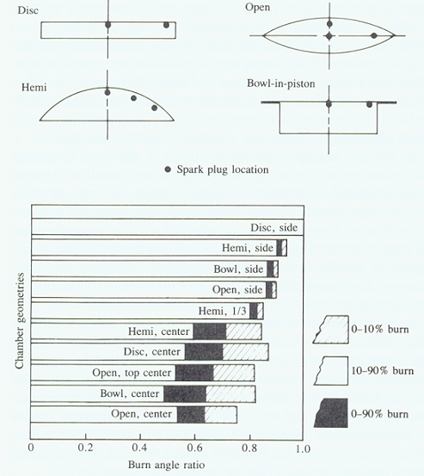

Figure 8. Comparison of burn angle ratio for different geometries

A burn angle ratio is the independent axis in Figure 8. This ratio is determined by using the fact that the disc combustion chamber with a side spark plug and 10-90% burn has longest burn time. All other burn times for the other chambers and spark plug configurations are normalized by dividing their times by the longest burn time of the disc. Also combustion is classified into three categories: 0-10% burn, 10-90% burn, and 0-90% burn. For the 10-90% burn with a side spark plug, the order of the chambers with respect to burn times (from fastest to slowest) is open, bowl, hemi, and then disc. The order holds for the other combustion categories. The hemi chamber with a 1/3 (or 60 degrees) spark plug location has burn time between that that of a central location and a side location. For all the chambers, the central plug produces a faster burn time than the side plug. For 10-90% combustion, the order of chambers with respect to burn times (from fastest to slowest) is bowl, open, disc, and then hemi. For 0-10% burn, the order is open, bowl, hemi, and then disc. For 0-90% burn, the order is open, bowl, disc, and then hemi. Therefore, the way in which combustion is classified affects the rate of burn time for different combustion chambers.

Volumetric Efficiency
Combustion chamber shape affects volumetric efficiency by its influence on valve size and degree of swirl. However, swirl is often produced primarily by the intake port or the design o the valves. For maximum performance, the size of the valve heads should be as large as possible. Open chambers, such as the hemi and pent-roof, maximize the size of the valve heads. However, the location of the spark plug influences the size of the valves.

Heat Loss
Maintaining heat inside the combustion chamber is very critical in combustion chamber design. Retaining heat allows for high temperatures and pressures, which produce a large amount of power on the power stroke. Open (including hemispherical chambers) have the low heat transfer due to low surface area to volume ratio. Closed (including bowl-in-piston) chambers have a higher heat transfer due to a high surface area to volume ratio.

There is a limit on how hot the combustion chamber should become. Excessive temperature and pressures will cause knock. Knock can be classified into surface ignition and auto-ignition (or self-ignition.). Auto ignition occurs when the mixture of fuel vapor and air reaches a particular temperature and pressure at which it will spontaneously ignite. Surface ignition is caused by the contact of the mixture with a hot surface, such as an exhaust valve. Both types of knocking are destructive to an engine. During knocking, the previously, orderly combustion becomes an explosion. This chaotic explosion results in structural vibration of the engine.

The octane requirement of a combustion chamber is related to knock. The compression ratio of an engine is determined by the octane requirement of the chamber. High compression ratios produce high temperatures and pressures in the combustion chambers. These high temperature and pressures can lead to knock. At higher compression ratios, a higher octane-rated fuel is needed to prevent knock.

There are two octane ratings for fuel that are currently used. These ratings are the Research Octane Number (RON) and the Motor Octane Number (MON). These ratings are very similar except that the MON applies slightly more stringent standards. Sometimes, the average of the two ratings is taken. This average can be seen as “R+M/2” on the gasoline pumps at many popular gas stations.

The method for developing an octane rating is similar for both ratings. First, one chooses a test fuel of which he wants to know the octane rating. The rpm (revolutions per minute) of an engine are increased until knocking is produced. The rpm at which knocking first occurs is recorded. Next, a reference fuel is used. This fuel will contain N-Heptane and Iso-Octane. The amounts of these two compounds are adjusted. The percentage of Iso-Octane in the fuel gives the octane rating. Basically, the engine will be run up to the same rpm as before with the test fuel. The amount of Iso-Octane of the fuel mixture will be varied until the engine first knocks at the same rpm with the reference fuel as it did with the test fuel. The percentage of Iso-Octane in the fuel at this time represents the octane number. Sometimes, the octane rating will be over 100. This rating represents the amount of tetraethyl lead added to 100% Iso-Octane.

There is some chemical theory behind the mixture of N-Heptane and Iso-Octane. Essentially, Iso-Octane is more knock resistant than N-Heptane. The reason for this knock resistance lies in the make-up of the chemical bonds. Figure 9 shows the chemical compositions of N-Heptane and Iso-Octane.

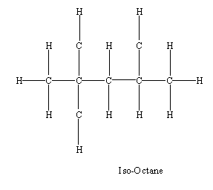
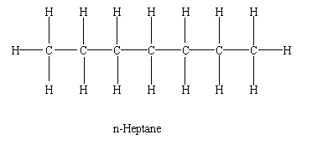

Figure 9. Chemical compositions of N-Heptane and Iso-Octane

Straight chain C-H bonds such as heptane have weaker C-H bonds than branched chained C-H bonds in branch chained HC such as iso-octane. These straight bonds are easier to break

Flow In A Cylinder

The flow inside of a cylinder in an internal combustion engine is a rather complicated matter. Fluid flow can be one of two types, laminar, which is characterized by microscopic mixing of adjacent layers producing a smooth and uniform flow, or turbulent, which is a more random and unorganized flow.

Turbulence
The flow inside a cylinder of an internal combustion engine is usually turbulent. Turbulent flow is desired so that sufficient mixing can take place in a given amount of time. It is important to note that this given amount of time decreases with increasing engine speed. Several problems can arise do to insufficient mixing, such as knock, a decrease in engine efficiency, and a decrease in overall engine performance. Turbulence decreases the time it takes for the air and fuel to mix and burn, thereby reducing the temperature of combustion. This lowering of temperature reduces knock and the emission of nitrous oxides and carbon dioxides. In addition, turbulence allows for a leaner air to fuel mixture to be used, such as those in stratified charged engines. By using a leaner mixture, there is a reduction in the emission of hydrocarbons. With the appropriate amount of mixing, which is related to the level of turbulence inside of the cylinder, these and other problems can be corrected.

Generating Turbulence
There are different ways to generate turbulence inside of the cylinder. The shape of the cylinder can contribute to the turbulence. One way the shape can contribute is by creating a squish area, which is the area where the piston crown comes very close to the cylinder head. The piston crown’s close proximity to the cylinder head creates a “squishing” of the air-fuel mixture and pushes it into the non-squish area, thereby increasing the tumble flow in the cylinder. The wedge combustion chamber shown in Figure 1 has this squish area. Timing, valve, and valve port design are some other ways to produce turbulent flow inside the cylinder.

Swirl Flow
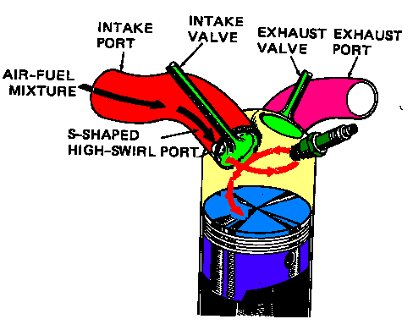 Swirl is a type of flow associated with turbulence, produced inside of the cylinder of a spark ignition engine. Note, that swirl flow is not turbulent but exists in the presence of turbulent flow in the cylinder. Swirl flow is defined as a rotational flow with its axis of rotation parallel with the axis of the cylinder. See Figure 10.

Figure 10. Swirl Flow

One way of measuring the swirl flow is to use a honeycomb flow straightener, see Figure 11. The honeycomb flow straightener measures the total torque exerted by the swirl flow. This angular velocity of the swirl flow ω_{s} can be calculated by modeling the flow as a solid body with the same angular velocity. The angular velocity ω_{s} can then be related to the rotational speed of the crankshaft with a swirl ratio R_{s}.

R_{s} = (ω_{s})(2πN)⁻¹ (1)

where N is equal to the crankshaft rotational speed.

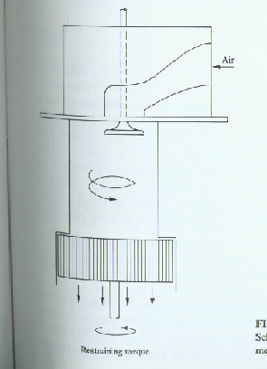 Figure 11. Honeycomb Flow Straightener

Tumble Flow
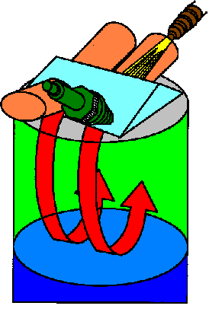Another type of flow in the cylinder associated with turbulent flow is tumble flow. Tumble flow has an axis of that is rotation perpendicular to the cylinder’s axis. See Figure 12.
Figure 12. Tumble Flow

Tumble is associated with swirl. If swirl flow is present, then tumble flow must also be present. However, tumble flow can exist without swirl flow. Like swirl flow, tumble flow has a ratio R_{t} that relates the angular velocity of the tumble flow ω_{t}, which is also modeled after a solid body with the same angular momentum, to the angular velocity of the crankshaft N.

R_{s} = (ω_{s})(2πN)⁻¹ (2)

Conclusion

This report covered many of the important aspects of combustion chamber design including flow in a cylinder, spark plug location, and heat transfer. An optimal chamber should have large valve heads to ensure a high volumetric efficiency. Certain chamber shapes allow for larger valve heads than others, such as the hemispherical and pent-roof combustion chambers. The chamber must minimize heat loss to produce adequate power to yield a rapid combustion process. Also, a central spark plug location will help produce this rapid combustion and increase the engines performance.

References

Lumley, John L. Engines, An Introduction. Cambridge University Press, (1997).

Stone, Richard. Introduction to Internal Combustion Engines. 3rd ed. Warrendale: Society of Automotive Engineers Inc., 1999.

Web Links
Our web page:
www.eng.fsu.edu/~fulton/ccd.htm

Related Links:
http://www.hemi.com.au/latehemi.htm
http://www.hemi.com.au/hemihistory.htm
http://www.hemi.com.au/hemidefinition.htm
http://www.bath.ac.uk/~en7ar/leanbu.htm
http://engine.mit.edu/obrien/ccd1.html
http://engine.mit.edu/obrien/ccd2.html
http://web1.mitsubishi-motors.co.jp/inter/technology/GDIEC/gdi_ti/05_1.html
http://web1.mitsubishi-motors.co.jp/inter/technology/GDIEC/gdi_ti/05_2.html
http://web1.mitsubishi-motors.co.jp/inter/technology/GDIEC/gdi_ti/05_3.html
http://web1.mitsubishi-motors.co.jp/inter/technology/GDIEC/gdi_ti/07_2.html
http://web1.mitsubishi-motors.co.jp/inter/technology/GDIEC/gdi_ti/07_1.html

Evaluation Report

Several useful lessons were learned from participating in this project. These lessons include:

- Learning to search for materials needed from sources other than the professor
- How to compose an informative presentation on one subject that lasts longer than 20 minutes
- Presentation skills: delivery of learned material to a group of peers
- How thermal and fluid principles affect the combustion chamber in an internal combustion engine
- Using the library to find material pertinent to desired area of interest.
- Learning to take a large amount of information and extract the important concepts.
- Deciding which of the important concepts should be chosen to teach to an audience.
- Learning ways of demonstrating or teaching a subject
- Learning how to create a professional looking presentation and web page
- Learning how to work in a group to bring an idea forward to an audience
- Discovering that while an idea might be very clear to a presenter, the presenter must still clearly explain the idea for the audience for them to comprehend it. Often, it will take a presenter two or three hours to learn a concept. Then, he has to convey that concept to the audience in a couple minutes. The presenter must understand that the difficulties that he faced in learning the subject will be the same the audience will face. He must keep these difficulties in mind when explaining a concept. Also, the explanation of difficult concepts should be rehearsed ahead of time.
- Learning to take a large amount of information and extract the important concepts.

Least Useful things learned in this project were:

- How to use PowerPoint. Cutting and pasting graphs and information.
- How to use a scanner to replicate images from books
- How to use book’s index to locate subject material
- Grading homework assignments and creating an Excel sheet with the grades for each person

Was the experience a positive (or negative) and how can one (i.e. the instructor) improve on the implementation of the project?

The experience had both positive and negative aspects. It was positive in that many new presenting and teaching skills were learned. Much new technical information was also learned. Learning the material through research had some lasting benefits. The time taken to sift through the material to determine the important concepts is likely to help students retain the information. Also, teaching the material requires a very good understanding of the subject. One level of understanding is needed to learn a material. Another higher level of understanding is needed to teach a material. To teach a subject effectively, one must first identify the key ideas. One must understand the “big picture” of the subject being taught. One must be able to anticipate where the audience will have trouble understanding concepts. This anticipation will facilitate the audience’s comprehension. When one can do the steps mentioned above, then he must organize his lecture into a logical sequence that will aid the audience’s understanding.

There were also some negative aspects to the project. One problem was that the presentations did not begin at 2:00 p.m. Due to the class that occupied the classroom before our class, most presentations began at 2:30 p.m. This abridgement of time may have caused some students to gloss over important concepts. The presentations could be made shorter if this decision is made prior to the day the presentations are given.

Having lectures on both propulsions and internal combustion engines is probably not optimal for students’ understanding. If the class were split into two classes, then all the class lectures of one class could focus on one subject (e.g., I.C. engines). Then, students could be made to how their subject matter related to the subjects in all the presentations previous to them. In the case of IC engines, it might be beneficial to have one group present on the general I.C. engine. For example, the group could explain how an IC engine works qualitatively, show pictures with names of all the internal parts, and explain qualitatively how these parts affect performance. This presentation should probably be given as one of the first presentations. Many students begin the class with a lack of understanding of the parts and functioning of an I.C. engine. A presentation providing a general overview would help these students.

Review presentation and point out a few things you would like to change in retrospect.

The graphs on fast combustion and burn angles are good. However, they took too much of the time in the presentation trying to explain in a way everyone could understand. In retrospect, the explanation of these graphs should have been rehearsed. This rehearsal should have been given to an audience not in the group. The difficulties in understanding the material would have arisen at that time. Explaining the graphs on fast combustion took away from other parts of the presentation because many questions arose. The time spent on these graphs severely limited the time spent on flow in the cylinder.

The slides containing the chemical compositions of N-Heptane and Iso-Octane are not the most accurate. The inaccuracy stems from the fact that the group realized at the last moment the professor wanted these compositions in the presentation. This procrastination is the fault of the students because they should have contacted the professor earlier.

In addition, some flow concepts, such as swirl, should have probably been introduced earlier in the presentation since fast combustion utilized some of these concepts.

Point out reasons why you chose the assignment given in class, and what important messages you want to convey in giving it. Also provide a statement about how you assessed you fellow students on this assignment.

Finding mathematical equations that were not too complicated for combustion chamber design was a difficult task. The assignment chosen dealt with swirl and tumble ratios. It was decided that the swirl and tumble in the cylinder are very important concepts in understanding how the combustion chamber influences the mixture of fuel and air. This assignment was simple enough mathematically for the students to solve. The focus of the assignment was more conceptual than mathematical. Unfortunately, there was not a lot of time to explain tumble and swirl in the presentation.

The assignment used equations for swirl and tumble ratios, as well as basic geometry for an engine. The group expected the student to find the tangential velocity of the swirl created in the chamber. Then, they where expected to find the ratio of tangential velocity and piston speed. These concepts were considered to be important information for the students to understand. Also, the physical measurement of abstract flow parameters could easily be seen.

Students where graded on a scale form 1 to 10, 10 being a perfect score. All but one student received a perfect score. This pattern occurred because any assignment that seemed wrong was given back to the student. The error in the answer was explained to the student. Further help was offered as needed. Only one grad of 8 out of 10 was given. This grade was given because the student turned the homework in very late, and no help could be offered at that time. Every other student was helped until he/she reached the correct answer.
The assessment question is shown below in Figure 13.

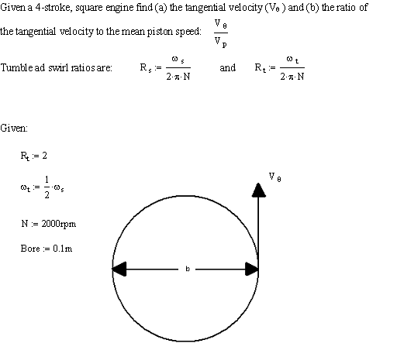
Figure 13. Assessment Question

The grade sheet is given in Figure 14.

Last Name | First, Name | Grade (x/10)
Adams | Thomas | 10
Anconetani | Arthur | 10
Beahn | James | 10
Cameron | James | 10
Castillo | Oscar | 10
Conn | John | 10
Credle | Sydni | 10
Dunlap | Damion | 10
Foster | Lancert | 10
Frascati | Joe | 10
Fulton | Ian | 10
Gleaton | Anthony | 10
Gonzalez | Juan | 10
Grimmel | Brad | 10
Hawthorne | Sheril | 10
Henderson | Everett | 10
Kurts | Greg | 10
Lou | Huadong | 10
Maatsch | John | 10
Mammolito | Daniel | 10
Myers | Eric | 10
Peters | Brian | 8
Pierre | Marcnell | 10
Thigpen | Wesley | 10
Toro | Nicholas | 10
Trotta | Richard | 10
Walsh | Brad | 10
Zwolinski | Andrew | 10
Figure 14. Excel Grade Sheet

Review all presentations and choose the top three (other than yours). State reasons why you think they are they are better than others.

- The manifold tuning presentation was very informative. The presenters were very knowledgeable on the subject. This was one of the better presentations because it was very well organized. The presenters explained complex concepts in simple terms. Simplification of each idea, even hard to grasp subjects made this presentation one of the best. Many references were made to practical applications. Also, the facts that need to be considered when designing a manifold were mentioned several times

- The Fuel Cell presentation was also very good. The high quality may have been because of their presentation style more than the actual material covered. The presenters used many pictures to illustrate the ideas. Each picture was very detailed and professional in appearance. Also, many future plans for the application of the information given were mentioned. This inclusion of possible new technology helped to increase class involvement and added to the overall learning experience.
- The Rotary Engine presentation was yet another outstanding presentation. This presentation one again was memorable due to the type of information presented. The Rotary Engine’s popularity in high performance automobiles (e.g., RX-7) made the presentation very interesting. Animated graphics were excellent for providing understanding. Discussions where plentiful and added to the learning. The slides where easy to understand. The presenter was able to answer any question and back it up with an example or a fact attained during research.

Comment on whether the learning-through-teaching project helped you to establish a better recognition to the need for, and an ability to engage in life long learning.

Learning through teaching definitely has helped us recognize the need for life long learning. We know how much technology changes. Even well trained engineers (such as ourselves) will become obsolete without keeping pace with new technology.

Members of the group already had an ability to self-learn. However, this ability was enhanced with this project. It was discovered finding information is one of the toughest problems. Deciding what information is important is also difficult. However, we now feel we are better equipped to tackle life-long learning.

How to use the SCI (Science Citation Index).

- Think of a subject in science that you would like to know more about. (Example: Cylinder Design).

- Open your web browser and type: http://www.fsu.edu/~library/ (FSU Library home page)



- Right Click on FSU Libraries Databases. This will take you into the libraries database. Now Scroll down until you see the Web of Science and right click on it.

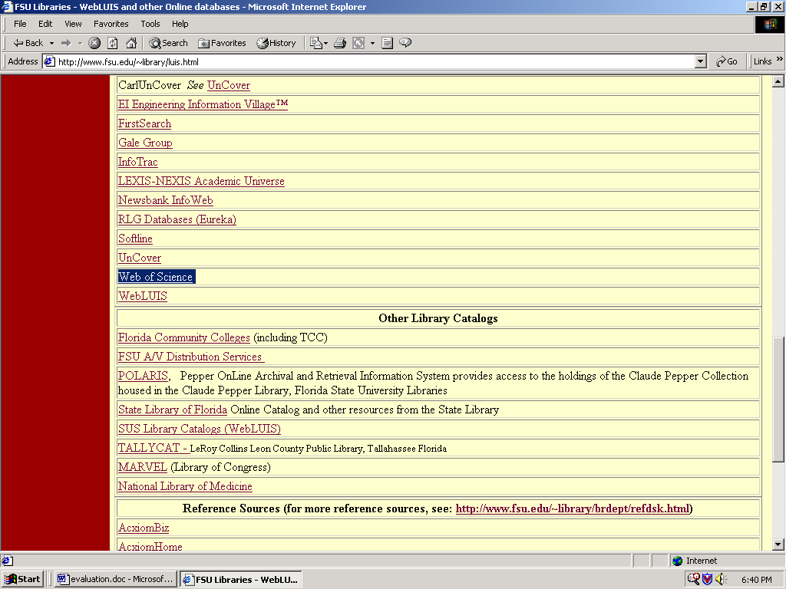
- This will take you into the ISI WEB of Science. Now, you can either right click on Full Search or Easy Search. (example, click on Full Search).

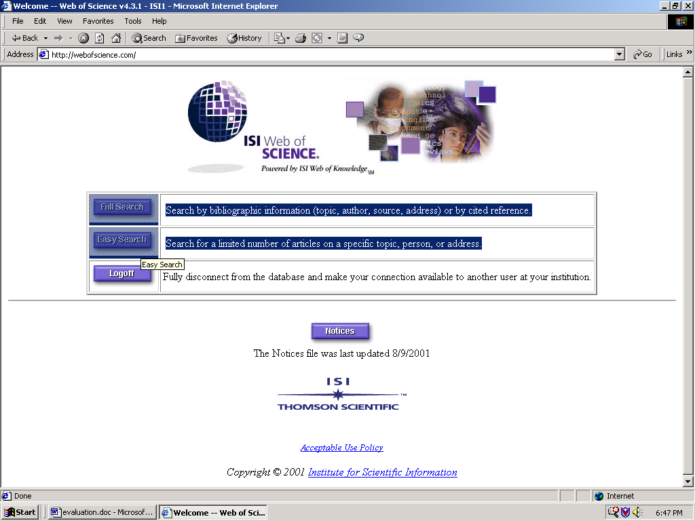

- In this screen you may select how your search will be conducted. Check the box that will allow you to search the Science Citation Index Expanded (SCI-EXPANDED)--1977-present . Then select any other criteria that you would like to search by (example seen below):

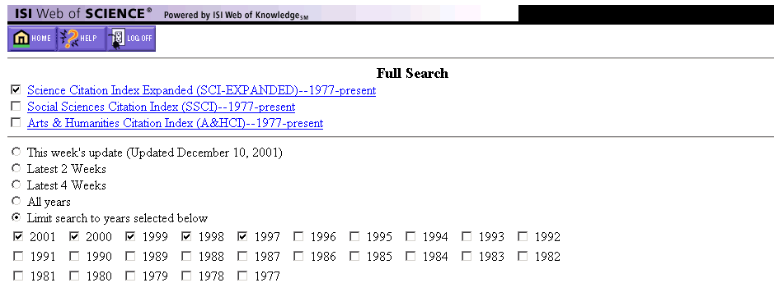
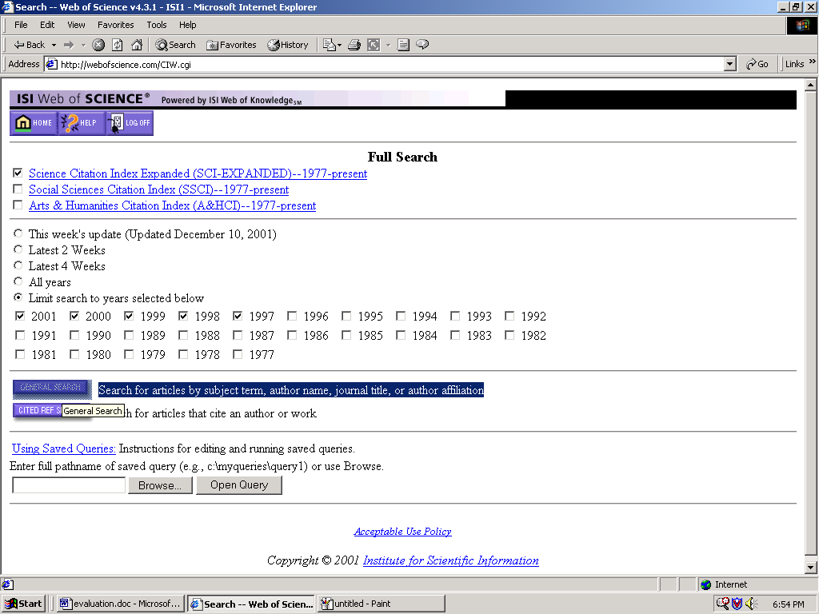

- Now, Right Click on the General Search box.

- In the General Search Screen select the information you want to search the index with. (from our original interest we will write: Piston design in the Topic box) Then right click on the Search button. On this screen, you may also restrict your search by language and document type, as well as selecting the order in which your results will come. Select the order appropriate for you (we selected, English, Article, Latest Date).

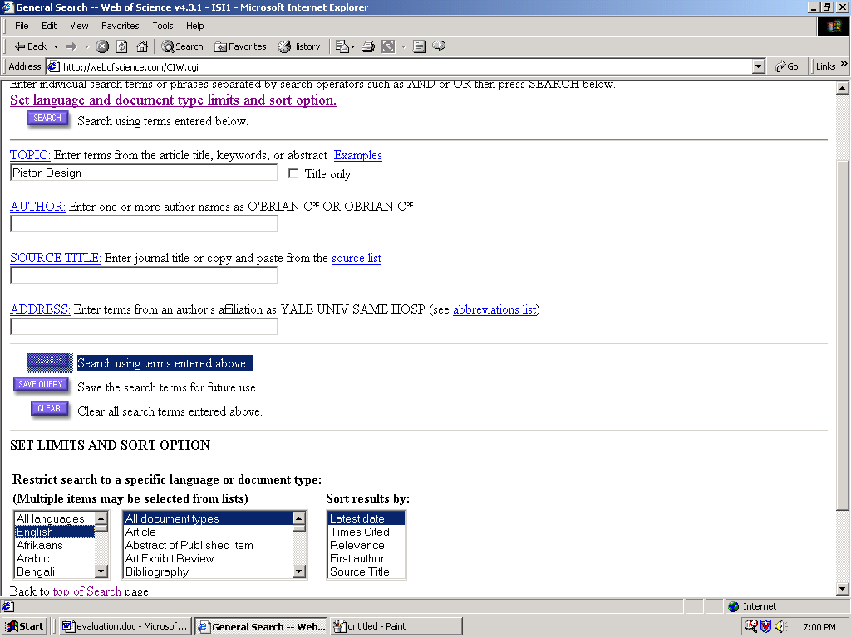

- You will now be in the general search result window. Here you have the results of your search, now right click on the article that you would like to know more about (A two-stage free-piston driver is the article we are interested in).

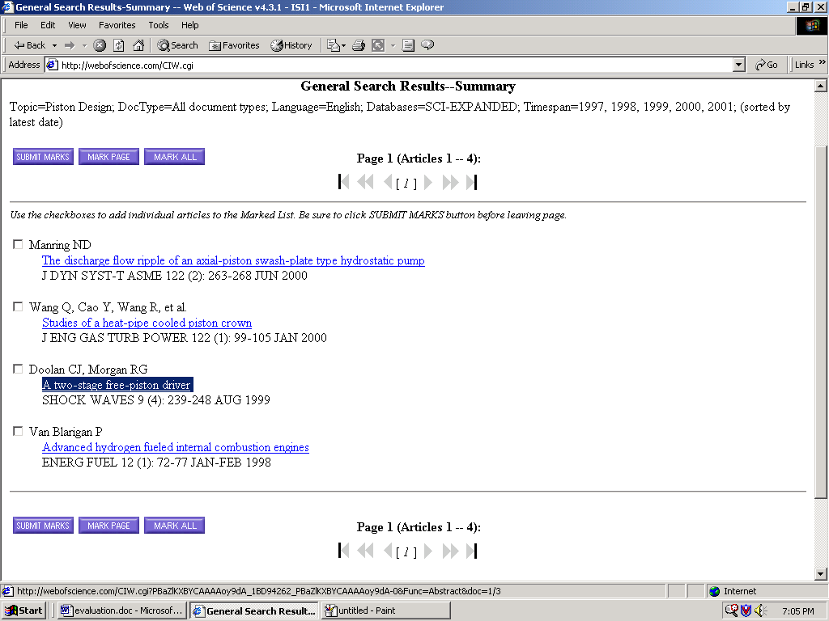

- You are now presented with an abstract of the chosen article. If this article is not helpful, then repeat steps needed to find an article that might be helpful (we will assume that this article is what we want). If the article is what you are looking for then, Write down the information at the top of the Abstract:

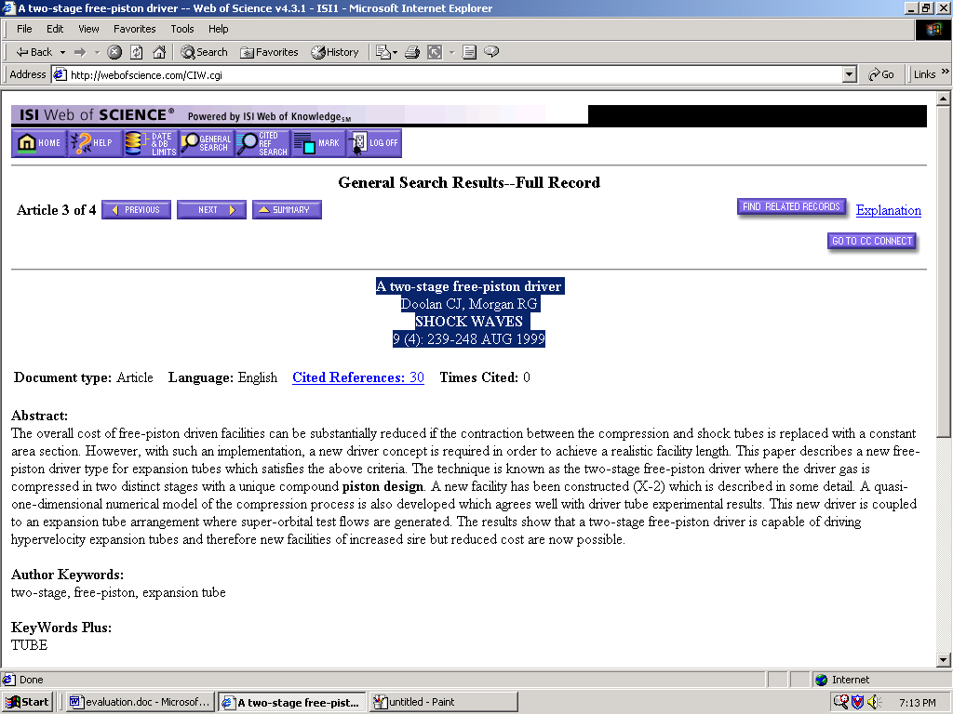

A two-stage free-piston driver Article Title
Doolan CJ, Morgan RG Author
SHOCK WAVES Journal Name (Name of magazine)
9 (4): 239-248 AUG 1999 Issue, Volume, Pages Located, Date

- Once you have this information, Go to WEB Louis. This is done by:

  - Type : http://www.fsu.edu/~library/ on your web browser.



  - Right Click on FSU Online Catalog WebLuis.

  - This will take you to a new window where you will select FSU from the Heading SUS Library Catalogs and Course Reserve Indexes from the Web Luis search system tab.

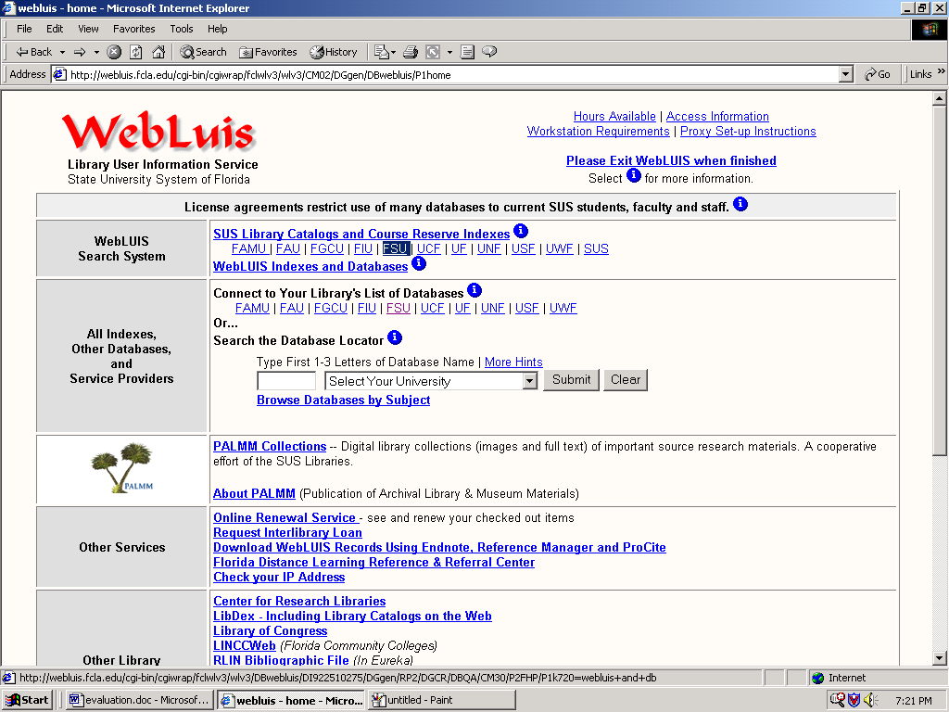

- In this new window select a search type from the menu on the left hand side. Then fill in the subject in the space provided in the center of the window. (We will select the Magazine title and fill in Shock Wave, as found earlier.) Then right Click on submit search button.

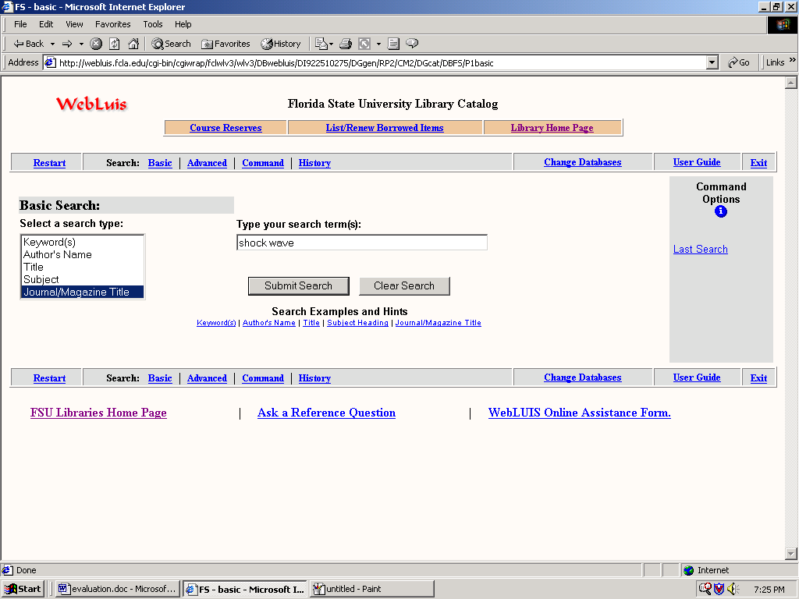

- You are now presented with the articles that The FSU library has available. Note, these may not include your article of interest. If not, select a different library to look in or select a different article present. Remember that issue and volume must coincide with your original search of interest. If you article is present, then write the call number and search for it in the library selected.

- It is very important to recognize that the he best way to search for availability is to do it from the Web Luis at the FSU libraries. It shows the call numbers in a better method.

- Once you have obtained the call number for the desired article, go to the library and find your article

For our search, the area of interest was Combustion chamber design. Looking for SCI references under this heading yielded no useful results. Therefore, using the following categories and search restrictions the following articles where found.

Topic | Search Restriction | Journal Name, Issue, Volume, Pg #, year
IC combustion Chamber | All years | Journal of Mechanisms Transmissions and Automation in design-transactions of ASME  106(2) 209-213, 1984
Piston Design | All Years | International Journal of Vehicle Design  5(3) 336-357, 1984
Swirl | All Years | Journal of Engineering for Gas Turbine and Power Transactions of the ASME  122(4) 570-578, Oct 2000

