Ramjet Engines

Ramjet Basics |  | Other Types of Propulsion  Interesting Links  Site Map  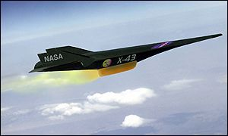
Shock Phenomena | 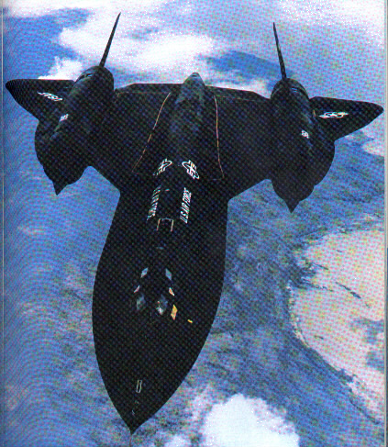
Example Inlet Problem
References

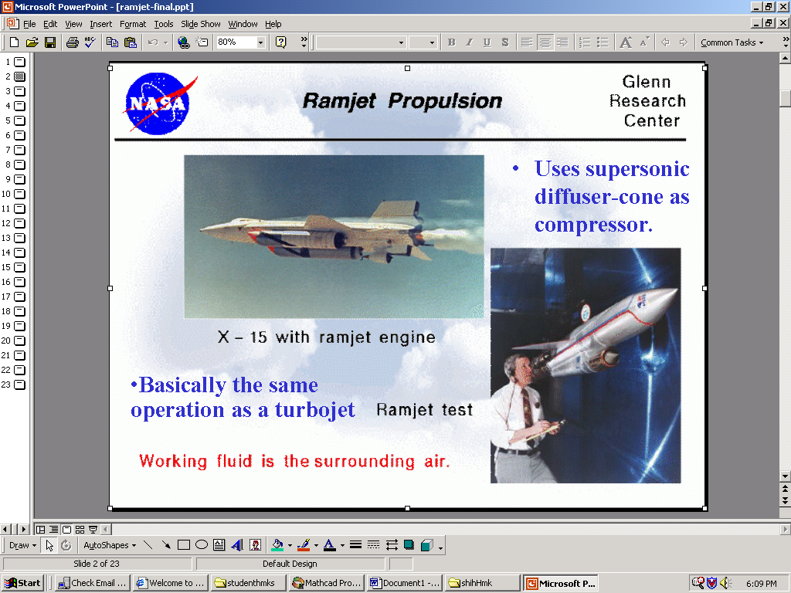
Sydni Credle
Thomas Adams

Wesley Thigpen
Propulsion Systems (EML 4221)
Dr. Shih
Fall 2001

