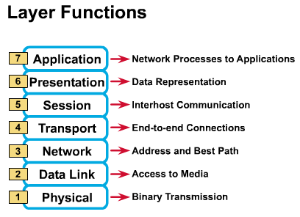

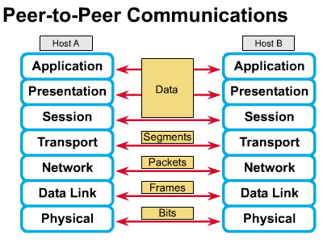
Summary
    - Physical Layer
Media Types
Encoding/Decoding
Scrambling/Descrambling
    - Data Link Layer
Medium Access Control
Logic Link Control
Network Topologies

- Network Layer
Establishing/maintaining/Terminating network connection
routed protocols: IP IPX Apple Talk
routing protocols: RIP RIPv2 OSPF IGRP EIGRP IS-IS
➔ To find the best route

- Transport Layer
Establishing/maintaining/Terminating transport layer connection
TCP SPX
segments and reassembles data
flow control
error control

- Session Layer
Managing data exchange
Pause and resume communication

- Presentation Layer
Character code translation/ Data conversion
Data compression/expansion
Encryption/Decryption
- Application Layer
Provides services to application processes or users.

  - File Transfer Protocol (FTP)
  - Remote Login (Telnet)
  - Transaction Server
  - Network Management
  - WWW Server/VoD Server
  - Browser (HTTP)
  - Internet Telephone

Basic Functions of Protocols

Encapsulation/Decapsulation

Segmentation/Reassembly

Connection Establishing

Flow Control

Error Control

Multiplexing

Synchronization

Sequencing

Addressing

Troubleshooting
Common problems
Hardware |  |  | Software
Line open/short |  |  | Software incompatible
NIC setup error |  |  | Workstation virus
Mixed lines |  |  | Slugish speed
Crosstalk/noise |  |  | Duplicated IP
Bad contact |  |  | Mask setup error
Hub reverse |  |  | Protocol or driver error
Deteriorated terminator |  |  | Server not working

Physical layer
 | line too short
 | line too long
 | terminator error
 | NIC out of order
 | crosstalk/noise
 | repeater error (check power?)

Data link layer
 | bridge error
 | collisions too many
 | frame storm and broadcast storm
 | utilization too high |  |  |  | 40%
 | frame too short |  |  |  | NIC/AP incompatible
 | frame too long |  |  |  | improper ground
 | CRC error
 | frame headless (no preamble) |  |  |  | may cause CRC error as well

Netwrok layer
 | Duplicated IP setup
 | Routing table error |  | (OSPF can improve)
 | Router down
 | Subnet mask setup error
 | ICMP (Internet Control Message Protocol) malfunction

Application layer
 | Version incompatible
 | Virus
 | Poor software efficiency
 | Repeated R/W actions, queries
 | Cannot setup connection with another workstation

Useful web sites

http://www.webdev.net/orca/nojava/faq.htm

http://www.arcetri.astro.it/irlab/doc/doc_pc/pc-hw-faq/eide.1

http://www.itheadline.com/

http://www.cs.wisc.edu/~ghost/aladdin/get601.html

