Lab 2 Static route
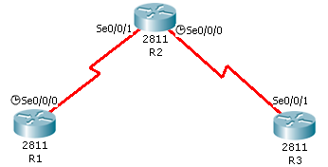
R1
s0/0/0: 192.168.12.1/24
lo0: 1.1.1.1/32

R2
s0/0/1: 192.168.12.2/24
s0/0/0: 192.168.23.2/24
lo0: 2.2.2.2/32

R3
S0/0/1: 192.168.23.3/24
lo0: 3.3.3.3/32

(1) Take R2 for example, finish configuring all routers:
conf t
host R2
int s0/0/0
ip addr 192.168.23.2 255.255.255.0
clock rate 128000
no shut
int lo0
ip addr 2.2.2.2 255.255.255.255
line vty 0 4
no login
privi lev 15
ip host R1 1.1.1.1
ip host R2 2.2.2.2
ip host R3 3.3.3.3

(2) Ping from R1 to R2, from R2 to R3, and from R3 to R1
(3) Add static route so that all ports can be reached
Example:
R1
conf t
ip route 192.168.23.0 255.255.255.0 192.168.12.2
ip route 2.2.2.2 255.255.255.255 192.168.12.2
ip route 3.3.3.3 255.255.255.255 192.168.12.2
or ip route 0.0.0.0 0.0.0.0 192.168.12.2

