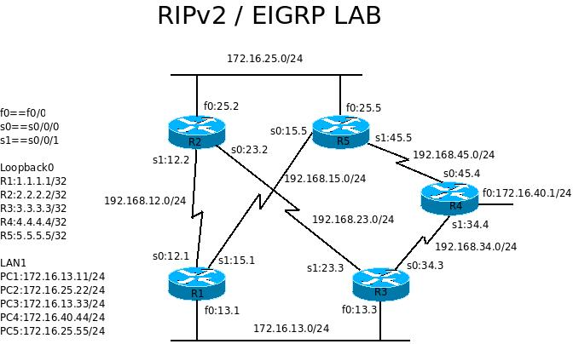
Lab 3 RIPv2

Reference commands:
no ip domain-lookup
logg sync
clock rate 64000
no shutdown
copy run start
do sh ip int br
no keep
exec-timeout 0 0
router rip
network 172.16.0.0
default-information originate

sh run
sh ip route
wr er
reload

- Connect serial cables as shown in the picture and connect the f0/0 ports with cross-over cables. No connections on R4 fa0/0. use no keepalive to keep it up.
- On each router, configure the following:
* host name as shown and privileged password as cisco
* interface address as shown in the diagram (LAN, WAN and Loopback0)
* clock rate and no shutdown as needed
* disable auto DNS request
* telnet password cisco
* console message synchronization
* console session and telnet session no time out
Upon finishing this part, you should be able to ping your neighbor router by the directly connected port.
- On each router, configure router rip and
network 172.16.0.0
network 192.168.xx.0
ver 2
no auto
You should be able to ping everywhere from everywhere except the loopback interfaces. show ip route for troubleshooting.
- On all routers, show cdp neighbor
- shutdown and no shut on related interfaces if the routing table does not change as expected.
- On R3, enter default-information originate under router mode.

- Type show ip route on R1, R2 and R4 to see the result.
- Add loopback interfaces into the RIP network info as needed.
- You should be able to ping everywhere from everywhere.

