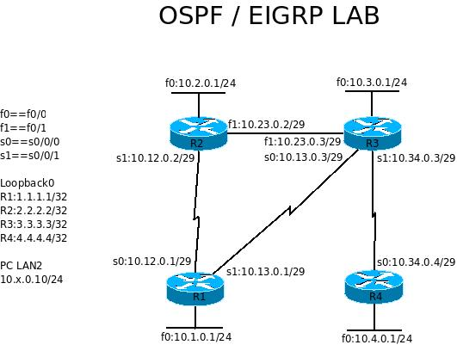
Lab 5 EIGRP and PC

Reference commands:
no ip domain-lookup
logg sync
clock rate 64000
no shutdown
copy run start
do sh ip int br
exec-timeout 0 0
sh run
sh ip route
wr er
reload

- Connect serial cables as shown in the picture and connect the Ethernet ports between R2 and R3 with a cross-over cable.
- On each router, configure the following:
* host name as shown and privileged password as cisco
* interface address as shown in the diagram (LAN, WAN and Loopback0)
* clock rate and no shutdown as needed
* disable auto DNS request
* telnet password cisco
* console message synchronization
* console session and telnet session no time out
Upon finishing this part, you should be able to ping your neighbor router by the directly connected port.
- On your PC, assign an IP address, 10.2.0.10/24 to the 3Com Ethernet interface, as shown above.
- On your PC, open a command window and add a static route to the lab network, 10.0.0.0/8.
Windows command: route add 10.0.0.0 mask 255.0.0.0 10.2.0.1
- Create a cloud and configure the cloud with a port to your 3-Com network card. Connect the cloud to the switch which connects to R2. ping 10.2.0.10 from R2 and ping 10.2.0.1 from your PC.
- On your PC, telnet to your lab network gateway and login to the router. When the telnet session is established, use it to show ip route and ping all points.
- The router logging message will not show on your telnet terminal. To show the message, type terminal monitor in privileged mode.
- On each router, configure router eigrp 100 and
network x.x.x.x y.y.y.y
where x.x.x.x is the direct connected networks and y.y.y.y is the wildcard mask of them. (including loopback interfaces) then check your routing table.
- On R2, on fa0/1 enter band 10 and check the ip route again.
- On each router, type sh ip eig top, sh ip eig nei, and sh ip prot
- On your PC, run tftp server and make sure the server's IP address is 10.2.0.10, and also pay attention to the “save to” location; on your router, copy the running configuration to the tftp server by copy run tftp and your PC's ip address.
- Use your e-mail service to send the configuration file as an attachment to tsai@eng.fsu.edu
- On your router, show run and pay attention to the eigrp configuration.
* under router eigrp 100 mode, change auto and no auto back and forth and type
do sh run | s eigrp to check the configuration. There should not be any difference.
* make it auto-summary, remove the networks with wildcard mask, and add them without wildcard mask. Type do sh run | s eigrp under router configuration mode, What did you find?
- Follow course material to change k1 and k3, hello intervals, etc.

- Turn on the following debugs: deb ip eigrp and deb ip eig noti
- sh deb
- in the end, use no deb all to turn off all debugging.

