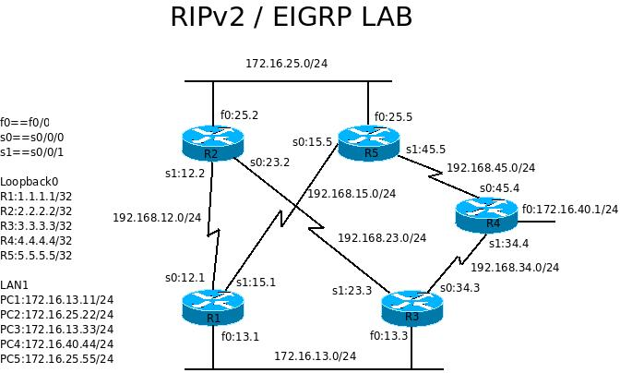
Lab 7 RIPv2 OSPF and EIGRP

Reference commands:
no ip domain-lookup
logg sync
privi lev 15
exec-t 0 0
copy run start
do sh ip int br
no keep
net 0.0.0.0 0.0.0.0 a 0
defaultinformation originate

sh run int s0/1
sh ip route
sh ip ospf nei
sh ip ospf int
sh ip prot
sh prot
sh run | ?

- Connect serial cables as shown in the picture and connect the f0/0 ports with cross-over cables. No connections on R4 fa0/0. use no keepalive to keep it up.
- On each router, configure the following:
* host name as shown and username cisco password cisco with level 15 privilege
* interface address as shown in the diagram (LAN, WAN and Loopback0)
* clock rate and no shutdown as needed
* disable auto DNS request
* no telnet password and directly get into privileged mode
* console message synchronization
* console session and telnet session no time out
On each router, sh ip int br and sh cdp nei det.
- On each router, configure router rip and
network 172.16.0.0
network 192.168.xx.0
network y.0.0.0
ver 2
no auto
Where y is router number and xx are the third octet of its associated network numbers. You should be able to ping everywhere from everywhere now. show ip route for troubleshooting.
- On R4, enter default-information originate under router mode. show ip route
- On routers 1,2,3,5. configure OSPF and advertise all interfaces except loopback0. sh ip ospf nei sh ip ospf int and show ip route Notice the R's becomes O's in the routing table.
- On routers 1 and 2, configure
router eigrp 100
network 0.0.0.0 255.255.255.255
and issue do show ip route. Notice the O's becomes D's on the routing table.
- Shut down R1 s0/0 and check the routing table on all routers again.

This is the end of Course 2 labs.

