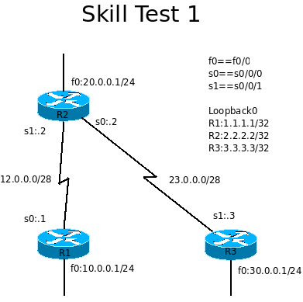
Skill Test 1 Name:_________________

Reference commands:
no ip domain-lookup
logg sync
clock rate 64000
ip host R1 12.0.0.1
ip host R3 23.0.0.3
no shutdown
ip route 0.0.0.0 0.0.0.0 #.#.#.#
copy run start
do sh ip int br
ver 2
no auto
default-information originate
exec-timeout ?
deb ip rip
sh run
sh ip route
wr er
reload

- (2%) Grab three routers and one switch in Packet Tracer. Connect serial cables as shown in the picture and connect all Ethernet cables into the same switch. Turn on routers, erase startup-config and reload.
- (43%) On each router, configure the following:
2-1 host name as shown and privileged password as cisco (10 points)
2-2 host to ip mapping (4 points)
2-3 interface address as shown in the diagram (LAN, WAN and Loopback) (15 points)
2-4 disable auto DNS request (2 points)
2-5 telnet password cisco (5 points)
2-6 console message synchronization (2 points)
2-7 console session no time out; telnet session time out 2 minutes (5 points)
Upon finishing this part, your neighbor router should be able to telnet to your router and enter privileged mode.
- (20%) On R2, configure two static routes to 1.1.1.1/32 and 3.3.3.3/32, respectively; (10 points)
On R1 and R3, configure default route to R2; (10 points)
At this point, you should be able to ping back and forth between 1.1.1.1 and 3.3.3.3 (source ping)
Ask the proctor to check your result before continue to next step.

- (20%) On all routers, configure RIPv2 and add all interfaces into the routing protocol database.
show ip route to check the result (10 points)
Remove the default route on R1 and R3 (5 points)
show ip route to check the result
On R2, enter default-information originate under router mode. (5 points)
On R1 and R3, show ip route to check the result
At this point, you should be able to ping everywhere from all interfaces.
- (15%) On R3, change RIPv2 to RIP (2 points)
On R2, enter deb ip rip and exit debug mode after all updates are made (5 points)
On R2, remove the two static routes (5 points)
show ip route again, 3.3.3.3 should be out of the R2 routing table. Why? (1 points)
You should not be able to ping 3.3.3.3 from R1 or R2 at this point.
On R1 and R2, change RIPv2 to RIP (2 points)
At this point, you should be able to ping everywhere from all interfaces. Why?

