Access Control List

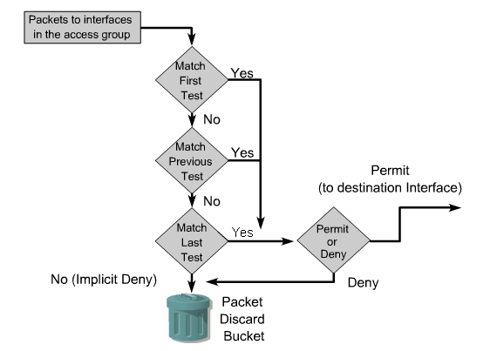

Command Syntax

Step 1 Router(config)# access-list <number> {permit | deny} {test conditions}

Step 2 Router(config-if)# ip access-group <number> {in | out}

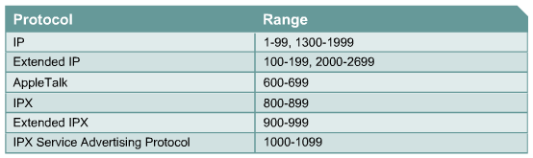
Wildcard Mask

bit | action
0 | Check/match
1 | ignore

Example

IP | Wildcard Mack | Range effected
192.168.1.100 | 0.0.0.255 | 192.168.1.0 ~ 192.168.1.255
10.10.1.100 | 0.0.0.127 | 10.10.1.0 ~ 10.10.1.127
10.1.1.200 | 0.0.0.63
10.10.10.0 | 0.0.31.255
10.10.10.10 | 0.3.255.255
 |  | 10.10.16.0 ~ 10.10.63.255
10.0.0.0 | 0.0.0.35 | 10.0.0.0 ~ 10.0.0.3 and  10.0.0.0.32 ~ 10.0.0.35
10.0.0.0 | 0.0.0.25

any == 0.0.0.0 255.255.255.255
host <ip> == <ip> 0.0.0.0

Standard ACL

permit 10.1.0.0/16
deney 10.1.1.0/25
permit 10.1.1.1/32

access-l 1 permit host 10.1.1.1
access-l 1 deny 10.1.1.0 0.0.0.127
access-l 1 permit 10.1.0.0 0.0.255.255
[access-l 1 deny any]
Extended ACL

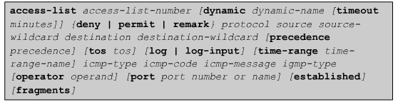
See examples on next page

Common Port Number

7 | echo
20 | ftp-data
21 | ftp
22 | ssh
23 | telnet
25 | smtp
49 | tacacs
53 | domain
63 | whois
67 | bootp server
68 | bootp client
69 | tftp
79 | finger
80 | http
110 | pop3
119 | nntp
123 | ntp
137,138,139 | netbios
155,156 | sql service
179 | bgp

Named ACL

Router(config)# ip access-list {standard | extended} <name>
{remark | permit | deny} <protocol> <source> <destination> <operator> <port>

Note: Ping uses ICMP echo request/reply
(deny icmp <source> <destination> echo-reply)
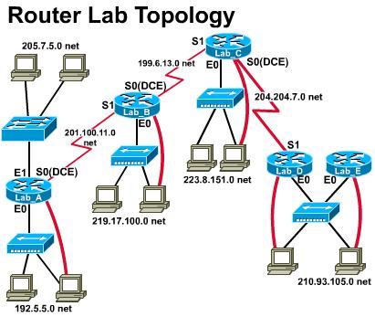

Note: Default gateway or static routes should be properly set up on each PC,
client or server. (using ifconfig and route command on Linux or FreeBSD)
- FTP server 192.5.5.10
From 210.93.105.0 cannot access FTP server, allow all other traffics.
Ans: On Lab_D:
access-list 101 deny tcp 210.93.105.0 0.0.0.255 192.5.5.10 0.0.0.0 eq 21
access-list 101 permit ip any any
interface s1
ip access-group 101 out
or interface e0
ip access-group 101 in
Note: 210.93.105.0 0.0.0.255 can be replaced with any in this case.
- Web Server 210.93.105.10
From 205.7.5.0 cannot browse Web server, allow all other traffics.
Ans: On Lab_A:
access-list 102 deny tcp 205.7.5.0 0.0.0.255 host 210.93.105.10 eq 80
access-list 102 permit ip any any
interface e1
ip access-group 102 in
Note: 205.7.5.0 0.0.0.255 can be replaced with any in this case.

- Telnet Server 223.8.151.10
From 192.5.5.0 cannot telnet to 223.8.151.10, allow all other traffics.
Ans: On Lab_A:
access-list 103 deny tcp 192.5.5.0 0.0.0.255 223.8.151.10 0.0.0.0 eq 23
access-list 103 permit ip any any
interface e0
ip access-group 103 in
Note: 192.5.5.0 0.0.0.255 can be replaced with any in this case.
- FTP server 205.7.5.10
Allow only from 192.5.5.0 to access the FTP server, deny from all other sources to access the FTP server, allow all other traffics.
Ans: On Lab_A:
access-list 104 permit tcp 192.5.5.0 0.0.0.255 host 205.7.5.10 eq 21
access-list 104 deny tcp any host 205.7.5.10 eq 21
access-list 104 permit ip any any
interface e1
ip access-group 104 out
OR: access-list 141 permit tcp 192.5.5.0 0.0.0.255 host 205.7.5.10 eq 21
access-list 141 permit ip any any
access-list 142 deny tcp any host 205.7.5.10 eq 21
access-list 142 permit ip any any
interface e0
ip access-group 141 in
interface s0
ip access-group 142 in
Note: 192.5.5.0 0.0.0.255 can be replaced with any in this case.

- Web Server 219.17.100.10
Allow clients from the left (LAB A), deny clients from the right to access the web server. Allow all other traffics.
Ans: On Lab_C:
access-list 105 deny tcp any host 219.17.100.10 eq 80
access-list 105 permit ip any any
interface s1
ip access-group 105 out
OR: On Lab_B:
access-list 105 deny tcp any host 219.17.100.10 eq 80
access-list 105 permit ip any any
interface s0
ip access-group 105 in
or interface e0
ip access-group 105 out

- FTP/Web/Telnet Server 223.8.151.10
(1) Allow all ip traffics except from the source of 205.7.5.0 ~ 205.7.5.127 to the server.
(2) Allow FTP ONLY from 192.5.5.0, deny all other FTP’s to the server.
(3) Allow telnet to the server from the right (210.93.105.0), deny from the left.
(4) Allow all sources to browse the web server except from 210.93.105.128~210.93.105.191
(5) Allow all other traffics.
Ans: On Lab_B:
(1) access-list 106 deny ip 205.7.5.0 0.0.0.127 host 223.8.151.10
(2) access-list 106 permit tcp 192.5.5.0 0.0.0.255 host 223.8.151.10 eq 21
(2) access-list 106 deny tcp any host 223.8.151.10 eq 21
(3) access-list 106 deny tcp any host 223.8.151.10 eq 23
(5) access-list 106 permit ip any any
interface s0
ip access-group 106 out
On Lab_D:
(2) access-list 106 deny tcp any host 223.8.151.10 eq 21
(4) access-list 106 deny tcp 210.93.105.128 0.0.0.63 host 223.8.151.10 eq 80
(5) access-list 106 permit ip any any
interface s1
ip access-group 106 out
or interface e0
ip access-group 106 in

Note: The clients in 223.8.151.0 cannot be stopped from accessing the server.

- FTP server at 192.5.5.12, web server at 205.7.5.12
Allow ONLY LAB A e0 to access the web server; allow ONLY LAB A e1 to access the FTP server; block all other FTP and Web traffics.
Allow all ip traffics but block the traffic to 210.93.105.0.
Ans: On Lab_A:
access-list 171 permit tcp 192.5.5.0 0.0.0.255 host 205.7.5.12 eq 80
access-list 171 deny tcp any host 205.7.5.12 eq 80
access-list 171 permit ip any any
access-list 172 permit tcp 205.7.5.0 0.0.0.255 host 192.5.5.12 eq 21
access-list 172 deny tcp any host 192.5.5.12 eq 21
access-list 172 permit ip any any
access-list 173 deny tcp any any eq 80
access-list 173 deny tcp any any eq 21
access-list 173 permit ip any any
interface e0
ip access-group 171 in
or interface e1
ip access-group 171 out
interface e1
ip access-group 172 in
or interface e0
ip access-group 172 out
interface s0
ip access-group 173 in

When are packets processed in an inbound access list?
A. Before they are routed to an outbound interface.
B. After they are routed for outbound traffic.
C. After they are routed to an outbound interface while queuing.
D. Before and after they are routed to an outbound interface.
E. Depends on the configuration of the interface
F. None of the above

Which of the following are benefits provided with access control lists (ACLs)? (Select all that apply)
A. ACLs monitor the number of bytes and packets.
B. Virus detection.
C. ACLs dentify interesting traffic for DDR.
D. ACLs provide IP route filtering.
E. ACLs provide high network availability.
F. ACLs classify and organize network traffic.

Which one of the access control list statements below will deny all telnet connections to subnet 10.10.1.0/24?
A. access-list 15 deny telnet any 10.10.1.0 0.0.0.255 eq 23
B. access-list 115 deny udp any 10.10.1.0 eq telnet
C. access-list 15 deny tcp 10.10.1.0 255.255.255.0 eq telnet
D. access-list 115 deny tcp any 10.10.1.0 0.0.0.255 eq 23
E. access-list 15 deny udp any 10.10.1.0 255.255.255.0 eq 23

Which of the following answer choices are correct characteristics of named access list? (Select all that apply)
A. You can delete individual statements in a named access list
B. Named access lists require a numbered range from 1000 to 1099.
C. Named access lists must be specified as standard or extended.
D. You can use the ip access-list command to create named access lists.
E. You cannot delete individual statements in a named access list.
F. You can use the ip name-group command to apply named access lists.

Which of the following access list statements would deny traffic from a specific host?
A. Router(config)# access-list 1 deny 172.31.212.74 any
B. Router(config)# access-list 1 deny 10.6.111.48 host
C. Router(config)# access-list 1 deny 172.16.4.13 0.0.0.0
D. Router(config)# access-list 1 deny 192.168.14.132 255.255.255.0
E. Router(config)# access-list 1 deny 192.168.166.127 255.255.255.255

Which IP address and wildcard mask would you use in your ACL to block all the
hosts in the subnet 192.168.16.43/28?
A. 192.168.16.32 0.0.0.16
B. 192.168.16.43 0.0.0.212
C. 192.168.16.0 0.0.0.15
D. 192.168.16.32 0.0.0.15
E. 192.168.16.0 0.0.0.31

A standard IP access list is applied to an Ethernet interface of a router. What does this standard access list filter on?
A. The source and destination addresses
B. The destination port number
C. The destination address
D. The source address
E. All of the above
A network is subnetted using 29 bits for the subnet mask. Which wild card mask should be used to configure an extended access list to permit or deny access to an entire subnetwork?
A. 255.255.255.224
B. 255.255.255.248
C. 0.0.0.224
D. 0.0.0.8
E. 0.0.0.7
F. 0.0.0.3

You wish to limit telnet access into your Cisco router to only a single host. In order to accomplish this, access list 1 has been written to allow host 172.16.1.224 access to the router vty lines. What command would assign this access- list to the Virtual Terminal Lines?
A. router(config-line)# ip access-group 1 in
B. router(config-line)# access-class 1 in
C. router(config-line)# ip access-list 1 in
D. router(config-line)# access-line 1 in

On the serial interface of a router, an inbound access list is configured to deny all traffic from UDP and TCP ports 21, 23, and 25. All other traffic is permitted. Based on this information, which types of traffic will be allowed through this interface? (Choose threee)
A. SMTP B. DNS C. FTP D. Telnet E. HTTP F. POP3

The following access list below was applied outbound on the E0 interface connected to the 192.169.1.8/29 LAN:
access-list 135 deny tcp 192.169.1.8 0.0.0.7 eq 20 any
access-list 135 deny tcp 192.169.1.8 0.0.0.7 eq 21 any
How will the above access lists affect traffic?
A. FTP traffic from 192.169.1.22 will be denied.
B. No traffic, except for FTP traffic will be allowed to exit E0.
C. FTP traffic from 192.169.1.9 to any host will be denied.
D. All traffic exiting E0 will be denied.
E. All FTP traffic to network 192.169.1.9/29 will be denied.

A network administrator wants to add a line to an access list that will block only Telnet access by the hosts on subnet 192.168.1.128/28 to the server at 192.168.1.5.
What command should be issued to accomplish this task?
A. access-list 101 deny tcp 192.168.1.128 0.0.015 192.168.1.5 0.0.0.0 eq 23
access-list 101 permit ip any any
B. access-list 1 deny tcp 192.168.1.128 0.0.0.15 host 192.168.1.5 eq 23
access-list 1 permit ip any any
C. access-list 1 deny tcp 192.168.1.128 0.0.0.255 192.168.1.5 0.0.0.0 eq 21
access-list 1 permit ip any any
D. access-list 101 deny tcp 192.168.1.128 0.0.0.240 192.168.1.5 0.0.0.0 eq 23
access-list 101 permit ip any any
E. access-list 101 deny ip 192.168.1.128 0.0.0.240 192.158.1.5 0.0.0.0 eq 23
access-list 101 permit ip any any
F. access-list 101 deny ip 192.168.1.128 0.0.0.15 192.168.1.5 0.0.0.0 eq 23
access-list 101 permit ip any any

The following access list is added to the HSSI interface for incoming traffic:
Access-list 101 permit tcp any 10.18.10.0 0.0.0.255 eq tcp
What is the effect of the “any” keyword in the above access list?
A. check any of the bits in the source address
B. permit any wildcard mask for the address
C. accept any source address
D. check any bit in the destination address
E. permit 255.255.255.255 0.0.0.0
F. accept any destination
What are some general guidelines regarding the placement of access control lists? (Select two answer choices)
A. You should place standard ACLS as close as possible to the source of traffic to be denied.
B. You should place extended ACLS as close as possible to the source of traffic to be denied.
C. You should place standard ACLS as close as possible to the destination of traffic to be denied.
D. You should place extended ACLS should be places as close as possible to the destination of traffic to be denied.

Which one of the following commands will display the placement and direction of an IP access control list on the interfaces of a router?
A. show interface list
B. show ip route
C. show ip interface
D. show ip interface brief
E. show interface

A network administrator has configured access list 172 to prevent Telnet and ICMP traffic from reaching a server with the address if 192.168.13.26. Which command can the administrator issue to verify that the access list is working properly? (Choose three)
A. Router# ping 192.168.13.26
B. Router# debug access-list 172
C. Router# show open ports 192.168.13.26
D. Router# show access-list
E. Router# show ip interface

A network administrator has configured access list 172 to prevent Telnet and ICMP traffic from reaching a server with the address if 192.168.13.26. Which command can the administrator issue to verify that the access list is working properly? (Choose three)
A. Router# ping 192.168.13.26
B. Router# debug access-list 172
C. Router# show open ports 192.168.13.26
D. Router# show access-list
E. Router# show ip interface

