Lab 0

Use GNS3 3725 routers to connect the WAN cables as shown in the picture.
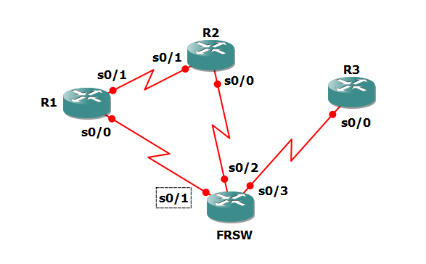

Refer to FRSW.txt for the configuration of FRSW (Frame Relay Switch). DLCI 102 is connected to DLCI 201; DLCI 103 is connected to DLCI301; and DLCI 203 is connected to DLCI 302.

Please confirm your connection with the FRSW configuration.

Ref: http://www.thebryantadvantage.com/Frame%20Relay%20Switch.htm

Please configure each router with the following template:
x should be replaced with 1, 2 or 3.

wr er
reload

hostname Rx
enable secret cisco
line con 0
logg sync
int s0/0
encap frame-relay
ip addr 10.10.0.x 255.255.255.0
no shut
end
wr

ping 10.10.0.x

