Lab 1 Frame Relay and PPP

1. Hub and Spoke Frame Relay
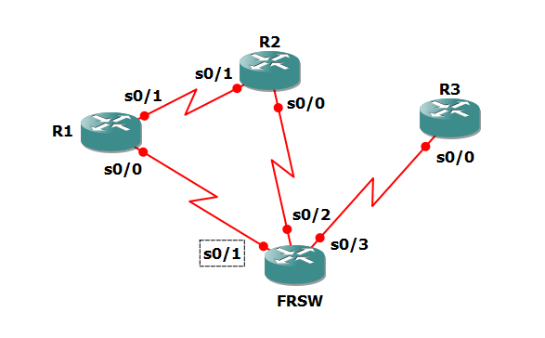

R1 is the hub, and R2 and R3 are spoke routers. DLCI 102 is connected to DLCI 201 and DLCI 103 is connected to DLCI301. No direct DLCI connection between R2 and R3.

R1:
int s0/0
shut
encap frame-relay
no frame inv
frame map ip 10.10.0.1 102
frame map ip 10.10.0.2 102 broadcast
frame map ip 10.10.0.3 103 br
ip addr 10.10.0.1 255.255.255.0
no shut

R2:
int s0/0
shut
encap frame-relay
no frame inv
ip addr 10.10.0.2 255.255.255.0
frame map ip 10.10.0.1 201 br
frame map ip 10.10.0.2 201
frame map ip 10.10.0.3 201
no shut

R3:
int s0/0
shut
encap frame-relay
no frame inv
ip addr 10.10.0.3 255.255.255.0
frame map ip 10.10.0.1 301 br
frame map ip 10.10.0.2 301
frame map ip 10.10.0.3 301
no shut

ping 10.10.0.x
Lab 1 Frame Relay and PPP

2. Point to Point Frame Relay

R1 is the hub, and R2 and R3 are spoke routers. DLCI 102 is connected to DLCI 201 and DLCI 103 is connected to DLCI301. No direct DLCI connection between R2 and R3.

R1:
int s0/0
no ip addr
no encap frame-relay
encap frame
int s0/0.2 point-to-point
ip addr 10.10.12.1 255.255.255.0
frame interface-dlci 102
int s0/0.3 point-to-point
ip addr 10.10.13.1 255.255.255.0
frame interface-dlci 103

R2:
int s0/0
no ip addr
no encap frame-relay
encap frame
int s0/0.1 point-to-point
ip addr 10.10.12.2 255.255.255.0
frame interface-dlci 201

R3:
int s0/0
no ip addr
no encap frame-relay
encap frame
int s0/0.1 point-to-point
ip addr 10.10.13.3 255.255.255.0
frame interface-dlci 301

ping 10.10.12.x
ping 10.10.13.x

R2:
ip route 10.10.13.0 255.255.255.0 10.10.12.1

R3:
ip route 0.0.0.0 0.0.0.0 10.10.13.1
Lab 1 Frame Relay and PPP

3. PPP FR with EIGRP routing

EIGRP AS number 100

3-0 remove all static routes
3-1 Configure Fa0/0 and loopback0 IP addresses as follows:
R1-fa0/0:10.1.0.1/24 lo0:1.1.1.1/32
R2-fa0/0:10.2.0.1/24 lo0:2.2.2.2/32
R3-fa0/0:10.3.0.1/24 lo0:3.3.3.3/32

3-2 Add EIGRP routing and introduce all interfaces into EIGRP database.
router eig 100
net 0.0.0.0 255.255.255.255

sh ip route when completed

4. Hub and Spoke Frame Relay with EIGRP routing
4-1 Remove all subinterfaces by no command.
4-2 Reconfigure your s0/0 as in 1. Hub and Spoke Frame Relay.
4-3 sh ip route and check the routing tables on R2 and R3.

Remedy:
R1
int s0/0
no ip split-horizon eigrp 100

5. PPP authentication
Please configure the following:
R1
user R2 pass 1234
int s0/1
no shut
encap ppp
ppp authen chap

R2
user R1 pass 1234
int s0/1
no shut
encap ppp
ppp authen chap

do sh cdp nei before and after no shut, encap ppp, and user Rx pass 1234
to test the communications.

