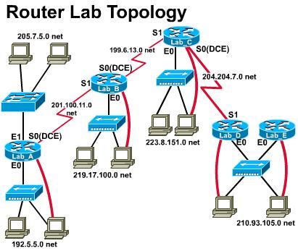
Note: Default gateway or static routes should be properly set up on each PC, client or server. (using ifconfig and route command on Linux or FreeBSD)
- FTP server 192.5.5.10
From 210.93.105.0 cannot access FTP server, allow all other traffics.

- Web Server 210.93.105.10
From 205.7.5.0 cannot browse Web server, allow all other traffics.

- Telnet Server 223.8.151.10
From 192.5.5.0 cannot telnet to 223.8.151.10, allow all other traffics.

- FTP server 205.7.5.10
Allow only from 192.5.5.0 to access the FTP server, deny from all other sources to access the FTP server, allow all other traffics.

- Web Server 219.17.100.10
Allow clients from the left (LAB A), deny clients from the right to access the web server. Allow all other traffics.

- FTP/Web/Telnet Server 223.8.151.10
(1) Allow all ip traffics except from the source of 205.7.5.0 ~ 205.7.5.127 to the server.
(2) Allow FTP ONLY from 192.5.5.0, deny all other FTP’s to the server.
(3) Allow telnet to the server from the right (210.93.105.0), deny from the left.
(4) Allow all sources to browse the web server except from 210.93.105.128~210.93.105.191
(5) Allow all other traffics.

- FTP server at 192.5.5.12, web server at 205.7.5.12
Allow ONLY LAB A e0 to access the web server; allow ONLY LAB A e1 to access the FTP server; block all other FTP and Web traffics.
Allow all ip traffics but block the traffic to 210.93.105.0.

