Homework 3/20/07
DUE: 3/29/07
TEAM up to 2 people

Based on the information giving below, applying CHAMP to conduct wave and erosion analysis for the coastal transect. Provide figures for beach erosion analysis, and provide table of wave height for wave analysis.

- General information

Vertical Datum: NGVD29
Projection: lat/long
Unit system: English
Estimated firm scale: 1”=500’

Transect type: sandy beach- small dune
Range and Direction left: 3000’ 90
Range and Direction Right: 3000’ 90
Location of Station 0: X35 Y 22, Bearing 90

Flooding source: Atlantic Ocean
1% SWEL: 9.9
10% SWEL: 6.7
Mean High water Elev: 2
Mean low water Elev: -2
Fetch length: 80
Significant wave height: 30
Deepwater wave period: 13.1
Wave setup magnitude: 2
Type of Event: Hurricane

2. Transect Data
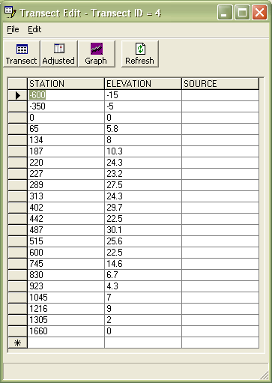
Other flooding source:
Source: back bay 1% SWEL: 7.3; 10%SWEL: 3.5
Station 229.2 and station795.57 are using OF card

