Project PART 1: example of data

3. Examples of transect data are given below:

Location: Lee County
Using the Vertical Datum NAVD 88
Projection: State Plane
Unit system: English
Firm scale: 1”=500’
No. of Transects: 4

Transect_1:

Transect type: Sandy beach- small dune
Range and Direction Left: 4500 North
Range and Direction Right: 5700 South
Location of Station_0: X: 771382.5 Y: 512952.1 Bearing: 230

Parameters
Flooding source: Gulf of Mexico
1%SWEL: 11.32
10% SWEL: 4.92
Mean High water Elevation: 0.51
Mean Low water Elevation: -0.76
Fetch length: 24
Significant wave: 23.3
Deepwater wave Period: 14.1
Wave Setup Magnitude: 1.5
Type of Event: Hurricane

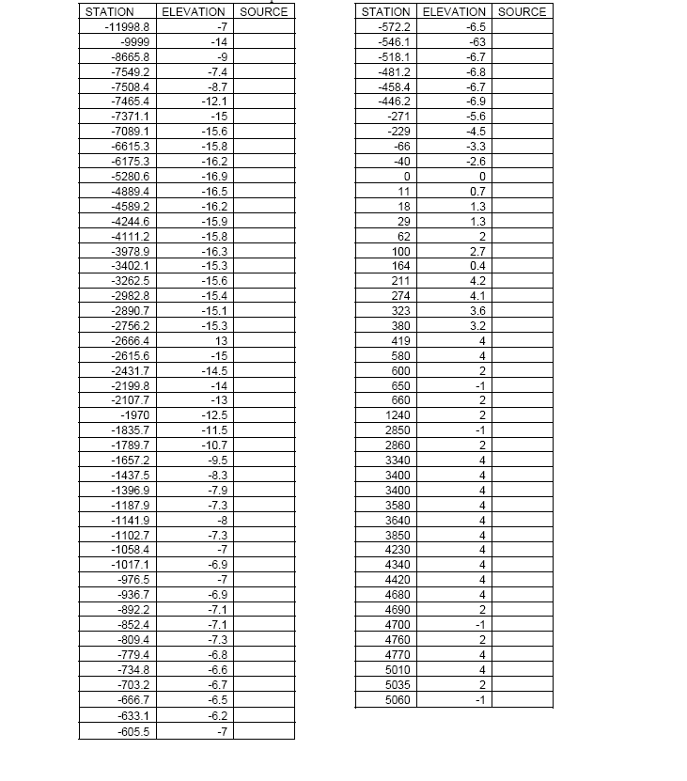

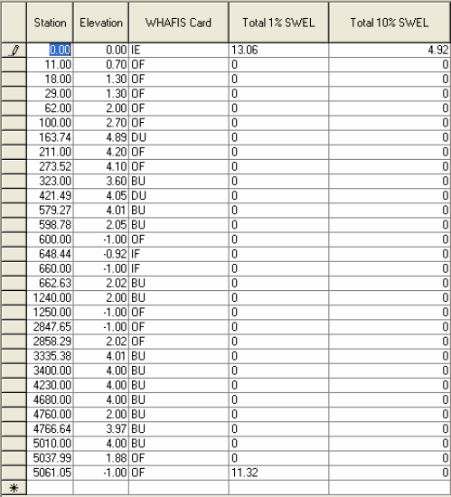
323 BU: Open space: 12’ Total length: 40 No. of Rows: 2
579.27& 598.78 BU: Open space: 16’ Total length: 40 No. of Rows: 1
662.63 BU: Open space: 18’ Total length: 40 No. of Rows: 2
1240 BU: Open space: 16’ Total length: 40 No. of Rows: 1
3400~4766.64 BU: Open space: 16’ Total length: 40 No. of Rows: 1

Transect_2:

Transect type: Sandy beach- small dune
Range and Direction Left: 4500 North
Range and Direction Right: 4500 South
Location of Station_0: X: 766303.5 Y: 522729 Bearing: 220

Parameters
Flooding source: Gulf of Mexico
1%SWEL: 11.32
10% SWEL: 4.92
Mean High water Elevation: 0.51
Mean Low water Elevation: -0.76
Fetch length: 24
Significant wave: 23.3
Deepwater wave Period: 14.1
Wave Setup Magnitude: 1.5
Type of Event: Hurricane
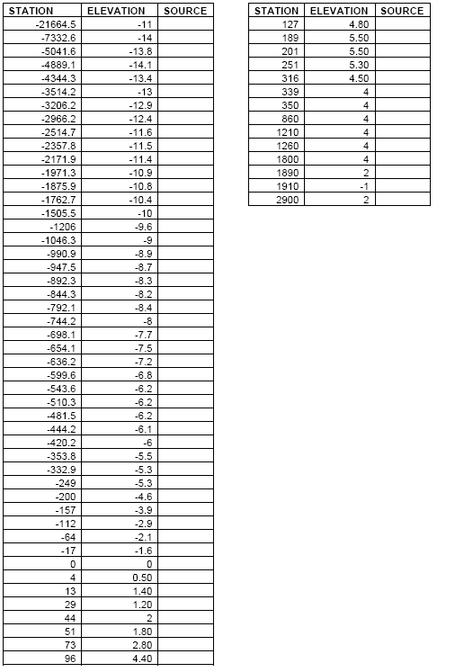

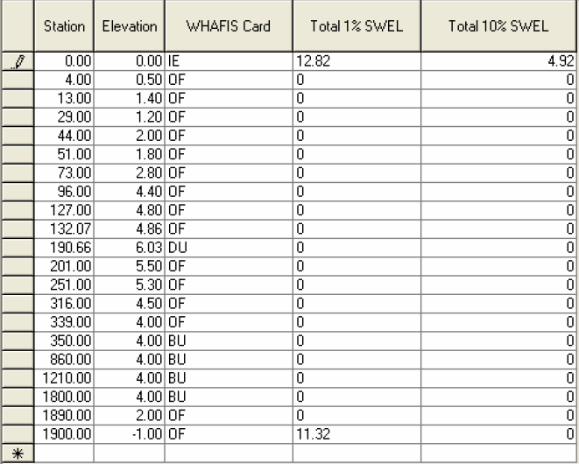
350 BU: Open space: 14’ Total length: 40 No. of Rows: 1
860 BU: Open space: 18’ Total length: 40 No. of Rows: 2
1210 BU: Open space: 16’ Total length: 40 No. of Rows: 2
1800 BU: Open space: 12’ Total length: 40 No. of Rows: 1
Transect_3:

Transect type: Sandy beach- small dune
Range and Direction Left: 5850North
Range and Direction Right: 2850 South
Location of Station_0: X: 759571.5 Y: 530241 Bearing: 230

Parameters
Flooding source: Gulf of Mexico
1%SWEL: 11.22
10% SWEL: 4.92
Mean High water Elevation: 0.51
Mean Low water Elevation: -0.76
Fetch length: 24
Significant wave: 23.3
Deepwater wave Period: 14.1
Wave Setup Magnitude: 1.5
Type of Event: Hurricane

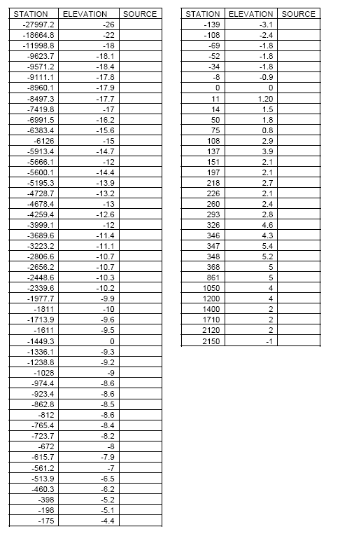

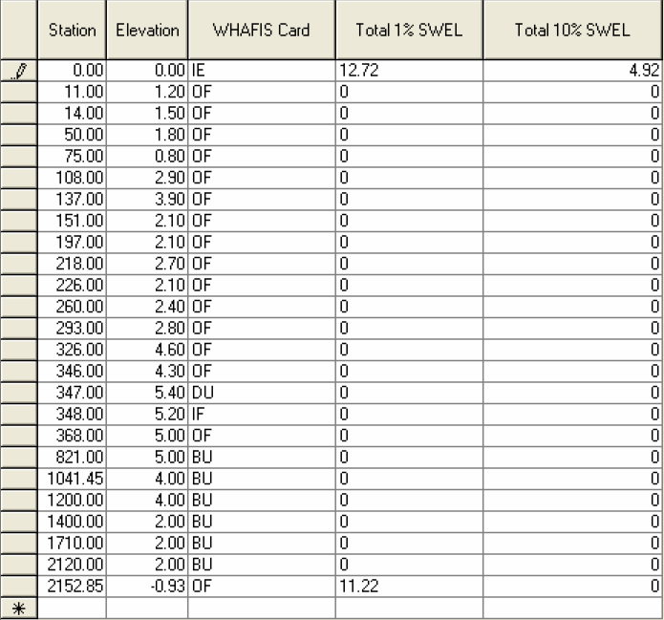

Transect_4:

Transect type: Sandy beach- small dune
Range and Direction Left: 3600North
Range and Direction Right: 3900 South
Location of Station_0: X: 752534.5 Y: 534590.5 Bearing: 190

Parameters
Flooding source: Gulf of Mexico
1%SWEL: 11.22
10% SWEL: 4.92
Mean High water Elevation: 0.51
Mean Low water Elevation: -0.76
Fetch length: 24
Significant wave: 23.3
Deepwater wave Period: 14.1
Wave Setup Magnitude: 1.5
Type of Event: Hurricane

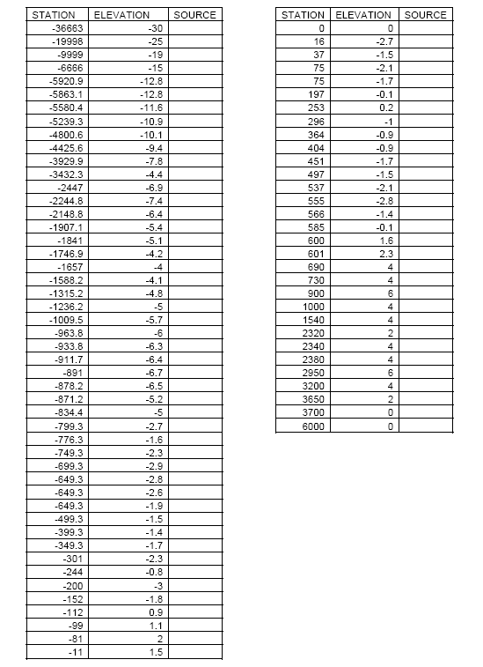

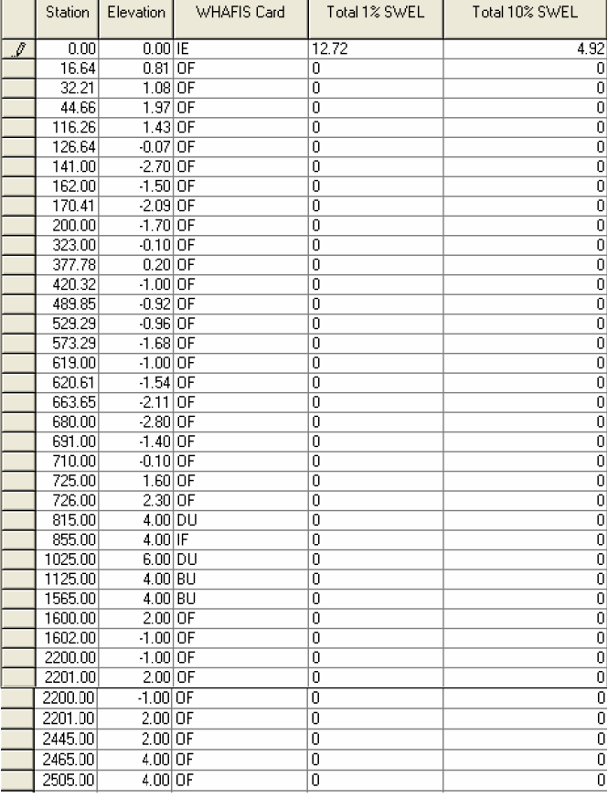
1125 BU: Open space: 16’ Total length: 40 No. of Rows: 1
1565 BU: Open space: 18’ Total length: 40 No. of Rows: 1

