Summary for Part III:

Drag force on submerged body (page 517)

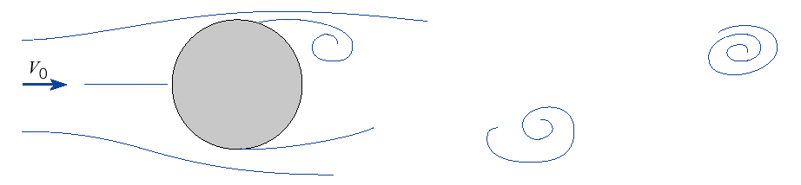

$$F_{D}=C_{d}Aρ\frac{V^{2}}{2}$$

Where Cd is the drag coefficient, A is the area, V is velocity

Open Channel Flow Hydraulics:

- Uniform flow (or normal flow). (page 440), and Manning equation
Manning equation (SI unit, Q in cubic meter per second): $Q=\frac{1}{n}{\text{AR}}_{h}^{2/3}S^{1/2}$
Manning equation (English unit, Q in cfs) $Q=\frac{1\text{.}\text{49}}{n}{\text{AR}}_{h}^{2/3}S^{1/2}$
Hydraulic radius: R_{h}=A/P, where A is the cross-section area, P is wetted perimeter.

Types of problems:
1.1 Determine wetted parameter (P) and hydraulic radius (R_{h}) for the following cross sections.

1.2: Determine velocity and flowrate when other data are given.

  - Determine normal depth ( the depth in Manning equation) when all other data are given.
( When you are asked to determine the super critical flow/subcritical flow, you need to find normal depth from Manning equation to compare with the critical depth)

- Specific Energy (page 677): $E_{s}=y+\frac{v^{2}}{2g}$.
- Critical depth, subpercritical flow, subcritical flow. Critical depth occurs at minimum specific energy

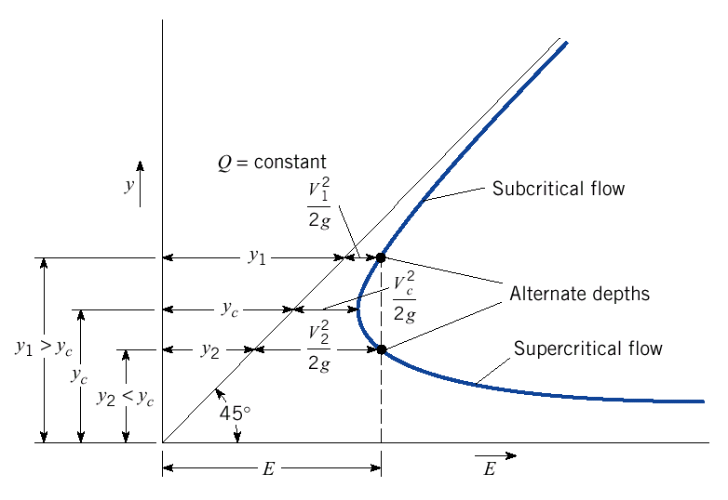

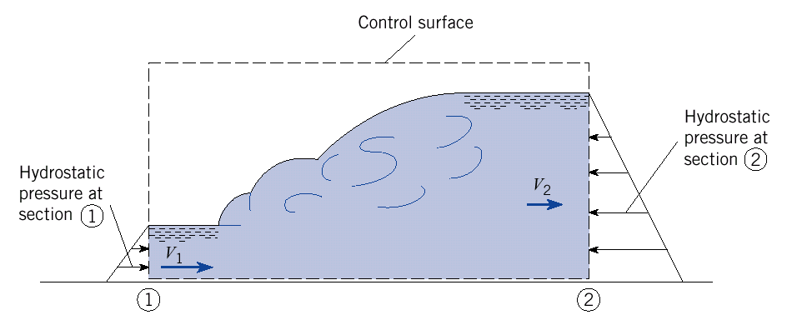

What you need to know:
3.1: General equation for critical depth (pg 679, eq 15.8): $\frac{Q^{2}T_{c}}{{\text{gA}}_{c}^{3}}=1$
3.2. For rectangular cross-section, critical depth can be determined from Eq 15.13:
$y_{c}=(\frac{q^{2}}{g})^{1/3}$, where q=Q/B
  - If yn > yc, flow is subcritical.
If yn=yc, flow is critical.
If yn<yc, flow is supercritical flow.

- Hydraulic Jump:
Hydraulic jump occurs only when flow changes from supercritical to subcritical flow.
What you need to know:
4.1: Water depth before and after the hydraulic jump (pg 692, eq 15.27 or 15.28)

$$y_{2}=\frac{y_{1}}{2}(\sqrt{1+8{\text{Fr}}_{1}^{2}}−1)$$

$$y_{1}=\frac{y_{2}}{2}(\sqrt{1+8{\text{Fr}}_{2}^{2}}−1)$$

Froude number Fr=v/sqrt(gy)

4.2. Head loss in hydraulic Jump:
$h_{L}=\frac{(y2−y1)^{3}}{4y_{1}y_{2}}$

Y1= 0.1 m, v1=10 m/s
Y2=5 m, v2 =0.5 m/s

FIND head loss in the hydraulic jump

