Wenrui Huang, Ph.D.,P.E., Professor
Civil and Environmental Engineering Dept., FAMU-FSU College of Engineering, Tallahassee, FL, 32310, USA.
Phone: 850-410-6199; E-mail: whuang@eng.fsu.edu
[Back to department main page]

Research Interests:
- Natural hazard modeling (coastal storm surge and waves, watershed runoff, floods, etc… )
- Integrated hydrodynamic and ecological modeling for estuarine ecosystem studies
- Hydrological analysis of extreme water levels and flows for flood frequency
- Impacts of human activities and climate changes on water resources and ecosystems.

Summary of Research, Services, and Publications
- Associate Editor: Estuarine, Coastal and Shelf Science (2017-2020 term)
- Associate Editor: Journal of Coastal Research (since 2009 - )
- Executive Editor-in-Chief: Frontiers of Structural and Civil Engineering (since 2013 -)
- Associate Editor: Journal of Engineering Mechanics (2010-2015 term)
- Member:ASCE/EMI Fluid Dynamics Committee
- Have conducted research projects funded by NSF,NOAA,USACE,USEPA,DHS,FEMA,DOT,DEP,NWFWMD,SWFWMD, etc.
- Have authored and co-authored over 80 peer-reviewed and SCI-indexed journal articles.

Link to examples of research projects

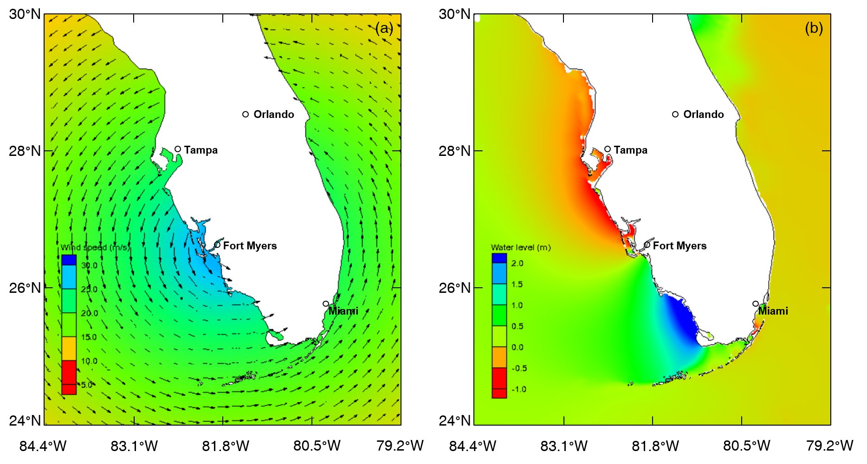
Example 1: Wind and storm surge during Hurricane Irma in 2017

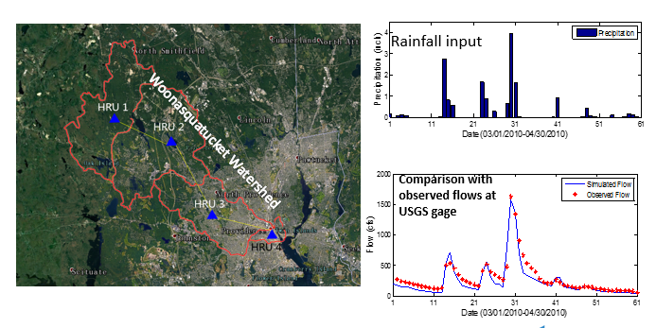
Example 2: Hydrological model of storm-induced rainfall runoff Woonasquatucket Watershed, RI

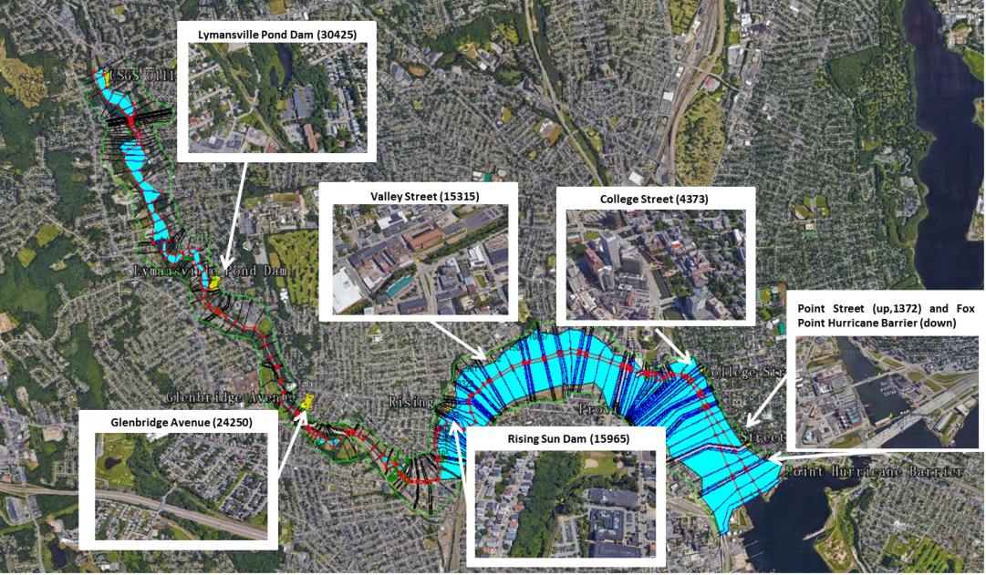
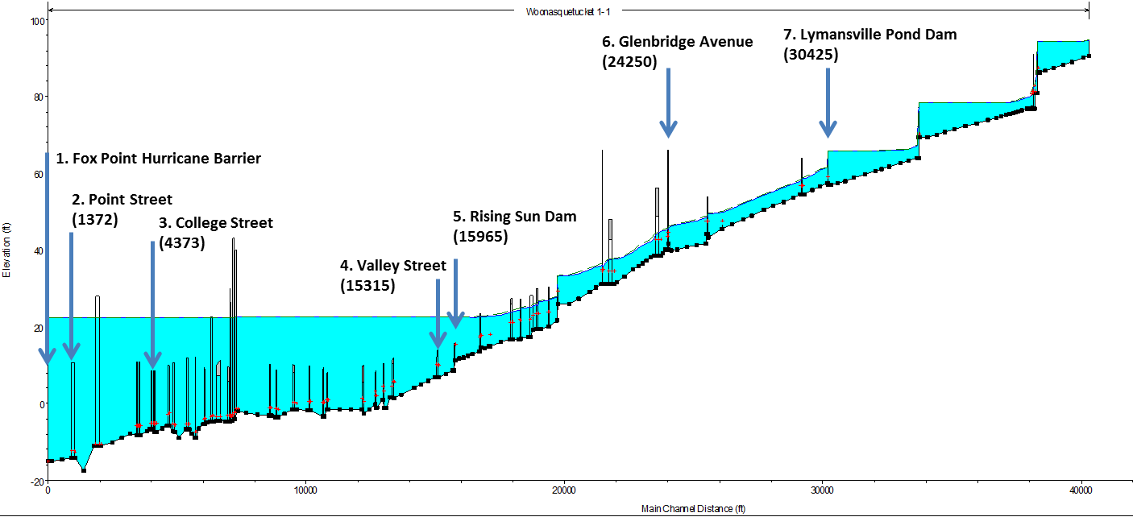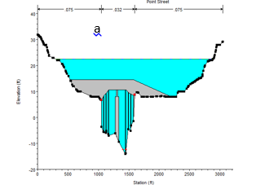
Example 3: Flood mapping in the City of Providence and Woonasquatucket River, RI

