**Wenrui Huang, Ph.D.,P.E., Professor**

**Civil and Environmental Engineering Dept., FAMU-FSU College of Engineering, Tallahassee, FL, 32310, USA.**

**Phone: 850-410-6199; E-mail:** [**whuang@eng.famu.fsu.edu**](mailto:whuang@eng.famu.fsu.edu)

**[**[**Back to department main page]**](http://www.eng.fsu.edu/cee/index.php?page=faculty)

**Research Interests:**

* **Natural hazard modeling (coastal storm surge and waves, watershed runoff, floods, etc… )**
* **Integrated hydrodynamic and ecological modeling for estuarine ecosystem studies**
* **Hydrological analysis of extreme water levels and flows for flood frequency**
* **Impacts of human activities and climate changes on water resources and ecosystems.**

**Research and training opportunity for FAMU undergraduate students in coastal hazard area. Email to Dr. Huang:** [**whuang@eng.famu.fsu.edu**](mailto:whuang@eng.famu.fsu.edu) **for information.**

[**NOAA Educational Partnership Program with Minority Serving Institutions (EPP/MSI): Center for Coastal and Marine Ecosystems (CCME)**](http://ccme.famu.edu/) **at FAMU**

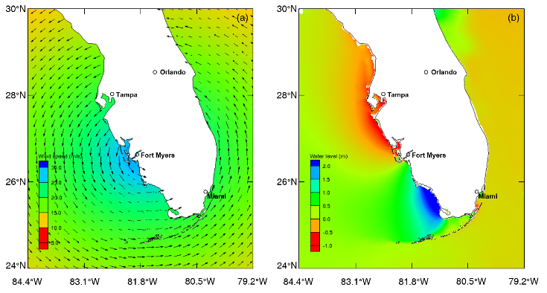

Research examples: Wind and storm surge modeling for Hurricane Irma

**Selected publications:**

Linoj Vijayan, Wenrui Huang, Kai Yin, Eren Ozguven, Simone Burns, Mahyar Ghorbanzadeh, 2021. Evaluation of Parametric Wind Models for More Accurate Modeling of Storm Surge: A Case Study of Hurricane Michael, Accepted for publication by the journal of Natural Hazards. DOI 10.1007/s11069-021-04525-y

Kai Yin, Sudong Xu, Quan Zhao, Wenrui Huang, Ke Yang, Meiting Guo, 2020. Effects of land cover change on atmospheric and storm surge modeling during typhoon event, Ocean Engineering, Volume 199, 2020, 106971, ISSN 0029-8018,

Xiao H., and Wenrui Huang, 2015. Three-dimensional numerical modeling of solitary wave breaking and force on a cylinder pile in the coastal surf zone. Journal of Engineering Mechanics, Volume 141, Issue 8, Article number A4014001, Published AGU. doi: http://dx.doi.org/10.1061/(ASCE)EM.1943-7889.0000834.

Xiao, Hong , and Wenrui Huang, 2008. Numerical Modeling of Wave Runup and Forces Acting on Beachfront House. Journal of Ocean Engineering. Ocean Engineering, 35 (1), pg 106–116

Wenrui Huang, Scott Hagen, Peter Bacopoulos, Dingbao Wang, 2015. Hydrodynamic modeling and analysis of sea-level rise impacts on salinity for oyster growth in Apalachicola Bay, Florida. Estuarine, Coastal and Shelf Science, Volume 156, 5 April 2015, Pages 7–18.

Huang, W.; Hagen, S.C.; Bacopoulos, P., and Teng, F., 2014. Sea-level rise effects on hurricane-induced salinity transport in Apalachicola Bay. Journal of Coastal Research, Special Issue, No. 68, pp. 49-56.

Huang, W., Scott Hagen, Peter Bacopoulos, 2014. Hydrodynamic modeling of Hurricane Dennis Impact on Estuarine Salinity Variation in Apalachicola Bay. Journal of Coastal Research: Volume 30, Issue 2: pp. 389 – 398