CWR4203. Hydraulic Engineering II

Project #1a: Computer Modeling of Unsteady Flow and Flood Area
Using HEC-RAS
Case study: Creek from Lake McBride-Alford Arm

Part I: Steady Flow Case as a base model

Due by: 11/14, 2006

(Students can group in teams with maximum three people)
_________________________________________________________________

For the study area given in the topo map, apply HEC-RAS to simulate surface water elevation in the small river basin. The basic cross section is marked in the topo map. However, students can add more cross sections to get more accurate resolution.

Please use HEC-RAS to examine flood area under a steady flow scenarios: Q=100 cfs. This basic model will be modified in the next step for unsteady flow modeling.

After the completion of computer simulation, write a report that consist of the following elements:

- Introduction of HEC-RAS for unsteady flow
Capability …

- Describe step by step the application menu for using HEC-RAS
(Use screen capture ..)

3. Describe results from the case study
- Area map,
- Model reach/segments
- Cross sections
- Surface profile
- Water cross section
- Flood map

- GIS data are available from links given in:
http://www.eng.fsu.edu/~whuang/cwr4203f06.htm

Appendix:
Leon County GIS website http://www.tlcgis.org/

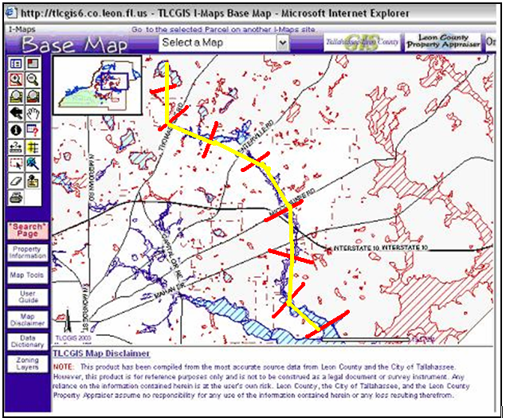

3D View of the Creak in Alford Arm – Lake McBride Basin

Lake McBride

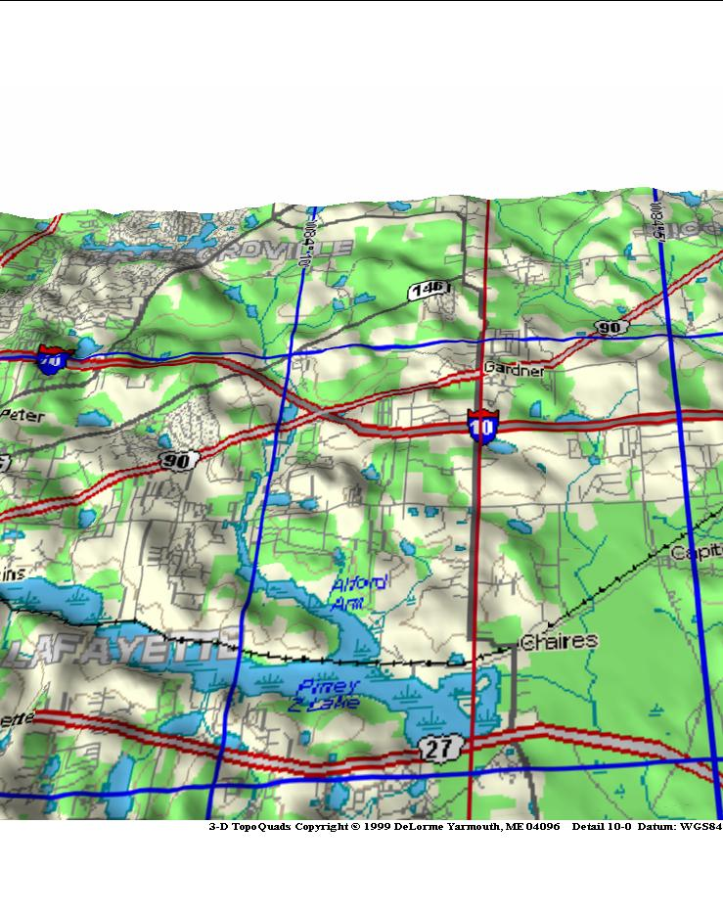

Alford Arm as downstream boundary

Part II.
Due by December 10, 2006

Apply the unsteady flow in the upstream boundary at Lake McBride. Conduct HEC-RAS simulations. Determine flood area under peak flow condition.

Flow data can be downloaded from course website

Please provide following results in the report.

- Plot and describe upstream unsteady boundary condition.

- Plots of profile and cross section under peak flow condition.

- Design culvert system in or near Road 90, and minimize the flood by appropriate selections of culverts.

(Final report can be submitted either in hardcopy or electronic PDF format to “Digit Dropbox”)

