CWR4202. Hydraulic Engineering I

Project : Computer Modeling of Flood Area Using HEC-RAS
Case study: Alforde Arm Area

Part I: Assume no causeway in Buck Lake Road

Due by: April 1

(Students can group in teams with maximum two people)
_________________________________________________________________

For the study area given in the topo map, apply HEC-RAS to simulate surface water elevation in the small river basin. The basic cross section is marked in the topo map. However, students can add more cross sections to get more accurate resolution.

Please use HEC-RAS to examine flood area under three flow scenarios: Q=500, 2000, 10,000 cfs for 25, 50, 100 years of return periods, respectively.

After the completion of computer simulation, write a report that consist of the following elements:

- Introduction of HEC-RAS
Capability …

- Describe step by step the application menu for using HEC-RAS
(Use screen capture ..)

3. Describe the case study
- Area map,
- Model reach/segments
- Cross sections
- Surface profile
- Water cross section
- Flood map

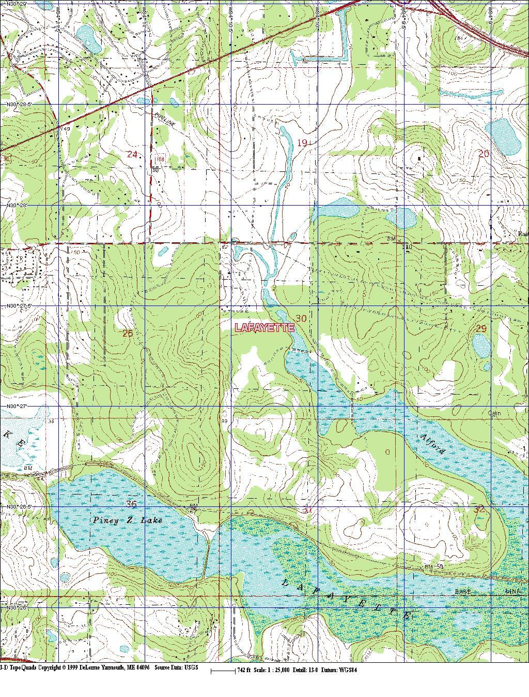

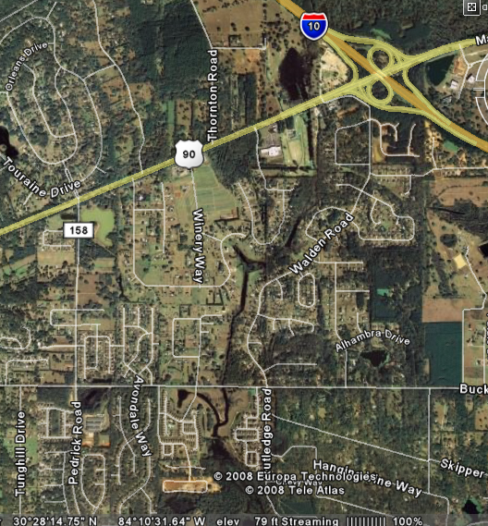

For more details, check Google Earth, type zip code: 32317

Tallahassee-Leon County GIS is the Geographic Information Systems (GIS)
http://www.tlcgis.org/

Other information on topographic maps:
http://www.topozone.com/map.asp?lat=30.43806&lon=-84.28083
http://www.dep.state.fl.us/geology/topo_source.htm
http://www.freac.fsu.edu/products.cfm

