Student ID#: Student’s NAME:

TEST #1-b CWR 4202 HYDRAULICS, , 10/26/2006
Time: 1:15-2:30
Computer based exam test
Application HEC-RAS to solve unsteady hydraulic flows and hydraulic design

Problems:---------------------------------------------------------------------------------------------------------

- Basic unsteady flow problem: “Beaver Cr- Unsteady Flow”
a. Specify unsteady upstream boundary and down steam boundary using data from the excel file.

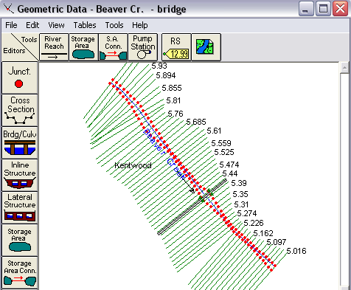

b. Run the model, and provide a profile plot and a cross-section plot

\

- Culvert Design (based on Beaver Cr-with Culvert)

2-a) modify culvert cross-section from box section to arch cross section

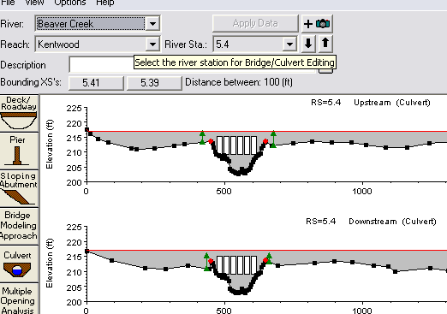

2-b) Create a new culvert section with a box culvert ( 15 ft x 6 ft, 50 ft long) ( include deck and culverts), other parameters are the same as the existing culvert and deck

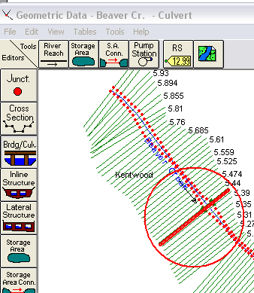

3.

